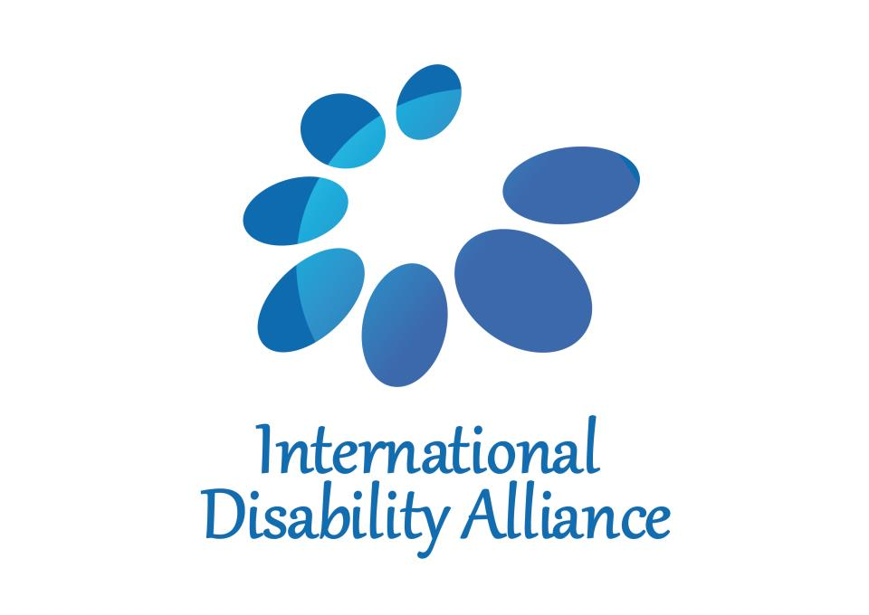
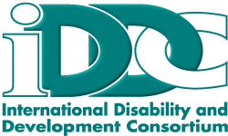

International Disability Alliance and International Disability and Development Consortium
Position Paper for 2018 report of the Inter-agency Task Force on Financing for Development

Persons with Disabilities

In the 2030 Agenda for Sustainable Development (2030 Agenda) and the Addis Ababa Action Agenda (AAAA), Member States committed to leave no one behind. The 2030 Agenda and the AAAA reflect the critical long-awaited political commitments of Member States toward ending poverty, reducing inequalities, and saving the planet. Two years into the implementation process very little of these have been translated into financial commitments. Globally, persons with disabilities - 15 percent of the world’s population - do not adequately benefit from funds and resources spent by public sector or economic, social and cultural development. Persons with disabilities face widespread exclusion from all areas of society and experience higher rates of poverty and deprivation and lower levels of income than the general population. This stems from pervasive discrimination and stigma, unequal opportunities, and physical and attitudinal barriers. During recent economic crises, many countries have reduced public funds that support social participation of persons with disabilities. Consequently, the poverty rate has increased for persons with disabilities and their families. Furthermore, without access to digital infrastructure and accessible ICT, persons with disabilities are at risk to be excluded from statistics and surveys, which leads to exclusion from programs and policies.

These same factors also mean that the rights of persons with disabilities are not adequately addressed in fiscal policies, poverty-reduction programs, social protection floors or development programs and funds. Consequently, promoting equity must be addressed at the center of all of these policies.

Development finance must be people-centered and based on human rights, which requires normative and systematic reform in order for countries to generate the requisite resources to deliver a sustainable agenda. As such, the 2030 Agenda and the AAAA must become an integral part of national policy commitments that are matched with system-wide resource allocation and include commitments on disability spending. It is not sufficient that Member States sign and ratify the UN Convention on the Rights of Persons with Disabilities (CRPD), because this does not ensure that coherent policies, their implementation and financing are carried out. In order to demonstrate that leave no one behind includes persons with disabilities and their families, disability resource allocation must be systematically tracked and reported on at national and global levels.

Domestic and international spending must be adapted in order to provide specific support for persons with disabilities and their families to make public services inclusive and accessible. In order to promote effective inclusion of persons with disabilities and their families, it is necessary to take all measures to make domestic, development assistance, foreign direct investment and public-private partnerships inclusive and accessible. When investment in infrastructure, services and programs do not consider the rights of persons with disabilities, they inadvertently create more barriers for persons with disabilities. This not only exacerbates existing exclusions, but retrofitting inclusion at a later stage is more expensive, reducing the effectiveness of domestic and international resources. The use of ICT and accessible and assistive technology improve the quality of life of persons with disabilities, but also are critical drivers to ensure that the SDGs are achieved. Accessibility of information and communication, including ICT, should also be achieved from the outset because subsequent adaptations to the Internet and ICT may increase costs. Finally, the UN must take a leadership role in supporting the implementation of sustainable development while simultaneously promoting inclusive international dialogue.

Ensuring disability-inclusive financing for development is about: 1) increased resources for the inclusion of persons with disabilities both through specific support and inclusive programming and 2) ensuring the mechanisms that are used promote rather than undermine disability rights.

Commitment to disability spending is necessary to achieve the SDGs by introducing:

I. Disability Rights Compliant Domestic Resource Mobilization

- Structural obstacles: the current global economic system is based on structural injustices, which must be replaced by people-centered development finances in which inequalities, particularly faced by persons with disabilities are addressed. The removal of structural obstacles is required, however, there is not enough dialogue on the alignment of policy and fiscal commitments in order to advance the SDG implementation. We are calling for regular, open, transparent, accessible and inclusive dialogues on the harmonization of policy and fiscal commitments.

- State-guaranteed rights, safeguarding public interests and financial accountability: there are certain responsibilities that must be State guaranteed. There must be concrete commitments to integrate social protection systems, including floors, to establish universal access to public services that are inclusive of persons with disabilities on an equal basis with others. These must be provided through unconditional support from the State. We are calling on the State to guarantee that these rights are safeguarded in society by all actors, including the private sector and business.

- The key function of tax should be redistribution. As such, tax is the most reliable source of financing for public services. Considering that public services are crucial for persons with disabilities, we are calling for commitments that national tax systems and budgets are designed to reflect the leave-no-one-behind principle. Thus, national tax systems must be based on the rights-based approach and they must ensure the rights of persons with disabilities are upheld. Tax systems and budgets must promote equity and equality of persons with disabilities as an objective in all tax and revenue policies. Insufficient money for public services and disproportionate burden of taxation on persons with disabilities of whom 80 percent lives in poverty must instead be reversed, as part of a broader shift in fiscal policy at the national level to address inequalities. Tax reduction in some areas have been developed as good practices in some countries, such as reduction on property taxes and indirect taxation on goods and services. We are calling for taxation reform – both nationally and internationally – that enables mobilization of sufficient resources to comply with State obligations to commit the maximum available resources in fulfillment of the rights of persons with disabilities.

- ICT: Access to financial services has proven to be a pivotal step in helping people get out of poverty, and thanks to digital financial services, many are now participating in the digital economy for the first time. Innovative technologies provide different accessibility features that can be easily integrated into existing systems and with accessible e-commerce platforms that provide support to micro-entrepreneurs with disabilities. We are calling on States to ensure with legislation to ensure the most marginalized have access to accessible, available, affordable and quality financial services.

II. Disability Rights Compliant Donor Funding

- International development cooperation (ODA): ODA remains critical for development financing and fulfilling the commitments in the 2030 Agenda. As such, it remains the cornerstone of success. To close the gap toward poverty eradication, it is important that the ODA framework is centered on human rights obligations and compliant with the rights of persons with disabilities. We are calling on the ODA to be used for achieving the realization of the rights of persons with disabilities by fulfilling the 2030 Agenda to leave no one behind and also to fulfill long-time commitments to accelerate full and effective implementation of the CRPD.

- The practice of combining ODA with non-concessional private resources through blended finance requires careful consideration from a human rights perspective. Blended finance presents risks for the rights of persons with disabilities and other marginalized groups. First, blending has an opportunity cost: ODA devoted to blending is no longer available for other interventions that fulfill the rights of persons with disabilities (e.g. making public services fully inclusive). Second, blended finance projects may be implemented in a way that does not safeguard the rights of persons with disabilities (e.g., if steps are not taken to ensure that persons with disabilities benefit on an equal basis from project results). We are calling for human rights to be the paramount consideration in all aspects of blended finance, including the initial decision on whether to use blending at all; and for persons with disabilities to participate meaningfully throughout the blended finance project lifecycle.

- OECD DAC Marker: There is a proposed OECD DAC policy marker on disability inclusion. While some donors, such as the Department for International Development in the UK have introduced their own policy marker and are therefore able to begin to track spending on disability inclusion; the majority of donors has no way of measuring their spending. The disability policy marker would be used by DAC members as part of the annual reporting of their aid activities, and would enable better tracking and monitoring of spending on disability inclusion in support of the 2030 Agenda. We are calling on OECD DAC members to agree and then take steps to effectively implement the OECD DAC marker on disability inclusion.

- Sources of private concessional funds: including international foundations and private donors provide significant resources in developing countries. All too often, funds aimed at poverty eradication, such as access to clean water and food, exclude persons with disabilities. We are calling for private donors to include persons with disabilities in funding related to poverty eradication.

- Global Partnerships: The idea of global multi-stakeholder partnerships builds on the reality that governments do not address global problems alone. Partnerships are pragmatic, solution-oriented, flexible, efficient and un-bureaucratic, all claimed as essential at a time of scarce resources. Meaningful engagement with all sectors of society is a pre-requisite for democratic decision-making as well as providing invaluable and essential expertise in the identification of problems and solutions. Global partnerships have the potential to focus efforts where the challenges are greatest, and to ensure the inclusion and participation of those who are furthest behind. We are calling on all actors to include persons with disabilities and their families as experts to ensure that global partnerships are inclusive.

III. Strengthening the role of UN in the Financing for Development process and the meaningful inclusion of persons with disabilities

A fundamental dimension of the Financing for Development process has always been the attempt to strengthen the role of the UN. Consequently, we are concerned that the current UN system is not representing an inclusive institution and is not fit for purpose. This is especially concerning in the era of the implementation of the SDGs and the realization of the overarching principle of leave no one behind.

The lack of commitment to the rights of persons with disabilities by the UN is deeply concerning. The United Nations Partnership on the Rights of Persons with Disabilities (UNPRPD) is the only response of the UN to promote the rights of persons with disabilities and the implementation of the CRPD. The UNPRPD has between 3-5 million USD in annual commitments. In comparison, UNICEF delivers on commitments on the UN Convention on the Rights of the Child (CRC) and has six billion in annual commitments, and UN Women delivers on commitments of the Convention on the Elimination of all Forms of Discrimination Against Women (CEDAW) and has 750 million USD in annual commitments. Looking at this discrepancy in fiscal commitments persons with disabilities will be left behind by the UN system. To resolve this, the UN must scale up its commitments toward persons with disabilities. As a result, we recommend the following:

- Inclusive institutions: Fit for Purpose: The UN must become an inclusive institution at all levels, particularly to support the implementation of the 2030 Agenda. As such, the implementation of the CRPD needs to be embraced by the entire UN system as a crosscutting issue, and only then can the 2030 Agenda be achieved for persons with disabilities. We are calling for the establishment of a task force directly reporting to the Secretary-General, to provide system-wide policy guidance toward efforts to enhance the implementation and integration of the CRPD in the UN system as a key for achieving the SDGs for persons with disabilities.

- System-wide action plan on disability: The SWAP would align and coordinate the reporting of every UN Agency, in particular the UN Country Teams, on issues related to the rights of persons with disabilities. It would have an instrumental role in bolstering interest of UN Agencies and their Country Teams. Furthermore, it would provide strategic guidance on the implementation of the SDGs for persons with disabilities. We are calling on the UN to establish a system-wide policy guidance toward efforts to enhance the implementation and integration of the CRPD in the UN system as a key for achieving the SDGs for persons with disabilities.

- Data: In 2017 May, the UN Secretary-General issued the Sustainable Development Goals Report 2017 that states ‘The lack of sound disaggregated data for …. persons with disabilities… exacerbates vulnerabilities by masking the extent of deprivation and disparities. What’s more, a lack of rigorous evidence and comprehensive data has long compromised the ability of governments and the international community to accurately document the discrimination faced by various groups. As a result, planning and budgeting for necessary services along with effective policymaking have suffered. …persons with disabilities and older persons, for example, have largely fallen off the statistical “map”.’ As such, we are calling on Member States and UN Agencies to urgently recommend the Short Set of Questions developed by the Washington Group to be the methodology for disaggregating SDG indicators by disability.

- International Financial Institutions: It is imperative that in all financing mechanisms and initiatives persons with disabilities are not left behind, and for this, participation is key. In addition, international financial institutions need to have inclusive programs for persons with disabilities. We are calling upon all International Financial Institutions, including Multilateral Development Banks to devise mechanisms that allow for the increase of allocation for human-rights-related expenditures and to ensure effective mainstreaming of persons with disabilities internally and externally.

In closing, compliance with universal standards in human rights must be upheld by States. Also, social dialogues must define actionable deliverables that are guaranteed by the State, including the meaningful participation of persons with disabilities. Full implementation of the commitments made by world leaders at the adoption of the 2030 Agenda, including the AAAA, requires a progressive increase in dedicated domestic resource allocation and international development cooperation to support the full inclusion of persons with disabilities. Yet in many countries austerity measures have been imposed, which reduce government expenditures on human rights, development and social welfare when and where they are most needed, and persons with disabilities are often among the very hardest hit. A rights-based response to economic crises could be lifting persons with disabilities and their families out of poverty, and would contribute to the achievement of inclusive growth and sustainable development.

