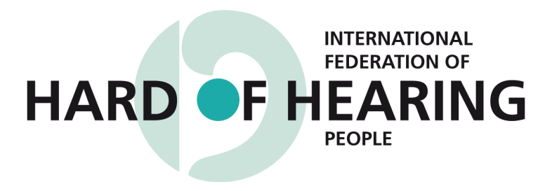

10th Session of the Conference of State Parties to the CRPD Side Events

Accessibility Issues for Hard of Hearing Persons

Wednesday, June 14th 4:45 pm to 6 pm

United Nations Headquarters

New York - Conference Room E

Presented by the

International Federation of Hard of Hearing People (IFHOH) and the International Disability Alliance (IDA)

Description
Accessibility is a key to the integration of hard of hearing persons in society. Hearing aids, assistive devices and captioning are essential yet many individuals go without due to issues of cost, stigma and lack of an infrastructure. These issues exist worldwide and particularly in developing countries.

Speakers:
Dr. Ruth Warick, President, IFHOH
Mr. Avi Blau, Vice-President, IFHOH
Mr. Patrick Gift Egessa, Board Member of IFHOH
Dr. Elizabeth Lockwood, CBM and International Disability & Development Consortium (IDDC) Representative at the United Nations

The session will be provided in Real-time Captioning and American Sign Language.

