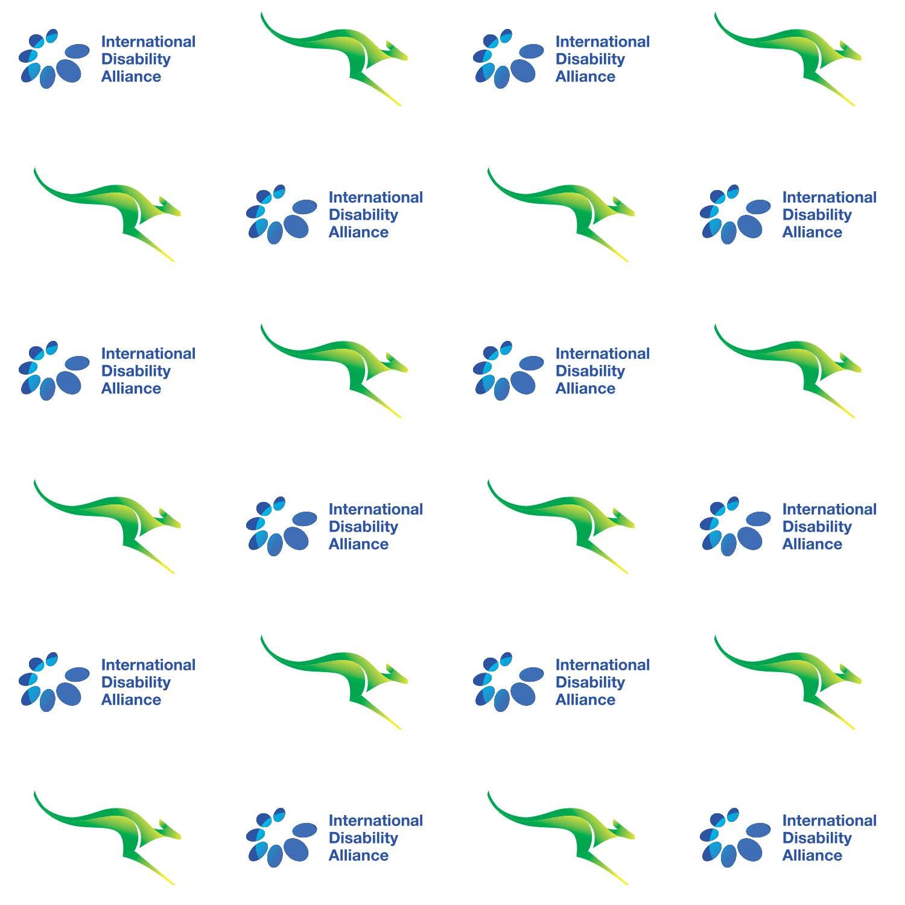

H.E. Ms. Gillian Bird  
Ambassador and Permanent Representative  
Permanent Mission of Australia to the United Nations

&

Mr. Colin Allen  
Chair, International Disability Allianceare pleased to invite Permanent Representatives, Experts,   
Delegations and Civil Society Representatives to a **Reception**

**in celebration of   
the Conference of States Parties to the   
UN Convention on the Rights of Persons with Disabilities**Monday 12 June 2017, 6.30pm – 8.30pm

Delegates’ Dining Room,   
4th Floor, Conference Building, United Nations

RSVP by 8 June at:   
<https://goo.gl/forms/DzUOmidAA0wtBYuv2>