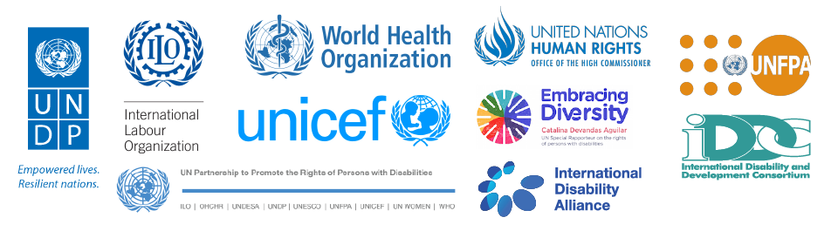
“In committing to the realization of the 2030 Agenda for Sustainable Development, Member States recognized that the dignity of the individual is fundamental and that the Agenda’s Goals and targets should be met for all nations and people and for all segments of society. Furthermore, they endeavoured to reach first those who are furthest behind.”
- Sustainable Development Goals Report 2016
Disability Data Disaggregation
Joint Statement by the Disability Sector
Fourth meeting of the IAEG-SDGs
Geneva, November 2016

Persons with disabilities are among those furthest behind and accordingly the Sustainable Development Goals (SDGs) and their indicators clearly state that disaggregated data are needed and should be collected for the purpose of monitoring advancement in the implementation of the goals for this segment of the population.

We - UN agencies, organizations of persons with disabilities, civil society and independent experts - would like to call the attention of the IAEG-SDGs and the UN Statistics Division to the need for taking immediate action and clearly recommend national statistical offices to move forward with the disaggregation of data by disability.

To that end, we would like to state our unanimous position that there are appropriate and broadly tested methodologies in place to disaggregate data by disability:

First, to ensure international comparability and comparability over time for the purposes of SDG data disaggregation for adults, we recommend the use of the Washington Group short set of questions. For disaggregation by disability among children the recommended tool is the UNICEF/Washington Group module on Child Functioning. Both instruments can be easily and cost effectively inserted in all national data collection efforts.

We also recommend going beyond disaggregation. Additional information could and should be collected to give guidance to policy makers on how to achieve the SDGs and measure the impact of policies and programmes. For this purpose, the WHO has developed the Model Disability Survey and other UN agencies are also in the process of developing additional modules.

