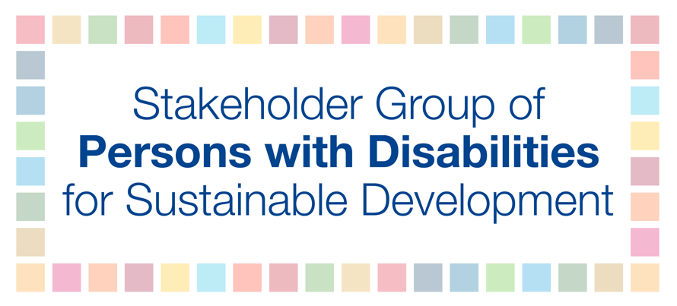

HLPF 2019

Official session: Discussion on SDG 8 - Decent work and economic growth
Wednesday, July 10th
3:00 PM – 6:00 PM

Jose Ranola

Persons with disabilities have disproportionately high levels of underemployment and unemployment as well as lower wages and are more likely to be in vulnerable forms of employment, including being self-employed or in part-time jobs. There are multiple intersecting factors that restrict persons with disabilities’ access to decent work and employment, including lack of access to education, training, resources, and technology; and lack of reasonable accommodations and adapted supports. In addition, stigma and discrimination by employers are major factors that contribute to exclusion.

To address this, we recommend that:
- equality, human rights, sustainability, participation, inclusion and accessibility be the core principles in line with Article 27 of the CRPD, the 2030 Agenda for Sustainable Development, and ILO Convention 159 to promote full and productive employment and decent employment for all persons with disabilities;
- employment of persons with disabilities is included as part of mainstream employment promotion programmes or those targeted at specific populations, such as youth and women with disabilities;
- States ensure that national legislation protects persons with disabilities from discrimination on the basis of disability in all matters of employment and that it includes the denial of reasonable accommodation as a form of discrimination; and
- more attention is given to the situation of youth with disabilities in the context of transition from school to work, including job placement and ongoing job coaching.

