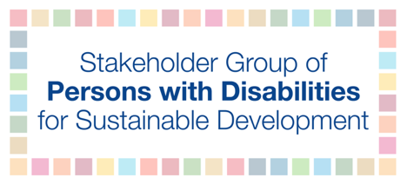

HLPF 2019
Official session: Discussion on SDG 4 - Quality education
Tuesday, July 9th
3:00 PM – 6:00 PM

Kamil Goungor – European Disability Forum

Ensure inclusive and equitable quality education and promote lifelong learning opportunities for all children with disabilities
Inclusive education is central to achieving quality education for children with disabilities and implementing Article 24 of the Convention on the Rights of Persons with Disabilities. The Stakeholder Group of Persons with Disabilities urges governments to consider the barriers faced by children with disabilities to achieve this Goal.
They face two issues: a schooling crisis and a learning crisis. 93 million children with disabilities are the most likely to be left behind. In low and middle-income countries, half the estimated 65 million primary and lower secondary school-aged children with disabilities are out-of-school. Further school enrolment is lower and dropout rates higher, with few transitioning into higher levels of training and education.
Children with disabilities often face barriers such as discriminatory social attitudes, physical access, communication, resource constraints and lack of support in classrooms and their community. Removing these barriers requires targeted strategies that address other dimensions, such as location, gender, poverty, language, including sign language, other means of communication and materials available in braille and easy read.
Meeting these challenges requires systemic change from early years, adopting child-centred and universal design approaches with reasonable accommodations provided. Educational spaces and resources must be accessible to all children with disabilities and safe including humanitarian contexts. This requires a multi-sectoral approach to provision and budgeting.
Ensuring that children have equal opportunities to learn and socialize with their peers, using the same language such as sign language, easy read materials, braille documents as well as safeguarding diversity and qualification among teachers are integral part of an inclusive education system.
Educating learners with disabilities in inclusive settings is critical for their empowerment and making them actors of the implementation of the 2030 Agenda.

UN News. (2019, March 4). 93 million children with disabilities ‘among the most likely to be left behind’: UN rights chief. Retrieved from https://news.un.org/en/story/2019/03/1034011.
UNESCO Institute for Statistics. Out-of-school children. Retrieved from: http://uis.unesco.org/en/glossary-term/out-school-children.
Banks, L. M., and Polack, S. (2015) The Economic Costs of Exclusion and Gains of Inclusion of People with Disabilities: Evidence from Low and Middle Income Countries. Retrieved from: http://disabilitycentre.lshtm.ac.uk/new-report-economic-costs-exclusion-gains-inclusion-people-disabilities/.

