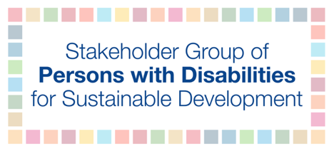

High-level Political Forum 2019

Official session: Empowering people and ensuring inclusiveness and equality - Perspectives of SIDS including main findings from mid-term review of the SAMOA Pathway

Wednesday, July 10th
9:00 AM – 11:00 AM

Laisa Vereti - Pacific Disability Forum

I represent the almost 1 million persons with disabilities in the Pacific. My name is Laisa from the Pacific Disability Forum.

To ensure equality and inclusion of all persons with disabilities:

- It’s Important for us to see the Mainstreaming of the UNCRPD compliance in all regional programmes
- PICs have low economic growth partly explained by the region’s unusual geographic and demographic characteristics, leading to diseconomy of scale and high cost of production and service delivery to cover extreme geographic dispersion. Fiscal space is therefore a challenge for inclusion.
- Nonetheless, CRPD compliance requires Progressive increase of domestic resource allocation e.g. towards disability-inclusive community support services, social protection and economic empowerment measures.
- The Inclusion of non-discrimination and accessibility requirements in public procurement for all infrastructure, goods and services at the national level, including for ODA-funded programs, would make significant impact.

Accessibility – is a precondition to our inclusion.

Accessibility is not just an obligation under the CRPD. It is also a key element for successful implementation of the SDGs.

With the lack of comprehensive standards across countries,
- a Pacific ‘blueprint’ for comprehensive accessibility standards for the built environment, transport, information and communication, which could then be tailored by countries for their own national standards. This collaborative process would avoid unnecessary duplication of efforts and costs across countries.

Lastly, multistakeholder partnership and regional cooperation:
- Applying SDG Goal 17 is particularly important to help my Pacific region achieve sustainable development, given the region’s many constraints and challenges.
- For sustained actions and greater impact, the many partnerships need further consolidation and a mechanism that will coordinate, drive and oversee and generate more synergies for lasting impacts.
- As most of the current approaches are siloed and we want to ensure that disability is mainstreamed in major regional initiatives and programs.

I thank you all.

