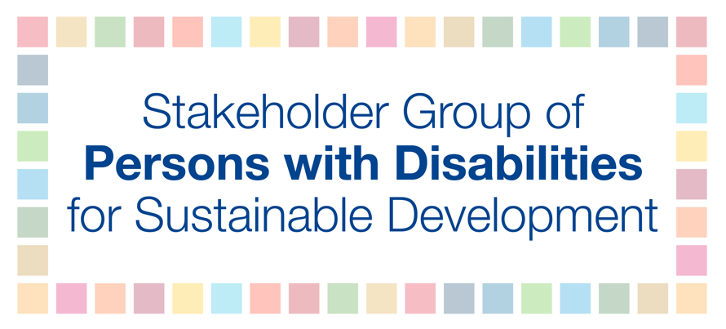
HLPF 2018
10 July
9-11am
Lan Ahn
Building resilience

While the adoption of the UN Convention on the Rights of Persons with Disabilities (CRPD) presented a paradigm shift for the international community to recognise the need for inclusive development, national policies and strategies are still not fully inclusive and responsive to the rights of persons with disabilities. This is coupled with persistent lack of evidence-based, reliable and high-quality data on persons with disabilities, despite that Article 31 of the CRPD, calls on States Parties to collect information including statistics and disaggregated data to identify barriers faced by persons with disabilities. Therefore, in order to achieve an inclusive, resilient and sustainable development for all, especially in poverty reduction, education, employment, health and gender equality, resilience-building of communities should ensure the equalisation of opportunities for full participation of persons with disabilities in all of their community activities. States should also to invest in high quality, timely, reliable and disaggregated data for reporting on the SDGs, and foster global partnerships on data such as Together we count to be counted, to ensure evidence-based policy making.

