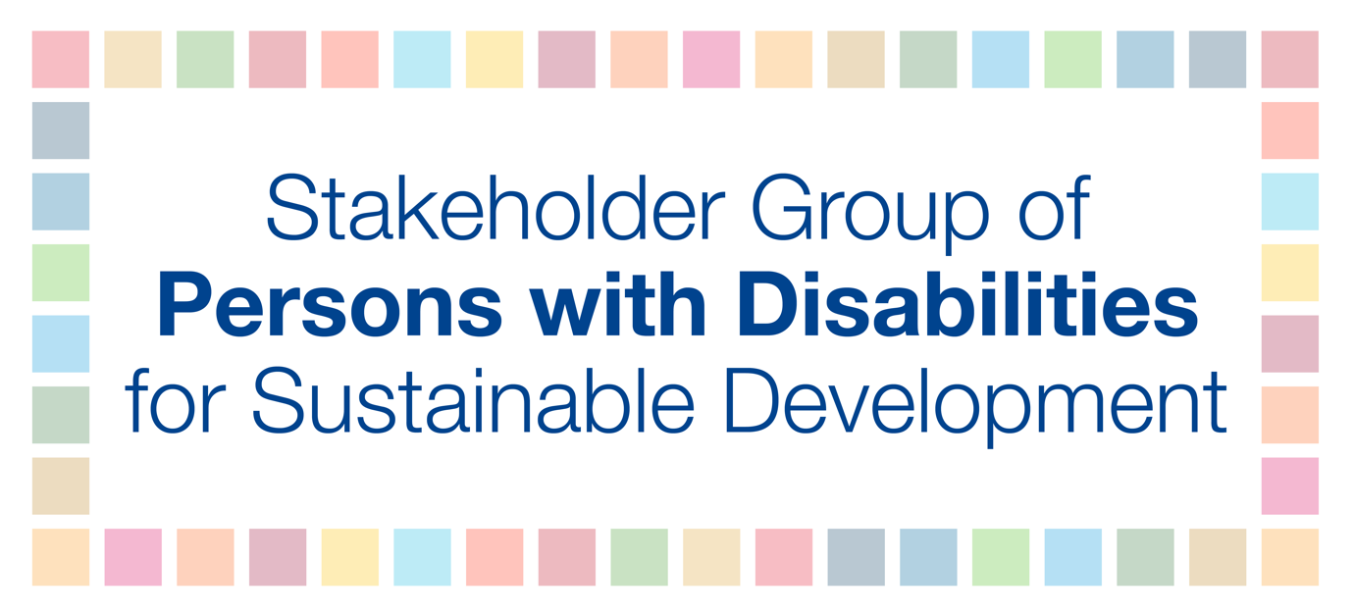

Leaders Dialogue 6: The 2020-2030 Vision
September 25, 2019
Mr. Jose Viera, Chief Executive Officer, World Blind Union and
Permanent Representative of the Stakeholder Group of Persons with Disabilities

Excellences,

I stand here before you representing persons with disabilities and other marginalized communities and I wish to share our vision. We believe that the 2030 Agenda for Sustainable Development can create a planet for every person - including those most marginalized and left behind - where we are recognized as equal citizens in every country with full rights on an equal basis with others, with dignity, respect and freedom.

We have started taking steps toward achieving the Sustainable Development Goals, but to fully realize them we need urgent actions, partnerships and strong political will. The first step should be to ensure meaningful inclusion, as we continue to face physical, legal, and institutional barriers to participate in society. Development is not sustainable if it is not fair and inclusive - and rising inequality hinders long-term growth for all. We are calling on the leaders of the world to urgently take concrete actions by:

Putting human rights at the center of policymaking and ensuring full and equal participation of marginalized groups in all aspects and levels of SDG implementation;

Aligning national-level fiscal policies with human rights obligations, and calling for system-wide resource allocation and commitments on increased spending for those most often left behind;

Allocating sufficient resources and strengthening capacity to collect, analyze and disaggregate data by sex, age, disability and other groups to shift to evidence-based policymaking and reporting;

Providing accessibility and inclusion to enable persons with disabilities to actively participate in society on an equal basis with others; and

Strongly urging world leaders to uphold the commitments made in the Paris Agreement because climate change is a common concern for humankind and concrete actions must uphold and protect the rights of all marginalized communities.

Let me conclude by emphasizing that multilateralism is key to this vision and building a just, peaceful, prosperous, inclusive and fair world. We believe that the 2030 Agenda has the potential to revitalize multilateralism and re-establish dialogue between governments and the people. Therefore we are calling on world leaders to reaffirm their commitment to multilateralism and the rule of law, to strengthen international systems and institutions, and to ensure wide and safe participation of civil society at all levels.

Only together, will we deliver our shared vision for people and the planet.

Thank you.

