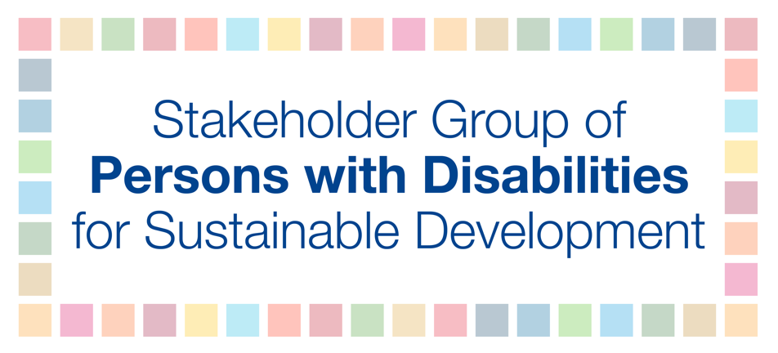

VNR Lebanon - Statement with questions

This first VNR is very strategic. Either Lebanon will take it as an ad-hoc tick-box exercise, implementing several short-term projects run by various ministries on a broad range of SDGs while monitoring goals and indicators with a quantitative approach, or it will be a U-turn through which a strong political commitment will be shown to address the root causes of structural-development challenges, adopting a nationally owned, comprehensive, rights-based development agenda, integrating the 5Ps. Localizing SDGs is still needed to address inequalities, corruption, social injustices, ending all forms of discrimination and ensuring full enjoyment of human rights for all.
The first VNR report is a minor step; but focus should be on a systematic, holistic approach integrating all human rights obligations and voluntary commitments. Serious follow-up calls for an inclusive mechanism for implementing the 2030 Agenda, prioritizing the participatory national dialogue process in policy making. Building on existing institutional mechanisms, ensuring their inclusivity and independence, Lebanon should engage all development actors in a transparent approach. National-level implementation, monitoring and evaluation after HLPF should transform momentary interest into wider awareness raising and engagement.
My questions are:
- The Capital Investment Plan stands at the center of the development plans, but will be implemented with austerity measures. Given the impacts of these measures, how will Lebanon ensure that capital interest is not over public interest and that distribution of the burden is equitable? To what extent will private-sector accountability be ensured in PPPs?
- While Syrian refugees’ presence in the country has allowed international pledges for investment, what are the prospects for the rights of refugees within these investments, while ensuring the Lebanese public not disproportionately bears the global responsibility or more debt?
- What measures Lebanon will take to ensure transparent and inclusive monitoring and implementation of the Agenda 2030?

