Here you will find some information which can be helpful for your stay in Helsinki. If you have any further questions please do not hesitate to contact
- Abilis Foundation, Nathaly Guzmán: nathaly.guzman@abilis.fi
- Or while you are in Helsinki nathaly.guzman@abilis.fi /+358 409402015

Venue (contact information and reachability):
Depending on where you stay, The House of the Estates can be reached by walk, tram or bus
- Tram stop “Hallituskatu” (Tram line 7); bus stop “Kaisaniemenpuisto” (bus numbers 55, 16, 23)
- The building has an accessible entrance. Please, see map at the end of this document to get information on the exact location of this entrance.

House of the Estates (Säätytalo)
Snellmaninkatu 9-11
00170 Helsinki

Phone: +358 9 16022200

Getting to Helsinki

Helsinki Airport is the local airport where all the flights to Helsinki will land. It is located 20 kilometres away from Helsinki city centre with good bus, train and taxi connections. You can also get more information from the airport website https://www.finavia.fi/en/helsinki-airport/

Transport in Helsinki

Helsinki’s public transport system is administered by HSL and consists of buses, trams, trains, and metro. For more information: https://www.hsl.fi/en (also in English)

Within the centre you may prefer to walk or take tram.

You can use Helsinki’s journey planner service at www.reittiopas.fi (also in English) to plan your trips inside the city.

With a single ticket you can hop aboard trams, busses, and the metro. Single tickets can be purchased from ticket machines, R-kiosks and other HSL sales points or by using HSL mobile application. On buses and trams you can also buy your ticket from the driver. Tickets are not sold on commuter trains. A single ticket is valid for one hour.

Day tickets are available for unlimited use on public transportation for 1-7 days. They can be purchased from ticket machines, from the Tourist Information or from the Helsinki City Transport service point in the Central Railway Station. One day ticket is also sold by the drivers.

Mobile ticket is a handy option. It is a single ticket that can be bought on HSL’s free Mobile ticket app available for Android, Windows and iPhone devices with iOS 8 or later. To use the ticket, mobile data must be enabled.

Accessible transport in Helsinki

Most of HSL’s buses are low floor and all trams are accessible from at least some of their entrances. HSL’s bus and tram timetables as well as VR’s commuter train timetables indicate which services are operated with low-floor vehicles.
If a taxi is needed, Abilis can arrange an accessible taxi for you upon request. You can contact Nathaly.guzman@abilis.fi, and provide details on your arrival/departure or date when taxi will be needed. You can also ask for a taxi independently if you prefer. This is a taxi company that offer services for persons with disabilities:

Taksi Helsinki: https://taksihelsinki.fi/en/book-a-taxi/

Hotels in Helsinki

This is a short list of accessible hotels near to the meeting venue. However, please inform yourself before booking whether the hotel meets your personal needs. When doing the room reservation, make sure to mention the need to have an accessible room, as not all rooms may be accessible.

- Original Sokos Hotel Helsinki
- Webpage: https://www.sokoshotels.fi/en/helsinki/sokos-hotel-helsinki
- Address: Kluuvikatu 8, 00100 Helsinki (500 metres to House of the Estates)
- Tel. +358 20 1234 601
- E-Mail: hotelhelsinki.helsinki@sokoshotels.fi

- Hotel Haven
- Webpage: https://www.hotelhaven.fi/en/helsinki-by-haven
- Address: Unioninkatu 17, 00130 Helsinki (650 metres to House of the Estates)
- Tel. +358 9 6824 2840
- E-mail: events@hotelhaven.fi

- Hotel Kämp
- Webpage: https://www.hotelkamp.com/en/
- Address: Pohjoisesplanadi 29, 00100 Helsinki (700 metres to House of the Estates)
- Tel. +3589576111
- E-mail: hotelkamp@hotelkamp.com

- Klaus Hotel
- Webpage: https://www.klauskhotel.com/en/
- Address: Bulevardi 2-4, 00120 Helsinki (1,1 Km to House of the Estates)
- Tel. +358 20 770 4700
- E-Mail: rooms@klauskhotel.com

- Hotel Katajanokka (an old prison made into a hotel)
- Webpage: www.hotelkatajanokka.fi/en/
- Address: Merikasarminkatu 1 a, 00160 Helsinki (1,3 Km to House of the Estates)
- Tel: +358 9 686 450
- E-mail: reception@hotelkatajanokka.fi

If you have any further questions regarding booking (especially the room contingents), please contact: nathaly.guzman@abilis.fi

Useful Numbers and contacts

Throughout Europe you can dial the common emergency phone number 112 around the clock to contact the emergency services (police, fire, ambulance). It is free to call from landlines and from any mobile network.

In case you need a pharmacy:

- 24-hour service:
University Pharmacy (Yliopiston Apteekki)
Address: Mannerheimintie 96
Telephone +358 300 20200 (nationwide customer service number)
- Other pharmacies in the city centre
University Pharmacy (Yliopiston Apteekki)
Address: Mannerheimintie 5, open Mon-Sun 7am-12midnight

Weather

The coldest time of the year is usually at the end of January, when temperature can fall to below -18°C (0°F) and the ground is covered by snow. The sea usually freezes over in the heart of winter.

Be aware that the sea wind chill can make the weather feel colder than it really is!

Therefore, it’s recommended that you bring some warm clothes. A winter jacket, scarf, gloves, and thick shoes/boots are appropriate.

- Phones might suffer performance issues in the cold weather. When cold, a phone battery can drain faster than normal and then suddenly shut down. The problems are only temporary and the battery should behave normally when the device is in warmer temperatures. To keep phones from getting too chilly put them inside pockets closest to your person, where they can absorb some of your body heat. Carry a charger with you in case the phone goes off.

Further Information and useful links (culture, travel, tourism, restaurants…)

Accessibility information for traveling and visiting Helsinki:

- https://www.hsl.fi/en/information/how-use-public-transport/accessibility
- http://www.visitfinland.com/article/accessible-adventures-finland/

Interesting information around Helsinki:

- http://www.visithelsinki.fi/en
- http://www.visitacity.com/en/helsinki

General contact information

For any additional queries related to the meeting itself, including the sessions, please contact the GLAD Secretariat (fsettimi@ida-secretariat.org).

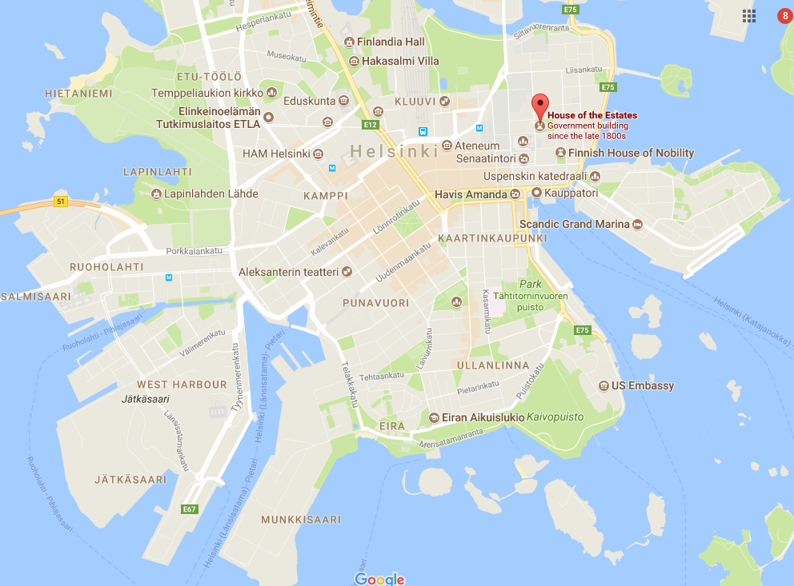
HELSINKI CITY CENTRE
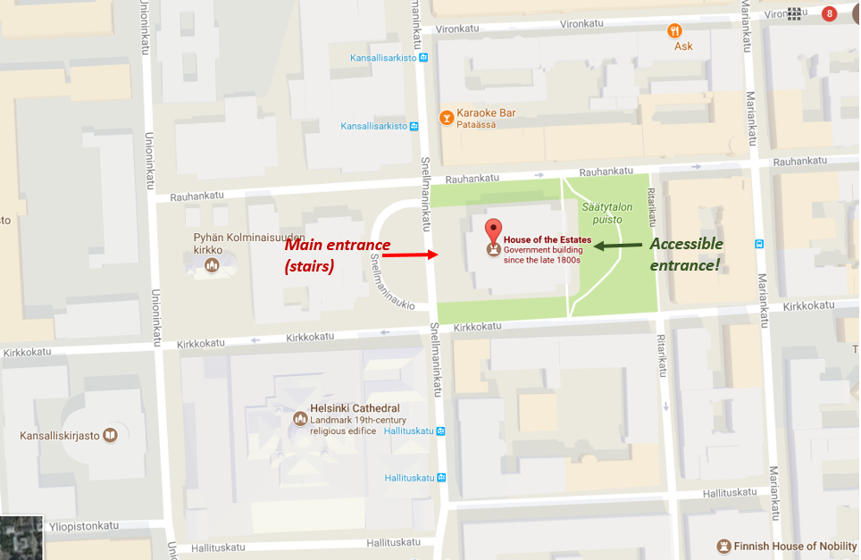
HOW TO ACCESS THE HOUSE OF THE ESTATES?

