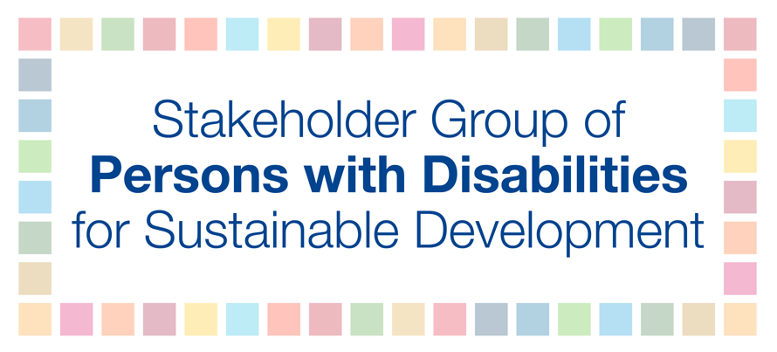
Official session: Science policy interface including the briefing from the independent group of scientists on the Global Sustainable Development Report (GSDR)
Thursday, July 11th
11:00 AM – 1:00 PM
Maulani Rotinsulu

Thank you Mr. Chair. My name is Maulani Rotinsulu, I represent the Stakeholder’s Group of Persons with Disabilities.
Accessible science, emerging technologies and new innovations have the potential to increase inclusion, participation and independence for all, including for persons with disabilities. But they must be critically assessed for effects on rights and freedoms, and comply with the three As: being available, affordable, and accessible to all. It helps to have a Universal Design approach from the outset – ensuring that technologies developed are usable and accessible to the greatest number of people possible without additional changes.
Many recent technologies have addressed barriers to accessing health, education, employment, political participation, justice, and overall community, enabling increased independence and improved quality of life for many persons with disabilities. Information and communication technologies are critical drivers to ensure that the SDGs are achieved for persons with disabilities, however, it is essential they are considered in line with Article 9 on Accessibility of the UN Convention on the Rights of Persons with Disabilities. There are still many barriers to overcome, and further efforts with technologies are needed for the full inclusion of persons with disabilities.
We recommend that:
- Persons with disabilities and their representative organizations are involved in development of new technologies;
- Accessibility and Universal Design are mainstreamed;
- Ensure availability of sign language, alternative and augmentative communication systems, Braille, large-print, and easy-read formats;
- Assistive and adaptive devices are readily available.

I thank you.

