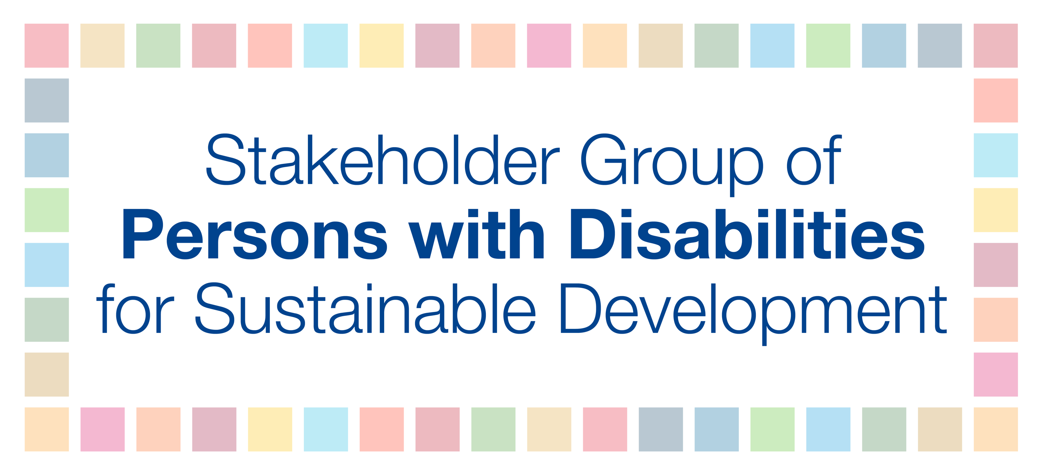
Political Declaration negotiations - May 22, 2019

Presentation on behalf of the Stakeholder Group of Persons with Disabilities

Orsolya Bartha

Thank you for giving me the floor.

I am speaking on behalf of the Stakeholder Group of Persons with Disabilities, and we welcome the zero draft of the political declaration.

The 2030 Agenda for Sustainable Development is profoundly political and achieving it requires the redistribution of power and resources. As such, tackling global challenges should be more prominently emphasized. The declaration must address the structural barriers to SDG implementation, such as illicit financial flows. The declaration must also reflect on the deep structural critique of economic development patterns that are necessary to enable Member States to craft needed system-wide solutions.

Stakeholder engagement in SDG implementation has been emphasized as critically important, and therefore, we would like to see recognition and commitment to “greater stakeholder engagement and participation.” In addition, we would like to recommend using language in line with the 2030 Agenda for Sustainable Development and resolution 67/290.
There needs to be commitment to reform the follow-up and review mechanisms of the 2030 Agenda (based on the HLPF and the Regional Fora) and to enable and highlight the effective participation of the Major Groups and other Stakeholders in the implementation and monitoring of the SDGs at the local, national, regional and global levels, particularly in paragraph 23 j) with regards to the Voluntary National reviews.
Persons with disabilities are among the furthest left behind globally, and thus we are quite disappointed to not find any references to our group, as we believe only by naming and spelling out vulnerable groups will it be possible to realize change. Therefore, we would like to recommend that paragraph 4+23a on leave no one behind should make specific reference to to existing language in the 2030 Agenda on “women and children, older persons and persons with disabilities.” Furthermore, we would like to have additional groups added, including “indigenous peoples, refugees, migrants and LGBTI and others” to ensure equal opportunities that can contribute to sustainable development to truly achieve the SDGs.
Finally, to fully monitor SDG implementation and to create evidence-based policies we need data. Thus, we recommend that in 23 i) disaggregation of data should be included.

