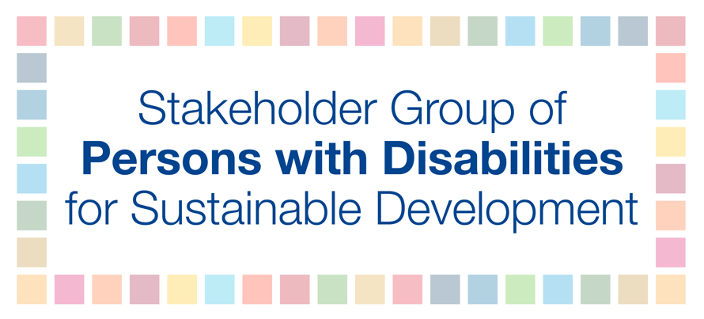
HLPF 2018
10 July
11am-1 PM
Peter
Advancing science, technology and innovation for SDGs
In almost three years of implementation of the 2030 Agenda for Sustainable Development, the significance of technology in creating opportunities for all people has been emphasized, including for persons with disabilities. However, for persons with disabilities unless affordability and accessibility are guaranteed to ensure that assistive technology is available on an equal basis with everyone and everywhere, such benefits will remain a distant dream for 15 percent of the global population. The UN Convention on the Rights of Persons with Disabilities (CRPD) affirms that assistive technology is essential to enable persons with disabilities to live independently and to participate fully in all aspects of life. To ensure that the advancement in science, technology and information includes persons with disabilities, States should promote research and development of new technologies, including accessible and inclusive information and communication technologies; provide technology without additional costs; and create an appropriate facilitation mechanism for persons with disabilities to access assistive technologies.

