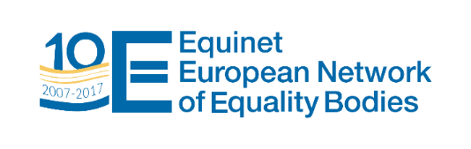
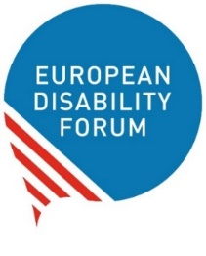
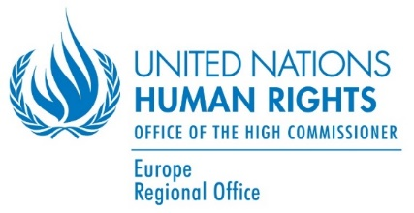

STRENGTHENING ENGAGEMENT WITH
THE UN CRPD COMMITTEE
BRUSSELS, 17-18 OCTOBER 2017
Venue: “Orega Meeting Center”, Rue du Commerce 123, 1000 Brussels
Tuesday 17 October 2017
13:30-14:00 | Registration
14:00-14:15 | Opening  Birgit Van Hout, OHCHR Regional Representative for Europe  Catherine Naughton, Director, European Disability Forum (EDF)
14.15-15:00 | Introduction to the UN Human Rights Mechanisms (Treaty bodies, Universal Periodic Review and Special Procedures)  Dima Yared, OHCHR Regional Office for Europe (tbc)
15:00-15.30 | Overview of the role of the CRPD Committee  Damjan Tatic (by video message) and László Lovászy, Members of the CRPD Committee
15:30-16:00 | Coffee
16:00-16:30 | Introduction to individual complaints  Albane Prophette, OHCHR Petitions Unit
16:30-18:00 | Stages of the reporting cycle and role of civil society and equality bodies  Secretariat of the CRPD Committee  An-Sofie Leenknecht, EDF secretariat  Darijo Jurišić, Deputy of the Ombudswoman for Persons with Disabilities in Croatia  Representatives of EDF national member (tbc)
18:00-19:30 | Reception

Wednesday 18 October 2017
09.00 – 10:30 | Workshop 1  Practical exercises: Drafting of alternative reports and replies to the list of issues  László Lovászy, Member of the CRPD Committee  Representative of EDF national member (tbc)  Juan Ignacio Perez Bello (IDA - tbc) and An-Sofie Leenknecht (EDF) | Workshop 2  Using Concluding Observations  for advocacy  Silvia Quan, International Disability Alliance (tbc)  Representative of EDF national member (tbc)  Carole Van Basselaere, Unia (Interfederal Centre for Equal Opportunities), Belgium
10:30-11:00 | Coffee
11:00 – 13:00 | Workshop 1 (continued) | Workshop 3  Practical exercises: Individual complaints  Albane Prophette, OHCHR Petitions Unit
13:00-14:30 | Lunch
14:30 – 15:30 | Feedback to plenary and discussion
15:30-16:00 | Conclusions  Anne Gaspard, Director of Equinet (tbc) and / or  Catherine Naughton, EDF (tbc)
