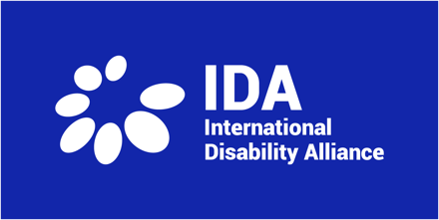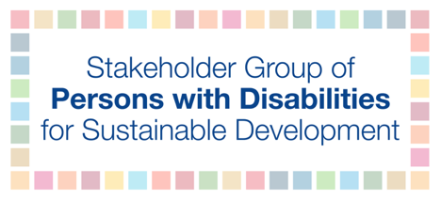

Please note that these guidelines are periodically updated.

January 10, 2022

Recommendations for accessibility at in-person and online events and meetings

For virtual sessions, we recommend the following accessibility services be provided for participants with disabilities:
- Ensure that the platform used for the online event is fully accessible for participants with disabilities, sign language interpreters, and real-time captioners and does not create additional barriers in participation;
- Use Zoom, if possible, as an online platform during events since it is by far the most accessible platform for persons with disabilities;
- Require that all videos shown in main sessions are accessible with captions, International Sign, and audio description;
- Provide real-time captioning services, such as CART, for all sessions online as well as on live and recorded webcast videos for all days;
- Provide International Sign interpretation for all main sessions, and panelists and interventionists including with voice interpretation, as well as on live and recorded webcast videos for all days;
- Allocate adequate time prior to a session to assist presenters with disabilities with technical support, e.g. how to turn on the microphone, how to position the camera;
- Preparatory time before sessions must include the necessary accessibility requirements for presenters, such as live captioning and International Sign interpretation (including voice interpretation);
- Ensure that the event website is fully accessible following the WCAG AA guidelines, including the event registration system;
- Ensure that participants with disabilities and their personal assistants/sign language interpreters/captioners are able to register and that these assistants are not counted as participants (when there is a maximum number permitted);
- Allow more time for presenters with disabilities, at least one minute more than for presenters without disabilities, especially for blind and partially sighted participants reading Braille, deaf and hard of hearing participations using sign language interpreters, and participants with speech disabilities;
- Ensure all shared materials are accessible for persons using screen reader software;
- Share event documents and presentations prior to events for captioners and sign language interpreters, as much as possible;
- Convert the event agenda into easy-read format; and
- Ensure that if any official session goes beyond working hours, that sign language interpreters and captioners are able to work these extra hours to ensure continued access to information for all participants.

For in-person sessions, we recommend the following accessibility services be provided for participants with disabilities:
- At minimum, plan a walk-through days in advance together with security, to identify accessibility points to ensure that there are adequate spaces for persons with disabilities to maneuver and be seated;
- Allow persons with disabilities to easily access the building and meeting rooms and be seated to have clear access to presentations, live captioning, and International Sign interpretation;
- Provide training and a briefing prior to the event to UN security and elevator personnel on disability and accessibility awareness;
- Allow wheelchair users to have priority access to elevators;
- Provide Braille versions of talking points to blind presenters for main sessions;
- Ensure that seating is reserved with signage for persons with disabilities and their personal assistants/sign language interpreters/captioners;
- Make sure that restrooms are accessible for wheelchair users and all obstacles are removed from entry;
- Ensure that all food service and seating are accessible, including for coffee breaks, and plastic straws are available upon request; and
- Provide signage and guides throughout the facility to guide participants to the meeting.

