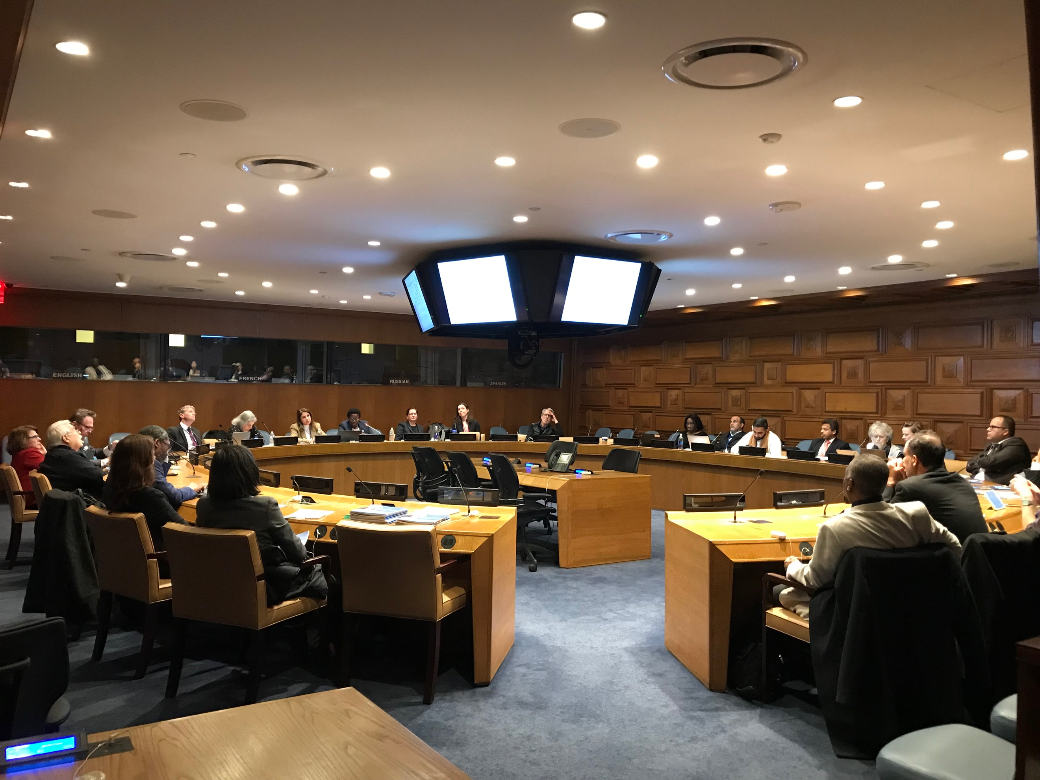

50th Session of the United Nations Statistical Commission

United Nations Headquarters, New York City
5-8 March 2019

REPORT

The 50th Session of the United Nations Statistical Commission was held from 5-8 March 2019 at UN Headquarters in New York under the theme “Better Data Better Lives”.

During the opening session of the Commission, data and indicators for the 2030 Agenda for Sustainable Development were discussed. This discussion centered around the report of the Inter-Agency and Expert Group on Sustainable Development Goal Indicators (IAEG-SDGs) on the ongoing work for the implementation of the global indicator framework, including a section about the Expert Group’s workstream on data disaggregation. Persons with disabilities were invited to participate in this workstream on disaggregation, which resulted in a consultation process on priority policy areas for disaggregation. As such, the Stakeholder Group of Persons with Disabilities identified poverty eradication, education, employment, health and accessibility as the policy priority areas. These policy priority areas have been included in the official report which was endorsed at the Statistical Commission. Click here to read the full report of the IAEG-SDGs in English, Arabic, Chinese, Spanish, French, or Russian.

The concept of open data, or ‘data that can be freely used, re-used and redistributed by anyone’ (Open Knowledge International), was also discussed at the Commission. The report of the Friends of the Chair group on the Fundamental Principles of Official Statistics and on open data was presented during the second session of the Commission. The report mentions a background document on the implementation of open data, which provides a synthesis of existing open data work covering data interoperability, the implementation of open data practices and the anonymization of data for official statistics. To learn more about these concepts, please read the full background document here. The report also includes a section on recent global activities highlighting the Fundamental Principles and open data, including the International Open Data Conference held in Buenos Aires in 2018 and the World Data Forum in Dubai in 2018. Interoperability, integration and reusability of data and data systems for the implementation and monitoring of the Sustainable Development Goals was discussed at these meetings. Click here to read the full report of the Friends of the Chair group on Principles of Official Statistics and on open data.

On the second day of the Commission, the Stakeholder Group of Persons with Disabilities co-sponsored a side event on ‘Making disability visible in statistics.’ The side event focused on bridging the gap between policy makers, civil society, and statisticians, which constitutes a major obstacle and hindrance to making progress on the development of evidence-based policies and thus improving the lives of persons with disabilities. The event highlighted current activities undertaken by NSOs, UN agencies, development ministries, organizations of persons with disabilities and civil society to improve the collection and use of disability data to meet the requirements of the UN CRPD and the SDGs. Click here to watch a recording of the side event.

Click here for more information about the Statistical Commission.

