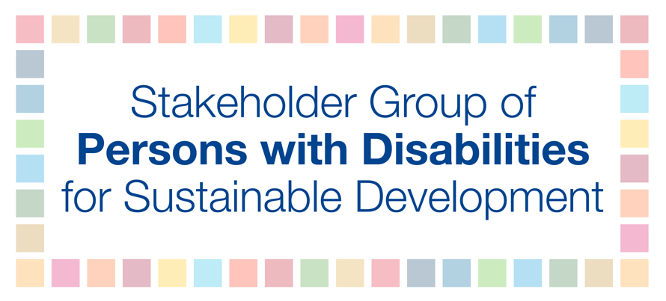
HLPF 2019

Official session: Discussion on SDG 10 - Reduced inequalities
Thursday, July 11th
3:00 PM - 6:00 PM

Rosario Galarza

In 2015, we have pledged to leave no one behind. Yet, in 2019, persons with disabilities keep being discriminated, excluded and marginalized. They are among those most left behind.
More than 80 percent of persons with disabilities live in poverty.
This link between poverty and disability stems from stereotypes and stigma, unequal opportunities, and structural barriers that persons with disabilities encounter worldwide. Because they are not a homogeneous group, persons with disabilities often face multiple and intersectional discrimination that fails to be addressed.
Women with disabilities experience an increased risk of violence and abuse, and discriminatory attitudes in sexual health and reproductive rights. Young people with disabilities experience higher rates of unemployment than their counterparts without disabilities. Children with disabilities are one of the most marginalized and excluded groups in society. They face systemic inequalities such as unequal access to healthcare, social services, and education. Older persons with disabilities frequently face specific human rights violations, such as the deprivation of legal capacity and institutionalization.
We call on all governments to ensure that their commitment to reduce inequalities is fully implemented. Persons with disabilities must access opportunities and resources necessary to live free and equal in dignity and rights.
We recommend to:
- Urgently repeal all discriminatory laws and take measures to eliminate discriminatory practices
- Gather disaggregated data on persons with disabilities at all levels
- Identify subgroups of persons with disabilities, including those who face intersectional discrimination, and adopt specific measures to accelerate or achieve inclusive equality.

