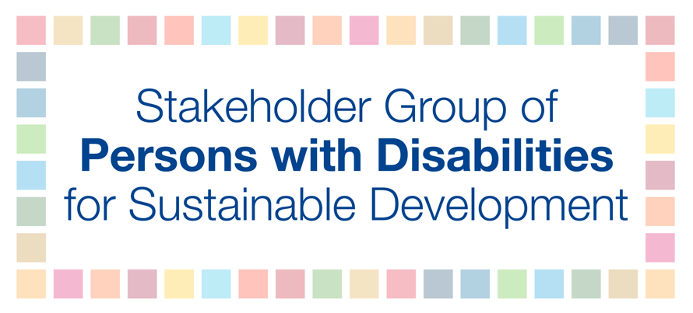
HLPF 2018
11 July
9-11am
Savina
SIDS perspective
Persons with disabilities are amongst the most marginalized groups during disasters and emergency situations. In disasters, persons with disabilities are more likely to be left behind or abandoned during evacuations due to inaccessible response efforts, including inaccessible shelters, camps, and lack of access to food distribution and recovery. This largely stems from poor preparation and planning with limited participation and leadership of persons with disabilities in these processes.
Findings from the first-ever global survey in 2013 on how persons with disabilities cope with disasters, indicated that persons with disabilities are rarely consulted about their needs in potential disaster situations. It was also revealed that 86% of respondents from 137 countries had never participated in community disaster management and risk reduction processes that had been implemented in their communities. As such, SIDS should take steps to ensure active participation and leadership of persons with disabilities in all disaster risk management, planning, and implementation. States should also incorporate universal design principles in ensuring that information, buildings, products and environments are inherently accessible from the outset.

