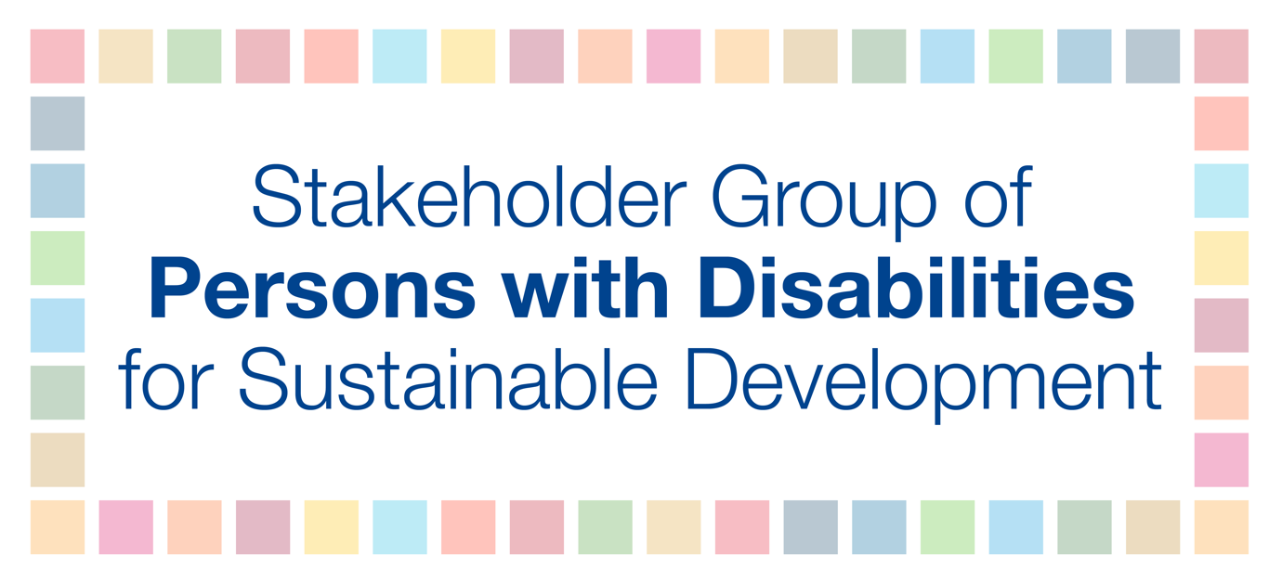
The Stakeholder Group of Persons with Disabilities emphasizes the following positive takeaways from the 2019 High-level Political Forum under the auspices of the Economic and Social Council:
- That persons with disabilities were able to easily access Conference Room 4, Trusteeship Council Chamber, and ECOSOC Chamber on the ground floors and be seated to have access to presentations, CART, and sign language interpreters;
- The CART services in person, online, and on webcast for all eight days of the HLPF;
- How seating was reserved for persons with disabilities and their personal assistants, sign language interpreters, and/or CART providers;
- The UN Sustainable Development Knowledge Platform was fully accessible;
- Persons with disabilities and their personal assistants/sign language interpreters/CART providers were able to register and obtain passes easily and that these assistants were not counted as participants (when there was a maximum number permitted);
- International Sign interpretation was provided during the Voluntary National Reviews via webcast;
- That Braille copies and large font of the HLPF agenda and presentations for speakers were easily and quickly provided with the correct formatting;
- Restrooms at the UN Headquarters were accessible for wheelchair users;
- Signage on the availability of plastic straws for persons with disabilities was visible at UN cafeterias;
- That an accessibility walk-through took place well in advance of the HLPF to ensure there are adequate spaces for persons with disabilities to maneuver and be seated;
- Security was briefed prior to the HLPF (first and second weeks) on accessibility and disability awareness;
- That more time was given to presenters with disabilities, at least a minute more than presenters without disabilities, especially for blind and low vision participants reading Braille, deaf and hard of hearing participations using sign language, and participants with speech disabilities;
- We ask that all the aforementioned accessibility services are provided again at the SDG Summit in September 2019.
In addition to continuing to provide the aforementioned actions, the Stakeholder Group of Persons with Disabilities also recommends that for the SDG Summit in September 2019:
- Documents and presentations are shared prior to events for CART providers and sign language interpreters, as much as possible;
- That the HLPF agenda be converted into easy-read format;
- Wheelchairs (two or more) are available and free for participants with disabilities to borrow during the day to move around the UN premises and there is an established system for pick up and return;
- International Sign interpretation is provided throughout the HLPF;
- If any official session goes beyond working hours, we ask that sign language interpreters and CART providers are able to work these extra hours to ensure continued access to information.

