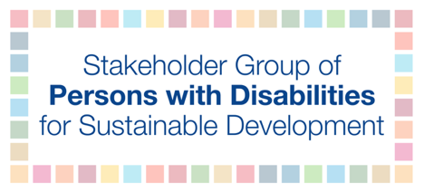

Written submission to the General Debate of HLPF 2020

Since the adoption of the UN Convention on the Rights of Persons with Disabilities followed by the adoption of the 2030 Agenda for Sustainable Development and its Sustainable Development Goals, we have witnessed a positive development and change in the lives of persons with disabilities. Slowly societies have begun to transition from the traditional charity and medical model approaches to inclusion into a social and human rights approach granting persons with disabilities more rights than ever before.

When the COVID-19 pandemic hit, it removed the curtain and in many ways the lives of persons with disabilities spiraled backward to the time before the adoption of the UN Convention on the Rights of Persons with Disabilities and Sustainable Development Goals. Historical inequalities have resurfaced, stronger than ever, discrimination has significantly increased and the fight for inclusion has become increasingly more challenging.

Persons with disabilities around the world have been adversely affected by the pandemic in one way or another with additional or new barriers, including new barriers in the re-opening phase. The most common barriers that emerged include: (1) lack of access to COVID-19-related information for all persons with disabilities, (2) barriers in receiving social protection measures and employment (formal and informal, losing employment first, and accessibility barriers in the virtual working environment) and (3) lack of disability inclusion in COVID-19 response efforts at all governmental levels creating significant disconnections between national and local actions.

Today governments are deliberating on how to restart the economy, open up society and are looking to their neighbors to build on lessons learned. But we do not need to do that. The answers lie with the Sustainable Development Goals. The Goals and targets are built on grassroots stories that were shared at the global level during the post-2015 negotiations. Governments translated real-life challenges into policies. We do not need to reinvent the wheel, but we do need to attach meaning and more important concrete actions to these policies, in light of our new reality.

We can build back better and create a new inclusive world if we take proper action. As countries continue the management of COVID-19 as a public health issue, while also transitioning to open up economies and societies, removal of existing barriers and building back better are critical for future implementation of the Sustainable Development Goals. Let’s use the Sustainable Development Goals to build back more resilient, sustainable, greener and kinder societies than existed in pre-COVID times.

Our key message is that life is more challenging and there are more barriers for persons with disabilities. Therefore in order to realize the UN Convention on the Rights of Persons with Disabilities and Sustainable Development Goals for persons with disabilities, governments at all levels must create inclusive policies by following a twin-track approach. This means going beyond mainstream policies by implementing specific policies that protect the lives of persons with disabilities and at the same time guarantee their rightful inclusion in society.

