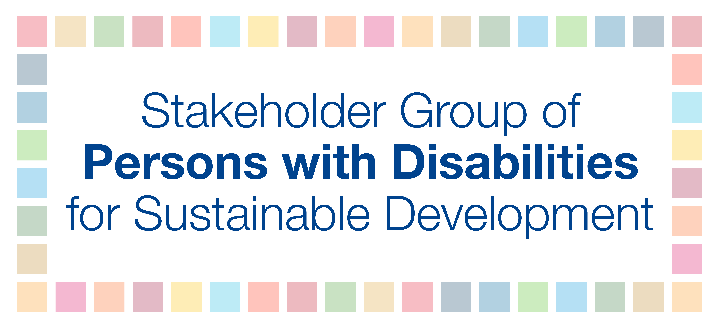

Position Paper for 2019 report of the Inter-agency Task Force on Financing for Development

In the 2030 Agenda for Sustainable Development (2030 Agenda) and the Addis Ababa Action Agenda (AAAA), Member States committed to leave no one behind. The 2030 Agenda and the AAAA reflect the critical long-awaited political commitments of Member States toward ending poverty, reducing inequalities, and saving the planet. Two years into the implementation process very little of these have been translated into financial commitments. Globally, persons with disabilities - 15 percent of the world’s population - do not adequately benefit from funds and resources spent by public sector, from the actions of the private sector, or economic, social and cultural development. Persons with disabilities face widespread exclusion from all areas of society and experience higher rates of poverty and deprivation and lower levels of income than the general population. This stems from pervasive discrimination and stigma, unequal opportunities, and physical and attitudinal barriers. During recent economic crises, many countries have reduced public funds that support social participation of persons with disabilities. Consequently, the poverty rate has increased for persons with disabilities and their families. Furthermore, without access to digital infrastructure and accessible ICT, persons with disabilities are at risk to be excluded from statistics and surveys, which leads to exclusion from programs and policies.

These same factors also mean that the rights of persons with disabilities are not adequately addressed in tax and budget policies, poverty-reduction programs, social protection floors, development programs and funds, and engagement with regulation of the private sector. Consequently, promoting equity must be addressed at the center of all of these policies.

Development finance must be people-centered and based on human rights, which requires normative and systematic reform in order for countries to generate the requisite resources to deliver a sustainable agenda. As such, the 2030 Agenda for Sustainable Development must become an integral part of national policy commitments that are matched with system-wide resource allocation and include commitments on disability spending.

Fiscal systems and inequality (SDG 10 inequality) – focus on UN Convention on the Rights of Persons with Disabilities (CRPD)-compliant budgeting

Ensure that existing expenditure fully aligns with commitments on the rights of persons with disabilities. This also applies to services that are publicly funded and/or regulated, but delivered by private entities. This implies among others:

- Ensuring that public funds:
  - do not create or perpetuate barriers, such as building inaccessible infrastructures or investing in segregated services that undermine inclusion of persons with disabilities;
  - are spent in an inclusive manner across all sectors, including by making accessibility for persons with disabilities requirements in all public procurements; and
  - Support the development, scaling up and sustainability of services and programs required for the inclusion of persons with disabilities.
- Reallocating funds from programs and services that are inconsistent with human rights obligations, toward existing or new ones that truly promote full and effective inclusion and participation of persons with disabilities. This includes setting aside adequate funds for the costs of transitioning from a segregated to an inclusive model.
- Ensuring that existing initiatives to promote gender-sensitive budgeting take into account the multiple identities that women have; and promote effective budget allocations for women who face multiple forms of discrimination, such as women with disabilities.

Integrate the rights of persons with disabilities throughout the budget process:

Enhance transparency, accountability and participation, including by:

- Ensuring and supporting meaningful participation of organizations of persons with disabilities throughout the budget process.
- Ensuring that censuses, surveys and administrative data are disaggregated by disability. Wherever possible data should also be made available on the intersection of disability and other grounds for discrimination (e.g. gender)
- Providing transparent, accessible and timely data on budget allocations for the rights of persons with disabilities.
- With the full involvement of persons with disabilities, offering capacity building on the rights of persons with disabilities and CRPD-compliant budgeting for (central and local) financial officials, elected representatives, supreme audit institutions, national human rights institutions, and other independent bodies charged with oversight of the rights of persons with disabilities.

Conduct comprehensive disability-responsive human rights impact assessments on all proposed budgets, drawing on context-sensitive assessments of the costs that persons with disabilities face to participate equally in society. The assessment should consider revenue generation as well as expenditures. It should cover all ministerial budgets, not just those ministries that have historically had budget lines for disability-specific services. Issues related to decentralization should be included.

Take action to address any gaps identified by the assessment, including by putting in place an inclusive plan of action for each ministry or local government department. Detailed steps may include:

- At a broad level, ensuring that economic policies allow for adequate domestic resource mobilization to fulfil human rights obligations at both central and local government level (for example, by avoiding getting drawn into a ‘race to the bottom’ on corporate tax rates).
- Redesigning tax policies or other revenue raising tools that have a regressive impact on groups experiencing economic inequality. (For example, VAT on basic goods, user fees that restrict access to a basic service). The assessment of whether a tool is regressive should take into account the extra costs that persons with disabilities face to participate in society on an equal basis with others.
- Allocating resources to address any minimum core obligations that are currently unfulfilled (e.g. inclusive primary education). Allocations should be sustainable and predictable, not tied to one-off short-term programs, and there should be controls to confirm that funds allocated are duly spent. Where responsibility for service delivery is devolved to local government level, this should be matched by a commensurate transfer of resources.
- Putting in place plans to ensure that as available resources increase, so too do the resources allocated to realizing the rights of persons with disabilities and other marginalized groups.
- Applying the principle of non-retrogression, so as to avoid disproportionate, arbitrary or discriminatory cuts in resources allocated to support the rights of persons with disabilities.
- Mobilizing international cooperation and Official Development Assistance (‘aid’) to support the inclusion of persons with disabilities

- The allocation of Official Development Assistance

Official Development Assistance (ODA): ODA remains critical for development financing and fulfilling the commitments in the 2030 Agenda, including the commitment to leave no one behind. As such, it remains the cornerstone of success. To close the gap toward poverty eradication, it is important that the ODA framework is centered on human rights obligations. This includes fulfilling long-time commitments to accelerate full and effective implementation of the CRPD.

We recommend that donor countries:

- Put in place a clear strategy which sets out how they will systematically ensure that all aid-funded programs are accessible to and inclusive of persons with disabilities.
- Through dialogue with partners governments and with local civil society organizations, including organizations of persons with disabilities, follow a human rights based approach to identify gaps in domestic resource allocation for the rights of marginalized populations. Plan how aid can best contribute to filling these gaps while the government progressively works to increase resources allocated domestically.
- Report to the Organisation for Economic Cooperation and Development’s Development Assistance Committee on the extent to which all aid spending is inclusive of persons with disabilities, using the new disability marker that has just been accepted for use on a voluntary basis.

- Science, technology, innovation and capacity building

ICT: Access to financial services has proven to be a pivotal step in helping people get out of poverty, and thanks to digital financial services, many are now participating in the digital economy for the first time. Innovative technologies provide different accessibility features that can be easily integrated into existing systems and with accessible e-commerce platforms that provide support to micro-entrepreneurs with disabilities. We are calling on States to put in place legislation to ensure the most marginalized have access to accessible, available, affordable and quality financial services.

- Data, monitoring and follow-up

The lack of data on persons with disabilities, both at the national level and in international development, is a major barrier for inclusion even though Member States called for global SDG indicators to be disaggregated by disability. Moreover, there is little financial resource allocation or capacity for conducting household-level surveys with adequate levels of disaggregation, adversely impacting persons with disabilities.

Ensuring that the rights of persons with disabilities are included in all development efforts requires the routine collection of data across all sectors as a means to monitor and ensure that persons with disabilities are fully participating in society. The short set of questions developed by the Washington Group is well tested and suitable for this purpose, along with the UNICEF/Washington Group Child Functioning Module that supports identification of children with disabilities.

These modules are internationally comparable and also efficient, low cost, and easy to incorporate into ongoing data collection of national statistical systems, making them sustainable and suitable for disaggregating by disability status and monitoring progress in attaining the SDGs on an ongoing basis.

In addition to using these modules, persons with disabilities and their representative organizations must be consulted on the design, implementation, and monitoring of SDG plans in line with CRPD Article 33. Qualitative data gathered through such consultations are essential to complement quantitative data, especially in order to reflect the situation of persons with disabilities that may not be captured easily by quantitative data alone. Also, governments must allocate budget for the inclusion of persons with disabilities and to measure inclusion to leave no one behind, and statisticians, policymakers, DPOs, and allies need to learn from each other and use available data to address challenges and gaps in policies.

Best Practice - Washington Group on Disability Statistics

The Washington Group has made considerable progress in improving disability measurement and statistics. Important methodological work has been conducted over the last decade to develop standardized data collection tools that are in line with the CRPD and produce comparable estimates. More importantly, the Washington Group short set (WG-SS) has been proven and widely tested as sustainable and suitable for SDG data disaggregation by disability.

As an example of a best practice, in light of the importance of disability data collection and the disaggregation of SDG outcome indicators by disability status, the WG reviewed, among WG member countries, the extent to which data on SDG indicators currently available can be disaggregated by disability status.

- Requests for disaggregated SDG data for 13 selected indicators were sent to 146 member countries and 48 responded and 39 provided data.

- 19 of the 39 countries that provided data used the WG-SS

- SDG indicators were selected and defined (for the most part) according to the global indicator framework.

- The findings illustrate that countries can, with available data, disaggregate a number of SDG indicators by disability status.

The most common SDG disability data provided include the following:

- Disability prevalence, specifically “Disability status by domain of difficulty, age and sex for population 5 years and over” (31 countries)

- SDG 8.5.2* Employment status disaggregated by disability status and sex for population 15-64 years (23 countries)

- SDG 4.1x* School completion rates disaggregated by disability status and sex for relevantly aged population (20 countries)

- SDG 4.5x* University completion rates disaggregated by disability status and sex for relevantly aged population (12 countries)

- SDG 1.2.1 Poverty status disaggregated by disability status and sex for population 15 years and older (11 countries)

- SDG 3.8.1 Health insurance coverage disaggregated by disability status and sex for population years and older (10 countries)

- SDG 7.1.1 Access to electricity disaggregated by disability status and sex for population 15 years and older (10 countries)

*Indicators that were “derived” include 4.1.x Primary, Lower secondary, and Upper secondary school completion rates, 4.5.x University completion rates, and 8.5.2 Employment status. The full study can be found here: http://www.washingtongroup-disability.com/data-dissemination/

Conclusion

In closing, compliance with universal standards in human rights must be upheld by States. Also, social dialogues must define actionable deliverables that are guaranteed by the State, including the meaningful participation of persons with disabilities. Full implementation of the commitments made by world leaders at the adoption of the 2030 Agenda, including the AAAA, requires a progressive increase in dedicated domestic resource allocation and international development cooperation to support the full inclusion of persons with disabilities. Yet in many countries austerity measures have been imposed, which reduce government expenditures on human rights, development and social welfare when and where they are most needed, and persons with disabilities are often among the very hardest hit. A rights-based response to economic crises could be lifting persons with disabilities and their families out of poverty, and would contribute to the achievement of inclusive growth and sustainable development.

This section is taken from Alexandre Cote and Polly Meeks (2017).“Disability is always an afterthought”: Why progress on inclusion demands action on budgets. Center for Inclusive Policy. Discussion Paper N.1.

