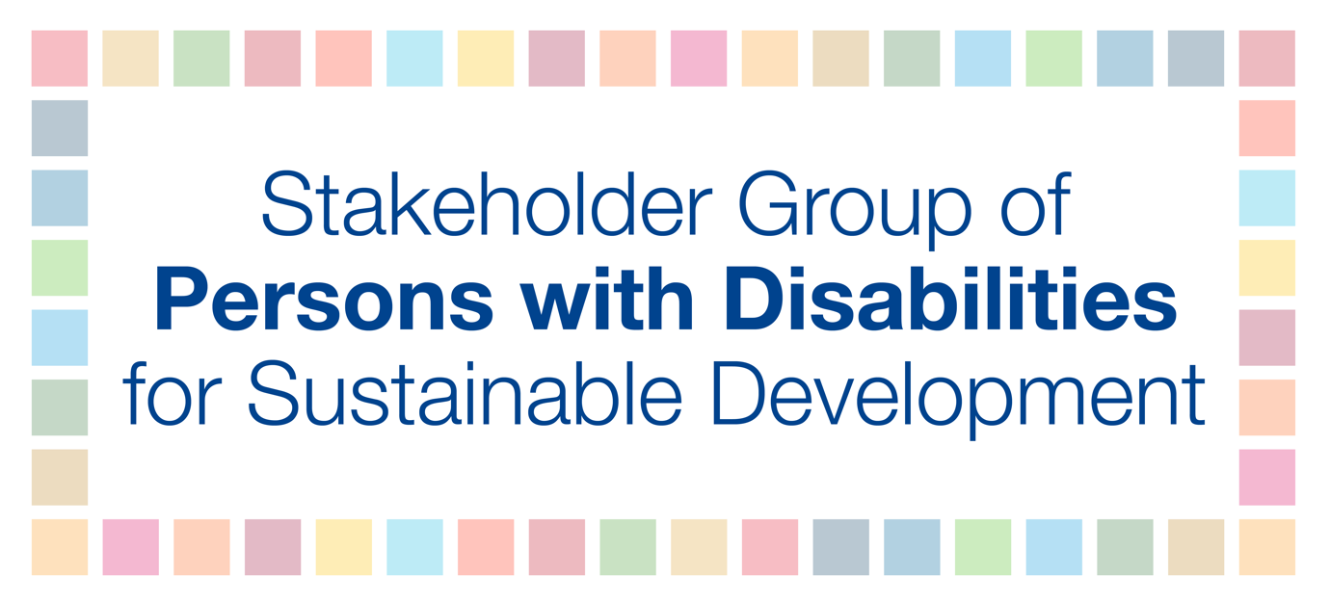
The Stakeholder Group of Persons with Disabilities suggests the following recommendations for security with persons with disabilities entering the UN Headquarters.
- Ensure that placement of barriers (the posts with retractable tape) do not obstruct automatic door opener buttons, and still allow movement for persons with mobility devices and/or service dogs. This is often an issue at the visitor's entrance.

- Ensure security staff are aware that attendees may have disability-specific requirements, e.g., wheelchair users need the ground floor entrance and elevators; persons with service dogs need the dog to remain with them; need for bathroom breaks (in cases when people are not supposed to leave a room), blind and low-vision individuals and others may have personal assistants with them who need to accompany them and also need access to rooms.

- Prior to an event, provide persons with disabilities with information on security procedures, such as what items are/are not permitted into the UN, what devices have to be removed to be scanned, and an explanation of the body-scanning procedure.
- Ensure both male and female security staff are available at the visitor’s entrance for those who need a pat-down security check.

- Ensure that security are aware of deaf, hard of hearing, blind and low vision individuals entering the UN and that security needs to sensitively get the attention of these individuals before providing instructions on how to go through security.

- Provide a clear system for entry into security and queues at the visitor’s entrance, such as providing a line specifically for persons with disabilities with clear signage.

- Establish a process for individuals with service animals, e.g. required documentation, process to get through security.

For blind and low vision individuals:
- Allow blind and low vision visitors to unpack and re-pack their bags themselves to know where items are located in their bags.
- Provide verbal explanations for blind and low vision individuals when guiding them through security and the scanner. If security needs to touch the blind or low vision person, ask first if it is okay to touch the person on the shoulder or arm.
- In the case of a blind person using a white cane, when the cane has to be scanned, security should verbally explain to the person where to go and what to do to avoid confusion and provide clarity.
- After the body scan, security should guide blind and low vision individuals to the tables where they can re-pack their bags. For this, security should carry the person’s box of items, offer their elbow to guide the person, and guide the person’s hand onto the box with their belongings. From this point on, the personal assistant can assist again.

