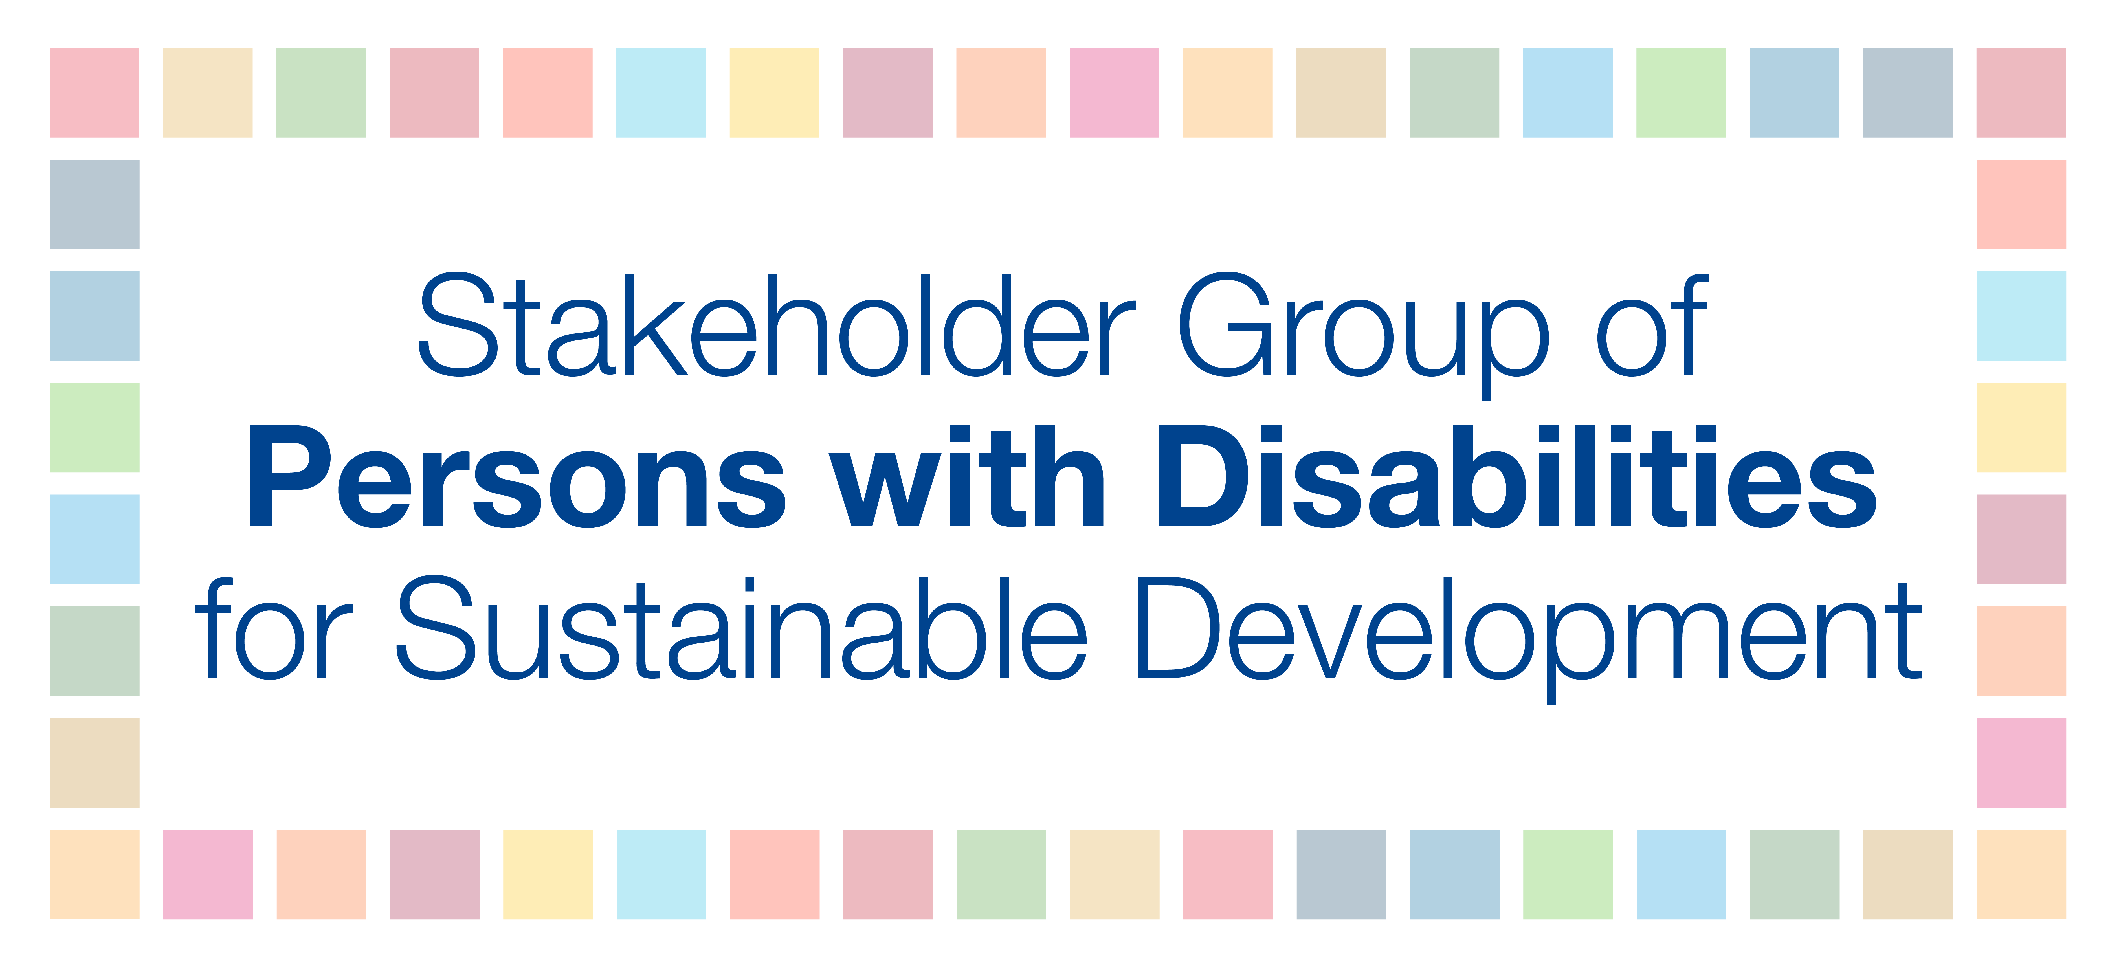

Informal multi-stakeholder consultation on “Making finance work for a sustainable world in 2019 and beyond”

The Stakeholder Group of Persons with Disabilities – representing persons with disabilities and their representative organizations globally - is ready to engage and hopes for a mechanism that will create a space for wide, open, and transparent participation for stakeholders in the financing for development processes. This must be in line with Article 4.3 of the UN Convention on the Rights of Persons with Disabilities (CRPD) that calls for States Parties to closely consult with and actively involve persons with disabilities through their representative organizations.

The rights of persons with disabilities are not adequately addressed in fiscal policies, poverty-reduction programs, social protection floors or development programs and funds. Thus, development finance must be people-centered and based on human rights, and the 2030 Agenda and the Addis Agenda must become an integral part of national policy commitments that are matched with system-wide resource allocation and include commitments on disability spending.

Specifically, we recommend:

- that Member States carry out commitments on accessibility in the 2030 Agenda, Addis Agenda, Sendai Framework in line with the CRPD by making accessibility a key criterion in the mobilization of finance, including building accessibility requirements into all public procurement procedures, as well as providing accessibility at the FfD Forum and the High-level Dialogue on Financing for Development; and

- the use of transparent reporting of domestic and international resource allocations to realize disability rights, including through the implementation of the voluntary OECD DAC disability policy marker and disability disaggregated data on development outcomes.

