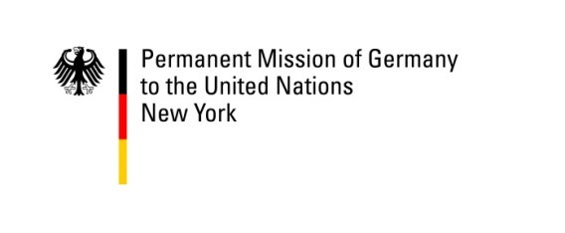
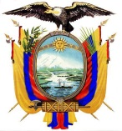
República de Ecuador

The Permanent Missions of Ecuador and Germany to the United Nations invite you to a
Side Event during the 10th Conference of States Parties to the Convention on the Rights of Persons with Disabilities
Organized by the Office of the High Commissioner for Human Rights, UN Women, Women Enabled International and the International Disability Alliance

Electing Women with Disabilities: Why and How to Ensure a Gender- and Regionally-Balanced CRPD Committee
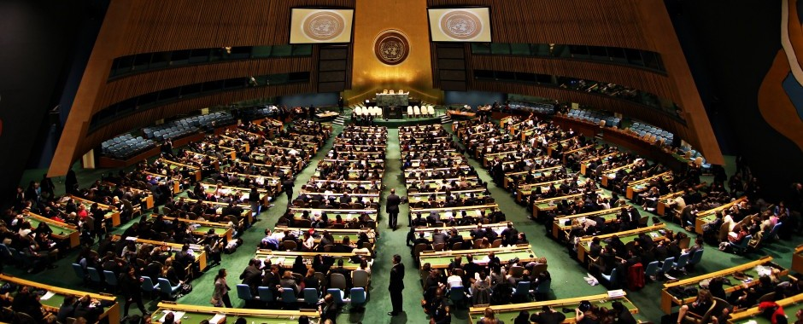
Image description: picture of the United Nations’ General Assembly Hall
Wednesday, 14 June 2017 - 13:15 - 14:30 – Conference Room 7 – UNHQ NY
Opening remarks H.E. Ambassador Ms. Helena Yanez, Deputy Permanent Representative of Ecuador
Moderator Professor Ms. Theresia Degener, Chairperson of the Committee on the Rights of Persons with Disabilities
- Mr. Colin Allen, Chairperson of the International Disability Alliance
- Ms. Amanda McRae, Legal Advisor, Women Enabled International.
- Ms. Viviana Krsticevic, Executive Director of the Center for Justice and International Law (CEJIL) – GQUAL Campaign
- Dr. Purna Sen, Director, Policy Division, UN Women
CART and international sign interpretation will be provided.
For further information, please contact: Amanda McRae at a.mcrae@womenenabled.org
Below logos of the organizers

