Side Event at Conference of States Parties to the UNCRPD
Title: From Policy to Action – Institutionalising Self-
Representation
Chair : Deputy Minister Hendrietta Bogopane Zulu
Panelists: South Africa, China, Zimbabwe and International
Disability Alliance .
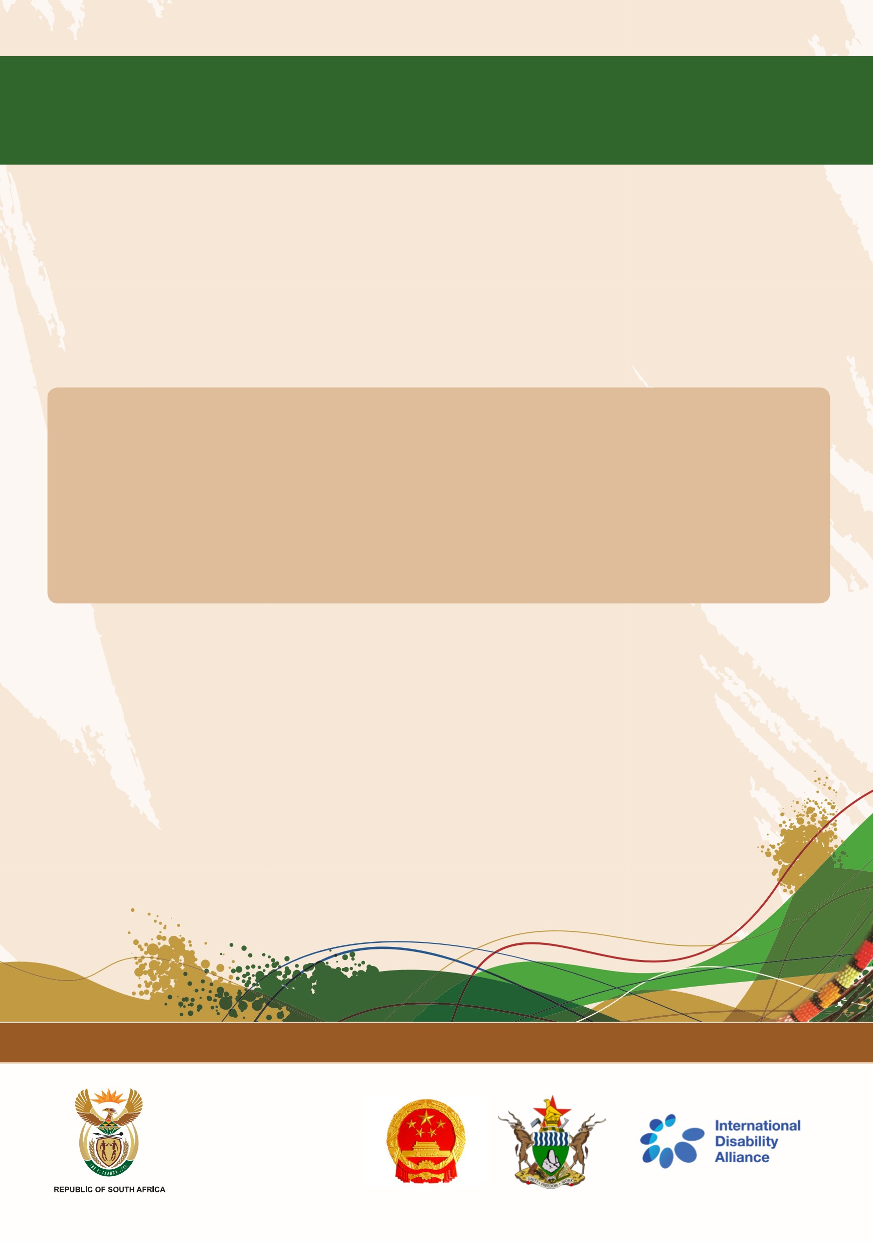
Article 4 of the CRPD under General obligations necessitates consultation and active involvement of persons with disabilities in, including children with disabilities, through their representative organisations in the development and implementation of legislation and policies to implement the present Convention and in other decision-making processes concerning issues relating to persons with disabilities.
South Africa will co-host this side event together with China, Zimbabwe and the International Disability Alliance.
The principle of self-representation is paramount in ensuring an adequate standard of living, and is intrinsically intertwined with the concepts of empowerment, participation and independent living.
The debate will focus on specific measures which have proven to be effective in institutionalising the right to self-representation, inclusive
Building a Caring Society. Together. www.dsd.gov.za
