On the occasion of the 10th Conference of States Parties to the UN Convention on the Rights of Persons with Disabilities the Permanent Mission of Sri Lanka, along with the International Foundation for Electoral Systems, Disabled People’s International, National Council for Disability Affairs in Egypt, the Special Talent and Exchange Program of Pakistan and International Disability Alliance invite you to attend
How Establishing Partnerships with Multiple Types of Stakeholders Helps to Increase Access to the Political Process
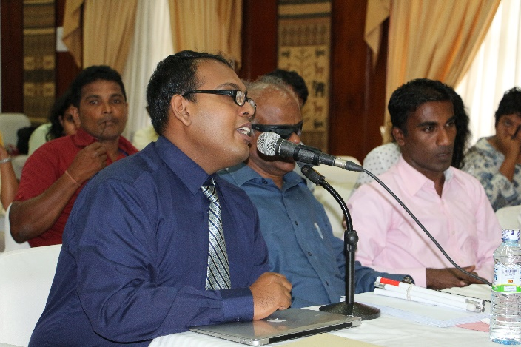
DPOs in Sri Lanka worked with IFES to advocate for disability-inclusive language in the new constitution.
Date: Thursday, June 15, 2017
Time: 1:15 – 2:30pm
Location: UN Headquarters,
Conference Room 12

Captioning will be available.

Collaboration of disabled people’s organizations with multiple types of stakeholders, such as election management bodies, political parties, disability rights councils, women’s organizations and media, can result in significant advances in achieving access to political rights. Successful strategies for engaging these stakeholders in different country contexts towards effective implementation of CRPD Article 29 on participation in political and public life and Sustainable Development Goal 16 on peace, justice and strong institutions will be discussed.

Chair
Ambassador A.S. Khan, Deputy Permanent Representative of Sri Lanka to the UN in New York
Panelists
Mr. Senarath Attanayake, Provincial Councillor, Sri Lanka
Ms. Virginia Atkinson, Senior Access and Inclusion Specialist, International Foundation for Electoral Systems
Dr. Ashraf Marei, Secretary General, National Council for Disability Affairs, Egypt
Ms. Silvia Quan, International Disability Alliance, Guatemala
Mr. Mohammed Atif Sheikh, President, Special Talent and Exchange Program, Pakistan

