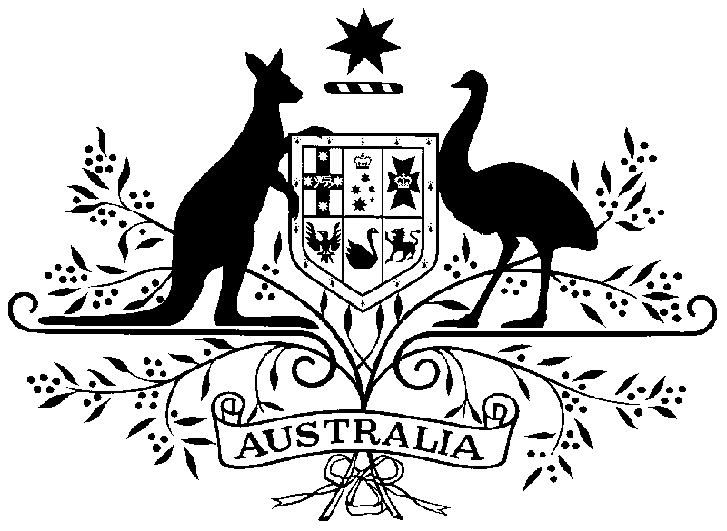**** 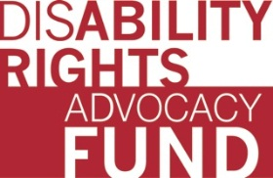

**INVITATION**

On the occasion of the 10th session of the Conference of States Parties to the CRPD

**The Disability Rights Advocacy Fund**

**The Permanent Mission of Canada to the UN**

**The Permanent Mission of the United Kingdom to the UN**

**The Permanent Mission of Australia to the UN**

**and the International Disability Alliance**

invite you to attend

***DPO Participation in SDG Implementation & Reporting: Experience from the ground***

**Tuesday June 13, 2017 from 4:45-6:00pm**

**Conference Room 11**

*Governments and civil society, including the disability movement, were critical players in the lead up to the adoption of Agenda 2030 and the Sustainable Development Goals (SDGs). This session will review progress in inclusive and partnership approaches that leave no one behind, and will detail the role of Disabled Persons’ Organizations (DPOs) in implementation of the SDGs and how the CRPD can be leveraged to promote sustainable development for all. Participation of DPOs in the process of reporting to the High Level Political Forum in 2016 and 2017 will be described.*

**Speakers**

* **Ms. Diana Samarasan**, Founding Executive Director, Disability Rights Advocacy Fund and Disability Rights Fund
* **The Honourable Carla Qualtrough,** Minister of Sport and Persons with Disabilities (Canada)
* **Ms. Penny Innes,** Head of Disability Inclusion Team, Department for International Development (UK)
* **Mr. Mika Kontiainen,** Director Disability, Development Policy Division, Department of Foreign Affairs and Trade (Australia)
* **Mr. Med Ssengooba,** Program Officer for Africa, Disability Rights Fund
* **Ms. Risnawati Utami,** Chair, OHANA Indonesia
* **Ms. Orsolya Bartha,** Senior Adviser, International Disability Alliance