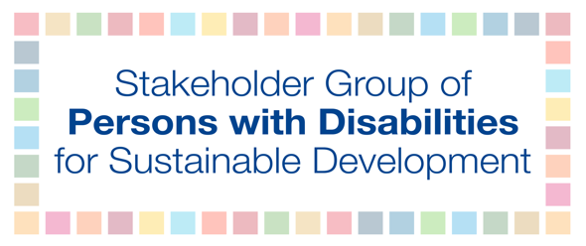

Stakeholder Group of Persons with Disabilities: List of SDG indicators to be disaggregated by disability

We are calling on States to carry out their responsibility to collect and disaggregate data in line with the 2030 Agenda for Sustainable Development and the UN Convention on the Rights of Persons with Disabilities (CRPD) by using the Short Set of Questions developed by the Washington Group. States must ensure that their national policies for persons with disabilities are informed by evidence-based data that realize the political commitments of the 2030 Agenda and legally-binding obligations outlined in the CRPD. To create effective and meaningful policies that guarantee the rights of persons with disabilities it is critical to disaggregate the SDG indicators by disability. The Stakeholder Group of Persons with Disabilities undertook a broad consultation process to choose which of the 232 global SDG indicators should be disaggregated by disability. There was a clear understanding among all contributors that all relevant SDG indicators should be disaggregated by disability, particularly all the indicators in Goals 1, 3, 4, 5, 11, and 16. The findings found 32 critically important indicators that must be disaggregated by disability, 11 of which already have disability references (below in red). The indicators are listed as follows.

Goal 1: 1.1.1, 1.2.1, 1.3.1

Goal 3: 3.3.1, 3.8.1, 3.8.2

Goal 4: 4.1.1, 4.2.2, 4.3.1, 4.4.1, 4.5.1, 4.6.1, 4.a.1

Goal 5: 5.2.1, 5.2.2, 5.6.1

Goal 8: 8.5.1, 8.5.2

Goal 10: 10.2.1, 10.3.1

Goal 11.2.1, 11.7.1, 11.7.2

Goal 16: 16.1.3, 16.1.4, 16.2.1, 16.2.3, 16.7.1, 16.7.2, 16.9.1, 16.b.1

Goal 17: 17.8.1

The 2030 Agenda for Sustainable Development: paragraph 48, paragraph 57, and Goal 17.18; CRPD Article 31; and GA resolution A/RES/71/313

