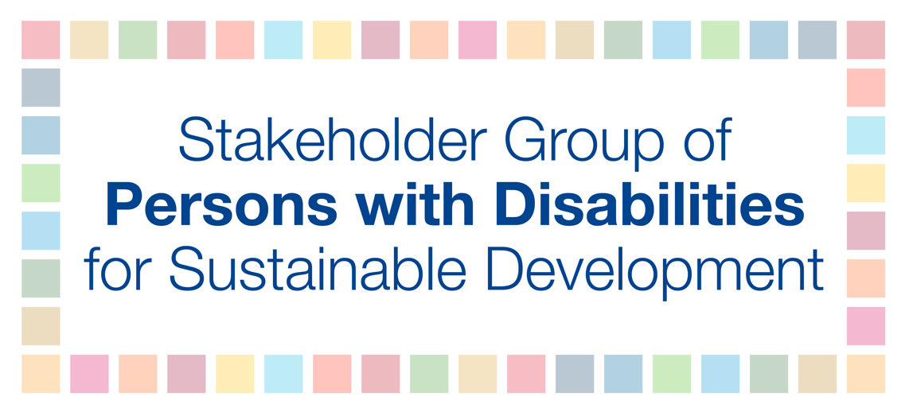

Humanity & Inclusion Side Event:
Title: Safer and inclusive roads and transports for cities that leave no one behind: How to ensure safe mobility for persons with disabilities and other vulnerable road users
Tuesday 10 July, 1:15-2:30PM CR3

Mohammed Ali Loutfy talking points

How can stakeholder engagement be more effective in the national, regional and global processes at the UN that lead up to the HLPF?

- Connect processes and advocacy aspirations;
- Awareness, capacity building, thematic, and follow-up processes;
- Recognition for coalitions on SDG implementation and civil society platforms must be part of government implementation and planning;
- Civil society representatives must sit in the implementation office;
- Emphasize meaningful civil society participation and thematic civil society outreach and consultation;
- Civil society platforms must be inclusive and accessible;
- SDGs must link better to grassroots and local government level where civil society must be involved;
- VNR country reports should be made available six months prior to reporting at the HLPF to provide for ample time to all actors for analysis;
- Prior to HLPF, two days should be allocated for an exchange between stakeholders and VNR countries representatives from the expert level;
- Countries should establish, regular and periodic inclusive follow-up processes at national level;
- We need to connect national aspirations to the regional level and strengthen the regional sustainable development forums by:
  - Creating civil society mechanism similar to the global level and the Asia-Pacific region at all regional levels;
  - Strengthen collaboration at the regional level between the UN and stakeholders;
  - Finance the regional civil society mechanism in order to allow for broad participation and meaningful engagement;
  - Conduct VNRs at the regional level and allocate ample time for exchange between civil society and reporting countries;

What political messages should stakeholders be promoting – should the HLPF Coordination Mechanism have a collective voice, at the HLPF?

Absolutely. Multilateralism is at a crossroads today. Basic human rights values are at stake and the UN can play a prominent leading role to guide us through these challenging times. The 2030 Agenda calls to leave no one behind and to realize this, the UN needs to open its doors and let stakeholders come in and meaningfully participate. We are not talking about just ticking the box, but really allowing for and opening meaningful and inclusive dialogue for stakeholders. The 2030 Agenda is the door for us to sit at the table and to be the critical voice. We have proven in the last few years that we, as stakeholders, are the drivers of change. If the UN wants to change or save multilateralism and become the torchbearer of values, it must open the door further for stakeholders to bring their expertise and critical thinking to the table. Resolution 68/1 is going in right direction, and so is the UNDS reform. We must allow and open the door for stakeholder participation for other mechanisms such as second or third committees as stakeholder engagement can contribute to elevate the value of resolution adopted by the General Assembly. This is critical and constructive.

