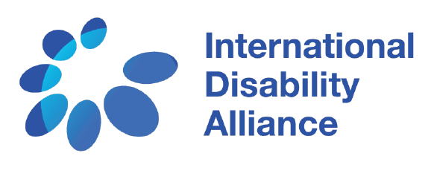
Human Rights Council 44th session –
8 July 2020
Panel discussion on the rights of persons with disabilities in the context of climate change
Intervention by Ms. Deborah Iyute Oyuu, Programme Officer at the National Union of Disabled Persons of Uganda, on behalf of the International Disability Alliance
Thank you Chair. On behalf of the International Disability Alliance, I thank the Human Rights Council for organizing this panel discussion with the participation of persons with disabilities. We also appreciate the report prepared by the OHCHR and its vital views on the promotion and protection of the rights of persons with disabilities in the context of climate change.
As the report shows, we, persons with disabilities, are extremely at risk to the adverse effects of climate change. Our access to basic services is further hampered and we are disproportionately exposed to water scarcity, food insecurity, economic losses, gender-based violence, inadequate housing, disruption of support services and involuntary displacement. For instance, the recent river flooding in Kasese district in Uganda displaced 147 persons with disabilities who lost their houses and household items and required relief support from the government.
Unfortunately, these injustices are not surprising: the effects of climate change are socially distributed and follow the exact same pattern of pre-existing inequalities in our societies that discriminate against persons with disabilities in multiple and intersectional ways. In most climate change or DRR committees, persons with disabilities are not represented to articulate their needs in this context.
Climate change is not the main cause of our hardships, but it is rather the social exclusion that we experience regularly in our daily life, the denial of our rights and the lack of legal protection. Solutions to climate change must address the root causes of social injustice, discrimination and inequality affecting persons with disabilities and we have a proper guide for this human rights perspective: the UN Convention on the Rights of Persons with Disabilities, including its article 11 on situations of risk and humanitarian emergencies.
By recognizing persons with disabilities as subjects of rights, the CRPD celebrates human diversity and provides guidance for the formulation of disability-inclusive climate action policies and for the empowerment of persons with disabilities as agents of change. Also, thanks to its Article 32 on international cooperation, the CRPD has the necessary Human Rights Based and people-centered approach to make climate action efficient, by tackling the root causes of marginalization and exclusion, by fostering social justice and meaningful participation and consultation, and by addressing discrimination.
In view of the crucial role of the CRPD in shaping inclusive climate action policies, IDA and its members around the world call out to States parties, UN agencies and relevant stakeholders to:
- Ensure that legislation incorporates a clear prohibition of all forms of disability-based discrimination, including multiple and intersecting discrimination, and the denial of reasonable accommodation, in order to reach substantive equality.
- Actively consult with and meaningfully engage persons with disabilities, including children, through their representative organizations, in all decision-making related to prevention and mitigation of climate change, for instance by considering the representation of persons with disabilities in national and lower levels DRR structures.
- Take the necessary measures to implement the full range of accessibility obligations under the Convention, including regarding information and communications technologies and systems on climate change, and ensure effective sanctions measures for non-compliance.
- Make sure that the rights and opinions of women and girls with disabilities and other under-represented groups, such as persons who are deafblind, persons with intellectual disabilities, persons with psychosocial disabilities, persons with autism and indigenous persons with disabilities are considered in climate change policies.
- Mainstream the rights of persons with disabilities in all development actions, including on climate change, and promote capacity building for persons with disabilities and their representative organizations, by including them in climate change education.
- Finally, we encourage all UN human rights mechanisms, including this Council, to keep monitoring the impact of climate change on human rights, and to provide clear guidance to make sure no one is left behind by the adverse effects of climate change.

