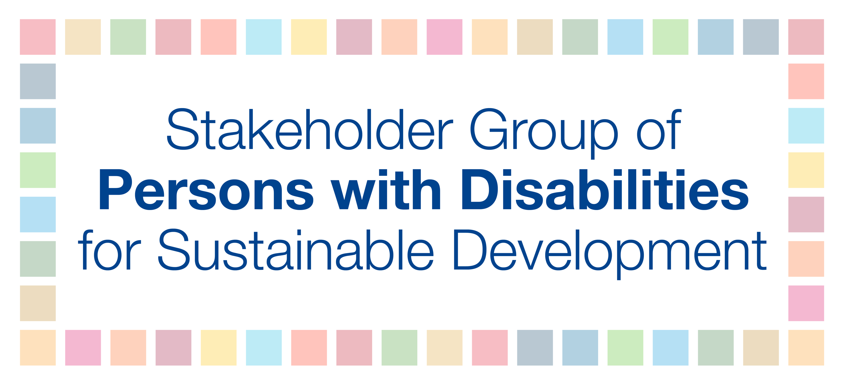

Fourth annual Multi-stakeholder Forum on Science, Technology and Innovation for the Sustainable Development Goals (STI Forum)

15 May 2019
11:30 AM – 1:00 PM
Statement for “STI for inclusive and equitable societies”
Dr. Elizabeth Lockwood, CBM

Excellency, ladies and gentlemen,

In the implementation of the 2030 Agenda, particularly the Goals on reducing inequalities and creating peaceful and inclusive societies, it is a human right to ensure inclusion and equality for all, including for persons with disabilities. The UN Convention on the Rights of Persons with Disabilities (CRPD) gives persons with disabilities the right to be involved, and together can ensure that emerging technologies contribute to the delivery of inclusion and independence for all.

Persons with disabilities are incredibly diverse in their identities, and those who experience other and intersecting forms of discrimination are at further risk of being excluded from society. All persons with disabilities, and particularly those from underrepresented groups, such as those in rural and urban areas, persons with psychosocial, intellectual, sensorial, and developmental disabilities, as well as children, youth, women, older persons, indigenous peoples, refugees, and others with disabilities must have equal opportunities to contribute to sustainable development to truly achieve the SDGs.

Accessible science, technologies and innovations have the potential to increase inclusion, participation and independence for all and to accelerate progress toward the realization of equal and inclusive societies and the achievement of the 2030 Agenda.

Emerging technologies, such as artificial intelligence, robotics, and smart environments are changing the way people work, travel, communicate and interact, both at home and in their communities. For persons with disabilities, emerging technologies have the potential to increase inclusion, participation and independence and in some cases, are already doing so.

However, there are very legitimate concerns and challenges about emerging technologies that all people, including those with disabilities, want to see addressed. Development and use of emerging technologies should be critically assessed for effects on rights and freedoms, and regulated accordingly. People are becoming aware of the potential of artificial intelligence, but also of the potential misuse of their data. So, it is essential to widen the debate about these technologies beyond the technology community.

In the past decade, technology has enabled persons with disabilities to overcome a range of barriers in access to health, education, employment, political participation and access to justice, and many other areas of life. For many, it has significantly increased independence.

Despite this, persons with disabilities still encounter widespread exclusion from all areas of economic, political, social, civil and cultural life, including in employment, education, healthcare and other services. Persons with disabilities experience higher rates of poverty and deprivation and lower levels of income than the general population.

Yet, emerging technologies can enable persons with disabilities to overcome these barriers to increase their independence, participation and inclusion in their societies.

In order to realize the full potential of emerging technologies and to create inclusive and equitable societies, I propose the following recommendations:

- Persons with disabilities and their representative organizations must be meaningfully included in all discussions related to emerging technologies and considered in all stages of the development process. Often, tech companies and policymakers tend to only think of the so-called “average users” in the technological development process. Yet, ICT users are extremely diverse. To address this, a universal design approach from the outset is essential when developing and procuring ICT-based solutions to be a tool to overcome barriers rather than reinforce barriers.

- Emerging technologies should be accessible and user-friendly, and if not, users may improperly use or not realize the full potential of the technology. To address this, adequate support and training should be offered to ICT users, including for persons with disabilities to access and safely use new technologies.

- Emerging technologies must be affordable to all users. High costs are a significant barrier for persons with disabilities in accessing technologies that have the ability to increase their inclusion in society.

- Technology companies need to ensure diversity in teams and employ persons with disabilities. In addition, academics should engage with persons with disabilities in their research in a participatory and ethical manner.

In summary, technology needs to comply with three As: technology must be available, affordable, and accessible to all, including to persons with disabilities.

In order to truly leave no one behind, the aforementioned recommendations must be considered as a red line for producers of emerging technologies. science, technology and innovation have the potential to increase inclusion and equality for persons with disabilities within and among societies, but only if done with the guiding principles of universal design and the disability movement’s motto “Nothing about us without us.”

Thank you.

This statement was informed by the European Disability Forum’s “Plug and Pray?” report. The full report is available here: http://www.edf-feph.org/sites/default/files/edf-emerging-tech-report-accessible.pdf

