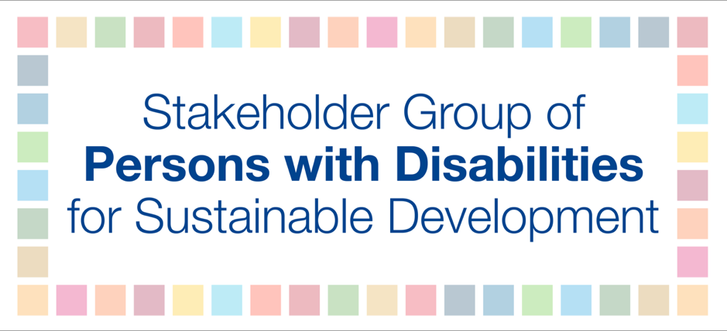

Switzerland individual VNR

Switzerland takes pride in its humanitarian tradition. The VNR refers to constitutionally anchored equality and inclusion principles. However, according to the mentioned Civil Society shadow report, Switzerland faces significant gaps and challenges with regard to discrimination still, and huge efforts are needed to guarantee non-discrimination and inclusion of all living in Switzerland; especially in terms of gender, sexual orientation, migrants living in Switzerland and persons with disabilities.
→ Questions:
- How is that reflected in the refugee and migrant policies of Switzerland? How does the Swiss government deal with the often referred to “migration crisis in Europe”?
- Concretely: How has Switzerland stepped up to allow safe entry on its territory for people whose human rights are violated? Is the Swiss government doing enough to prevent the over 3000 deaths a year of migrants trying to cross the mediterranean sea?
- In Switzerland, there are severe and unsolved mental health aspects; the youth suicide rate is high, especially among young people from the LGBTQI+ community. How is the government planning to effectively tackle these specific matters?
- How is Switzerland guaranteeing an inclusive and participatory process for the future Agenda 2030 process, that includes all, also persons with disabilities and sign language users?
- How will the government tackle the much larger gap as compared with neighboring states with regard to the real life situation and specific needs of persons with disabilities, such as physical and societal barriers, the non-existence of communication access in sign language, which is a prerequisite to participating in social and political processes, etc?
- Will the Swiss Federal Administration systematically collect data disaggregated by different types of disabilities as required by the CRPD?
- And: Will all of these important matters be addressed in the next VNR?

