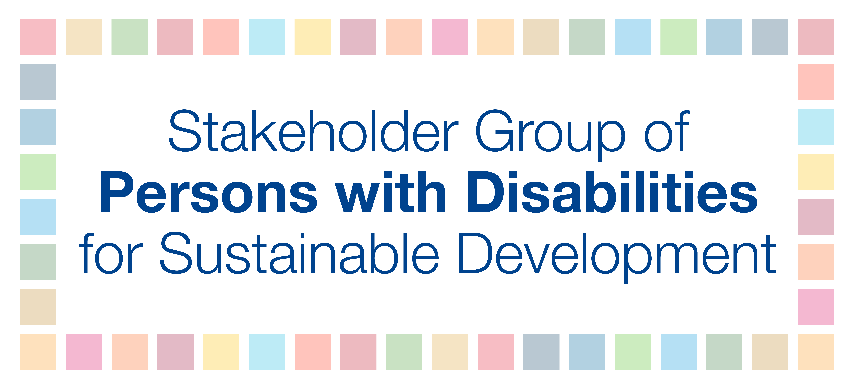

Talking points for the global trade union strategy meeting
Hosted by Friedrich-Ebert-Stiftung (FES) New York and Public Services International
November 6, 2018

- Persons with disabilities comprise an estimated 15 percent of the world’s population, are overrepresented among the most impoverished in the world, and encounter widespread exclusion from all areas of economic, political, social, civil, and cultural life, including employment.

- In fact, due to barriers in accessing education, skills training, and transportation, and inaccessible environments, persons with disabilities have higher rates of unemployment and under employment compared to their counterparts without disabilities. This can result in a loss of between 3-to-7 percent of a country’s GDP (ILO, 2009).

- Promoting employment and decent work opportunities for all, including for persons with disabilities, is essential to ensure that no one is left behind and benefits all of society.

- Since the 2019 HLPF theme is “empowering people and ensuring inclusiveness and equality” and Goal 8 is under review, full and productive employment and decent work for persons with disabilities and their representative organizations must be fully integrated into strategic opportunities for trade union action and be meaningful partners in joint campaigns.

We have some brief recommendations:

- To promote full and productive employment and decent employment for all, equality, human rights, sustainability, participation, inclusion, and accessibility should be core principles in line with Article 27 of the Convention on the Rights of Persons with Disabilities, the 2030 Agenda for Sustainable Development, and ILO Convention 159.

- To realize inclusive employment with full participation of persons with disabilities, first, inclusive education and skills training must be provided, which also contributes to eliminating stigma against persons with disabilities as unemployable.

- To create decent employment – and universal social protection systems -, public investment is fundamental combat poverty and exclusion, promote social justice and cohesion, and strongly benefit persons with disabilities and other marginalized groups.

- To achieve decent work for all, persons with disabilities and their representative organizations must be consulted by trade unions and trade union membership of disabled workers needs to be encouraged. Further, it is essential to strengthen partnerships and encourage mutual learning between the workers’ movement and the disability sector.

- To ensure inclusive employment practices, there must be inclusive employment policies; accessibility in the built environment, information technology, and communication; disability awareness training for staff; and safety and protection measures put in place.

I’ll end on an applicable quote: “When there are people with disabilities in the trade union, the social climate improves, and the enterprise improves as well.” (Jose Ma Fernández de Villalta, specialist, Spain)

