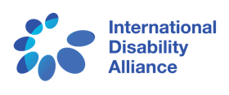
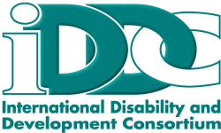

The Stakeholder Group of
Persons with Disabilities
invites you to a town-hall style discussion on
The Contributions of Persons with Disabilities in the HLPF Voluntary National Reviews
With examples from Germany, Morocco, Latin-America, the Philippines and Uganda
Monday, 18 July 2016
1:15pm – 2:45pm
Ford Foundation, East River Room, 11th Floor
320 E 43rd St, New York, NY 10017 (between 1st and 2nd Aves)
Michael Herbst, CBM Germany
José Maria Viera, World Blind Union, Latin America
Abdelmajid Makni, Collectif pour la Promotion des Droits des Personnes en Situation de Handicap, Morocco
Lauro Purcil, ASEAN Disability Forum, Philippines
Ambrose Murangira, National Association of the Deaf, Uganda
Moderated by Yetnebersh Nigussie, Light for the World, Ethiopia
Respondents from UN Member States
Lunch and refreshments will be served
RSVP: Megan Smith – msmith@ida-secretariat.org
with support from:
