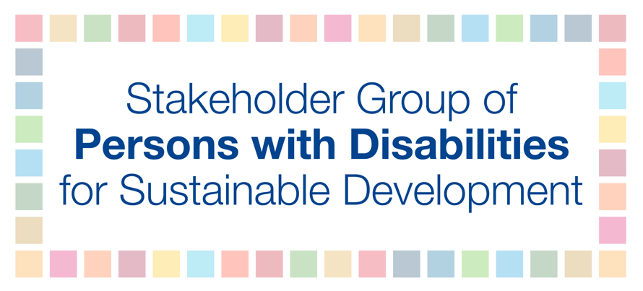

HLPF 2017
13 July
4:30-6:00 pm
Berhanu

Review of Goals / Thematic review: SDG 17 Advancing science, technology and innovation for SDGs

In line with the 2030 Agenda for Sustainable Development technology and accessibility can promote inclusion and help realize the full and equal participation of persons with disabilities in society and shape the future of sustainable development for all. This is especially important since one billion persons with disabilities globally encounter widespread barriers or lack of accessibility in built environments, transport and information and communication services, including relevant information and communications technology. These barriers often deny persons with disabilities access and inclusion into mainstream society.

The use of ICT and accessible and assistive technology improve the quality of life of persons and children with disabilities by increasing access to education, employment, community activities and other services. ICT is a critical driver to ensure that the SDGs are achieved for persons with disabilities, however, ICT can only effectively contribute to the realization of the SDGs if considered in line with Article 9 on Accessibility of the UN Convention of the Rights of Persons with Disabilities.

We recommend that:
- International standards need to consistently include accessibility features and be implemented and licensed fairly to all organizations;
- that tools and standards for universal design and accessibility are specified in procurement and financing of innovation programs for e-health, education, innovation programs and other relevant areas;
- Mainstream universal design approaches and accessibility in curricula for professionals, research and innovation programs and in procurement in both public and private organizations; and
- Accessibility is understood and addressed as another key characteristic of the digital environment aligned with the CRPD for full implementation of human rights.

