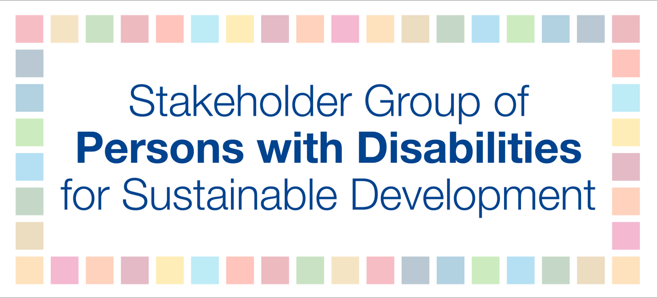

VNR Greece - Statement with questions

We want to congratulate you for including civil society in the implementation of the SDGs.

We recognize your efforts to reference and align to the UN Convention on the Rights of Persons with Disabilities in topics like education. Could you elaborate your commitment around the political participation of persons with disabilities, as full and engaged citizens? Measures must be taken to give all persons with disabilities the right to vote, not only persons with physical disabilities.

We want to compliment you for leading the way to strengthening democracy by lowering the voting age in the country to 17. We welcome both the development of the National Implementation Plan for the SDG and the commitment to develop a National Youth Strategy. Could you specify how you will mainstream sustainable development in the national youth strategy as well as how do you include national youth council as actors and rights holders in decision making processes for implementation of the Agenda 2030 National Strategy?

Furthermore, leaving no one behind means ensuring the inclusion of marginalized groups such as women, youth, persons with disabilities and others. It is highly important to have reliable, strong and accurate data. Could you elaborate on your strategy, in collaboration with your National Statistical Office, to collect data disaggregated by age, gender and disability?

Ultimately, you wrote on Greece’s unique ecological treasures; clearly there is astounding beauty in your Cyclades.Yet, the arid island conditions are challenging. For example, currently water is shipped to Aegina by tanker which residents supplement by purchasing bottled water to drink. Are there any proactive local or regional strategies for dealing with the large flow of plastic waste? In what way do you ensure community participation in water decision making and management?

Thank you.

