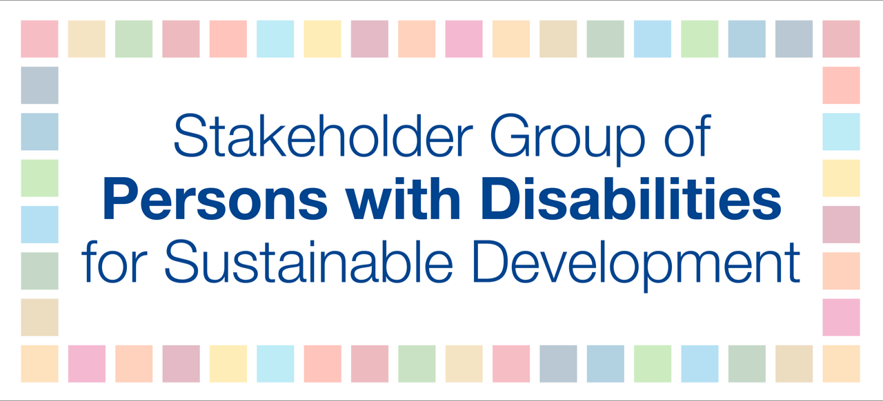

VNR Namibia - Statement with questions

While there are good policies in Namibia, there is a need for Namibia to review its policy on inclusion to ensure that everyone is included and it benefits all. One example is on inclusive education in which the definition of access and inclusion is narrow

How does Namibia implement SDG4 including equal participation and self-representation on decisions-making processes?

As an example, in the Namibian government there is no person with a disability in a high-level office or managerial position.

How does Namibia commit to carry out Article 5 of the UN Convention on the Rights of Persons with Disabilities that all persons are entitled to equal protection and equal benefit of the law.

Finally, we want to highlight the importance of poverty reduction in all its forms everywhere.

How can Namibia with a small population reduce the unemployment rate especially for youth while addressing the importance of education?

