Voices of Mexico: Disability and COVID-19
Names have been changed to protect the individuals mentioned in the story.
COVID-19 is a worldwide concern and measures from authorities are far from ideal in many parts of the world. Authorities in Mexico declared health emergency as COVID-19 cases exceeded 1000 on the 30th of March. IDA has been in touch with persons with disabilities, to understand what the situation is like in the country, learn what measures have been put to prevent contagion and what kind of support has been offered. The accounts are rather shocking. Securing food has become one of the greatest challenges, as well as receiving medical assistance, government support and information in accessible formats.

María: a disability activist with no medical assistance

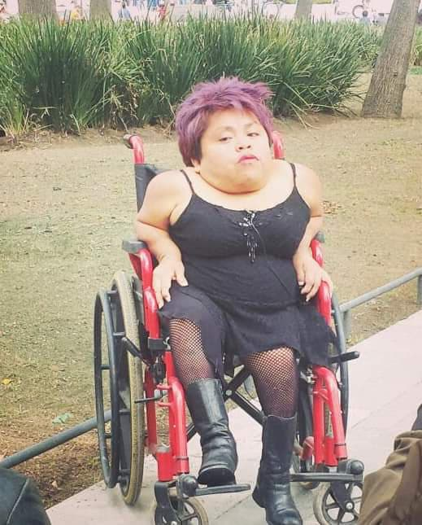

“Since March, we are obliged to stay at home. Supposedly the government was going to help me more, but that hasn’t happened.”
María is a Mexican woman with Morquio Syndrome, a disability that is in the category of rare diseases which are chronic degenerative. She was diagnosed only 3 years ago, after many years wondering why she was different to others. María is now an activist for disability rights.
She is 46 years old and can’t walk, is also hard of hearing and experiences other heart and lung diseases.
“I should have received medication that would have helped my condition but it was denied to me due to my age. As a consequence of my complex disability, I am at high-risk for severe illness from COVID-19.”
The government has advised for individuals with pre-existing medical conditions to stop working and strictly observe stay-at-home measures. She receives no support against coronavirus and it is very difficult for her to reach public health insurance. She lives in a dangerous street of Mexico, named Madero, in the Cuautepec neighborhood and works as an artisan making handmade soaps and candles and used to sell them in the streets.
She has been asked to stay at home due to her respiratory condition. María receives a small amount of funds from the government but still relies on others for getting my medication and food. “I require a lot of medical attention and feel very vulnerable at the moment. My doctor appointment was cancelled and we should be able to receive home based medical assistance. They have us locked up with no support.”
María explains that there is no access to masks nor gloves and the little information available is obtained through TV. There are no specific recommendations for persons with disabilities. She says everything is frozen, also the local organisations that used to support her.
“They ask for our stories and pictures but that’s all they do. I feel useless and sometimes get depressed. I’m used to being active and earn a living. I’d like to believe this will pass and try to rationalize my food so I don’t run out of it."

Rodrigo : a man waiting for a government’s support

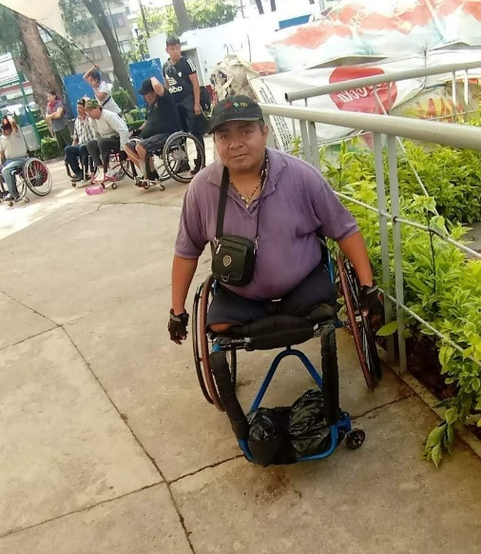
“If I leave the house, I can get sick. I have no protection masks or gloves. But how will I survive?”.
Rodrigo became a wheelchair user 3 years ago due to a severe diabetes and lost both legs. “I lost everything I had due to my disability, including my marriage.” Before, he was a taxi driver and earned a living that way. He is now 41 years old and lives alone. Before COVID-19, he used to make living out of selling candy and sweets in the street. Due to the confinement, Rodrigo was recently informed by the authorities and he can no longer work in the streets, for security reasons.
“How do I earn a living? I have to pay rent and food is running out.”
A person comes to his house every couple of days and helps with cooking. “That is all the support I get”, he says.
“I have requested government financial support three times and I am still waiting. That is what they keep telling you, you just have to keep waiting.”
Only a year ago, Rodrigo was registered as a person with a disability. They came to his house to request my information and report the conditions he was living in. But he still don’t come up on the screen.
“Again, I’m told to wait. I’m desperate and have no financial means. This is pure survival. I don’t have access to public healthcare and have no direct support. My mom helps with the insulin. I wonder if this is a way to live?”
Rodrigo belonged to a local disabled organisation but they have shut down and have no services. They used to offer transport and wheelchairs. His only source of information is TV.
“Again, the government keeps promising things that never happen. I’m sad, feeling down. What will happen with us? I feel unprotected and with no support.”
Rodrigo has lived in the streets before and explains he wouldn’t want to go back to that situation. “But how long am I supposed to wait?”, he wonders.

Martín: a deaf painter with no access to information

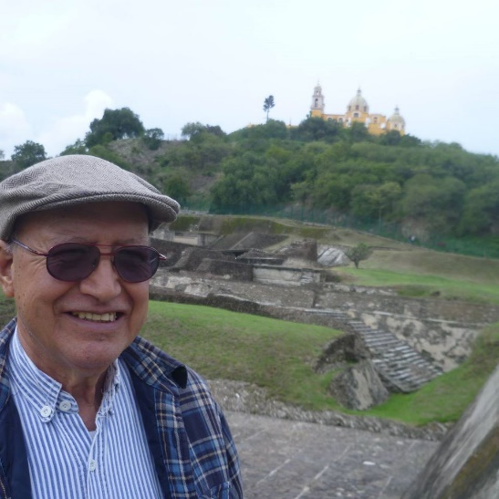

“There are still so many things I do not understand. There are no interpreters available that can explain to me well what is happening and reaching them is very difficult.”
Martín Diaz Calderón is 78 years old and did not finish school. As a kid, he experienced meningitis and I did not receive medical assistance for economic reasons, as a consequence, he had amnesia and became permanently deaf.
“I did not recognize anyone in my family and lived under my bed for many months, where a plate of food was handed over to me until the day I decided to come out and discover the world.” That day, he recalls, he was born again.
He learnt Mexican sign language with some other deaf colleagues and worked as a painter for many years, selling his paintings in the streets. That’s way, he took care of his family and raised 4 sons.
He is living the COVID-19 crisis with a lot of fear. Martín says he has never seen anything of the sort and does not comprehend entirely how the virus works nor the science behind it.
“I am isolated but try to follow instructions”, as the government has recommends for people over 60 years old to not leave the house unless strictly necessary.
“It is painful to see how this is affecting my work and not being able to see my family.” Art is his safe haven.
Martín regrets that the government often forgets about deaf people.
“Since many years, there is no schooling for deaf people, nor employment. How are we supposed to live?”
He explains there are very few interpreting services available and they aren’t publicly funded.
“I’ve experienced this kind of discrimination for my whole life. My retirement allocation is really not enough, even to secure food.”
4. Jorge: when COVID-19 seems more like a dream than a reality
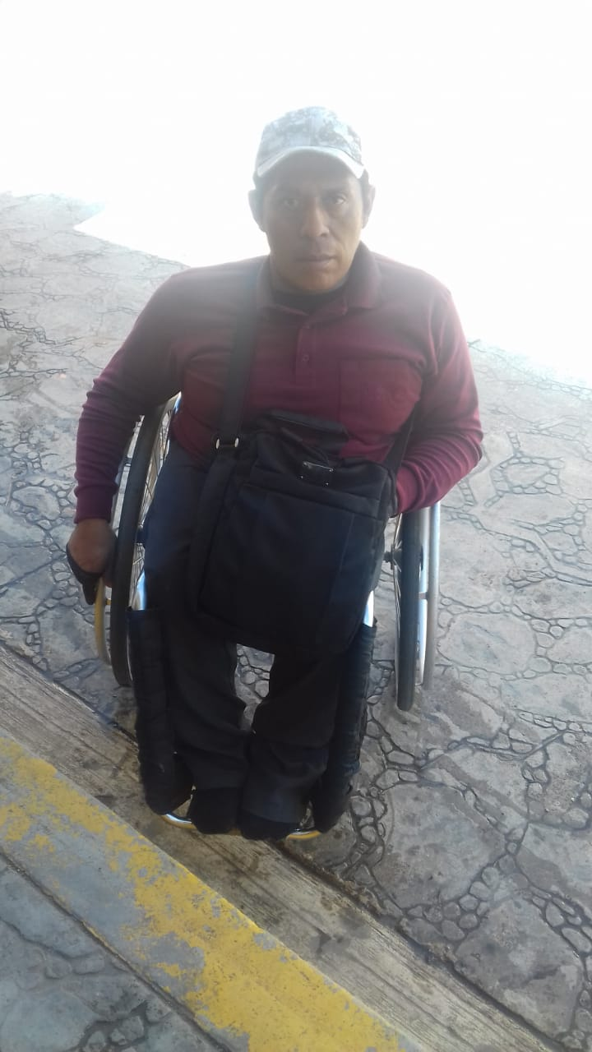
“We cannot work or pay rent. Disability is left behind by the government. There is a lot of promises but it is all a lie. There is no protection for us. We are abandoned and forgotten. ”
Jorge is a 40-year-old man who has no education and was raised in a hospital due to his many illnesses. He uses a wheelchair and has backbone problems. "I do not have financial resources. I need colostomy bags. I have a valve on my head but my government does not support me. I feel rejected”. Jorge has lived under a bridge for some time and is afraid to go back to that. Now he lives in an apartment and before the quarantine, he used to sell hair bands in the streets.
Jorge does not have television nor internet at home, therefore, access to information is very limited for him. “I didn't know there was coronavirus, I kept selling in the streets until the police asked me to leave. That's when I learnt about it.” At first, Jorge did not take the epidemic seriously and kept going out "to get food or ask for help on the street." Jorge explains that will try to get out again because he needs to do so to survive. He relies on a friend to obtain information on COVID-19. “The authorities lie so much that I don't believe anything anymore. I don't quite understand what coronavirus is. ”

