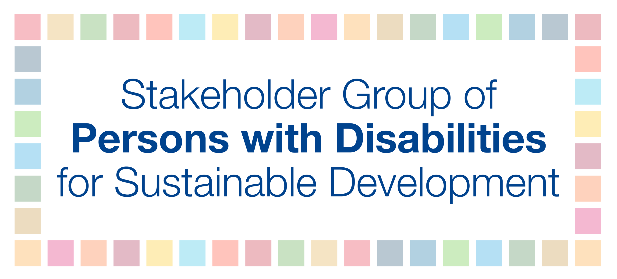
Webinar: ‘Information on HLPF 2019’
12 December 2018, 9:00am – 10:00am

In 2019, there will be two High-level Political Forums. The first HLPF will be eight days long and convened in July under ECOSOC. The second HLPF, which is the SDG Summit, will be two days long and convened in September at the opening of the UN General Assembly.

High-level Political Forum under ECOSOC
- The meeting of the High-level Political Forum on Sustainable Development convened under the auspices of the Economic and Social Council will be held from Tuesday, 9 July, to Thursday, 18 July 2019; including a three-day ministerial meeting of the forum from Tuesday, 16 July, to Thursday, 18 July 2019.

- The theme of the forum will be “Empowering people and ensuring inclusiveness and equality”

- During the first week of the forum, six Goals will be reviewed through panel discussions. These Goals include:
  - Goal 4. Ensure inclusive and equitable quality education and promote lifelong learning opportunities for all
  - Goal 8. Promote sustained, inclusive and sustainable economic growth, full and productive employment and decent work for all
  - Goal 10. Reduce inequality within and among countries
  - Goal 13. Take urgent action to combat climate change and its impacts
  - Goal 16. Promote peaceful and inclusive societies for sustainable development, provide access to justice for all and build effective, accountable and inclusive institutions at all levels
  - Goal 17. Strengthen the means of implementation and revitalize the global partnership for sustainable development

- These thematic reviews will provide an update on where we stand in terms of progress on individual SDGs and offer insight into the implementation of the SDGs. In addition, they facilitate peer learning, exchange of experiences, and identification of lessons learned as well as gaps.

- During these thematic reviews, the Stakeholder Group of Persons with Disabilities will have the opportunity to make interventions and provide recommendations to Member States on how to best achieve these Goals for persons with disabilities.

- During the second week of HLPF, Member States will present Voluntary National Reviews (VNRs) to share their national experiences, including successes, challenges and lessons learned, in the implementation of the 2030 Agenda. In 2019, fifty-one countries will conduct voluntary national reviews during the last three days of the session:
- 41 countries will report for the first time: Algeria, Bosnia and Herzegovina, Burkina Faso, Cambodia, Cameroon, Central African Republic, Chad, Congo, Côte d’Ivoire, Croatia, Eritrea, Eswatini, Fiji, Ghana, Guyana, Iceland, Iraq, Israel, Kazakhstan, Kuwait, Lesotho, Liechtenstein, Mauritania, Mauritius, Mongolia, Nauru, New Zealand, Oman, Pakistan, Palau, Rwanda, Saint Lucia, Serbia, South Africa, Timor-Leste, Tonga, Tunisia, Turkmenistan, UK, Tanzania, and Vanuatu.
- 10 countries will report for a second or third time: Azerbaijan, Brazil, Chile, El Salvador, France, Guatemala, Indonesia, Philippines, Sierra Leone, and Turkey.

- During the forum, the Stakeholder Group of Persons with Disabilities actively participates in VNR sessions and asks Member States about the situation of persons with disabilities in their implementation of the SDGs at a national level.

- Engagement in VNRs for persons with disabilities starts prior to HLPF. We will be holding a webinar on 23 January 2019 at 10:00am to explain how to engage with your government if they are compiling a VNR report. If you would like to learn about how to engage now, you can visit the IDA website for a VNR toolkit: http://www.internationaldisabilityalliance.org/toolkitvnr

- Member States will be asked by the UN to issue short versions of their VNR reports in May and full versions no later than Mid-June. As such, there is time for persons with disabilities to influence these reports in the coming months.

- If you require additional support to input into your country’s VNR report, please email us at HLPF2019@ida-secretariat.org

Preparatory activities towards HLPF under ECOSOC by the United Nations:
- Expert Group Meetings
- Expert Group Meetings (EGMs) are organized by the UN in preparation for HLPF, however, participation is limited and on an invitation only basis.

- Each Expert Group Meeting will discuss a Goal under review in 2019.

- The objective of these meetings is to take stock of where we are in terms of progress made towards achieving the Goal, to share success stories, good practices, and challenges, to identify particular areas of concern, and to suggest ways forward in terms of policies, partnerships, and coordinated actions.

- The first Expert Group Meeting was held last week in Brussels from 3-5 December to discuss SDG 4 – education. https://sustainabledevelopment.un.org/?page=view&nr=2946&type=13&menu=1634

- There will be an Expert Group Meeting on SDG 13 – climate action – from 4-6 March 2019 in Copenhagen. http://sdg.iisd.org/events/expert-group-meeting-on-sdg-13/

- At this time, not all Expert Group Meetings are announced. We are still waiting for information on Expert Group Meetings for Goal 8, Goal 10, Goal 16, and Goal 17. We will share information as it becomes available.

- In addition, complementary to the Expert Group Meetings, we are expecting the UN to launch e-consultations on the Goals under review for the first time. This will allow for broad participation and contributions. All inputs will be compiled and shared on the UN website. We will update you further as more information is shared with us on this process.

- Regional Sustainable Development Forums held by UN Regional Commissions
- Each year, the five UN Regional Commissions organize regional preparatory meetings leading up to the High-level Political Forum in July. The meetings will be convened between March and April 2019. The regional platforms usually have a pre-meeting of civil society.

- Regional meetings will take place:
  - from 21-22 March in Geneva, Switzerland, for the Europe region;
  - from 27-29 March in Bangkok, Thailand, for the Asia and Pacific region;
  - from 22-26 April in Santiago, Chile, for the Latin American and the Caribbean region;
  - from 16-18 April in Beirut, Lebanon, for the Western Asia region; and
  - in April with actual date and venue to be confirmed, for the African region.

- More information on the Regional Sustainable Development Forums can be found here: https://sustainabledevelopment.un.org/hlpf/2019

- The Stakeholder Group of Persons with Disabilities has regional coordination mechanisms in place in Asia-Pacific and Europe.
  - In Asia-Pacific, the focal point for persons with disabilities is Ms. Savina Nongebatu. Email address: savinafnongebatu@gmail.com
  - In Europe, the focal point for persons with disabilities is Ms. Marion Steff. Email address: marion.steff@edf-feph.org

- Sectoral position paper on behalf of the Stakeholder Group of Persons with Disabilities
- Each year the Stakeholder Group of Persons with Disabilities submits a sectoral position paper to the High-level Political Forum (HLPF).

- This year, our submission to the 2019 HLPF will have the overarching theme of “Empowering persons with disabilities and ensuring their inclusiveness and equality with others”. The submission will consist of 5 chapters around the following Goals under review:
- Chapter 1. Education (Goal 4: Ensure inclusive and equitable quality education and promote lifelong learning opportunities for all)
- Chapter 2. Employment (Goal 8: Promote sustained, inclusive and sustainable economic growth, full and productive employment and decent work for all)
- Chapter 3. Inequalities (Goal 10: Reduce inequality within and among countries)
- Chapter 4. Climate change (Goal 13: Take urgent action to combat climate change and its impacts)
- Chapter 5. Title pending. In light of Goal 16, this chapter will address violence, participation in decision-making processes, and access to justice. (Goal 16: Promote peaceful and inclusive societies for sustainable development, provide access to justice for all and build effective, accountable and inclusive institutions at all levels)

- Following this webinar, the first HLPF Bulletin will be shared tomorrow. It will include an invitation to input into any of the chapters by filling out the form attached. Form found here.

- The process in which the sectoral paper will be drafted is as follows:

- You will have several opportunities to contribute and be part of the drafting process.
- First, we will collect written inputs through the form attached above.
- Second, with the guidance of experts, we will draft an initial chapter that you can provide comments to in writing. We will also hold thematic webinars on each chapter, where the content of chapter will be explained, and you will have an opportunity to share your thoughts/ concerns/ etcetera.
- Finally, in light of all inputs, we will finalize the sectoral position paper and allow ample time for final input before submission.

- Election of Alternate Representative to the Stakeholder Group of Persons with Disabilities
- The Alternate Representative’s mandate expires every two years. As such, we are initiating an open, transparent and participatory application process to identify the next Alternate Representative of the Stakeholder Group of Persons with Disabilities.

- The core responsibilities of the Alternate Representative in collaboration with the Permanent Representative of the Stakeholder Group of Persons with Disabilities are:
- To facilitate the public representation of the SGPWD and to provide strategic direction and guidance.
- To promote and coordinate the active participation of members in national, regional and global meetings related to sustainable development, and to conduct advocacy meetings in New York and regional meetings on behalf of the Stakeholder Group of Persons with Disabilities.
- To ensure coherence and synergies between the different Working Groups of the Stakeholder Group of Persons with Disabilities.

- More information about the roles and duties can be found in the Terms of Reference of the Stakeholder Group of Persons with Disabilities here.

- We strongly encourage and welcome nominations of all persons with disabilities – and particularly those from underrepresented groups – in rural and urban areas, including persons with psychosocial, intellectual and developmental disabilities, as well as women, older persons and indigenous persons with disabilities.

- If you wish to apply, click here.

- Selection Committee for the Alternate Representative of the Stakeholder Group of Persons with Disabilities
- The Terms of Reference for the Stakeholder Group of Persons with Disabilities foresees that an open, transparent, inclusive and accessible nomination process shall be conducted, and the election of the Alternate Representative shall be undertaken through a Selection Committee.

- The Selection Committee is open to all who wish to partake. Members of the Selection Committee will be requested to review applications received.

- The Selection Committee will rank the candidates through a secure and accessible online survey platform. This will be followed by an online call, where Selection Committee members will discuss their choices and will aim to agree on a final decision.

- The work of the Selection Committee will remain confidential.

- If you would like to be part of the Selection Committee, apply here.

- HLPF Bulletin
- We will continue our previous year’s practice by sharing information via a monthly bulletin on the preparatory work towards the 2019 HLPF and related processes. The bulletin will provide information about opportunities that the UN shares at the global level and how persons with disabilities can practically engage in these activities.

- The first bulletin will be released tomorrow and will contain all the information provided during this webinar and additional notes.

- Webinar series
- The Stakeholder Group of Persons with Disabilities will hold a series of webinars towards the 2019 HLPF.

- The first webinar of the series will be on the 23rd of January at 10:00am on the topic of VNRs. Please monitor your email for more information to come on this webinar series.

HLPF under UNGA
- A special session of HLPF, an SDG Summit will be convened at the highest level under the auspices of the UN General Assembly from 24-25 September 2019. Such sessions of the HLPF take place every four years at the beginning of the UNGA session with the objective to provide for political guidance discussions on the SDGs. The Summit aims to provide leadership and reconfirm global consensus and commitments to support the implementation of the 2030 Agenda and SDGs.

- The UN SDG Summit provides an opportunity to reinvigorate international commitment to the 2030 Agenda, showcase areas of global progress towards the SDGs, and raise awareness on the importance of the 2030 Agenda and SDGs globally.

- We are anticipating that the UN will be pushing for an action-oriented/ commitment-oriented SDG Summit. However, the design and outcome of the Summit will largely depend on how the Member States envision the implementation of the SDGs. This will be reflected in the outcome document, which will be a Political Declaration, negotiated by Sweden and Bahamas.

- For more information, click here.

