DIAUD Network during World Urban Forum 9, Kuala Lumpur
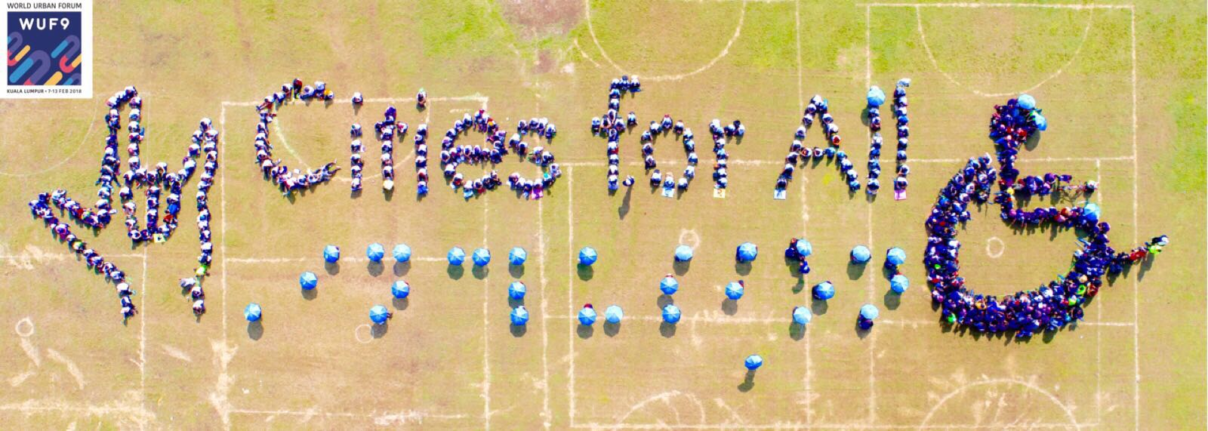

From February 7th until the 13th, the Disability Inclusive and Accessible Urban Development (DIAUD) Network actively engaged in the ninth session of the World Urban Forum (WUF9). The WUF9 mobilized diverse stakeholders in urban development to discuss their best practices, inputs on monitoring and evaluation, and facilitate strategic partnerships for the effective implementation of the New Urban Agenda.
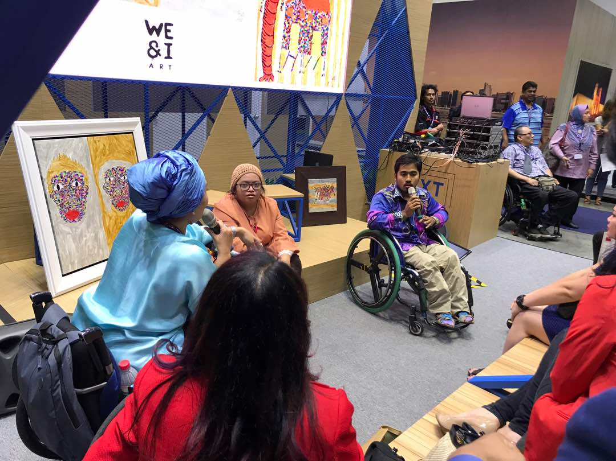
The activities of the DIAUD Network at the WUF9 were critical in raising the profile and importance of inclusion and universal accessibility towards the effective implementation of the New Urban Agenda (NUA), and included: active participation of persons with disabilities, representing all constituency groups from the Global North and South; mentorship and engagement of local youth; national and international media interaction; development of strategic partnerships with diverse stakeholders (government, industry, and civil society) on implementation of NUA; collaboration with a Malaysian DPO to strengthening the Network’s engagements with local community in and around the Forum.
Through pre-planning and onsite coordination with 20 plus members of the DIAUD, we actively engaged in the WUF9 by organizing, co-sponsoring, presenting and speaking in the following 8 events:
- City in the Mirror
- Universal Design Principles and Applications to Urban Development-Embracing a more livable Future
- Smart Cities 2030- Smart Cities for all Toolkit
- Implementing Universal Accessibility at the Local Level- Practical Actions for Realizing an Inclusive New Urban Agenda
- Cities for All- Aerial Art Advocacy
- Stakeholder Roundtable for Persons with Disabilities
- Persons with Disabilities and Older Persons Networking Event
- Smart Cities 2030- How to Build Smart Cities

Following the events above, the DIAUD Network had central roles in 4 separate side events that were organized by the Gesellschaft für Internationale Zusammenarbeit(GIZ), United Cities and Local Governments (UCLG) and UN Habitat, as well as two interviews on Malaysian national television. Our active participation in the Forum formalized and secured dynamic and diverse range of strategic partnerships, which will lead the Network’s planning and engagements around inclusive urban development at the international, regional and local level.
In addition to the events at the Forum, The DIAUD Network directly influenced the outcome Declaration of the Forum and secured and explicit mention of Accessibility and Universal Design as core aspects of action plans towards implementation of an inclusive New Urban Agenda.
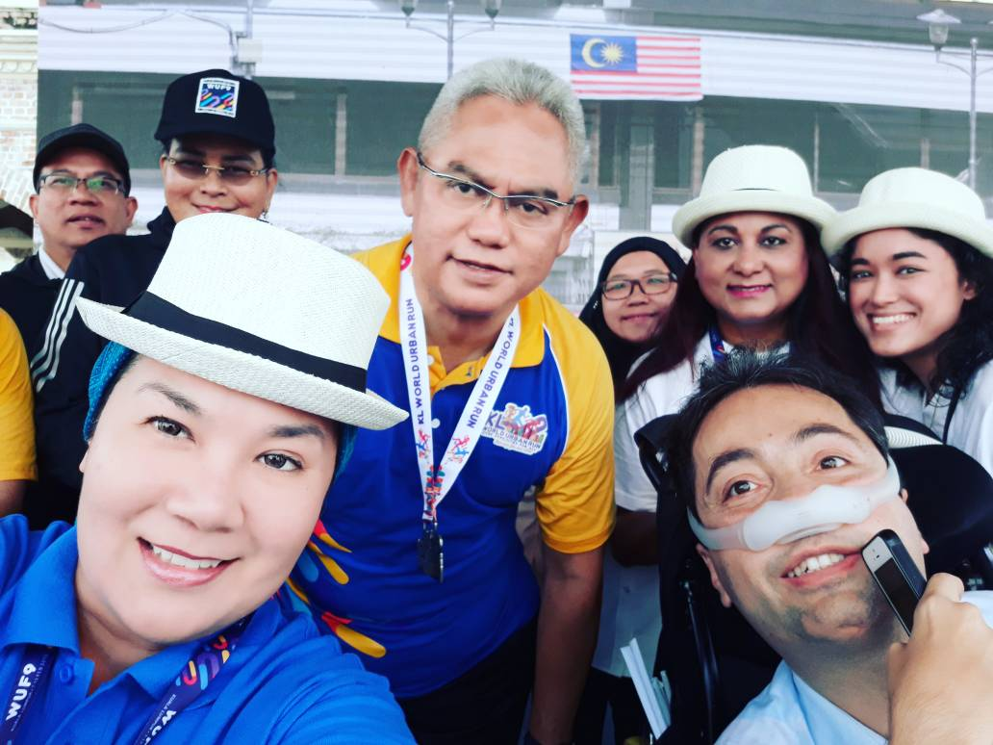
We would like to give a special thanks to UN Habitat, the Global Alliance on Accessible Technologies and Environments (GAATES), World Bank, World Enabled, GAP Older Persons Partner Constituent Group, Next City, G3ict, Ford Foundation, Microsoft, CBM, Dr Mason Global, HEWI Inc., Bernama TV, Astro TV, OKU Sentral, and the Malaysian Minister of Urban Wellbeing, Housing and Local Government – for their active coordination and support of our events at WUF9. Let’s continue building an inclusive future together and see you in Abu Dhabi in 2020 for WUF10!

