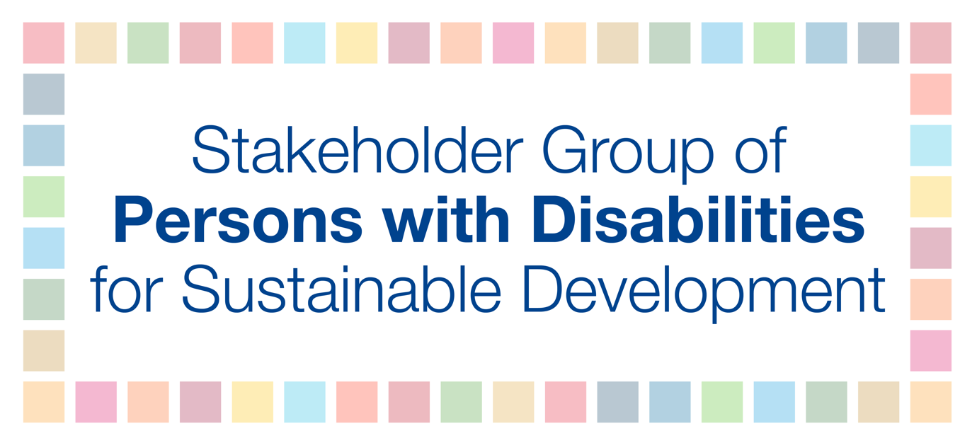
The Stakeholder Group of Persons with Disabilities is pleased with the positive takeaways from the 2019 High-level Political Forums under the auspices of the Economic and Social Council and General Assembly (SDG Summit). Due to the COVID-19 pandemic and the virtual nature of the 2020 HLPF, we ask for the following accessibility services to be provided for participants with disabilities:
- Ensure that the platform used for the online 2020 HLPF is accessible for participants with disabilities, sign language interpreters, and real-time captioners;
- Provide real-time captioning services, such as CART, for plenary sessions online as well as on live and recorded webcast videos for all eight days of the HLPF;
- Provide International Sign interpretation for plenary sessions online as well as on live and recorded webcast videos for all eight days of the HLPF;
- Ensure that the UN Sustainable Development Knowledge Platform is fully accessible;
- Ensure that participants with disabilities and their personal assistants/sign language interpreters/captioners are able to register and that these assistants are not counted as participants (when there is a maximum number permitted);
- Allow more time for presenters with disabilities, at least one minute more than for presenters without disabilities, especially for blind and partially sighted participants reading Braille, deaf and hard of hearing participations using sign language interpreters, and participants with speech disabilities;
- Ensure all shared materials are accessible for persons using screen reader software;
- Share HLPF documents and presentations prior to events for captioners and sign language interpreters, as much as possible;
- Convert the HLPF agenda into easy-read format; and
- Ensure that if any official session goes beyond working hours, that sign language interpreters and captioners are able to work these extra hours to ensure continued access to information for all participants.

