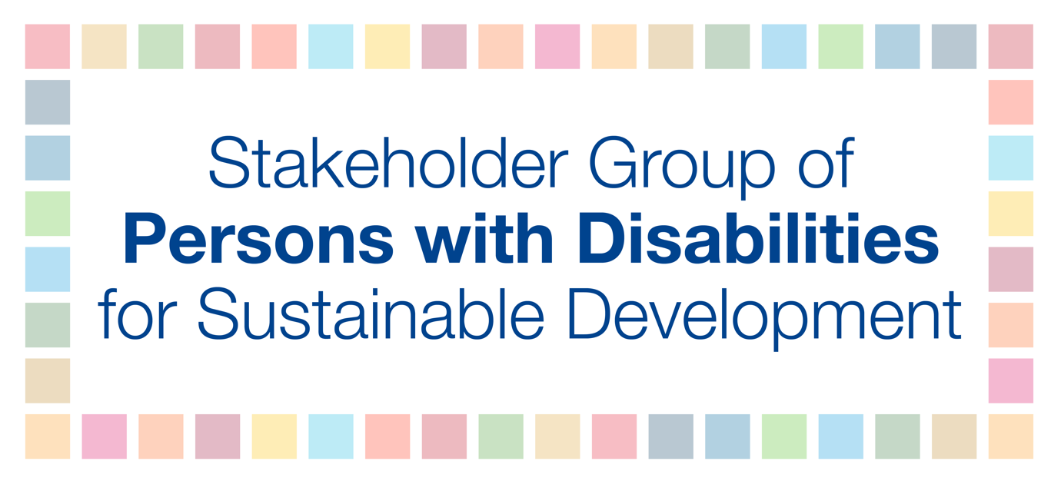

On behalf of the Stakeholder Group of Persons with Disabilities, we are pleased with the accessibility features that the UN did provide in the 2020 HLPF, including real-time captioning throughout the HLPF, extra time for presenters with disabilities, and for quickly responding to our requests and questions. We ask that these accommodations continue to be incorporated into future HLPFs.

At the same time, some representatives of the SGPwD encountered barriers during the 2020 HLPF. We recommend that these barriers are addressed going forward, especially since virtual platforms may continue to be used for some time.

Accessibility challenges during the 2020 HLPF include:
- The Webex platform used was not accessible for blind users. For example, blind presenters were unable to find the microphone button with their VoiceOver system.
- Blind people who were presenters and had to be on camera had difficulty positioning the camera.
- Messages in the chat box during meetings created a barrier for blind users. This is because the VoiceOver system reads the messages during the session and interrupts the blind person’s ability to listen and follow what is happening.
- There was no International Sign interpretation during the HLPF, which is a step backward from previous HLPFs and a significant gap for deaf persons.

Suggestions on how to address these barriers:
- The technical person assigned to respective sessions should assist blind people on how to face the camera in the right direction for their presentation.
- Adequate time should be allocated to assist persons with disabilities who are presenting prior to the session, e.g. how to turn on the microphone, how to position the camera.
- Include International Sign interpretation throughout the HLPF.
- Encourage countries to include captions and sign language interpreters in their own VNR presentations. Great examples from the 2020 HLPF were Panama and Uganda that included sign language interpreters and Panama and Slovenia that included captions in their pre-recorded VNR videos.
- Use Zoom as an online platform during events since it is by far the most accessible platform for persons with disabilities.
- In addition, request that Webex developers make the Webex platform accessible.
- Commit to including marginalized groups of persons with disabilities at the HLPF, e.g. persons with intellectual disabilities, deafblind persons.

The SGPwD composed guidance notes on accessibility of online platforms that may be useful:

- Checklist for making virtual meetings accessible
- Overview on Accessibility of Video Conferencing Apps and Services

We look forward to continuing to collaborate on creating accessible and inclusive HLPFs for persons with disabilities. Please feel free to contact us for accessibility feedback and guidance.

