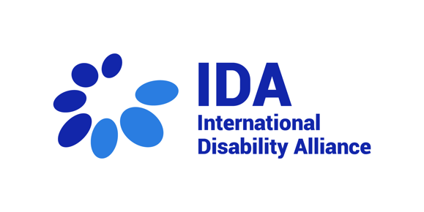
Opening 30th session of the CRPD Committee - 4 March 2024

Statement by Cato Lie, First Vice-President, International Disability Alliance
Distinguished members of the CRPD Committee,
It is with great honor that I address you today as the First Vice-President of the International Disability Alliance (IDA). I would like to commence by acknowledging and commending the outstanding efforts of the CRPD Committee and its Secretariat. Despite facing significant institutional challenges, including limited resources, your unwavering commitment has greatly contributed to the progress we have achieved together.
IDA, as the unique international network of global and regional organisations of persons with disabilities whose members represent a large number of national organisations of persons with disabilities (OPDs) from around the globe, continues to prioritize support for organizations of persons with disabilities and the CRPD Committee's mandate and we greatly appreciate the Committee's ongoing engagement with organizations of persons with disabilities from the countries under review. For this session, we are pleased to have representatives from five countries attending in person. Additionally, we look forward to engaging in discussions on the development of General Comments No. 9 and No. 10 on Article 11 of the CRPD.
IDA remains committed to collaborating with other UN Treaty Bodies to integrate CRPD standards into their work. Recently, we have supported representatives from various countries in engaging with committees such as CEDAW, CESCR, and the Human Rights Committee. We also anticipate contributing a disability perspective to the forthcoming general comments on sustainable development by the CESCR Committee and the joint comment on xenophobia by the CERD-CMW Committees. IDA is pleased to contribute to increased normative coherence on the basis of the highest standards of disability-rights as articulated by the CRPD.
We know that the resource constraints and challenges faced by the CRPD Committee, and its Secretariat are significant. This impacts all aspects of work, including general comment drafting and reviews of State parties. IDA must express its regret regarding the postponement of the adoption of the List of Issues for Cyprus, Moldova, and Monaco, initially scheduled for the 19th Pre-sessional Working Group. Such delays exacerbate the already critical backlog in State reviews, which would include 68 reports pending review and a 4 to 6 years timespan between reception of a report and the actual review, underscoring the urgent need for enhanced allocations to regular budget to ensure timely human rights monitoring.
Furthermore, IDA is concerned about the abrupt discontinuation of remote participation for representatives of organizations of persons with disabilities and other groups in UN Treaty Bodies' official meetings. Despite prolonged discussions on the digital transition, the failure to establish a permanent framework for remote participation in 2024 has significantly hindered OPD and civil society engagement. It would be immensely disappointing if the UN is regressing rather than advancing in terms of ensuring inclusive and meaningful participation, which is essential for a properly functioning human rights framework.
In anticipation of the upcoming General Assembly resolution on human rights and the treaty body system in December 2024, IDA urges UN Member States and relevant UN Committees especially the General Assembly's Fifth Committee and the ACABQ, to augment the regular budget for the CRPD Committee's activities and devise innovative solutions to address the backlog of State reviews.
As the CRPD Committee elections will take place in New York on June 15th, IDA calls on States to maintain gender balance and increase representation from underrepresented regions and disability constituencies, in accordance with Article 34 of the CRPD. Keeping gender-balance would mean electing at least 3 women, and in terms of regional balance we note that there are not currently any Committee members from the UN region of Eastern Europe. We also wish to stress the ongoing need for diversity of disability constituencies on the CRPD Committee, including from underrepresented groups such as persons with intellectual disabilities and persons with psychosocial disabilities.
As the work on the general comments on Article 11 proceeds, we look forward to increased attention in this and future sessions on issues such as:
- The role of organizations of persons with disabilities in peacebuilding processes
- States’ implementation of UNSC resolution 2475 in the context of Article 11
- Developing standards on asylum claims based on a well-founded fear of disability-related persecution
- Climate action and implementing a just and disability-inclusive transition
As we noted at the previous session, we look to the Committee to provide further guidance on other important topics that have recently attracted considerable international attention, and on which States could benefit from the Committee’s views in implementing their CRPD obligations, including: how to ensure disability-inclusive development and realize the SDGs for all persons with disabilities; how to achieve the highest attainable standard of health without discrimination on the basis of disability, and what the full implications of applying the CRPD and the social model of disability to ‘mental health’ might be on existing laws, policies, and frameworks, having particular regard to the rights of persons with psychosocial disabilities.
Given that the CRPD Committee is actively working on a general comment on Article 11, IDA appreciates the Committee's efforts to consider all the relevant conflicts, situations of occupation, and other crisis situations around the world -as they evolve- and that are under the CRPD Committee’s mandate, noting with great concern the lack of availability of information on persons with disabilities impacted, while remaining fully focused on clearing the backlog of States’ reviews.
In closing, we reaffirm our steadfast support and appreciation for the CRPD Committee's critical work. We wish you a highly successful 30th session.
Thank you.

