The Missing Billion Initiative announces global Commitment to Action on
disability inclusion
On the heels of new research identifying major gaps in disability health data, the Missing
Billion Initiative and partners announce a new commitment to action at UNGA 78
September 18, 2023 — The Missing Billion Initiative and its partners today announced a
Commitment to Action centered on accelerating disability inclusion in health systems globally
during the Clinton Global Initiative (CGI) 2023 Meeting in New York City. The committing
partners, include the Mission Billion Initiative, the McKinsey Health Institute (MHI), the Clinton
Health Access Initiative (CHAI), the International Disability Alliance, and the London School of
Hygiene & Tropical Medicine.
The two-year commitment aims to reduce the staggering 10- to 20-year life expectancy gap
people with disabilities face compared to people without disabilities. This involves changing
entire national health systems to ensure that people with disabilities can access the health
services they need—from prenatal checkups to eye exams to urgent care, and beyond.
To do this, partners will work with global, national, and community stakeholders to design
inclusive health systems that serve as case studies for scale in at least six countries. These
case studies will help build a global coalition of health stakeholders, mobilize donors to pledge
financial support, and cultivate the evidence base to inform action on disability inclusion.
The Commitment to Action comes on the heels of a new report published by the Missing Billion
Initiative and MHI exploring major gaps in data about people living with disabilities, who
represent 16 percent of the world’s population.
The missing billion: Lack of disability data impedes healthcare equity shines a light on how
these gaps prevent healthcare professionals, policy makers, and other stakeholders from
understanding lived experiences and present a barrier to achieving global health equity goals.
The report offers actionable recommendations on better data collection and usage, including
strengthening emergency health records, registries, and leveraging national censuses and
household surveys to collect data.
“
In a world where 1.3 billion people are living with a disability, inclusive and equitable health
services are critical. Yet we know that this is not the case globally, at a foundational level due to
missing data about people with disabilities,” said Ahmed Osman, associate partner and
McKinsey Health Institute Geographical Leader. “Equity in health is a priority at the McKinsey
Health Institute, and we are committed to advancing healthier lives for all. Whether one is
operating from a healthcare organization, government, donor, or implementing organization, we
all need to work together.”
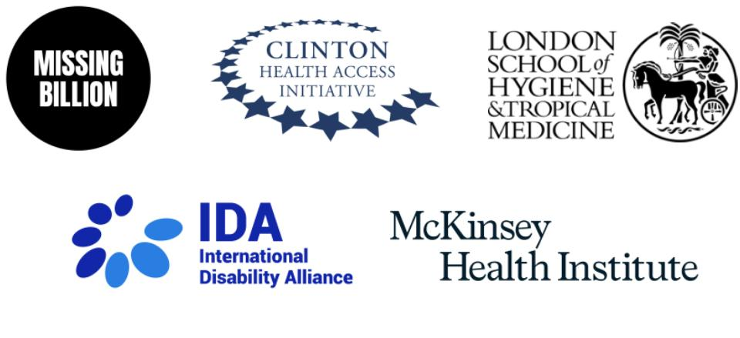

“
We cannot close in on global health equity without clarity on what health challenges people
with disabilities face,” said Phyllis Heydt, co-founder of the Missing Billion Initiative. “Data is
essential to provide greater clarity and move to action.”
“
Creating equitable access to health services for individuals living with disabilities requires
collaboration from stakeholders across global health systems,” said Jose Maria Veria, Director
of Advocacy of the International Disability Alliance. “By bringing together a coalition of
organizations dedicated to advancing inclusive healthcare, and with the strong involvement of
organizations of people with disabilities, we are signifying our commitment to a world where
every individual can get the healthcare they need and deserve.”
Read more details about the significant health access barriers and poorer health outcomes of
people with disabilities in the latest Missing Billion report. Read more about the state of global
health data on people with disabilities and where the health community should go from here on
the MHI website.
About The Missing Billion Initiative
The Missing Billion Initiative is a catalyst for system change aiming to improve the health of 1.3
billion people with disabilities. It gathers data and evidence, partners with governments and
funders to implement change at scale, develops innovative solutions and mobilizes global health
actors on disability inclusion.
About the McKinsey Health Institute
The McKinsey Health Institute (MHI) is an enduring, non-profit-generating entity within the firm.
MHI believes, over the next decade, humanity could add as much as 45 billion extra years of
higher-quality life, which is roughly six years per person on average —and substantially more in
some countries and populations. MHI’s mission is to catalyze the actions needed across
continents, sectors, and communities to realize this possibility.
About the Clinton Health Access Initiative
The Clinton Health Access Initiative, Inc. (CHAI) is a global health organization committed to
saving lives and reducing the burden of disease in low- and middle-income countries to create
and sustain high-quality health systems that can succeed without our assistance. For more
information, please visit www.clintonhealthaccess.org.
About the International Disability Alliance
2

IDA is a global alliance of eight global and six regional member organizations representing over
,100 organizations of persons with disabilities (OPDs)¹ and their families from 182 countries.²
1
IDA’s work is primarily focused on promoting the effective and full implementation of CRPD and
compliance by governments and the UN System through the active and coordinated involvement
of representative OPDs at the national, regional, and international levels. IDA’s work is structured
around the pillars of Human Rights, Advocacy, and Capacity Building, which mutually reinforce
each other in thematic areas.
About the London School of Hygiene & Tropical Medicine
The London School of Hygiene & Tropical Medicine is a world-leading centre for research and
postgraduate education in public and global health.
About the Clinton Global Initiative
Founded by President Bill Clinton in 2005, the Clinton Global Initiative is a community of doers
representing a broad cross section of society and dedicated to the idea that we can accomplish
more together than we can apart. Through CGI’s unique model, more than 9,000 organizations
have launched more than 3,900 Commitments to Action — new, specific, and measurable
projects and programs. Learn more about the Clinton Global Initiative and how you can get
involved at www.ClintonGlobal.org.
1
The CRPD emphasizes the representative role/mandate of organizations of persons with disabilities, distinguishing
them from organizations for persons with disabilities. This was further reinforced by the General Comment 7 of the
CRPD Committee which states that organizations of persons with disabilities (OPDs) are those that are led,
directed and governed by persons with disabilities. A clear majority of their membership are recruited among persons
with disabilities themselves. See CRPD General Comment No.7, para 10-14 on definition of OPDs and contrast with
civil society organizations https://daccess-ods.un.org/access.nsf/Get?OpenAgent&DS=CRPD/C/GC/7&Lang=E
2
IDA’s membership (members and members’ members) includes 227 OPDs in Africa; 230 in the Americas; 88 in
Asia; 390 in Europe; 63 in MENA; and 163 in the Pacific.
3

