Accessibility Guide for Visitors to the United Nations Headquarters

2022

Contents

1. Purpose 2
2. Contact details 2
3. Venue description 2
3.1 UN Pass and ID Office 3
3.2 Food and Dining in the UN Headquarters 4
4. Accessibility services and reasonable accommodations 5
4.1 Service Dogs and Guide Dogs 6
5. Access to facilities inside the building 6
6. Security and evacuation 7
6.1 Security 7
6.2 Evacuation procedures for persons with disabilities for the Conference and General Assembly buildings (prepared by the UN) 7
7. Transportation 8
7.1 How to get to the UN: Always give yourself plenty of time to get around New York City. 8
7.2 How to get around NYC using taxis, car services, and public transportation: 9
(3) MTA's Access-A-Ride Paratransit services 9
• It may be possible for some visitors from other states or countries to obtain a 21-day visitor's pass for Paratransit Access-A-Ride services if the person has existing Paratransit services elsewhere. Click here for more information and scroll down to “Visitors’ Information” for details. 9
(4) MTA Guide to Accessible Transit 9
• Accessible subway information 9
• Accessible subway stations 9
• Accessible bus information 9
• Long Island Railroad 9
• Metro-North Railroad 9
• NJ Transit (click on accessibility for details) 9
7.3 How to get to the airport: 9
8. Accommodation and venues near the UN 10
8.1 General information on accessibility in NYC 10
8.2 Accessible venues near the UN 10
8.3 Accessible restaurants and cafes near the UN 11
8.4 Accessible hotels near the UN (prices may vary) 12
9. Additional Services and Resources 14
9.1 Wheelchair Rental/Repair 14
9.2 Medical Information 15

Purpose
The purpose of this document is to provide accessibility information for visitors to the United Nations Headquarters in New York City.

Contact details
- Dr. Elizabeth Lockwood (elizabeth.lockwood@cbm-global.org), UN accessibility focal point for the Stakeholder Group of Persons with Disabilities.
- The UN Accessibility Centre has information on accessibility and available services at the UN Headquarters, contact: accessibilitycentre@un.org.

Venue description
Access to the UN Headquarters
When requesting a taxi or paratransit to and from the United Nations Headquarters, the drop-off and pick-up location is at 44th Street and 1st Avenue.
To enter the United Nations Headquarters there is an access ramp at the 46th Street and 1st Street Visitors’ Entrance. After exiting the security screening area, there are entrances allocated for persons with disabilities to enter the General Assembly Building marked with signs. Upon entering the building, there is an information desk to ask for additional information. Throughout the UN complex, security officers will guide anyone who needs assistance to the appropriate turnstiles to access the respective areas.
The UN Headquarters is located on 1st Ave, between 42nd and 48th Streets. The delegate entrance is located near 42nd Street, and the visitors’ entrance is near 46th Street (map below). Additional information can be found in the Accessibility Centre Map of the UN Headquarters.

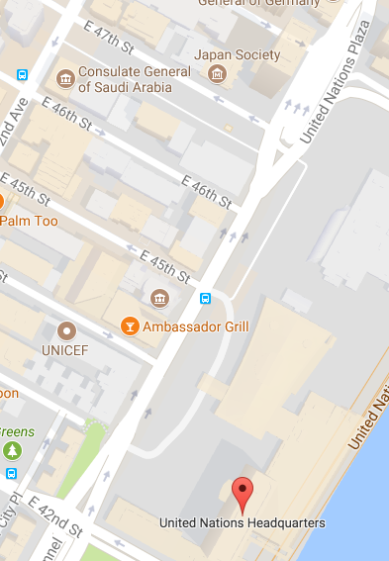
Delegate Entrance
Visitors’ Entrance

UN Pass and ID Office
The UN Pass and ID Office is located at 320 E 45th Street, New York, NY, 10017 (between 1st and 2nd Avenues).
To pick up a UN pass, enter the office at 45th Street. If you are accompanying someone picking up their UN pass, wear yours while on the premises. Bring the required printed paperwork and government-issued photo ID (e.g., passport), wait in the appropriate lines, and follow instructions.

Food and Dining in the UN Headquarters

LEVEL 4:
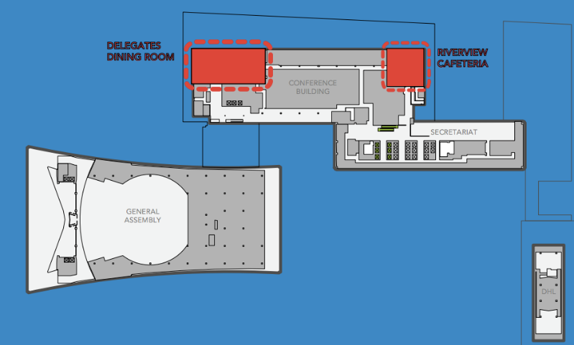

Delegates Dining Room
Reservation only; three-course prix fixe meal
Hours: Mon-Fri, 11:30 AM – 2:30 PM
Public: $39.99, Badge-holders: $29.99

Riverview Cafeteria
Offers vegetarian, vegan, and gluten-free options
Hours: Mon-Fri, 8 AM – 3 PM

LEVEL 1B:
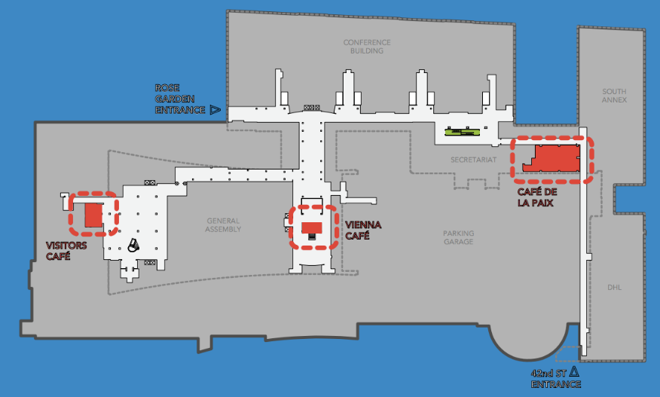

Vienna Café
Located near Conference Room 4
Hours: Mon-Fri, 8 AM – 6 PM

Visitors’ Café
Hours: Mon-Fri, 9 AM – 6 PM, Sat, 9 AM – 5 PM

Café de la paix
Hours: Mon-Fri, 11:30 AM – 4 PM

LEVEL 1:
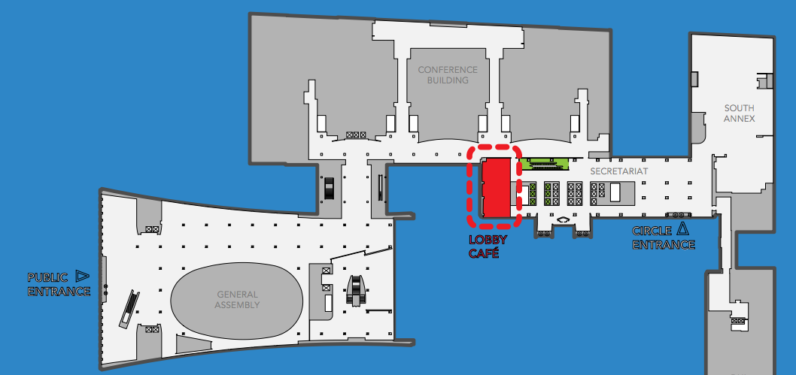

Lobby Café
Hours: Mon-Fri, 8 AM – 5 PM

Accessibility services and reasonable accommodations
Typically, when requesting reasonable accommodations for a conference or meeting at the UN Headquarters, participants must do this by contacting the organizers of that particular event ahead of time (e.g., DESA for Conference of States Parties to the CRPD, UN Women for the Commission on the Status of Women). Please note that this does not guarantee that all requested accommodations will be provided.
Accessibility Services
- Participants and visitors with disabilities can contact and/or visit the Accessibility Centre for assistive tools and technologies; computer stations with assistive devices including screen readers, Braille and other assistive keyboards; portable DAISY players, hearing aids, bone conduction headsets, specialized mice, and Braille notetakers, contact: accessibilitycentre@un.org
- Wheelchair charging provisions with signage are located at various locations in the conference facilities.
- Upon request, plastic straws are available at UN cafeterias.
- Upon request and with adequate time, the UN can print Braille (grade 1 and 2 in English, French, and Spanish) and large-print documents for presenters and participants at UN events (this is not guaranteed).
- The UN provides reserve wheelchairs for use within the UN Headquarters (these are available at security, but are not guaranteed).
- Upon request, the UN can reserve specific seats for persons with disabilities with ample space to maneuver, and also additional seats for personal assistants, sign language interpreters, and/or captioners.
- Upon request ahead of time, additional time can be given to presenters with disabilities, but is not guaranteed.
- The UN Headquarters is continually upgrading and making its website more accessible.
- Upon request, real-time captioning (in English and Spanish) and sign language interpretation are available, but not guaranteed due to lack of capacity and resources.

Service Dogs and Guide Dogs
Upon entering UN premises with a service or guide dog, security may ask you to produce a pass or paperwork for your working animal. We recommend that you inform security that your dog is a service animal required due to a disability. You can also provide information about the specific work or task(s) your dog has been trained and certified to perform to aid your disability. Although you may be asked to step aside while security confirms requirements, you should eventually be granted access with your working dog.
Many UN conference and/or meeting rooms have limited space to accommodate working dogs. Thus, we recommend that you request seating to accommodate space for you and your dog ahead of time with the organizers of the meeting. Request seating that provides space for you and your service dog and avoids too much foot traffic around your dog. In addition, it is always advisable to arrive to the UN and the meeting room early.
When providing your working animals with water, make sure you do not place water bowls in aisles, paths of traffic, or on carpeted floors; you will likely be asked to remove it.

Access to facilities inside the building
- There is an accessible bathroom in 1B with extra room to maneuver.
- There is a Braille removable cover for voting buttons (for Member States).
- The UN General Assembly Hall has a section of accessible seating, accessible seating on stage, and access to the podium for wheelchair users.
- There is a meditation room dedicated to silence located on the first floor of the GA building. This room can provide a quiet space to limit auditory, visual, and other input.
Accessibility challenges

- Most meeting rooms can get filled beyond capacity and making it difficult to maneuver.
- No bathroom facilities or conference rooms have automatic accessible doors.
- Most rooms have thick carpeting, which can make it difficult to move around.
- There are no clear audio guidelines on how to use the microphones.
- Rooms do not have tactile flooring to assist someone using a white cane.
- The lighting is not clear enough in some of the corridors, which can make it difficult to maneuver.

Security and evacuation

Security
Regarding security, please make sure to give yourself plenty of time to get through security, as lines to enter the UN can be long. Security is similar to an airport in that laptops have to be in a separate bin, belts have to come off, nothing can be in pockets, and you need to take off coats (but do not need to remove shoes). It is recommended that you do not bring a large bag or suitcase with you into the UN.

Evacuation procedures for persons with disabilities for the Conference and General Assembly buildings (prepared by the UN)
- General Assembly Building:
In the event of an evacuation due to fire, persons in the General Assembly Hall (2nd floor) will be directed to evacuations exits to the east and west of the Hall. There are specially marked exits on either side from which persons with wheelchairs can evacuate. These exits will take all evacuees to ramps leading to the plaza. From there, security officers will guide the evacuation.
Persons on the 3rd and 4th floors of the balcony of the General Assembly, will either be directed to the emergency stairs, and will be assisted down by responding officers, or to the elevators, which would be controlled by a responding officer.
Persons in conference rooms in the basement (1B) level of the General Assembly Building, namely conference rooms 4, 5, 6, 7, and 8 will exit through the same doors they entered and proceed east toward the elevators, make a left and exit through the north garden doors. From there, security officers will guide the evacuation. The security officer posted in the visitor’s concourse gift shop area will guide the evacuation of persons in conference rooms 11, 12, and F.
- Conference Building:
In the event of an evacuation of the 2nd floor of the Conference Building, proceed north towards the Delegates Lounge and exit via the ramp in the area with flags.
Persons in conference rooms on the 1st floor will exit through the doors in the Peace Bell area, otherwise, security officers will guide the evacuation. Persons in conference rooms on the basement (1B) level of the Conference Building, namely Conference rooms, A, B, C, D, 1, 2, 3, and 9 will proceed north from the main corridor toward the turnstile and through the north garden doors. From there, security officers will guide the evacuation.
Persons on the 3rd floor of the Conference Room, will either be directed to the emergency stairs, and will be assisted down by responding officers, or to the elevators, which would be controlled by a responding officer.
Please be advised that the building is equipped with requisite fire alarms / public address systems as per New York City Fire Codes and is monitored on a 24-hour basis by the United Nations Fire and Safety Unit.
In the event of an evacuation and activation of the fire alarms, an announcement will be made giving directional guidance and instructions and UN security officers will also be available to assist.
- Secretariat Building:
In the Secretariat Building there is a warden on every floor who is in charge of evacuation procedures and will guide the evacuation.

Transportation

How to get to the UN: Always give yourself plenty of time to get around New York City.
Accessible taxis and shuttle services from airports:

- From Newark Airport to anywhere in NYC you must book prior to arrival using a company called Carmel to get an accessible taxi at +1 212 666 6666.
- From JFK Airport and La Guardia Airport to anywhere in NYC you can ask for an accessible taxi in the taxi line.
- Super Shuttle provides wheelchair-accessible buses and vans between all hotels and private residences in Manhattan and JFK, LaGuardia, and Newark airports. Schedule: 24 hours a day, 7 days a week. Customers who require a lift-equipped vehicle should call at least 24 hours in advance to schedule this service. Information and fares: +1 212-258-3826, and accessible information

How to get around NYC using taxis, car services, and public transportation:
- Request a New York City wheelchair-accessible taxi through the Citywide Accessible Dispatch Program by:
- Using the mobile app NYC Accessible Dispatch available free at the Apple or Android App Stores
- Ordering online
- Calling the dispatch center directly at +1 646-599-9999
- Download the CURB app - request the accessible taxi logo

- Other Car services
- First Corporate Sedan +1 212-972-2222
- Carey Limousine +1 800-336-8582
- Luxury Worldwide Transportation +1 800-546-6633
- Lyft has some accessible cars

- MTA's Access-A-Ride Paratransit services
- It may be possible for some visitors from other states or countries to obtain a 21-day visitor's pass for Paratransit Access-A-Ride services if the person has existing Paratransit services elsewhere. Click here for more information and scroll down to “Visitors’ Information” for details.

- MTA Guide to Accessible Transit
- Accessible subway information
- Accessible subway stations
- Accessible bus information
- Staten Island Railway
- Long Island Railroad
- Metro-North Railroad
- NJ Transit (click on accessibility for details)

How to get to the airport:
- Use accessible NYC taxis or accessible Uber (information above)
- Wheelchair-accessible service to JFK and LaGuardia Airports (bus and subway)
- Super Shuttle provides wheelchair-accessible buses and vans between all hotels and private residences in Manhattan and JFK, LaGuardia, and Newark airports (information above)

Accommodation and venues near the UN

General information on accessibility in NYC
- Accessible NYC
- AXS Map for accessible spots in NYC and elsewhere
- Central Park Access Map
- How to explore NYC with a wheelchair

Accessible venues near the UN
Baha’i International Community
866 UN Plaza, Lobby 120
(48th between 1st and FDR Drive)
New York, NY 10017
Phone: +1 212 803 2500
E-mail: uno-nyc@bic.org
- Conference room available
- Wheelchair accessible
Church Center of the United Nations
777 United Nations Plaza
New York, NY 10017
- Conference rooms available
- Wheelchair accessible
- Accessible bathroom
- Elevators can get crowded
ONE UN New York
One United Nations Plaza
(between 1st and 44th)
New York, NY 10017
- Conference rooms available
- Wheelchair accessible
- Good lighting
Roger Smith Hotel
501 Lexington Avenue
New York, NY 10017
- Conference room available
- Wheelchair accessible
- Poor lighting and sound system
- Elevators can get crowded
Scandinavia House
58 Park Avenue
New York, NY 10016
- Conference room available
- Wheelchair accessible
- Accessible bathroom
- Good lighting
Westin New York Grand Central Hotel
212 E 42nd Street
(between 2nd and 3rd)
New York, NY 10017
- Conference rooms available
- Wheelchair accessible

Accessible restaurants and cafes near the UN
A map of accessible restaurants near the UN (from Human Rights Watch)

Restaurants

Ali Baba restaurant
862 2nd Avenue
New York, NY 10017
- First floor is wheelchair accessible
The Comfort Diner
214 E 45th Street
New York, NY 10017
- Wheelchair accessible
- Good lighting
Da Raffaele restaurant
883 1st Avenue
New York, NY 10022
- Wheelchair accessible
- Poor lighting
Osteria Laguna restaurant
209 E 42nd Street
New York, NY 10017
- Wheelchair accessible
- Poor lighting
Sinigual
640 3rd Avenue
New York, NY 10017
- Wheelchair accessible
- Accessible bathroom
- Good lighting
Cafes

Chelsea Bagel of Tudor City
800 2nd Avenue
New York, NY 10017
- Wheelchair accessible
- Small space
- No restroom
Pennylane Coffee
305 E 45th Street
New York, NY 10017
- Wheelchair accessible
- Can be loud

Accessible hotels near the UN (prices may vary)
Club Quarters Hotel, Grand Central
128 E 45th Street
New York, NY 10017
Weekday: $150-$375 per night
Weekend: $150-$400 per night
Accessible rooms available

Double Tree Hilton
569 Lexington Avenue
New York, NY 10022
(between Lexington Ave and 51st)
(15-minute walk to the United Nations)
Weekday: $280 - $450 per night
Weekend: $180 - $250 per night
Accessible rooms available

EVEN Hotels New York – Midtown East
221 East 44th Street
(between 2nd and 3rd Avenues)
New York, NY 10017
Weekday: $300 - $550 per night
Weekend: $200 - $300 per night
Accessible rooms available

Fitzpatrick Grand Central
141 East 44th Street
(between Lexington and 44th)
New York, NY 10017
Weekday: $280 - $420 per night
Weekend: $230 - $350 per night
Accessible rooms available
Accessible bar attached, so it can be noisy

Hampton Inn United Nations
231 East 43rd Street
(between 2nd and 43rd)
New York, NY 10017
Weekday: $350 - $400 per night
Weekend: $250 - $350 per night
Accessible rooms available

Kimberly Hotel
145 E 50th Street
(between 3rd and 50th)
New York, NY 10022
Weekday: $300 - $600 per night
Weekend: $250 - $380 per night
Accessible rooms available
Rooftop bar is accessible

The Lexington Hotel
511 Lexington Avenue
(between Lexington Avenue and 48th)
New York, New York 10017
Weekday: $320 - $490 per night
Weekend: $180 - $250 per night
Accessibility information
Accessible rooms available
Accessible restaurant
Spacious seating area in lobby
Service animals allowed

ONE UN New York
One United Nations Plaza
(between 1st and 44th)
New York, NY 10017
Weekday: $300 - $450 per night
Weekend: $250 - $320 per night
Accessible rooms available

The Pod 39 Hotel
145 East 39th Street
(between Lexington Ave and 3rd)
New York, NY 10016
Weekday: $170 - $250 per night
Weekend: $160 - $220 per night
Accessible rooms available

The Pod 51 Hotel
230 E 51st Street
(between 2nd and 3rd)
New York, NY 10017
Weekday: $160 - $250 per night
Weekend: $160 - $220 per night
Accessible rooms available

Westgate New York Grand Central
304 East 42nd Street
(between 41st and 42nd Streets)
New York, NY 10017
Weekday: $190-$300 per night
Weekend: $170-$250 per night
Accessible rooms available
Shaking alarms available (upon request)
Roll-in shower (upon request)

Westin New York Grand Central Hotel
212 East 42nd Street
(between 3rd and 42nd)
New York, NY 10017
Weekday: $430 - $520 per night
Weekend: $200 - $260 per night
Accessible rooms available
Pet-friendly rooms available

Additional Services and Resources

Wheelchair Rental/Repair
Big Apple Mobility
241 W 37th Street
(between Times Square and Penn Station)
Phone: 212-278-8100
Hours: Mon-Fri: 9:00 AM – 6:00 PM,
Sat: 9:00 AM – 4:00 PM, Sun: 9:00 AM – 3:00 PM
$115-$215/5 days, +$10 for each additional day
Delivery and Pickup services available for $20

Solano Medical Equipment
Phone: 1-800-986-5091
Open 24 hours

After Hours Repair Service
Phone: 917-374-2323
Hours: 2:00 PM – 10:00 PM

Dwight Ubiñas - Wheelchair Repair Man
Will provide in-person visits;
Speaks English and Spanish
Phone: 917-242-6629
Email: wcrepairman@gmail.com
Hours: Mon-Fri 10 AM – 7 PM,
Sat - Technical Support 10 AM – 2 PM, Sun closed

Medical Information
Pharmacies and Medical Services are located throughout New York City. The following are listed based on convenience, hours and proximity to the United Nations Headquarters. Most general drugs can be obtained without prescription at pharmacies.
Pharmacies
- CVS Pharmacy: (150 E 42nd Street) Open 24 hours, 7 days a week (there are various locations)
- Walgreens: (1000 2nd Ave) Open 24 hours, 7 days a week (there are various locations)
- Duane Reade: (852 2nd Avenue) Mon-Fri: 08:00 AM—9:00 PM, Sat: 09:00 AM—6:00 PM, Sun: 10:00 AM—5:00 PM
- UN Plaza Pharmacy: (800 2nd Avenue) Mon-Fri: 08:00 AM - 8:00 PM, Sat: 09:00 AM -7:00 PM, Closed Sunday
- Carnegie Hill Pharmacy Broadway: (1721 Broadway) Mon- Fri: 8:30 AM-8:30 PM, Sat-Sun: 10:00 AM- 6:00 PM Phone: 212-246-0020

Hospitals/Urgent Care

- NY Hotel Urgent Medical Services: 952 5th Ave #1D, New York, NY 10075 (open 24 hours)
- CityMD: 1150 3rd Avenue, New York, NY 10065 (depends on health insurance coverage)
- NYU Langone Medical Center: 550 1st Avenue
- New York Presbyterian Weill Cornell Medical Center: 1300 York Avenue, New York, NY 10065

https://www.un.org/accessibilitycentre/
www.supershuttle.com
https://www.supershuttle.com/ada/
http://www.nyc.gov/html/tlc/html/passenger/accessible.shtml
https://mtm.ridewithzoom.com/#/booking/
https://mobileapp.gocurb.com
http://www.goinluxury.com/
https://www.lyft.com
https://new.mta.info/accessibility/paratransit
https://new.mta.info/accessibility/paratransit/how-to-apply-or-recertify-for-access-a-ride
http://web.mta.info/accessibility/transit.htm#subways
http://web.mta.info/accessibility/stations.htm#manhattan
http://web.mta.info/accessibility/transit.htm#buses
http://web.mta.info/accessibility/stations.htm#sir
http://web.mta.info/accessibility/stations.htm#lirr
http://web.mta.info/accessibility/stations.htm#mnr
http://www.njtransit.com/hp/hp_servlet.srv?hdnPageAction=HomePageTo
http://web.mta.info/accessibility/stations.htm#airports
https://www.nycgo.com/plan-your-trip/basic-information/accessibility
https://www.axsmap.com/
http://assets.centralparknyc.org/pdfs/maps/Central_Park_Access_Map.pdf
https://www.nycgo.com/videos/how-to-explore-nyc-with-a-wheelchair
http://www.millenniumhotels.com/usa/oneunnewyork/
https://roger-smith-hotel-new-york-city.at-hotels.com/en/
http://www.scandinaviahouse.org/
http://www.westinnewyorkgrandcentral.com/?SWAQ=958P
https://www.google.com/maps/d/viewer?mid=1Ns-yvFmuavj1wr667J7PhoIZumpyxTmq&ll=40.75028301181521%2C-73.97935050000001&z=15
https://clubquartershotels.com/locations/club-quarters-hotel-grand-central-new-york-city
http://doubletree3.hilton.com/en/hotels/new-york/doubletree-by-hilton-hotel-metropolitan-new-york-city-NYCDTDT/index.html
https://www.ihg.com/evenhotels/hotels/us/en/new-york/nycev/hoteldetail/hotel-room-rates?cm_mmc=GoogleMaps-_-VN-_-US-_-NYCEV#scmisc=nav_hotel-room-rates_vn
https://www.fitzpatrickhotels.com/fitzpatrick-grand-central/
http://hamptoninn3.hilton.com/en/hotels/new-york/hampton-inn-manhattan-grand-central-NYCUNHX/index.html
http://www.kimberlyhotel.com/?mcid=gptag52k1
http://www.marriott.com/hotels/travel/nyclx-the-lexington-new-york-city-autograph-collection/
http://www.marriott.com/hotels/fact-sheet/travel/nyclx-the-lexington-new-york-city-autograph-collection/#accessbility
http://www.millenniumhotels.com/usa/oneunnewyork/
https://www.thepodhotel.com/pod-39/
https://www.thepodhotel.com/pod-51/
https://www.westgateresorts.com/hotels/new-york/midtown-manhattan/westgate-new-york-grand-central/
http://www.westinnewyorkgrandcentral.com/?SWAQ=958P
http://www.fixmywheelchair.net/

