African regional report on the implementation of the SDGs and the CRPD for women and girls with disabilities in Rwanda, Nigeria, Kenya, Mali and Niger

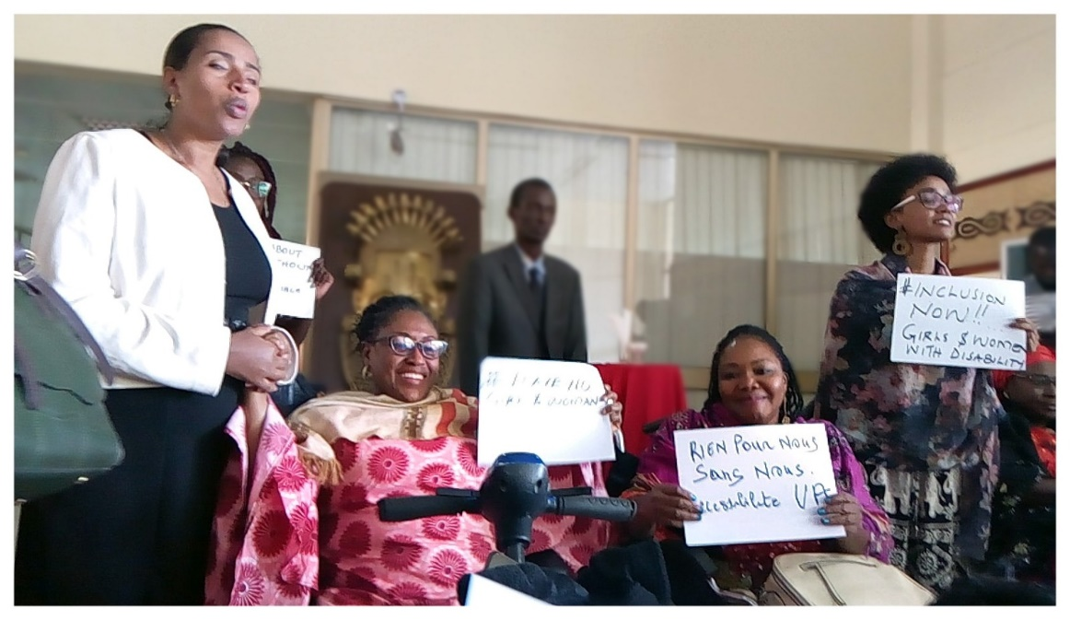

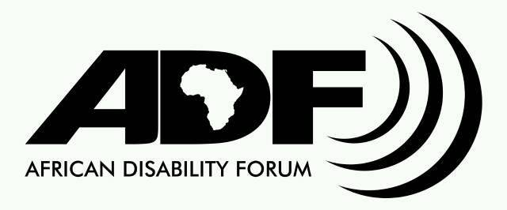

Published by African Disability Forum
Copyright @2020
Joseph Tito St. Kirkos Sub-City, Woreda 08,
Nega City Mall 5th Floor 511
Addis Ababa, Ethiopia
Mail : africandisabilityforum@gmail.com

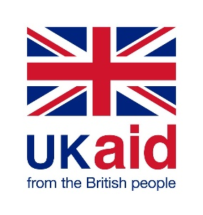
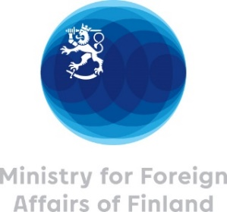

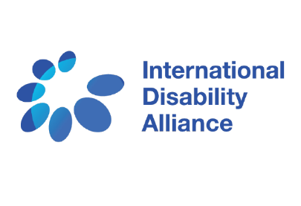

Table of Contents
I. Introduction 6
1.1 Methodology 7
1.2 Constraints 8
II. Legal and policy analysis: Understanding how SDGs 3: Good health and well-being, 4: Quality education, 5: Gender equality, 8: Decent work and economic growth and 17: Partnerships for the goals, are being implemented to address the rights of women and girls with disabilities in compliance with the CRPD in Rwanda 8
A. the legal and policy framework on SDG 4: Quality Education in Rwanda 8
B. The legal and policy framework for SDG 5: Good Health and Well-being in Rwanda 13
C. The legal and policy framework on SDG 8: Decent Work and Economic Development in Rwanda 18
D. Gender Equality in Rwanda – SDG 5 21
E. Data and information on disability and gender in Rwanda – SDG 17: Partnerships for the Goals 23
III. Legal and policy analysis: Understanding how SDGs 3: Good health and well-being, 4: Quality education, 5: Gender equality, 8: Decent work and economic growth and 17: Partnerships for the goals, are being implemented to address the rights of women and girls with disabilities in compliance with the CRPD in Nigeria 25
A. The legal and policy framework on SDG 4: Access to quality education in Nigeria 25
B. The policy and legal framework on SDG 5: Health in Nigeria 28
C. the legal and policy framework on SDG 8: Access to decent work in Nigeria 31
D. The legal and policy framework on SDG 5: Gender Equality in Nigeria 33
E. Data and information on disability and gender in Nigeria– SDG 17: Partnerships for the Goals 34
F. Focused Group discussion in Nigeria on the rights of women with disabilities in the implementation of the sustainable development goals in accordance with the un convention on rights of persons with disabilities 35
IV. Legal and policy analysis: Understanding how SDGs 3: Good health and well-being, 4: Quality education, 5: Gender equality, 8: Decent work and economic growth and 17: Partnerships for the goals, are being implemented to address the rights of women and girls with disabilities in compliance with the CRPD in Kenya 46
A. the legal and policy framework on SDG 4: Access to quality education in Kenya 46
B. The legal and policy framework on SDG 8: Decent Work and Economic Development 49
C. The legal and policy framework on SDG 3 (Healthy Lives and Well-being for All) in Kenya 52
D. The legal and policy framework on SDG 5: Gender Equality in Kenya 56
E. Data and information on disability and gender in Kenya – SDG 17: Partnerships for the Goals 58
F. Focus Group Discussion on the situation for women and girls with disabilities in Kenya regarding SDG 3 (Good Health and Well-being), 4 (Quality Education for All), 5 (Gender Equality) and 8 (Decent Work and Economic Growth) 59
V. Legal and Policy Analysis: Understanding how GDS 3: Health and Well-being, 4: Quality Education, 5: Gender Equality, 8: Decent Work and Economic Growth and 17: Partnerships for Goals, are being implemented to address the rights of women and girls with disabilities in compliance with the CRPD in Mali 73
A. the legal and policy framework of SDG 4: Quality Education in Mali 74
B. the legal and policy framework of SDG 3: Health and well-being in Mali 77
C. the legal and policy framework of SDG 8: Decent Work and Economic Development in Mali 80
D. Gender equality in Mali - SDG 5 84
E. Data and information on disability and gender in Mali - SDG 17: Partnerships for the Goals 86
F. Focus Group avec l’Union Malienne des Associations et Comités de Femmes Handicapées (UMAFH). 88
VI. Legal and Policy Analysis: Understanding how GDSs 3: Health and Well-being, 4: Quality Education, 5: Gender Equality, 8: Decent Work and Economic Growth and 17: Partnerships for Goals, are being implemented to address the rights of women and girls with disabilities in compliance with the CRPD in Niger 94
A. the legal and policy framework of SDG 4: Quality Education in Niger 95
C. the legal and policy framework of SDG 8: Decent work and economic development in Niger 98
D. Gender equality in Niger - SDG 5 100
E. Data and information on disability and gender in Niger - SDG 17: Partnerships for the Goals 102
RECOMMENDATIONS 104
Legal and policy reforms needed to ensure all women and girls with disabilites access health services, including sexual and reproductive health services, that are accessible and of good quality in the communities where they live in line with CRPD Article 25 (Health) and Article 23 (Respect for home and family): 104
Measures needed to combat discriminatory attitudes and end harmful practices towards women and girls with disabilities in accessing health 105
Legal and policy reforms needed to ensure all women and girls with disabilites access inclusive education on an equal basis with others in line with CRPD Article 24 (Education): 105
Measures needed to combat discriminatory attitudes and harmful practices towards women and girls with disabilities in accessing inclusive and quality education on an equal basis 106
Legal and policy reforms needed to ensure gender equality and empowerment of women and girls with disabilites in line with CPRD Article 6 (Women with disabilities) 106
Measures to ensure gender equality for women and girls with disabilities 107
Measures needed to combat discriminatory attitudes and promote access to work and employment on an equal basis by women with disabilities 109
Recommendations on data and information 109
Recommendations for partnerships to implement the SDGs 109
BIBLIOGRAPHY 111

Acknowledgements
We would like to acknowledge the contribution and important role played by organizations of persons with disabilities (DPOs) in the African region, in particular Kenya - United Disabled Persons of Kenya (UDPK); Mali - Fédération Malienne des Associations de Personnes Handicapées (FEMAPH); Niger - Fédération Nigérienne des Personnes Handicapées (FNPH); Nigeria - Joint National Association of Persons with Disability (JONAPWD); Rwanda - National Union of Disability Organisations of Rwanda (NUDOR).
Without your dedication and involvement, this report would not be possible.
We would like to sincerely thank Mamadou Sissoko and Lizzie Kiama for their essential contributions to developing this report and collecting inputs from African women with disabilities, as well as the International Disability Alliance for their technical and operational support guidance. Thanks to your technical and informative contributions, this important data and evidence were effortlessly articulated in the report.
We thank the International Disability Alliance for creating the opportunity to carry out this work through the Disability Catalyst Programme.
This report has been produced with the support and financial contributions of the UK Department for International Development (DFID), the Norwegian Agency for Development Cooperation (NORAD), Inclusive Futures and the Finnish Ministry for Foreign Affairs.

I. Introduction
The African Disability Forum (ADF) is a pan-African organization of African Disabled Person's Organizations (DPOs) with member DPO federations from 34 countries, 8 continental DPO federations and 4 sub-regional DPO federations. ADF focuses its attention on strengthening its DPO membership, while unifying and amplifying the voice of African persons with disabilities at both regional and international levels through ADF's membership in the International Disability Alliance (IDA).
IDA is an alliance of 14 global and regional organisations of persons with disabilites. IDA brings together over 1,100 organisations of persons with disabilites and their families from across eight global and six regional networks. IDA promotes the rights of all persons with disabilites across United Nations’ efforts to advance human rights and support sustainable development for a more inclusive global environment for all. IDA supports organisations of persons with disabilites around the world to hold their governments to account and advocate for change locally, nationally and internationally.
In 2017, as part of the DFID-funded Catalyst project, IDA and its members prioritized support to DPOs to fully engage in advocacy and rights monitoring processes on the implementation of the SDGs to ensure they are inclusive of all persons with disabilites. As part of this process, IDA members both at regional and national levels have carried out comprehensive evidence-based reports on how the SDGs are being implemented at national and regional levels to be inclusive of persons with disabilites. To date, six of IDA's regional members, namely the European Disability Forum (EDF), Arab Organization of People with Disabilities (AOPD), ASEAN Disability Forum (ADF), African Disability Forum (ADF), Pacific Disability Forum (PDF), and Latin American Network of Non-Governmental Organizations of People with Disabilities and their Families (RIADIS) have completed or are in the process of completing their regional reports.
The African Disability Forum (ADF) prioritized the rights of women and girls with disabilites in the implementation of the SDGs for the regional report in Africa. The regional report was also designed to align with the ongoing regional processes to review the Beijing Declaration and Platform for Action (BPfA) to advance women’s rights through the Beijing + 25 review to monitor progress and outcomes on the BPfA in Africa over the past 25 years.
Since January 2019, the African region has increased its commitment to ensuring civil society engagement in the Beijing +25 review. Governments and civil society organizations are preparing shadow reports on the status of the implementation of the BPfA, and in particular on progress made or not made since 2015. This process is similar to the Agenda 2030 review process in which states produce reports on SDG implementation with different levels of CSO input, and CSO networks at national and regional levels produce parallel reports.
This African report focuses on critical sectors identified by ADF as priorities for women and girls with disabilites including:
- SDG 3: Ensure a healthy life and promote the well-being of all people at all ages.
- SDG 4: Ensure inclusive and equitable quality education and promote lifelong learning opportunities for all.
- SDG 5: Achieve gender equality and empower all women and girls.
- SDG 8: Promote sustained, inclusive and sustainable economic growth, full and productive employment and decent work for all.
- SDG 17: Strengthen the means of implementation and revitalize the global partnership for sustainable development.
The report looks at SDG implementation in Kenya, Nigeria, Rwanda, Mali and Niger. ADF prioritized these five countries as they could make useful contributions to the ADF sub-regions while taking advantage of the opportunities created by the ongoing preparatory events for Beijing + 25. The report examines how SDGs 3, 4, 5, 8 and 17 are being implemented to ensure the rights of women and girls with disabilities in compliance with the CRPD.
This report seeks to understand and identify the gaps and barriers in implementing these five SDGs for women and girls with disabilities. The report also outlines the reforms and measures needed to ensure that all women and girls with disabilities in Kenya, Nigeria, Rwanda, Mali and Niger are able to enjoy their human rights on an equal basis in the implementation of these five Sustainable Development Goals.
This report is divided into two parts:
- Legal and policy analyses for the five SDG sectors to identify gaps in compliance with the CRPD from a gender perspective;
- The lived realities of women and girls with disabilites in the five countries in accessing their rights in these five sectors through focus group and online survey discussions

1.1 Methodology

The fundamental principle in drafting this report was participation and consultation with women with disabilities and their representative organisations to identify priority rights issues, seek their inputs on the barriers they face and the reforms needed to ensure development efforts leave no one behind. A desk review was carried out to assess the legal and policy framework for each SDG sector in each country. The team also worked with national DPOs to carry out the desk review of laws and policies on health, education, employment, gender equality and data collection. The legal and policy review was aimed at assessing compliance with the CRPD for each sector as well as a gender analysis to assess how laws and policies ensure the rights of all women and girls with disabilites and promote equality. With support from DPOs in Mali, Nigeria and Kenya, the team organized focus group discussions (in person and online) to ensure the invaluable contributions of women with disabilities to inform the report. Focus group discussions gathered a diverse group of women with disabilites including those from under-represented groups such as women with intellectual disabilities, women with psychosocial disabilities, Deaf women and women with albinism to better understand the barriers they face in exercising their rights and what needs to be done to ensure gender equality is realized for all women and girls with disabilities. The team also carried out consultations with a delegation of women with disabilities during the Bejing+25 Africa regional consultation in Addis Ababa in 2019 to understand the rights advocacy priorities of women with disabilites on a regional level.
Upon delegation of the Executive Council, Ms. Ekaete Judith Umoh validated the overall report and recommendations. An advanced edited version will be produced by December 2020 to enable for wider consultation within the ADF board and membership.

1.2 Constraints
Due to the COVID 19 pandemic and subsequent lockdowns throughout Africa, DPOs in Niger, Rwanda and Kenya were not able to organize in-person focus group discussions. As a solution, the United Disabled Persons with Disabilities of Kenya carried out an online survey rather than in-person focus group discussion. The survey was administered by email reaching over sixty-one women with disabilities representing different disability groups including: women with psychosocial disabilities, deaf women, women with intellectual disabilities and women with albinism. Because the survey was administered online it did not allow for follow-up questions or for oral submissions bur relied only on written responses to questions. The survey also required that respondents have access to internet and a computer.
In Niger and Rwanda, lack of access to computers and internet during the lockdown prohibited members from participating in an online survey. Trying to work through alternative means such as phone and email was equally challenging limiting our ability to implement focus group questions with women with disabilites in these two countries.

II. Legal and policy analysis: Understanding how SDGs 3: Good health and well-being, 4: Quality education, 5: Gender equality, 8: Decent work and economic growth and 17: Partnerships for the goals, are being implemented to address the rights of women and girls with disabilities in compliance with the CRPD in Rwanda

The Rwandan government has demonstrated political will to address the rights of persons with disabilities by ratifying the CRPD, by implementing legal reforms to incorporate disability-specific equality provisions in national law, and by establishing an active National Council of Persons with Disabilities (NCPD). However, the overarching legal and policy framework leaves large gaps in compliance with the CRPD and these gaps contribute to a system of exclusion, segregation and widespread discrimination. For women and girls with disabilities, these rights violations are even greater as they face discrimination and exclusion on the basis of both their disability and gender.

A. the legal and policy framework on SDG 4: Quality Education in Rwanda
After the genocide in Rwanda, the country restructured its education system based on building national unity. The government of Rwanda, like many other countries in the continent, focused efforts on achieving universal primary education and education for all. In sub-Saharan Africa, Rwanda is one of the top performing countries with 98 percent of children enrolled in primary education. According to the Ministry of Education, in 2016, students with disabilities represented less than 1 per cent of all enrolled students in primary education. As for gender equality in accessing education, according to the Ministry of Education, girls and boys are equally enrolled in primary and secondary education. However, according to UNICEF, girls are more likely to drop out after secondary school. Boys also outperform girls in 26 of Rwanda’s 30 districts and girls are significantly under-enrolled in technical, vocational and tertiary education. The Ministry of Education highlights, few schools in Rwanda are accessible and there is a severe lack of accessible transportation to and from schools. These are major reasons for high dropout rates for learners with disabilities. In addition, mainstream public schools often lack of adequate teacher training, lack of an adapted curriculum and a lack of accommodating materials and services.
Rwanda’s laws and policies on education still contribute to a system where very few persons with disabilities attend mainstream schools and complete primary education. The legal and policy framework on education in Rwanda sets up two different schooling systems for learners with disabilities that operate separately: special schools established outside the mainstream education system and inclusive schools or child-friendly schools. These are schools within the mainstream education system that have been adapted to be barrier-free and accessible to accommodate learners with diverse learning needs. Each of these systems face challenges that include staffing constraints, lack of training on inclusive education, educational material inadequacy, needs for support services like sign language interpreters, occupational therapists etc. but, they still remain the only schooling options for learners with disabilities in Rwanda.
- The legal framework on education in Rwanda
The national Constitution of Rwanda of 2003 (amended in 2015), protects the right of every Rwandan to education and provides free and compulsory primary education to all in Article 20: Right to education. The Constitution also prohibits discrimination on the basis of disability and gender amongst other statuses such as ethnicity and geography in Article 16: Protection from discrimination. Article 15: Equality before the law guarantees that all persons are equal before the law and entitled to equal protection of the law however, it does not explicitly list persons with disabilities or girls and women. In article 51, the Constitution gives the State the duty to establish special measures for the education of persons with disabilities. However, the Constitution does not explicitly state that students with disabilities must be educated in mainstream schools.
For girls and women in education, Article 2 (h) of the Constitution defines the mission of education to: advocate for the elimination of all obstacles that hinder the education of girls and women as well as of all those who clearly need special attention. The law does not explicitly address girls and women with disabilities.
There are various national laws on education in Rwanda including one overarching law that determines the organization of the education system and those that regulate the different education levels including primary education, secondary education and higher education.
Law no 36/2018 of 29/06/2018: Determining the Organization of Education, organizes the overall education system and sets out a separate education system for learners with disabilities through special education and special schools. In this law, it defines special education in Article 2 (5) as: courses offered to people with physical or mental disabilities or those with unusual intellectual ability which does not allow them to study with other learners. In Article 12 it defines the aim of special education to: receive children with mental or physical disabilities or both of them and who can not study in ordinary schools so as to give them knowledge and education that may improve their abilities and skills in order to be self-supporting and participate in the development of the country. The law defines special schools as institutions outside of mainstream education in Article 13: Special education schools Special education schools are intended to admit students whose condition requires special care due to their disabilities or due any other specific reason which prevents them from being in mainstream school settings. Modalities for such special care are determined by an Order of the Minister. In this law, education of students with disabilities is defined and confined within a Special Education system that is outside of the mainstream one.
The Law Establishing the Organisation and the Functioning of Nursery, Primary, and Secondary schools (Law no 23/2012 of 15/06/2012), governs nursery, primary and secondary education in Rwanda. This law further defines special schools and the special education system. In Article 47: Transfer from specialized school to ordinary school, the law states that a student with disabilities may attend mainstream schools only when “the obstacles that prevented [that] pupil from attending ordinary schools are overcome.” The responsibility rests on the student with a disability to overcome barriers in order to attend mainstream school. The Law does outline the participation of NGOs in education and gives a role to the National Council of Persons with Disabilities as well as to the Coordination of the National Women’s Council giving opportunities for DPOs and organizations led by women to input into the governing of nursery, primary and secondary education.
Law no 20/2017 of 28/04/2017 Establishing Higher Education Council and Determining its Mission, Organization and Functioning defines the roles and responsibilities of the Higher Education Council, the formal body that oversees the higher education system. The law sets the standards for higher education and monitors how these standards are implemented. However, the law does explicitly mention disability or gender when defining how higher education will be governed nor does it include any articles on monitoring the inclusion of students with disabilities or women and girls in higher education. There is also no mention of how the special education system will connect to higher education system.
Law no 01/2017 of 31/01/2017 Governing the Organisation and Functioning of Higher Education and Law no 22/2017 of 30/05/2017 Establishing Rwanda Polytechnic Higher Learning Institution and Determining its Mission, Powers, Organisation and Functioning define the functioning of higher education and polytechnic and vocational training programmes respectively. Neither law addresses disability or gender in accessing education nor is there a mention of inclusive education, accessibility or promotion of access to higher education, polytechnic or vocational education for women and girls.
The legal framework on education in Rwanda leaves large gaps in compliance with CRPD Article 24 (Education). The education laws do not define inclusive education in which all children with disabilities, regardless of the type or severity of disability have the right to free primary and access to secondary education within their public neighborhood schools. Instead, the laws call for the creation of a separate education system for learners with disabilities. The laws on education do not prohibit discrimination, harassment or violence on the basis of disability in education including in educational assessments and in the classroom. As specified in CRPD Article 24, the laws do not provide a non-rejection clause that ensures no child can be deemed uneducable. The laws do not provide for reasonable accommodation in accessing education or recognize the denial of reasonable accommodation as disability-based discrimination. As specified by CRPD Article 24, the education laws should protect the right of all learners to be taught in their language, including national sign language, an issue that is not regulated by the education laws. Finally, the education laws are lacking complaint mechanisms for reporting discrimination with effective remedies and sanctions.
- The policy framework regulating education in Rwanda
The main education policy is the Education Sector Strategic Plan Framework for Basic Education (ESSP) 2018/19-2023/24 developed by the Ministry of Education (MINEDUC). The policy calls for the State to include all children in mainstream schools including those that are most excluded or that experience high dropout rates which includes learners with disabilities. The strategic plan makes the link between disability, poverty and lack of equitable access to education. Disability and gender are prioritized as crosscutting issues and they are both part of the strategic outcome areas of the ESSP. The ESSP policy calls for equitable access to education for children with disabilities within mainstream schools as well as special schools, thus creating two separate systems of education. The focus of ESSP’s strategy is to integrate leaners with disabilities within the mainstream system, “where possible,” and create a separate system for those deemed ‘uneducable’ thus creating two separate systems of education.
The policy does call for cross-ministerial coordination and engagement with civil society including organizations of persons with disabilities (OPDs), women’s rights organizations and the National Council of Persons with Disabilities.
Confusion of terms
The policy does not clearly define its vision for inclusive education nor does it propose a clear transition from special education to a fully inclusive mainstream education system. Instead, it uses the terms special education and inclusive education interchangeably and it is not clear from the policy what the government’s vision for inclusive education is or how they define it. The policy does call for all learners to be accommodated in community schools but confuses special needs education with inclusive education with no clear messaging about the schools and classrooms responding to the individual needs of all learners.
Revised Special Needs and Inclusive Education Policy 2018
Similar to the ESSP, this policy uses the terms inclusive education and special needs education interchangeably and sets up two different schooling systems for learners with disabilities that operate separately: special schools established outside the mainstream education system and Child-Friendly School (CFS) or and Inclusive Education (IE) schools (terms that are used interchangeably). Civil society is particularly active in this areas as CFS and IE school concepts are funded by donors and mostly private. There is no system of accreditation or quality standards being used for these schools. Furthermore, it is unclear how child friend and inclusive schools adhere to the mainstream education curriculum and how well they comply with the definition of inclusive education outlined in CRPD 24. Within some of these schools there are “special education resource rooms” with adapted materials and resources teachers and parents can use – a quasi-support services function but these resource rooms are under-funded with no standardized quality assurance mechanism and offering limited services.
This policy also calls for the development of two curricula – a special needs education curriculum and an inclusive education one. This call for alternative curriculum is not in-line with inclusive education reforms that comply with the CRPD. The mainstream education curriculum should be used for all students and adapted or modified as needed, rather than creating an alternate curriculum. Furthermore, it is unclear how CFS and IE schools adhere to the mainstream education curriculum and how well they comply with the definition of inclusive education outlined in CRPD 24.
The policy does call for special education needs assessments and education interventions/support services to be implemented progressively in all schools. The support services that will be offered are not defined clearly but include: therapeutic services and resource provision. While the policy outlines the desired outcome of providing support services to all learners with disabilities (such as CBR and assistive devices) in all schools throughout Rwanda, the framework for this support is still within the medical model focused on individual learners adapting to the classroom rather than schools adapting to the needs of students. It also confuses the role of education with the development of community-based support services. Community-based rehabilitation and the provision of assistive devices should not be provided within schools under the Ministry of Education. Furthermore, the model outlined in the policy does not aim to keep all students in the same classroom and learning the same curriculum with adaptations and support but rather providing services and an adapted curriculum to learners with disabilities under a special needs paradigm.
Disability and gender
Both policies look at disability and gender in accessing education but not from an intersectional approach. The Special Needs Education Policy points out that there are inequalities in accessing education based on disability, gender and urban/rural dichotomies that make accessing education even more challenging. However, the policy does not propose policy interventions to address these intersectional forms of discrimination. For example, neither education policy looks at the issue of gender or disability-based violence, harassment or abuse in schools or its impact on girls with disabilities staying in or attending school. Furthermore, neither education policy identifies girls with disabilities as a specific target group in ensuring equitable access to education.
Compliance with the CRPD
The education policy framework in Rwanda proposes reforms in the education sector that are contradictory to the principles of inclusive education defined by Article 24 of the CRPD. For example, the ESSP policy calls for the development of residential intuitions to minimize the distance a child with a disability has to travel to attend school. This goes against the rights enshrined in Article 19 (Living independently and being included in the community) as well as Article 24 in which all children have the right to attend public schools in their community. It calls for the professional development of a cadre of “special needs” educators to understand the learning needs by impairment type rather than learning how to provide education on an individual needs basis. The ESSP does not outline programmes for regular teaching training on inclusive education or the development of an inclusive curriculum that can be used in all mainstream schools. Neither the ESSP or the Special Education Policy call for a teaching culture that focuses on the needs of individual students. Instead, they devise two separate education systems with no clear path towards a fully inclusive education system in which all learners can be accommodated and supported. The policies also lack clear targets for how schools will be made fully accessible, how the curriculum will be adapted or how a cadre of teachers will be trained on inclusive education significantly limiting a meaningful transition to inclusive education. The current policy framework does not seek to create a new inclusive education system for all schools but to bolster the current CFS and IE initiatives.
The Special Needs Education policy defines mainstream education as: schools that educate learners that present no or minimal Special Educational Needs (SEN) and therefore do not require any exceptional educational adjustments. Most of mainstream Rwandan schools accommodate learners with a range of mild and moderate disabilities without any adjustment to suit their needs. Special Needs Education is defined as: This is an education that aims at providing education services to all children who may, for any reasons, have temporary or permanent needs for adjusted education, different from the ordinary education.
This concept of students with disabilities being uneducable within the mainstream education system denies students and learners with disabilities their right to education and is completely incompliant with the concept of inclusive education defined in CRPD Article 24 (Education). The policy calls for a separate education system for learners with disabilities. The mainstream education system does not provide adjustments in curriculum or accommodations for students. By denying curriculum adjustments and accommodations for learners within the mainstream education system, the Rwandan Special Education policy is based upon segregated education.
Finally, there is no explicit mention of policy interventions to promote access to education on an equal basis and without discrimination. Instead, the focus is on resources for schools, adaptations to curriculum and increased support services etc. Without policy interventions that aim to achieve equality in education, learners with disabilities and especially girls with disabilities who face multiple and interesting forms of discrimination, will be left behind.

B. The legal and policy framework for SDG 5: Good Health and Well-being in Rwanda
The laws and policies regulating health in Rwanda are focused on ensuring all Rwandans have access to healthcare and that mechanisms are in place for community health services with an adequate number of community health workers trained and resourced to deliver quality services. However, within this drive to develop services at the community level, the legal and policy framework has not adequately addressed the rights and needs of women and girls with disabilities in accessing health.
- The legal framework on access to health in Rwanda
To align with CRPD Article 25 and SDG 3, the laws regulating health must ensure equal access of persons with disabilities (including those living with HIV) to all health services, essential medicines and vaccines without discrimination on the basis of disability and gender with provisions for:
- Prohibition of all forms of discrimination in the provision of healthcare on the basis of disability and the denial of services to persons with disabilities constitutes disability-based discrimination
- Reasonable accommodation in accessing all health services and recognition that its denial constitutes disability-based discrimination
- Respect for confidentiality of health-related records and privacy of persons with disabilities, including women, children and older persons
- Reporting and complaint mechanisms on discrimination with the provision of effective remedies and sanctions
- Prohibition of discrimination by health insurers based on pre-existing disability
- Complaint mechanisms for all anti-discrimination provisions for reporting discrimination with the provision of effective remedies and sanctions
The constitution of Rwanda guarantees all persons are equal before the law and that they are entitled to equal protection of the law in Article 15. In Article 21 of the Constitution, all Rwandans have the right to good health. The constitution does not explicitly mention persons with disabilities or girls and women in guaranteeing the right to good health nor does it prohibit discrimination on the basis of disability or gender in accessing health rights.
The main law regulating health services in Rwanda is Law no 20/39 of 29/01/2016, Ministerial Order Determining the Medical Services Provided at Each Level of the Health Facility. This law spells out the different services at various levels of the healthcare system. It does not govern rights to health or regulate the prohibition of discrimination in accessing health. The law does not address accessibility of services or reasonable accommodation in accessing healthcare. It lists the various medical services to be provided but within the various services, there are no specialized services for persons with disabilities such as provision of assistive devices, the full spectrum of rehabilitation services or early intervention services. It does include a very limited type of physiotherapy services and rehabilitative services which include physiotherapy, speech and audiology, optometry, therapeutic nutrition rehabilitation and the provision of prosthetics.
The law governing the organization, functioning and management of health insurance schemes in Rwanda, Official Gazette n° 04 of 25/01/2016 prohibits the denial of health insurance on the basis of discrimination in Article 15. However, the law does not explicitly mention discrimination on the grounds of disability or gender. In addition, as per CRPD Article 28 (Adequate standard of living and social protection) and CRPD Article 25 (Health), health insurance laws must prohibit health insurers from discriminating against pre-existing disability by denying coverage or setting different premiums on the basis of pre-existing disability.
Law n° 21/05/2016 relating to human reproductive health does not have any provisions prohibiting discrimination in accessing reproductive health or for the provision of reasonable accommodation in accessing reproductive health services. Women and girls with disabilities are not explicitly mentioned in the law. The law defines an incapable person as a child or a person with a mental disability and includes provisions for health care professionals to perform HIV tests on ‘incapable persons’. To align with CRPD Articles 25 (Health), 23 (Respect for home and family) and 6 (Women with disabilities), sexual and reproductive health must be reformed to ensure universal access to all women and girls with disabilities without discrimination and in accessible health settings which provide reasonable accommodations. Laws and regulations should also be in place to guarantee women aged 15-49 years access to sexual and reproductive health care, information and education in accessible and alternative formats.
- The policy framework for health in Rwanda
There are numerous health policies that regulate access to healthcare in Rwanda. In the Vision 2020, a strategy for equitable social and economic development, the government commits to achieving Universal Health Coverage (UHC). As part of this effort, they developed a community-based insurance scheme along with the community health worker initiative. Since 2005, Rwanda has trained a cadre of community-health workers (over 45,000) and has launched a performance based financing system that rewards community health worker cooperatives, health centres, and district hospitals for better patient follow-up and improved primary care indicators, such as the proportion of women delivering at health facilities and children receiving a full course of basic immunizations. Such incentives have helped boost the use of maternal and child health services. However, data on the number of women and children with disabilities using these services is missing. While this approach has extended the reach of the health system and help improve the coordination of care, more research is needed to understand if the system is meeting the needs of women and girls with disabilities and to ensure that efforts to achieve UHC are inclusive.
Health Sector Policy 2015-2018
This policy sets out reforms for the health sector that will contribute to various poverty reduction strategies and plans including the National Strategy for Transformation (NST). As such, the Health Sector Policy will mainstream various cross cutting areas to implement the NST including disability, gender and family promotion. To do this the policy states that physical and communication barriers will be addressed to promote social inclusion and access to services for persons with disabilities will progressively be improved. The policy also states that protocols for disability-friendly health services will be rolled out in hospitals. In the policy indicators, persons with disabilities are only mentioned twice in the outcomes for tuberculosis and in increased coverage of injuries and disability interventions. In addressing gender equity in accessing health services, the policy does not explicitly include girls and women with disabilities or look at disability and gender from an intersectional lens.
However, the policy does not address call for equitable access to health services for persons with disabilities. The policy does not establish a budget or commitment by government to ensure health services are fully accessible. Equally important, the policy does not commit to developing specialist health services that respond to the health needs of persons with disabilities and specialist professions that can deliver these services. As explained by the Special Rapporteur on the Rights of Persons with Disabilities in her report on access to health, the policy framework on health should also organize, strengthen and extend comprehensive health-related habilitation and rehabilitation services and programmes for persons with disabilities. Government efforts should be made to ensure access to health-related habilitation and rehabilitation services in the community that are affordable and adequately meet the needs of persons with disabilities. The policy framework should also ensure persons with disabilities have adequate access to affordable assistive devices and technologies. These services should be included in national health-care budgets.

National Community Health Policy and Strategic Plan

The objective of the National Community Health Policy of 2008 is to ensure the provision of holistic community health care services for all embracing the values of equity in service delivery and solidarity with those who are most excluded. The policy commits to equitable and equal access to services at all levels of the community and that the Ministry of Health will remove socio-economic, gender, age, geographic and cultural inequities in health for all persons including children with disabilities. Despite these values, the policy hardly addresses disability and the barriers persons with disabilities face in accessing services. For example, one of the community-health cross-cutting issues is distance to services and the proposed solution is to distribute bicycles.

The National Community Health Strategic Plan, 2013-2018 does little to advance the rights of women and girls to access community health services. Disability is not addressed as a cross-cutting issue in the strategy and there is no call for universal access to healthcare by persons with disabilities in the strategic plan. While access to health for women and girls is addressed throughout the strategic plan, women and girls with disabilities are not explicitly mentioned. Disability is addressed within the prevention of gender-based violence with targeted planning of vulnerable groups including women and girls with disabilities. The strategic plan includes several indicators on disability to capture the numbers of persons with disabilities referred to mental health facilities and general health facilities. There are also indicators on the number of teaching sessions conducted by community health workers to equip family members on the “management of their family member with a disability.”
While these indicators are limited, it does show that community-based healthcare is not addressing the number of persons with disabilities accessing and benefitting from health services. There are no indicators on the adaptations of services to be accessible to persons with disabilities or on the number of specialized services in the community for persons with disabilities. Instead of developing the capacity of community health workers to provide accessible and relevant services to persons with disabilities, they place the onus on individual families to provide these services to their members with a disability.
The Maternal Newborn and Child Health Strategic Plan 2018-2024
The Maternal Newborn and Child Health Strategic Plan is the main policy document regulating maternal and child health as well as sexual and reproductive health in Rwanda. This strategic plan does not many any mention of women and children with disabilities or accessibility of services from the perspective of disability.
Economic Development and Poverty Reduction II 2013-2018 (ERPRS 2)
EDPRS’ main objectives in the health sector are to maximize preventive health measures and build the capacity of CHWs to provide high quality and accessible health care services for the entire population in order to reduce malnutrition, infant and child mortality, and fertility, as well as the control of communicable diseases (EDPRS 2008-2012). EDPRS recognizes that the problem of access to primary health care is not only a health sector issue, rather a multi-sector challenge that proposes all sectors to work together in synergy to deliver a comprehensive community health package with full community participation through CHW cadres. However, disability is barely addressed in the ERPSD and accessibility of health services is not explicit to disability barriers.
National Mental Health Policy
The Rwanda Mental Health Policy regulates mental health through the medical diagnostic model in which psychiatrists, psychologists and other mental health medical professionals treat persons with psychosocial disabilities in clinical settings such as a psychiatric hospital. For example, the policy calls for mental health discussion groups to be run by health workers. The policy also takes a psychopharmacological approach placing an emphasis on pharmaceutical drugs to treat mental health.
The policy calls for mental health services to be mainstreamed in the general health system in which the national psychiatric hospital plays a leading role in diagnosing and treating persons with psychosocial disabilities. The policy calls for the training of district doctors to provide mental health services to decentralize services. There is no reference to the CRPD in the policy and in particular, it does not address forced treatment, legal capacity or prevention or torture or cruel and inhumane treatment.
The policy does call for a legal framework in mental health to be developed by the government that clarifies patient’s rights, rights of caregivers and rights of families as well as to mitigate abuses. The policy does not address gender as a cross-cutting issue and there is no explicit mention of women and girls with psychosocial disabilities and the specific barriers they may face in accessing services.
Compliance with the CRPD
The legal and policy framework for health in Rwanda falls short of meeting the needs of women and girls with disabilities and leaves large gaps in compliance with the CRPD. To comply with CRPD Article 25 (Health), the health policy framework should ensure:
Equal access by persons with disabilities to mainstream health programmes and services that are available in the community, accessible, affordable and of good quality, covering all areas of health (including sexual and reproductive health, mental health, HIV/AIDS, adolescent and older person’s health, etc.) on an equal basis with others
Dedicated budget and training to establish specialist health services that respond to the health needs of persons with disabilities and specialist professions that can deliver these services
Ensuring integration of comprehensive health-related habilitation and rehabilitation services as well as assistive devices into primary healthcare
Mental health should be mainstreamed in the national primary health care budget
Targeted measures must be in place to improve health outcomes of persons with disabilities

C. The legal and policy framework on SDG 8: Decent Work and Economic Development in Rwanda
Similar to the legal and policy frameworks on education and health, there is an inadequate legal framework for access to decent work and employment for persons with disabilities in Rwanda. For women with disabilities, the current labour laws do not adequately address the multiple and intersecting forms of discrimination they face in accessing decent work and employment.

- The legal framework for labour rights in Rwanda

The Law Regulating Labour in Rwanda n° 66/2018 du 30 août 2018

The Law Regulating Labour in Rwanda is the main labour act in the country. It provides for equal opportunities in the workplace and prohibits discrimination on the basis of disability and gender in Article 9. In Article 9, there is also a provision on equal salary for work of equal value without discrimination of any kind. Under Article 40 on the rights of an employee, it stipulates that all employees have the right to receive equal salary for works of equal value without discrimination of any kind; to join a trade union of his/her choice; to be trained by his/her employer; to receive information relevant to his/her work. This article applies to all citizens of Rwanda including women with disabilities.

The law has articles specifically on the working conditions for an employee with a disability and for pregnant and/or breast feeding women employees. In Article 64 on the working conditions for an employee with disability, the law states: An employer grants an employee with disability the working conditions suitable to his/her disability. In Article 65, the law states: Transfer of a person with disability to another job position stipulates that employers can transfer employees with disabilities to others posts taking into consideration their qualifications, disability and place of residence. This is a conflict with the anti-discrimination provision as it allows for the consideration of a job transfer on the basis of one’s disability.

In terms of the gaps in compliance with CRPD Article 27 (Work and employment), while there are provisions prohibiting discrimination on the basis of disability and gender in the workplace, there is not a provision prohibiting, harassment and violence on the basis of disability in the workplace and relating to working conditions as required by the CRPD. In Article 8: Prohibition of sexual harassment, it protects workers from sexual harassment (but not sexual or gender-based violence) by a supervisor but the law does not address disability-based violence and harassment in the workplace.

There are no provisions on the right to reasonable accommodation to access work and employment or the recognition that its denial constitutes discrimination. Additionally, as required by the CRPD, there are no provisions for equal opportunities for self-employment, entrepreneurship, the development of cooperatives and starting one's own business by persons with disabilities. There are no provisions for equal treatment regarding parental leave and entitlements. Finally, there are no clear complaint mechanisms for anti-discrimination provisions established in the law nor mechanisms for reporting discrimination with the provision of effective remedies and sanctions.

- The policy framework on work and employment

Revised National Employment Policy, 2019

This is the main policy regulating labour issues in Rwanda and the main objective is to realize as much as possible fully productive, decent and freely chosen employment especially for youth, women and persons with disabilities through economic growth. The policy calls for a paradigm shift where employment is integrated in all policy frameworks, including macroeconomic and sectorial policies. This National Employment Policy therefore seeks to provide a framework for enhancing coherence among national and sectoral policies towards the goal of creating productive and decent employment.

The proposed policy interventions to promote employment of persons with disabilities include:

- Advocate for skills development and special infrastructure provision for persons with disabilities which enable them to be more productive at work place
- Conduct a study on feasible incentives to promote employment for persons with disabilities
- Promote creative industries among persons with disabilities
- Facilitate access to finance for persons with disabilities business starters
- Strengthen linkages between persons with disabilities with relevant financial institutions to access finances for implementation of their projects

While some of these initiatives are important, particularly enabling access to finances to begin a business, there is not a clear policy directive to promote access to employment on an equal basis with others and create a more inclusive overall labour force in Rwanda. Some of the proposed interventions are incongruent with the CPRD such as special infrastructure provisions which is not the same as reasonable accommodation. Promoting creative industries amongst persons with disabilities is not a clear policy intervention but it leads one to imagine segregated working environments or the development of working opportunities that are not competitive on the open labour market. The policy interventions are to be implemented by the National Council of Persons with Disabilities which is problematic because this is not a body that has authority over labour and employment skill building issues. The policy also neglects to put in place programmes to support persons with disabilities in gaining work such as supported employment or inclusive vocational training. For example, there are no policy recommendations for inclusion of persons with disabilities in Massive Vocational Training (MVT) programmes in Rwanda.

To enhance employment of women the policy calls for:
- promoting equal access to productive resources (such as land, finance and other resources) and women’s entrepreneurship development;
- Encouraging gender-friendly strategies and appropriate technology to reduce the unnecessary hard work of women's domestic and economic activity and thus enhance their productivity and incomes.

The policy interventions are targeted to youth and women while persons with disabilities are addressed separately by the policy. The policy interventions for youth and women do not call for an increase in education and training or the creation of gender and youth-friendly labour markets and recruitment practices. Thus it isn’t calling for a major paradigm shift or a breaking down of the barriers women and youth face. The same can be said for how the policy addresses disability and work/employment.

The National Skills Development and Employment Strategy of Rwanda, 2018-2024
Is policy regulates technical and vocational education training in Rwanda. The policy does not address the inclusion of persons with disabilities nor call for accessible and inclusive vocational and skills training programmes. The strategy does address the inclusion of women and youth in the various training and skills building programmes in Rwanda. However, apart from including women in trainings and skills development initiatives, the strategy does not take a specific gender approach to promoting and building the skills and employability of women. The strategy does not address strategies for reducing gender-based stigma and discrimination in relation to working training and skill building.
Compliance with CRPD Article 27
Policies and strategies on access to work and employment for persons with disabilities should spell out the measures needed to support access to work and employment in both the public and private sectors such as:

- Gender and disability inclusive affirmative action policies to support women with disabilities in accessing work
- Targeted vocational training programmes for women with disabilities
- Inclusion of women with disabilities in micro-finance or cooperative programmes
- Accessible and inclusive vocational training programs and employment services available to all persons with disabilities regardless of their impairment types with training that is relevant to the open labour market
- Supported employment and individualized job coaching programs designed to provide on-going support to persons with disabilities in the workplace
- Promotion of self-employment, entrepreneurship, the development of cooperatives and starting one’s own business inclusive of persons with disabilities
- Promotion of job retention (or disability management) ensuring a comprehensive approach to hiring, training and retaining employees with disabilities and promoting equality of opportunity in the workplace
- Engaging employers in public and private sectors with support and training on recruiting, training and hiring persons with disabilities, making reasonable accommodations and ensuring job retention
- Accessibility standards applicable to the workplace to facilitate inclusive work settings

D. Gender Equality in Rwanda – SDG 5

In this section, the report reviews gender policies and programmes as well as poverty reduction strategies to understand how they address the rights of women and girls with disabilities. This section also looks at how gender policies and frameworks in Rwanda address intersections between gender and disability. In most cases, policy framework on gender equality does not take an intersectional approach looking at the multiple and intersecting forms of discrimination women and girls with disabilities face. Policies look at gender and age, rural and urban dichotomies ethnicity but do not address disability in gender equality reforms.
Law no 59/2008 of 10/09/2008 on Prevention and Punishment of Gender-Based Violence
While the law applies to all women and girls in Rwanda, there is no explicit mention of women and girls with disabilities. In addition, the law does not call for reasonable accommodation in accessing gender-based prevention or protection services. The law also does not address accessibility of gender-based violence prevention efforts.
Vision 2020
Vision 2020 is a framework for development in Rwanda with the objective of transforming the country into a middle-income economy by 2020. While the policy is largely based on economic and finance reforms and the development of private sector led development initiatives, it does promote gender equality as a cross-cutting issue throughout the plan. However, the plan does not take an intersectional approach to gender but speaks broadly about gender as cross-cutting without any specific initiatives or programmes to promote equality, reduce discrimination and ensure inclusion. Furthermore, the policy does not make any explicit reference to women and girls with disabilities and the specific rights issues and barriers they face.
Economic Development and Reduction of Poverty Strategy II 2013-2018 (ERPRS 2)
In ERPRS 2, disability and social inclusion is a cross cutting issue in the ERPRS and is defined as: Disability & Social Inclusion include accessible infrastructure and information, media practitioners will develop standards for reporting news accessible to people with disabilities. This is a very limited scope for promoting disability inclusion and there is no policy mechanism that calls for the promotion of the rights of persons with disabilities to fully participate on an equal basis with others.
Gender equality is a cross-cutting issue but it is framed in relation to the care and protection of the family:
Rwanda is committed to placing the family at the center of development, the care and protection of children and gender equality are prerequisites to achieving equitable and sustainable development for girls and boys, women and men. Gender equality and family promotion were firmly entrenched in both PRSP and EDPRS 1 and will continue as cross cutting themes in EDPRS 2. These approaches have transformed the socio-economic and political lives of men and women of Rwanda and have earned the country the highest position in promoting gender equality in the world. EDPRS2 will ensure that the achievements realised in the past years are sustained and that new approaches and innovations towards family and gender are promoted.
The strategy calls for mainstreaming gender and family planning in all development strategies as well as promoting the economic empowerment of women and greater political participation. However, women and girls with disabilities are not explicitly included in any of the gender equity reforms proposed in the strategy. Similar to Vision 2020, the strategy does not take an intersectional approach to gender but looks broadly at gender equality without taking into account different characteristics such as age, disability, ethnicity etc.
National gender policy of 2010:
The policy does not outline any explicit interventions, programmes or recommendations related to promotion of gender equality of women and girls with disabilities. There are no calls for accessibility or inclusion within gender equality measures to remove barriers for women and girls with disabilities.
Compliance with CRPD

In line with CRPD Article 6 (Women with disabilities) and SDG target 5.C, the legal and policy framework in Rwanda should address the rights of women and girls with disabilities and promote their empowerment, equal opportunities and participation in:
- All national action plans, strategies and policies concerning women and girls, children, and persons with disabilities (including: gender-equality laws and policies, prevention of gender-based violence laws and policies, child right laws and national disability laws).
- All sectoral plans and policies (including: health, economic empowerment, social protection, education, employment, access to justice etc.).
- All national development plans (such as poverty reduction strategies, UN Development Frameworks, or national plans to implement the SDGs)
- States must also adopt a twin track approach by taking targeted actions aimed specifically at promoting the rights and empowerment of women and girls with disabilities and strengthening their participation in the community through positive measures. Positive measures can include affirmative action in the fields of education and employment with measures to address the multiple and intersecting forms of discrimination women and girls with disabilities face including for those from particularly excluded impairment categories. This should also be reflected in resource allocation directed at specific targeted actions as well as allocations across sectoral budgets dedicated to integrating women and girls with disabilities.

E. Data and information on disability and gender in Rwanda – SDG 17: Partnerships for the Goals

This section looks specifically at SDG target 17.18: By 2020, enhance capacity-building support to developing countries, including for least developed countries and small island developing States, to increase significantly the availability of high-quality, timely and reliable data disaggregated by income, gender, age, race, ethnicity, migratory status, disability, geographic location and other characteristics relevant in national contexts. In line with CRPD Article 31 (Statistics and data collection), data and information collected by States should be disaggregated and used to help assess the implementation of States Parties’ obligations under the present Convention and to identify and address the barriers faced by persons with disabilities in exercising their rights. In order to understand the barriers faced by women and girls with disabilities, data should be disaggregated by disability and sex (male, female, non-binary) as well as age and other key characteristics such as geography, ethnicity etc.
Rwanda carried out a population and housing census in 2012 census uses the International Classification of Functioning, Disability and Health (ICF) to measure disability. The Washington Group on Disability was established to address the urgent need for population-based measures of disability that can provide a more accurate demographic picture of persons with disabilities living in a country or region. For example, according to the 2012 census, there were 446,453 persons with disabilities living in Rwanda in 2012. The total population of Rwanda in 2012 was 10,515,973, meaning that persons with disabilities constituted 4.2 per cent of the population. According to the World Health estimate that 15 per cent of the global population has a disability, the 2012 national census result seem to be an underestimate.
The disability measurements used in a census or population survey yield varying results. The ICF measurement is different from the Washington Group set of questions because the ICF is based on asking people what type of disability they have. In a census, respondents may be hesitant to say they have a disability due to stigma and shame. The Washington Group set of questions ask what people can do rather than asking what type of disability asking differently about disability to get a more accurate count.
In Rwanda, there are no national strategies or initiatives within the National Institute of Statistics (NIS) to carry out data or information collection processes specifically on disability or on women and girls with disabilities. However, the NIS issued a thematic report on disability and a thematic report on gender in 2014 based on the findings from the 2012 census. Thus far, there are not any initiatives build NIS capacity on the Washington Group on disability statistics measurement tools.

III. Legal and policy analysis: Understanding how SDGs 3: Good health and well-being, 4: Quality education, 5: Gender equality, 8: Decent work and economic growth and 17: Partnerships for the goals, are being implemented to address the rights of women and girls with disabilities in compliance with the CRPD in Nigeria

In 2018, the government of Nigeria enacted the Discrimination against Persons with Disabilities (Prohibition) Act. This is only a first step in the fulfillment of Nigeria’s obligations under the CRPD. Authorities should now put effective measures in place for its full implementation to ensure equal treatment and participation of people with disabilities across Nigeria. Stigma and discrimination on disability and gender are pervasive in the country leading to exclusion and marginalization. The legal framework needs to protect their rights and guarantee freedom from discriminatory practices. However, the existing legal and policy framework regulating heath, labour, education and gender equality have large gaps in compliance with the CRPD.

A. The legal and policy framework on SDG 4: Access to quality education in Nigeria
In Nigeria, primary education is official free and compulsory to all children. Gender and disability are both important factors in an overarching pattern of educational marginalization in Nigeria. In states in the northeast and northwest of Nigeria, female attendance in primary school is 47.7 percent and 47.3 respectively meaning that more than half of all girls are not in schools. Exclusion from school is driven by different factors including economic barriers, socio-cultural norms and practices that discourage attendance in formal education. For girls with disabilities, the barriers are even greater including inaccessible schools, inaccessible school materials and information, stigma around disability and discriminatory attitudes within families themselves discouraging their members to attend school.
- Legal framework on SDG 4: Access to quality education in Nigeria
The Compulsory Universal Basic Education Act 2004 regulates primary and secondary education. The act does establish that every child in Nigeria has a right to basic education in Article 2: Every Government in Nigeria shall provide free, compulsory and universal basic education for every child of primary and junior secondary school age. While this act mandates free, universal education for all at the primary and secondary levels, it does not have any provisions prohibiting discrimination on the basis of disability or gender.
The act defines basic education in article 15 (1) as: In this Act- "Basic education” means early childhood care and education and nine years of formal schooling; "Child or ward" means a person of primary or junior secondary school age who is between the age of 6 years and 16 years whether disabled or not;
Also in article 15, the law further defines who can attend basic education:
"Universal Basic Education" means early childhood care and education, the nine years of formal schooling, adult literacy and non-formal education, skills acquisition programmes and the education of special groups such as nomads and migrants, girlchild and women, almajiri, street children and disabled groups.
Learners with disabilities and girls are included in the list of those who can attend mainstream basic education. However, the law does not regulate access to education, accessibility of the school system and curriculum or provide for reasonable accommodation in accessing education as enshrined in CRPD Article 24 (Education). Thus, the act calls for basic and compulsory education for all irrespective of diverse needs of students.
The Disability Rights Act of 2018
The Disability Rights Act of 2018 establishes a National Commission for Persons with Disabilities and gives it responsibility to ensure the civil rights of all persons with disabilities as well as their health, education, social and economic rights. In line with CRPD Article 5 (Equality and Non-discrimination), the law prohibits discrimination on the basis of disability but does not guarantee to persons with disabilities equal and effective legal protection against discrimination on all grounds. In terms of women and girls with disabilities, the law does not prohibit discrimination on the basis of disability and gender. As called for in CRPD Article 5, the law does not provide for reasonable accommodation or provide that its denial constitutes discrimination. There are fines established for acts of discrimination (up to approximately 2400 EUR) but complaint mechanisms for anti-discrimination provisions for reporting discrimination are not outlined in the law with effective remedies or sanctions. The law does call on the Ministry of Information to carry out awareness raising on the rights of persons with disabilities and to promote messaging on the capabilities and contributions of persons with disabilities in line with CRPD Article 8 (Awareness raising). In line with CRPD Article 9 (Accessibility), the law does call for accessibility standards in public buildings and for roads and transportation systems. The accessibility standards outlined in the law are focused on physical accessibility without consideration of accessible information and communication.
The Disability Rights Act guarantees access to education without discrimination on the basis of disability as stipulated in CRPD Article 24 (Education). However, it does include provisions for equal opportunities in accessing education. For example, the act does not provide for reasonable accommodation in accessing education or a non-rejection clause protecting learners with disabilities from being deemed ‘uneducable’. The law has a provision that all primary and secondary schools shall be inclusive and that special facilities will be provided for the effective education of learners with disabilities. While the legal text is somewhat vague, it seems to contradict the premise of inclusive education as defined in CRPD Article 24 by establishing separate facilities for students with disabilities outside the mainstream education system.

- The policy framework on education
National Education Policy 2004
The National Policy on Education (NPE) is the main policy instrument regulating education in Nigeria. The policy guarantees education for all without any discrimination and that every Nigerian child shall have a right to equal educational opportunities irrespective of any disability. The plan also defines special education through a diversified curriculum for all and within the mainstream education system. The policy outlines special units for special education within mainstream schools, training for teachers and administrators and support services and materials such as braillers, speech therapists, wheelchairs, artificial limbs, mobility canes and hearing aids. The policy also calls for schools to be adapted to be accessible. The policy does address gender imbalances in education within the primary policy objectives but it does not spell out how this will be addressed and what policy interventions are needed to promote access to education for girls and reduce dropout rates.
National Inclusive Education Policy

The National Inclusive Education Policy calls for a shift in segregated education under the Special Education model to all learners being educated together in mainstream schools within the general education system. The policy outlines an education system where teachers are trained to teach students with diverse learning styles and needs and where supports and resources are available to teachers and students for specific needs such as adapted and modified curriculum, Braille, sign language instruction, hearing loops, speech-to-text etc. The policy calls for a learner based approach in which classrooms and curricula are adjusted to meet the individual needs of learners. However, the policy uses a definition for disability that is not compliant with the CRPD: , is defined as: this is a condition where a person cannot function optimally without an aid either in a long term or in a permanent basis. Fundamental to a policy aimed at generating a paradigm shift, the definition must comply with the CRPD.

Compliance with the CRPD

While the National Inclusive Education Policy defines inclusive education in accordance with CRPD Article 24 (Education), it does not spell out the necessary measures to implement these reforms in practice. There are not significant resources allocated to re-train and provide continuous training to teachers on inclusive education and adapted learning methodologies. The policy does not spell out the budgets, timeline or responsible authorities to implement wide scale reforms such as: adaptations to all schools to make them accessible with the needed support services such as Sign Language interpretation, Braille printers, hearing loops etc. For example, the policy calls for refurbishing one special school per year to serve as a resource center on inclusive education. Finally, the National Inclusive Education Policy also lacks a gender lens looking at the multiple and intersecting forms of discrimination girls and women with disabilities face in accessing and completing education.

The policy lacks key implementation mechanisms to make inclusive education a reality in Nigeria including:

- Setting a timeframe and coverage for the transition to an inclusive primary and secondary education system that is free and available in the learner’s community
- Shifting the responsibility for all children and learners to the Ministry of Education
- Mandate a fully accessible school learning environment
- Dedicate budget and training to build the capacity of the education sector on inclusive education
- Establish a national curriculum with modified and adapted teaching methods and materials to meet diverse needs
- Set protocols that allow for choice and self-determination in the education process by learners with disabilities. It is important for learners with disabilities and their families to be empowered to make choices about their education and where they go to school as a key part of self-determination. For example, a blind learner may want to attend a mainstream school using accessible learning materials in Braille and audio recordings and other accessible formats. Or, the learner may choose to attend a school specifically for blind students where they learn in Braille.
- Establish transparent reporting and enforcement mechanisms with effective remedies
- Mandate the collection of data on learners with disabilities in and out of school
- Gender and disability measures for equal opportunities in education such as anti-bullying campaigns, accessible transportation to and from school to prevent gender and disability-based violence and harassment and reduce school drop-out rates

B. The policy and legal framework on SDG 5: Health in Nigeria

The legal and policy framework on health in Nigeria does address disability and gender but the laws on health fail to comply with key provision of CRPD 25 (Health) and the health policies do not address gender and disability but look separately at both issues rather than addressing the specific health needs and rights of women and girls with disabilities.

- The legal framework on access to health for women and girls with disabilities in Nigeria

The 1999 Constitution does not place an emphasis on the right to health nor does it indicate the government roles and responsibilities in the management of health care system. The National Health Act 2014 is the first legislative framework for regulating health. The country has several sub-sectoral policies and plans, including the Reproductive Health Policy, the National Human Resources for Health (HRH) Policy and Plan, the National Health Promotion Policy, the Health Financing Policy, and the National Strategic Plan of Action for Nutrition, amongst others.

The National Health Act 2014

In chapter 22 of the National Health Act, the law guarantees all persons with disabilities access to health without discrimination on the basis of disability as outlined in CRPD Article 25 (Health). It states that: the Government shall guarantee unfettered access to adequate healthcare without discrimination on the basis of disability. In chapter 22, the Health Act states that a permanent disability certificate entitles persons to the rights enshrined in the disability act. In the Disability Act, a disability certificate is granted after a medical assessment and it entitles persons with disabilities to have access to free healthcare in public healthcare settings.

In terms of compliance with CRPD Article 25 (Health), the National Health law does not guarantee persons with disabilities the right to health services, including access to sexual and reproductive health services that are accessible and available as close as possible to the communities where persons with disabilities live. Furthermore, in compliance with Article 25, the law must also guarantee the provision of disability specific health services such as early intervention, speech therapy, occupational therapy, rehabilitation etc. The law does not regulate the quality of care that is provided to persons with disabilities ensuring they receive the same care on an equal basis with others and on the basis of free and informed consent. The law does not include a provision on the denial of services to persons with disabilities constituting disability-based discrimination nor does the law provide for reasonable accommodation in accessing health. Finally, the law does not prohibit the denial of healthcare on the basis of disability.

The national Constitution and disability-based deprivation of liberty

There are violations that can take place in healthcare settings in which persons with disabilities are placed into institutions, psychiatric wards in hospitals and other residential treatment facilities against their will. These acts of disability-based deprivation of liberty disproportionately affect persons with disabilities and in particular, persons with intellectual and psychosocial disabilities. To safeguard against this, the legal framework must protect against forced treatment and deprivation of liberty within healthcare settings. The Constitution of Nigeria is incongruous with the CRPD on these issues. In Article 35 of the Constitution, it states: Every person shall be entitled to his personal liberty and no person shall be deprived of such liberty save for the following cases and in accordance with a procedure permitted by law: In the case of persons suffering from contagious diseases, persons of unsound mind, persons addicted to drugs and alcohol or vagrants, for the purpose of their care, treatment or the protection of the community. This article is incompliant with CRPD Article 14: Liberty and Security of Person and has wide implications for the confinement of persons with disabilities in healthcare settings against their will.
- The policy framework on SDG 5 in Nigeria
The National Health Policy and Strategy 2016
The National Health Policy and Strategy of 2016 is the main policy regulating health in Nigeria. The overall goal of the policy is to strengthen Nigeria’s health system and primary healthcare to deliver quality effective, efficient, equitable, accessible, affordable, acceptable and comprehensive health care services to all Nigerians. Therefore, with this goal, the policy should be fully compliant with CRPD Article 25 (Health) in order to ensure healthcare is accessible to all persons with disabilities. There is a section of the policy dedicated to disability which is centered on reducing the burden of disabilities in the country, reducing morbidity and mortality associated with disabilities, ensuring access to health services for persons with disabilities and improving their quality of life. The policy measures on disability include: integrating disability-related interventions into the existing national health programs, ensuring accessing to health services by persons with disabilities, promoting measures to reduce stigma against persons with disabilities and strengthening the evidence base on disability.
While these policy measures are a positive step, the policy does not address the strengthening and expansion of disability-specific health services such as physiotherapy, speech therapy, occupational therapy and early intervention. It does not specify a budget or programmes to ensure the mainstream health services are fully accessible, affordable and available closer to the communities where people live. Furthermore, neither the national health law nor the health policy provide explicit protections from denial of health services on the basis of disability as stipulated by the CRPD. Finally, as specified in CRPD Article 25, the policy does not address access to health on the basis of informed consent.
While the health policy does not make an analysis of how persons with disabilities access health services it does indicate that in general, all Nigerians face barriers in accessing healthcare due to long distances to health facilities, cost of services and the attitude of health workers. These barriers would likely be exacerbated for persons with disabilities given the additional barriers of accessibility and stigma around disability and gender.
The policy does call for gender equity and responsiveness in providing healthcare but does not explicitly include women and girls with disabilities nor does it take an intersectional approach to gender. The policy makes a gender analysis of health outcomes disaggregating health data by sex but not by sex and disability. The policy also looks at health inequities including gender, socio-economic status and geographical location but not by disability status. From a gender perspective, the policy outlines some of the major health risks women face including: pregnancy and birth-related complications constitute other major drivers of the increasing burden of diseases. However, without a disability and gender intersectional approach, the policy measures for women and girls in accessing health will not address the needs and rights of women and girls with disabilities.
National Policy on Population for Sustainable Development (2004)
The legal and policy framework on access to sexual and reproductive health in Nigeria is regulated by the National Policy on Population for Sustainable Development (2004). Nigeria’s population policy provides the framework within which its family planning services are provided. The policy does include persons with disabilities within one of the implementation strategies on population dynamics. Persons with disabilities are included along with nomads, older persons, refugees or displaced persons. In addition, the policy calls for increased efforts to increase literacy rates of women and girls including women and girls with disabilities as one of the groups excluded from education in Nigeria. However, the policy does not address how to make reproductive and family planning services accessible to women with disabilities, how to address stigma and discriminatory attitudes of healthcare providers or the specific reproductive health and family planning health needs of women with disabilities as outlined in CRPD Articles 6 (Women with disabilities) and 23 (Respect for home and the family). Finally, the policy does not address gender-based or sexual violence against women and girls with disabilities or the particular rights violations they may experience such as forced or coerced sterilization, abortion and/or contraception in line with CRPD Article 16 (Freedom from exploitation, violence and abuse).
National Policy for Mental Health Services Delivery Nigeria, 2013
Access to mental health services are regulated under the National Policy for Mental Health Services Delivery Nigeria of 2013. The policy was developed in consultation with a wide range of actors including “service users” and it has a social justice and equality lens on mental health with one of the guiding principles being focused on human rights and inclusion in social life. Through this principle, the policy intends to dismantle stigma and discrimination faced by persons with psychosocial disabilities in order to promote inclusion through equitable access to services. The policy calls for better understanding and training on mental health within the primary care system as well as the development of community-based decentralized comprehensive services. The aim of the strategy is to reduce long-term institutionalization. The policy suggests treatment on a voluntary basis but does not call for a prohibition of involuntary treatment. The policy does not call for access to services on the basis of informed consent not does it address the issue of legal capacity The policy does look at gender in one section by outlining a need to support women post-partum to ensure they get support for post-partum depression. However, there are no other policy initiatives outlined to support women and girls with psychosocial disabilities using gender equitable and gender sensitive planning to access services.

C. the legal and policy framework on SDG 8: Access to decent work in Nigeria
The right to work and employment is guaranteed through the Constitution of Nigeria, 17 (3) a ensuring that all citizens have access to an adequate means of livelihood as well as access to employment without discrimination. Discrimination on the basis of disability or gender are not explicitly prohibited in the Constitution. The Constitution also ensures conditions of work are just and humane, the health, safety and welfare of all persons in employment are safeguarded and not abused or endangered, there is equal pay for work without discrimination on the basis of sex and any other basis (without explicitly mentioning disability).
- The legal framework on access to work and employment for women with disabilities in Nigeria
Nigeria Labour Act
The Nigeria Labour Act looks at rights, working conditions, minimum wage, termination clauses and other rules set by the Nigerian government. The Labour Act does not address discrimination in accessing work or just and favourable working conditions such as accessible workplaces, reasonable accommodation or equal pay for equal work. Prohibition of discrimination in accessing work is regulated in the constitution but not explicitly on the basis of disability:
The Labour Act does have Special Classes Of Worker And Miscellaneous Special Provisions in section III, chapters 54-58 and 59-64 which includes women and young people. Persons with disabilities are not included in this section. This section of the Labor Act protects women and young people from child labor, working at night, working in mines and ensuring they receive compensation while on medical leave.
In compliance with CRPD Article 27 (Work and employment), the law does prohibit forced labor however, there are no provisions prohibiting discrimination on the basis of disability or gender and there are no provisions to provide for reasonable accommodation in accessing work or employment. Finally, the law does not address equal pay for equal work as outlined in Article 27 however, this is protected by the constitution but not explicitly for persons with disabilities or women.
- The policy framework on access to women and employment for women with disabilities in Nigeria
National Employment Policy 2017
The National Employment Policy of 2017 is the main policy regulating labor issues in Nigeria. The policy addresses both gender and disability inequality in accessing work and employment as part of the policy’s main objectives. In objective 1, the policy sets out to: ensure the full employability of Nigerians with disability; removing all forms of discrimination against PWDs; provide them access to inclusive educational and vocational training demanded by the labour market to enable them integrate into the country’s workforce. The policy calls for increasing accessibility of workplaces, flexible working hours and scheduling to account for transportation time to and from work, health needs and other considerations, access to inclusive education including vocational training, prohibition of discrimination on the basis of disability, and implementing tax incentives for employers. The policy also calls for the Government to improve the quality and availability of disability data and statistics in Nigeria in order to formulate of disability-sensitive development policies and programs across the country.
The policy also calls for greater employment of women through access to self-employment programmes, career counselling for women, affirmative action programmes and measures to eliminate discrimination on the basis of gender in accessing work or employment. However, the policy does not look intersectionally at women with disabilities or other non-majority identities in accessing work or employment. However, in the implementation plan for the policy, gender and disability objectives are not defined in terms of activities or policy interventions.
Nigeria’s Agricultural Transformation Agenda
Women comprise 70% of the agricultural sector in Nigeria. While the Agricultural Transformation Agenda does call for the mainstreaming of gender in the agriculture sector, the policy does not look intersectionally at how women with disabilities can be included in agricultural development efforts. The policy does not address accessibility or reasonable accommodation in agricultural work or the specific barriers women with disabilities face in accessing work or employment whether on the formal or informal labour force. The Agricultural Transformation Agenda devotes on a small sub-section to gender overall which is surprising given the fact that women comprise the majority of the agricultural production force.

Vision 2020

Vision 2020 is the main development strategy driving economic development in Nigeria. The strategy has special interest groups that must be participate in the Vision 2020 processes which includes women and persons with disabilities. The strategy is vague in how it will address disability issues. It aims to address disability issues by reviewing the educational system and laws on discrimination as well as awareness raising aimed at developing Self-Help Groups but there are no clear policy directives, initiatives, indicators, or budgets to address gender and disability inequality.

In terms of gender, Vision 2020 takes a more intersectional approach promoting equality for all irrespective of race, class, disability or gender. The strategy set a target of increasing the number of women in top positions in the workplace by at least 30 per cent by 2015 and put in place reforms to promote the principles of non-discrimination, protection and promotion of gender equality. It is unclear how successful Vision 2020 has been in reaching this target. In the mid-term implementation report, there is no mention of persons with disabilities. Gender is addressed in the report within the section on human capital development. It is not clear how the strategy is addressing the human capital development of women with disabilities. Vision 2020 does not include goals and targets that are inclusive of persons with disabilities.

D. The legal and policy framework on SDG 5: Gender Equality in Nigeria

National Gender Policy of 2006 by the Federal Ministry of Women’s Affairs and Social Development
The National Gender Policy has a chapter on social inequalities and under-represented groups including women with disabilities. This section of the policy addresses persons with disabilities as a vulnerable group and calls for full realization of their rights and equal opportunities. The gender policy does reference the CRPD and recognizes the multiple forms of discrimination women with disabilities face. While there is a section of the policy on vulnerable groups, disability is not mainstreamed throughout the policy such as within women’s empowerment, women’s economic development etc.

National Gender Strategic Framework 2008-2013

The National Gender Strategic Framework of 2008-2013 does set the development of a disability and gender strategy as one of its indicators. However, the document does not address disability and gender in any other area of the strategy.

National Guidelines and Referral Standards on Gender Based Violence in Nigeria
These guidelines set the standards for gender-based violence prevention and protection systems in Nigeria. Unfortunately, the guidelines make only one mention of persons with disabilities as being a group vulnerable to gender-based violence. There is no mention throughout the guidelines on accessibility, women and girls with disabilities and the specific forms of violence and abuse women and girls with disabilities face.
Compliance with the CRPD
In line with CRPD Article 6 (Women with disabilities) and SDG target 5.C, the legal and policy framework in Nigeria should address the rights of women and girls with disabilities and promote their empowerment, equal opportunities and participation in:
- All national action plans, strategies and policies concerning women and girls, children, and persons with disabilities (including: gender-equality laws and policies, prevention of gender-based violence laws and policies, child right laws and national disability laws).
- All sectoral plans and policies (including: health, economic empowerment, social protection, education, employment, access to justice etc.).
- All national development plans (such as poverty reduction strategies, UN Development Frameworks, or national plans to implement the SDGs)
- States must also adopt a twin track approach by taking targeted actions aimed specifically at promoting the rights and empowerment of women and girls with disabilities and strengthening their participation in the community through positive measures. Positive measures can include affirmative action in the fields of education and employment with measures to address the multiple and intersecting forms of discrimination women and girls with disabilities face including for those from particularly excluded impairment categories. This should also be reflected in resource allocation directed at specific targeted actions as well as allocations across sectoral budgets dedicated to integrating women and girls with disabilities.

E. Data and information on disability and gender in Nigeria– SDG 17: Partnerships for the Goals

According to the General Household Survey conducted in 2011 and 2013, the disability prevalence rate in Nigeria is 2%. Given the World Health Organization’s estimate on the global prevalence of disability at 15%, this figure is likely a gross underestimate.

The Statistical Master Plan for Nigeria National Statistics System 2004-2008 calls for robust data on gender and poverty in national statistics system including disaggregation of data on gender to address gaps in current data collection systems. However, the plan does not address collection and disaggregation of data in this plan.

The National Strategy for the Development of Statistics in Nigeria 2017-2021 does not address disability but does look at gender and poverty monitoring. The strategy calls for more robust gender data and mainstreaming of gender statistics in statistical production. It also calls for developing a gender data programme, gender responsive data in the national census and in surveys and training on gender statistics. However, there is no mention of gender and disability data or data collection and disaggregation on disability. The strategy does not address the Washington Group on Disability and Data or capacity building of the National Office of Statistics and data collectors on disability data.

However, in 2016, Nigeria did carry out sample surveys on disability prevalence amongst children in 17 states. They did not use the Washington Group questions or train enumerators on disability issues prior to carrying out the surveys. Unfortunately, the data results are unavailable so it is difficult to know how the survey findings compare to the WHO prevalence figure of 15%.

F. Focused Group discussion in Nigeria on the rights of women with disabilities in the implementation of the sustainable development goals in accordance with the un convention on rights of persons with disabilities

4.2 First Session (SDG 4 – Quality and Inclusive Education in line with CRPD-Article 6 and 24):
    - Accessibility to special and mainstream schools—
4.2.1.1 Nigeria has in place a National Disability law which provides for inclusive education for children and learners with disabilities. There are also disability right laws in more than half of the 36 states of the federation. There is also policy on inclusive education at National and Sub-national levels in the country. However, there is no full and proper implementation of these National and Sub-national disability laws and policies with regards to the provision of inclusive education for children with disabilities, (Ajuwon, 2008). In particular, none of these laws and policies makes specific provisions to support the peculiar needs of GWDs.
4.2.1.2 Participants confirmed that GWDs go to both special and mainstream schools and enrollment in a particular school depends on the type of disability. It was generally agreed that GWDs go to both special and mainstream schools at primary and secondary levels. However, participants noted that most of the mainstream schools and special schools are too few in number, located in far distances, poorly staffed, poorly equipped and underfunded.
4.2.1.3 A deaf participant noted that the Deaf prefer to go to special primary and secondary schools due to the need to build proper skills in sign language culture. She indicated that inclusive education is not effective for Deaf girls at primary and secondary levels due to inadequate special teachers, subject teachers who understand sign language and interpreters.
4.2.1.4 Blind participants also indicated that most blind girls go to special schools. They noted that the current practice of inclusive education in Nigeria was not meeting the needs of blind girls. This, according to them is due to lack of trained teachers, absence of Brailed textbooks and assistive technologies. They advocated that inclusive education should be encouraged but necessary human, material, financial and other technical provisions should be made to make it work better. A blind participant noted that with inclusive education, discrimination and other bad practices towards WWDs will be reduced.
4.2.1.5 A participant with physical disability stated that the major barrier to GWDs in primary and secondary schools is the inaccessible school buildings and inaccessible public transport. She also noted that most available public inclusive schools are too few and far from residential locations.
“I know a 35 year old lady who has never been to any school because the only school within her residential location is not accessible and she does not have the resources to attend schools in distant locations.” (A participant with a physical disability).
4.2.1.6 Participants with albinism indicated that girls with albinism do not face much difficulty in accessing primary and secondary schools. However, they revealed that their major challenge is the lack of visual aids, stigma and lack of awareness and understanding by school teachers.
4.2.1.7 Persons with intellectual disabilities and their representatives (parents) at the FGD noted that there is very little access for girls with intellectual disabilities for primary and secondary schools because there are very few public primary and secondary schools which support girls with various intellectual disabilities. In addition, there are few teachers with requisite professional skills to support girls with intellectual disabilities.
“Most of us keep our children at home, those who can afford home support get professionals to come and train them at home” (participant-parent of a girl with intellectual disability).

    - Rate of completion
4.2.2.1 Participants generally observed that GWDs (especially those who are Blind, Deaf, with Physical disabilities, with intellectual disabilities) enroll in primary and secondary schools very late; mostly around the age of 10 to 15 and as a result of the rapid physiological development, they are faced with various challenges including sexual harassment, age discrimination, pressure for marriage, poverty etc. Consequently, only about 3% of GWDs are able to complete primary and secondary education due to these problems.
4.2.2.2 Most participants agreed that GWDs who are blind, deaf, with albinism, with physical disabilities mostly complete both primary and secondary education.
4.2.2.3 However, participants with intellectual disabilities indicated that girls with intellectual disabilities are worst hit in terms of acquiring formal education, only a very few manage to pull though primary education with lots of difficulty before they are transited to vocational skills training institutions.
4.2.2.4 Participants noted that fewer GWDs and WWDs go to and complete higher education mostly due to lack of financial capacity on the part of parents.
“I didn’t have the opportunity to go to high institution because my parents had no means of supporting me.” (A Deaf participant).
    - Support from parents—
4.2.3.1 The consensus among participants was that parents are generally very supportive of the education of their GWDs and WWDs. However, most parents, especially those in the rural areas are grossly lacking in awareness and knowledge of how to support their children’s education. This is why most parents in such areas still keep their children at home.
4.2.3.2 A Deaf participant indicated that parents especially mothers are willing to support their GWDs to go to school. However, available special and mainstream schools are too few and too far away and too costly in terms of transporting both caregivers and children to school.
4.2.3.3 Participant-parent of a girl with intellectual disability noted that some parents, especially mothers, are forced to leave their jobs so they could take their GWDs to school.
“I had to quit my job because I can’t leave my daughter at home alone and there is no nearby school that I can take her. I also had to take her for therapy in a very farCentre.” (Participant-parent of a girl with intellectual disability)
4.2.3.4 A Blind participant indicated that there is very low awareness, such that parents are not aware about how to give their GWDs basic education. According to her:
“When I got blind, my parents were not aware of where or which school to take me for a long time.” (A blind participant)

    - Barriers –
4.2.4.1 Participants agreed that GWDs and WWDs are more prone to exclusion from education due to negative sociocultural beliefs and practices, pressure for marriage, gender-based discrimination, sexual abuse, etc.
4.2.4.2 A blind participant indicated that Blind girls and women are confronted with acute inaccessibility challenges due to lack of learning aids, special teachers and poor attitude of teachers and administrators.
4.2.4.3 A deaf participant noted that the only challenge for Deaf girls and women is the lack of interpreters and learning aids.
4.2.4.4 Participants agreed that girls and women with intellectual disabilities are often not welcomed in schools unlike other disabilities. It was also noted that there are inadequate special teachers, no appropriate teaching aids.
4.2.4.5 A participant with physical disability shared her experience as a student in a tertiary institution:
“I acquired my disability as an adult and attending tertiary institution was hell. The classes are very far from the hostels; the school management is not sensitive to my disability and needs. I had to struggle for everything including sitting spaces in class.” (Participant with physical disability)
4.2.4.6 A participant who is a parent of a child with intellectual disability narrated her experience of taking her girl child to school:
“I go through serious difficulties taking her to school everyday. I had to abandon my job to give her all the attention she needs.” (Participant-parent of a girl with intellectual disability)

    - Recommendations–
4.2.5.1 Participants agreed that DWOs are striving to do their best to advocate for inclusive education. However, these DWOs are faced with huge financial challenges, discrimination, etc. They agreed that DWOs should come together to advocate for more educational access and inclusion for GWDs and WWDs. These groups should support dissemination of more information about locations of schools.
4.2.5.2 A deaf participant who runs a Preprimary Special School for Deaf Children suggested that DWOs should do more to engage parents of GWDs in order to improve educational access for GWDs and WWDs. She noted that in most cases, parents are unable to support their children due to ignorance:
“Parents are often not committed to education of GWDs. Parents often prefer to leave them at home because they think the GWDs are not socio-economically relevant and viable.” (A Deaf participant)
She further noted that “most parents don’t know sign language”. As such, deaf children don’t enjoy communication at home:
“Deaf girls learn from outside; thereby picking wrong information and behavior in the process.” (A Deaf participant)

  - Second Session (SDG 5 – Gender Equality and SDG 17 – Global Partnership, in line with CRPD-Article 6):

    - Gender Equality:
4.3.1.1 Participants observed that there are no major Gender Equality legal and policy frameworks at National and Sub-national levels in Nigeria. It was acknowledged that the only attempt to enact Legislation on Gender and Equal Opportunities (GEO) law at the National level was unsuccessful. (GEO Bill, 2011 http://www.aacoalition.org/images/Gender_and_Equal_Opportunities_Bill_National.pdf.) Meanwhile, a Blind participant noted that her review of the failed GEO Bill indicated that the Bill was not sensitive to issues concerning GWDs and WWDs.
4.3.1.2 However, a participant with physical disability noted that there exists a National Gender Policy (http://www.aacoalition.org/national_policy_women.htm) which makes a very limited reference to WWDs only with regards to employment-based discrimination. She added that:
“…This National gender policy is not popular, largely unimplemented, especially with regards to GWDs and WWDs, and is obviously outdated because it was made in line with the MDGs and was supposed to have been reviewed in 2015.” (Participant with physical disability)
4.3.1.3 Participants agreed on being aware of legal and policy frameworks on Gender-based violence (GBV) at National and state levels. Reference was made to the Lagos State Domestic Violence Law. All participants indicated their knowledge of various agencies in Lagos State responsible for dealing with domestic and gender-based violence. However, none of the participants indicated knowledge of the provisions of any existing GBV laws and policies at national and state levels targeted at GWDs and WWDs.
4.3.1.4 In terms of access to, and participation in gender equality and gender-based violence programs, participants generally admitted to have attended several events; mostly capacity-building programs on women rights, Gender equality, GBV, etc.
4.3.1.5 A participant with physical disability noted that women groups have been engaged in advocacies on gender equality in Nigeria. She noted further that GWDs and WWDs are reached in programme and initiatives of women’s rights groups.
4.3.1.6 A Deaf participant however noted that even when WWDs participate in mainstream women and gender-based advocacies, WWDs are often too few and their voices are hardly heard.
4.3.1.7 A blind participant stated that:
“I attended one event on women’s rights advocacy and I was the only WWD in attendance and my inputs were recognized. However, no provision was made for me because all materials were in print; although someone had to read the materials to me.” (Blind participant)
4.3.1.8 With respect to availability and accessibility to GBV services, participants agreed that GBV services are available and mostly administered by government and non-governmental organizations. However, most participants indicated that there were always challenges with accessing such services.
4.3.1.9 A Blind participant shared her work experience with a state-owned Agency for women affairs:
“I did my compulsory one year National Youth Service with the Lagos State Ministry of Women Affairs and Poverty Alleviation. However, the location of the agency is not accessible to GWDs and WWDs. For example, while those on wheelchairs can’t easily reach the office, documented information is not accessible to the blind, and there are no sign language interpreters for the deaf in that agency.” (A Blind participant)
4.3.1.10 A deaf participant observed that Deaf girls and women are not able to access GBV services because such agencies don’t have sign language interpreters. According to her:
“I have heard cases where deaf women go to report incidences of both physical and sexual abuses and they are even more molested by officials of such agencies, they say that deaf women are too aggressive, impatient, etc.” (A Deaf Participant)
4.3.1.11 A blind participant noted that the processes of reporting abuse or rights violation are not accessible. For example:
“When you go to report, you are told to write and there is no facility for a blind woman to write with Braille and for Blind women who are illiterate, there won’t be anyone to write for them.” (A Blind participant)
4.3.1.12 A participant with physical disability shared the experience of a GBV case she witnessed:
“I know of a WWD who is being abused by her husband but she is afraid to report because she doesn’t want to leave her marriage.” (Participant with physical disability)
4.3.1.13 A deaf participant shared the case of a deaf girl raped by a man:
“When the case was reported to the Police, the parents of the deaf girl were further exploited financially by law enforcement officials. This frustrated the parents of the deaf girl and stopped pursuing the case.” (A Deaf Participant)
4.3.1.14 A participant-parent of a girl with intellectual disability noted that women and girls with various intellectual disabilities are worst affected by GBV because they can’t easily articulate themselves or report when they are abused. She shared the case of a male parent who molested and variously abused his female child with autism. The case has been reported and is currently receiving attention from appropriate Lagos State Domestic Violence agencies.
4.3.1.15 Discussions indicated that although there are no women-focused economic empowerment programs, there are several universal economic empowerment programs at National and Sub-national levels. Some of these programs are also implemented at the grass root levels. Programs identified include the National Social Investment Program (NSIP), the Lagos State Disability Empowerment Fund, the Lagos state Employment Trust Fund, etc.
4.3.1.16 Participants agree that WWDs have had reasonable opportunities to participate in some of these programs. However, accessibility and participation is still limited with some challenges such as insensitivity of most of the economic empowerment programs to the peculiar needs of WWDs; use of inaccessible venues for the conduct of many empowerment programs; absence of accessible vocational training materials, information and assistive aids; and the absence of qualified sign language interpreters in most empowerment programs.
4.3.1.17 A blind participant shared her experience with regards to economic empowerment:
“Since I got blind, I have never seen where WWDs are given economic empowerment like micro credits. There are places I used to go before I got blind and I would get micro credits. However, since I got blind, I’ve been to such places and they out rightly denied me access to micro credit because of my disability.” (A Blind participant)
4.3.1.18 A Deaf participant indicated that even when WWDs are trained with vocational skills, they are not given start-up capital:
“I’ve seen places where vocational skills are conducted with deaf women in attendance and there are no sign language interpreters for them.” (Deaf participant)
4.3.1.19 A blind participant complained that when vocational trainings are conducted such trainings are not accessible and inclusive:
“I attended one in Ikeja (the Lagos state Capital) where we learned about catering services. The training did not provide accessible materials for blind participants and they were using illustrations and demonstrations which I couldn’t see.” (Blind participant)
4.3.1.20 With regards to education, participants identified existing legal and policy frameworks to include the Nigeria Disability Act and similar laws at Sub-national levels, as well as the National Policy on Inclusive Education with similar policies at Sub-national levels. However, these legal and policy frameworks do not make provisions for gender-specific educational needs of GWDs and WWDs. In addition, discussions revealed that most of the provisions in these legal and policy frameworks are yet to be fully and properly implemented.
4.3.1.21 Access of GWDs and WWDs to sexual and Reproductive Health (SRH) rights and services are still quite far-fetched, (FACICP, 2019), (JAAIDS, 2017) Although participants acknowledged that existing National and Sub-national disability laws and policies make provisions on access to health services for PWDs, it was agreed that health provisions in most of these disability laws do not take SRH needs of GWDs and WWDs into cognizance.
4.3.1.22 Participants noted that most public health facilities are not accessible to GWDs and WWDs. It was also indicated that there is low awareness on disability issues and discriminatory attitudes among health workers.
4.3.1.23 Nonetheless, most participants indicated that they had participated and benefited from SRH awareness and capacity-building programs organized by DWOs, DPOs and other mainstream CSOs.
4.3.1.24 Participants were unanimous in their suggestions that there is need for DWOs and DPOs to increase advocacies and awareness on inclusion of GWDs and WWDs in gender equality and GBV programs. It was strongly suggested that there should be more strategic use of social media by GWDs, WWDs, DWOs and DPOs to increase campaigns in this regard.

    - Partnership and collaboration—
4.3.2.1 There are agencies of government at National, State and Local levels which are responsible for women affairs. These agencies mainstream and interact with GWDs and WWDs. However, participants noted that there are still serious barriers with engaging GWDs and WWDs such as poor attitude, lack of accessibility, etc.
4.3.2.2 While it was acknowledged that there are visible women and gender-rights movements in Nigeria, however, most of these movements are not inclusive of GWDs and WWDs. In addition, there are no strong partnerships between DWOs and mainstream women rights movements.
4.3.2.3 Participants agreed that discrimination and other negative attitudes on the part of the mainstream women organizations, lack of awareness on disability issues, lack of sufficient knowledge about DWOs are some of the reasons why mainstream women’s rights movements exclude GWDs and WWDs. It was also observed that many DWOs lack capacity to engage and partner with mainstream women rights movement.
4.3.2.4 Most participants indicated that they had attended several programs on women’s rights advocacy, capacity-building and awareness raising programs organized by mainstream women’s rights organizations. Only 4 participants indicated that they had opportunity to speak or play other roles in such events. However, it was noted that this is a new development which is still faced with challenges of accessibility and attitudinal barriers.
4.3.2.5 Generally, participants recommended that mainstream women rights movements should deliberately build capacity, develop institutional mechanisms such as disability policy to include GWDs and WWDs in their programs. It was also suggested that DWOs should develop strategies to reach out to the mainstream women’s rights movements for collaboration and partnership.
  - Third Session (SDG 8 – Economic Growth and Decent Work for All, in line with CRPD-Article 6 and 27):
4.4.1 WWDs generally access employment in both formal and informal sectors of the Nigerian economy. There are no reported or documented cases of wage differentia between WWDs and non-disabled women; although there are reports and documented evidence of unequal employment opportunities between WWDs and non-disabled women (USAID,2011), between men and women generally, and between men and women with disabilities as well.
4.4.2 There are affirmative provisions in virtually all National and Sub-national disability laws and policies on the need for employers to reserve specific quotas (ranging from 1% to 5%) for qualified PWDs. However, none of these affirmative provisions grants specific quotas to WWDs.
4.4.3 Participants agreed that the disability space in Nigeria is largely dominated by their male counterparts who often are the first to take advantage of employment and other economic empowerment opportunities. This, they say is the major barrier to employment opportunities for WWDs.
4.4.4 A Blind participant noted that men with disabilities are more favoured with getting jobs than WWDs. According to her:
“In the recent recruitment of PWDs by the Lagos state government, more men with disabilities got employed than WWDs.” (A Blind participant)
4.4.5 WWDs are not necessarily restricted to jobs in specific sectors or cadres of organizations. The employment profile of participants indicated a fair distribution across management, senior and junior staff cadres; employment across private and public sectors; and employment across formal and informal sectors respectively.
4.4.6 Nonetheless, participants agreed that government is a major employer of PWDs including WWDs. However, some private sector employers also employ WWDs. Notwithstanding, WWDs are still confronted with accessibility and inclusion challenges.
4.4.7 In Nigeria, National and Sub-national disability laws and policies which specify inclusive employment conditions and accessible work environment for PWDs (including WWDs) are quite recent and have not been fully and properly implemented. As such, Participants with employment indicated that their various places of work are largely inaccessible to WWDs. None of the participants provided evidence of employers providing reasonable accommodation such as Sign Language interpretation, extra time for finishing work, a higher desk for working to accommodate a wheel chair, accessible technology to enable screen reader programmes etc.
4.4.8 A participant with albinism admitted that there are no specific barriers to a person with albinism getting employment.
4.4.9 A blind participant shared her experience:
“I have faced serious accessibility challenges in trying to get jobs especially with accessing information on job vacancies, attending interviews, etc. I once got a call for a job offer, apparently because the employer didn’t know that I’m blind and when they got to know, the job offer was withdrawn.” (A Blind participant)
4.4.10 A Deaf participant said that most Deaf women work with government in the administrative sections where there isn’t need for too much of human vocal communication. She also said that many Deaf work as teachers in special schools because of lack of accessible jobs in other sectors.
4.4.11 A participant, who represents women with intellectual disabilities, noted that the formal sector lacks basic awareness and proper orientation about the employment potentials of women with intellectual disabilities. As such, women with intellectual disabilities hardly get formal employment both in government and in the private sector. She added that most women with intellectual disabilities are self-employed.
4.4.12 A participant with physical disability shared the case of a blind employee in her office:
“The blind colleague in my office usually sits doing nothing because she’s not provided with assistive work aids.” (Participant with physical disability)
4.4.13 A participant with spinal cord injury indicated that:
“When I went to resume in my current work place, those I met there complained on why I was posted to the place because they believed I am not fit to work there and that their office is not accessible for me.” (Participant with physical disability- spinal cord injury)
4.4.14 The consensus views of participants were that women with intellectual disabilities seem to suffer more employment discrimination. This is because most women with intellectual disabilities are unable to access secondary and higher education; thus possessing limited skills required by formal employers. On the other hand, there is little or no awareness about the employment potentials of women with intellectual disabilities in both public and private sector employers.
4.4.15 Nonetheless, Blind and Deaf participants respectively also indicated prevalence of various forms of discrimination due to challenges with hiring sign language interpreters for the deaf and challenges with accessing print information for the blind.
4.4.16 Most participants acknowledged that WWDs are often exploited sexually in the process of seeking employment.
4.4.17 A Deaf participant indicated that deaf women are discriminated because employers feel that the use of sign language interpreters overrides official confidentiality in the work place. As such, Deaf women don’t get jobs in the formal sector.
4.4.18 A Blind participant noted that Blind women do not have access to proper education such as poor access to learning mathematics and this cause limitation to their employment opportunities.
4.4.19 In terms of vocational skills acquisition for WWDs, it was revealed that there are vocational training programs for PWDs (including WWDs) in Nigeria. Most of the vocational training centers are owned by National, State and local governments. Only very few are owned by non-governmental organizations. In addition, mainstream vocational skills acquisition centers are also available and owned by both governmental and non-governmental organizations.
4.4.20 Participants agreed that there are no restrictions to WWDs in accessing these vocational skills acquisition centers. However, participation in most mainstream vocational skills acquisition centers are often limited by various accessibility challenges. In addition, participants noted that WWDs are often unable to access post-training start-up financial support because men with disabilities dominate such opportunities.
4.4.21 A blind participant stated that:
“As a caterer, I have been severally discriminated from getting catering jobs because I’m told that I’m blind and I can’t cook.” (A Blind participant)
4.4.22 There are no documented evidences on the existence of accessible and inclusive supported employment services especially for WWDs in Nigeria. This is one of the reasons why PWDs (including WWDs) are unable to secure formal employment in both public and private sectors. In addition, most employability skills training and entrepreneurship development programs are often not inclusive of and not accessible to PWDs (including WWDs) because in most cases, organizers of such programs lack awareness and capacity on how to engage WWDs. Also, there is usually general lack of physical and other forms of accessibility to such programs.
4.4.23 Participants agreed that DWOs should strengthen advocacy and engage more with relevant stakeholders especially formal employers in both public and private sector with a view to increasing employment opportunities for WWDs.
4.4.24 A Deaf participant indicated that employment for WWDs should not be charity-based. She suggested that self-advocacy should be increased, while those WWDs with good employment should support those without employment in advocating for employment opportunities.
4.4.25 A participant who is a parent of a girl with intellectual disability advocated that mothers of girls and women with disabilities who have lost jobs while caring for their GWDs and WWDs should be included in the advocacy process and considered for economic empowerment and job opportunities.
- SUMMARY OF FINDINGS
5.1 SDG 4—
5.1.1 Despite the presence of disability laws and policies which provide for inclusive education in Nigeria, GWDs are confronted with challenges of accessing education at all levels.
5.1.2 Challenges identified range from poor implementation of inclusive education program to meet with specific needs of GWDs, inadequate number of schools and the challenge of long distance from school to home, inaccessible school infrastructure, lack of trained teachers and learning materials, etc.
5.1.3 Low completion rate among girls with intellectual disabilities compared b with other disability groups.
5.1.4 Inability of most GWDs and WWDs to complete higher education due to lack of financial support, discrimination, etc.
5.1.5 Limitations in parental support due to inadequate school support and poor financial status of most parents.

5.2 SDGs 5 & 17–
5.2.1 There is no functional law on gender equality in Nigeria. However, there are legal and policy frameworks on gender-based violence at National and Sub-national levels.
5.2.2 Although GWDs and WWDs enjoy reasonable level of participation in gender equality and GBV programs, they are still confronted with the challenges of physical accessibility to program venues, lack of information and other materials in accessible formats, lack of sign language interpreters, etc.
5.2.3 GBV services are still largely inaccessible to GWDs and WWDs due to low capacity among service providers.
5.2.4 Economic empowerment programs do not take into cognizance the peculiar needs of GWDs and WWDs. This is due to low capacity of the proprietors of such programs and the typical accessibility challenges.
5.2.5 The inaccessibility of public health facilities and their services to GWDs and WWDs, as well as the low capacity of health workers makes it difficult for them to access SRH programs.
5.2.6 There are agencies of government at National and Sub-national levels saddled with the responsibility for women affairs. There are also mainstream women’s rights organizations and movements across Nigeria.
5.2.7 While the services of most women-focused agencies of government are not accessible to GWDs and WWDs, GWDs and WWDs find it very difficult to participate in the programs of mainstream women’s rights organizations and movements.
5.2.8 Discrimination and other negative attitudes on the part of the mainstream women organizations, lack of awareness on disability issues, lack of sufficient knowledge about DWOs are some of the reasons why mainstream women rights movements exclude GWDs and WWDs.
5.2.9 Many DWOs lack capacity to engage and partner with mainstream women’s rights movement.

5.3 SDG 8—
5.3.1 WWDs generally access employment in both formal and informal sectors of the Nigerian economy. There are no reported or documented cases of wage differentia between WWDs and non-disabled women; although there are reports and documented evidence of unequal employment opportunities between men and women generally, and between men and women with disabilities as well.
5.3.2 There are affirmative provisions in virtually all National and Sub-national disability laws and policies on the need for employers to reserve specific quotas (ranging from 1% to 5%) for qualified PWDs. However, none of these affirmative provisions grants specific quotas to WWDs.
5.3.3 Males with disabilities have more employment advantage than WWDs because they lead most DPOs and have more access to job opportunities.
5.3.4 Most employers do not make provisions for reasonable accommodation in work places for PWDs including WWDs.
5.3.5 There are no documented evidence on the existence of accessible and inclusive supported employment services especially for WWDs in Nigeria. This is one of the reasons why PWDs (including WWDs) are unable to secure formal employment in both public and private sectors. In addition, most employability skills training and entrepreneurship development programs are often not inclusive of, and not accessible to PWDs (including WWDs) because in most cases, organizers of such programs lack awareness and capacity on how to engage WWDs. Also, there is usually general lack of physical and other forms of accessibility to such programs.

GENERAL RECOMMENDATIONS
6.1 Participants propose that gender-sensitive provisions or guidelines should be developed to support implementation of inclusive education laws and policies at National and Sub-national levels in order to meet the needs of GWDs and WWDs.
6.2 It is also proposed that necessary amendments should be made to existing National and Sub-national disability rights laws to accommodate affirmative provisions for employment opportunities and decent work for WWDs.
6.3 The participants agreed that more advocacy, public awareness raising, community-based social mobilization and sensitization should be done to improve awareness of, and participation in gender equality and GBV laws, policies and programs.
6.4 Participants also indicated that Disabled Women’s organization-DWOs should collaborate with mainstream women’s rights organizations to take collective action to advocate for law and policy reviews to ensure gender equality and inclusion for GWDs and WWDs especially in critical sectors of health, education, employment and economic empowerment, etc.
6.5 The participants indicated that with necessary technical and financial support, DWOs can raise awareness and conduct advocacies. However, the strategic use of the social media should be stepped-up to promote rights of GWDs and WWDs with regards to education, SRH, economic empowerment, as well as on issues of gender equality and gender-based violence.

CONCLUSION
7.1 The FGD was an opportunity for the participants to learn about the SDGs, the CRPD, as well as existing National and Sub-national Legal and Policy frameworks on the rights of GWDs and WWDs. They were able to share their experiences on all the issues raised and give recommendations as appropriate.
7.2 The FGD revealed that GWDs and WWDs in Nigeria are still confronted with challenges of social discrimination and lack of access to basic services including education, health and employment opportunities. Participants agreed that not only are existing National and Sub-national disability laws and policies poorly implemented to protect rights of GWDs and WWDs, other mainstream laws on gender equality and gender-based violence are not sensitive to issues concerning GWDs and WWDs. It was also observed that there is weak partnership between DWOs and mainstream women’s rights movement.
7.3 All participants agreed that creating an equitable and accessible environment for women with disabilities to live and thrive among their peers is very essential because it is the responsibility of the government and is in the best interests of the citizenry they represent. They urged the government and all relevant stakeholders to deploy the Rights Based Model of disability in treating disability issues instead of Charity Model which is not the best.

IV. Legal and policy analysis: Understanding how SDGs 3: Good health and well-being, 4: Quality education, 5: Gender equality, 8: Decent work and economic growth and 17: Partnerships for the goals, are being implemented to address the rights of women and girls with disabilities in compliance with the CRPD in Kenya
The Kenyan government has made commitments to addressing the rights of persons with disabilities by ratifying the CRPD, committing to amending the Persons with Disabilities Act of 2003 through the 2019 amendment bill and ratifying the Marrakesh Treaty. The Treaty was later domesticated into an Act of Parliament through the new national copyright laws in September 2019 and the National Population and Housing Census of 2019 used the Washington Group Short Set of question for the first time. Additionally, Kenya co-hosted the Global Disability Summit with the UK government in 2018 and subsequently committed to the Charter for Change, and to that effect has developed a National Action Plan on Implementation of the Global Disability Summit Charter. However, the overarching legal and policy framework leaves large gaps in compliance with the CRPD and these gaps contribute to a system of exclusion, segregation and widespread discrimination. For women and girls with disabilities, these rights violations are even greater as they face discrimination and exclusion on the basis of both their disability and gender.

A. the legal and policy framework on SDG 4: Access to quality education in Kenya

In Kenya laws and policies on education contribute to a system where very few persons with disabilities attend mainstream schools and complete primary education. The legal and policy framework on education in Kenya sets up a special education schooling system for learners with disabilities that operates outside the mainstream education system.
- The legal framework on access to education in Kenya

In Kenya, the right to education is explicitly provided for in Article 53(b) of the Kenya Constitution 2010 which guarantees the right to free and compulsory basic education for every child. Article 54 of the Constitution particularly targets persons with disabilities and provides that persons with disability have a right to access educational institutions and facilities that are integrated into society to the extent compatible with their interests and needs. The Constitution of Kenya, in Article 53 (1) (b) states that every child has a right to free and compulsory basic education and Article 55 (a) says that the State shall take measures, including affirmative action programmes, to ensure that youth access relevant education and training. Furthermore, the Bill of Rights prohibits discrimination of the basis of disability and gender among other identity markers.

The Basic Education Act Number 14 of 2013

The Basic Education Act 14 of 2013 ensures the right of all children with disabilities to free and compulsory education for the first time in Kenya (Part IV, section 28). The law also prohibits denial of admission to public schools in Part IV, section 34 and it prohibits discrimination in accessing education on the basis of disability and gender (Section 34 (2)).

While the Basic Education Act ensures the right of all children to education, it also creates a system in which children with disabilities are required to attend separate schools, solely based on their disability. In Part IV, section 28 (d), the law calls for special (separate) and integrated schools for learners with disabilities and the establishment of a special needs education system. The law adopts a medical model when defining special needs education in which there is a separate curriculum defined as: ‘an appropriate curriculum for children with disabilities’ and separate schools defined to be: established for the benefit of a particular class of children who require some special form of education, treatment or care. The law also fails to provide reasonable accommodations in education which is equivalent to disability -based discrimination. Secondly, the law fails to ensure an inclusive education system is established in Kenya as required by Article 24 of the CRPD. Finally, the law does not provide a non-rejection clause in education ensuring all learners with disabilities can go to mainstream school. While the law does provide for free compulsory education in Kenya for the first time, it does not do enough to promote equal educational opportunities for children with disabilities as required by the CRPD.

- The policy framework on access to education in Kenya

Special Needs Education Policy Framework 2008

This policy calls for access to education for all learners however, it takes a special needs approach to education in which learners with disabilities must adapt to the classroom or be placed in a special unit or special school. In this policy, regular schools are defined as exclusionary: These are institutions referred to as mainstream schools and normally admit learners who are not disabled. The policy uses terms such as ‘integration’ and ‘intervention’ and defines special schools as schools that are established outside mainstream education to offer education to children with special needs in education, based on their disability.

The Special Needs Education Policy of 2008 attempts to promote inclusive education by calling for the mainstreaming of special needs education through the creation of more special schools and by expanding inclusive education in mainstream schools. Rather than calling for all schools to be inclusive, it expands the notion of special schooling to meet the educational needs of learners with disabilities. The policy is progressive in that it promotes the principle of equal access to education, equal access to services that meet the needs of individual learners and gender and disability equality in learning. However, the policy does not go far enough to promote equal opportunities for learners with disabilities by ensuring that all classrooms are accessible, inclusive and meet the needs of all learners. The policy does not mention reasonable accommodation in accessing education, nor does it outline the need for individualized support and a flexible curriculum within the mainstream school system to ensure an inclusive education system at all levels of the education system.

The Sector Policy for Learners and Trainees with Disabilities from 2018

This policy calls makes a step forward in inclusive education in Kenya calling for inclusive education and a curriculum that is adapted to the individual needs of all learners. It sets out to mainstream and provide inclusive education at all education levels while providing access to quality and relevant education and training at all levels. It also sets out to implement assessment and early intervention standards and regulations in education. The policy also prioritizes equity and gender mainstreaming and the establishment of barrier-free learning environments at all levels of education. Inclusive education is seen as the main approach, while recognising the role of special institutions of learning, special units/classes and home-based education programmes.

While this policy calls for inclusive education, it confuses terms alternating between inclusive education reforms and special education. The policy is also not clear on how the country will transition to a fully inclusive education system. The policy does not go far enough to outline needed initiatives to promote access to education on an equal basis with others. For example, the policy does not address the need for reasonable accommodation in accessing education, the need for a non-rejection clause which ensures that no child can be deemed uneducable. It reinforces that that all children with disabilities, regardless of diagnosis or severity, have the right to free primary and access to secondary education within their public neighborhood schools. The policy also does not outline plans and budget to transition to a fully inclusive education system. The policy does not outline how children will be taught in their own language including Kenyan Sign Language. Finally, the policy does not do enough to outline the programmes needed to address the discrimination and exclusion girls and women learners with disabilities face in accessing education. For example, there are no programmes proposed to address gender and disability discrimination in the classroom or to prevent bullying, harassment and/or gender-based violence in schools against girls and women with disabilities.

The National Education Sector Strategy Plan for Education

This plan calls for inclusive education and highlights the exclusion learners with disabilities have faced in accessing education. The strategic plan identifies learners with disabilities as a target group in reducing disparities in access to and retention in primary education. The strategy also calls for a progressive transition to inclusive education including:

- Upgrade infrastructure, equip and staff regular schools, special schools, special units and integrated programmes (334 regular schools, 290 special primary schools, 470 special units, 47 integrated programmes, 35 special secondary schools, 78 integrated secondary schools) to offer inclusive education and serve as IERCs;
- Upgrade and equip a workshop at KISE for production of assistive devices, technologies and materials;
- Conduct needs assessment to establish specialised learning resources, assistive devices and technologies required to support inclusive education;
- Provide specialised learning resources, assistive devices and technology to learners with special needs and disability;
- Provide instructional materials to 334 inclusive regular schools;
- Establish, equip and staff a National Academy for gifted and talented children;
- Adapt and transcribe print materials for learners with special needs;
- Develop a differentiated unit cost for learners and trainees with special needs and disabilities to inform planning and financing of inclusive education; and
- Develop guidelines and curriculums for provision of hom- based education and support its implementation.

The strategy also outlines activities to support more effective early intervention services in education and support for quality inclusive education through enhanced curriculum and teacher training. The strategy lays out targets and activities to ensure schools are accessible and inclusive. Finally, the strategy outlines activities and targets to ensure stakeholder collaboration, accountability and awareness raising on inclusive education. This plan provides the most comprehensive strategy for reform of the education system towards a fully inclusive system in the country. It will be up to the disability movement to monitor its progress in implementation.

SDG policies on education: A Policy Framework for Reforming Education and Training for Sustainable Development in Kenya

The Ministry of Education issued a policy document for reforming education in line with the SDGs and within this policy framework there is a brief section on special needs education. It calls for provision of inclusive education but the strategies they outline are vague calling for strengthening assessment for early identification and reforming special education. It is not clear whether the policy framework adopts an inclusive education approach that aligns with CRPD Article 24 or not.

B. The legal and policy framework on SDG 8: Decent Work and Economic Development

- The legal framework on SDG 8 in Kenya

The Employment Act (2007)

This Act provides regulations concerning terms of employment and in Section 5, the law prohibits discrimination and harassment directly or indirectly against employees or prospective employees, on the grounds of disability, sex, race, language religion and other non-majority identity markers in respect to recruitment, training, promotion, terms and conditions of employment, termination of employment or other matters arising out of the employment. The Act also outlines that affirmative action measures are not a form of discrimination. In line with CRPD Article 24, the Act calls for equal pay for equal work and prohibits forced labour. The Act does not provide for reasonable accommodation in accessing work and employment or regulate that its denial constitutes disability-based discrimination. Although the Act does not address specific issues such as reasonable accommodation for PWDs, the PWD Bill 2019 (under repeal), has addressed these gaps in line with CRPD provisions and the Constitution of Kenya (2010).

The PWD Act (2003) on employment

The PWD Act does not explicitly prohibit discrimination on the basis of disability when accessing work or employment. Instead it stipulates that no person with a disability shall be denied
requires employers to provide reasonable accommodations but it is not stipulated as a right and if reasonable accommodation is not provided, the act does not explicitly state that this is a form of discrimination.

In Article 12 (Employment) of the Act, it states that:
- No person shall deny a person with a disability access to opportunities for suitable employment
- A qualified employee with a disability shall be subject to the same terms and conditions of employment and the same compensation, privileges, benefits, fringe benefits, incentives or allowances as qualified able-bodied employees
- An employee with a disability shall be entitled to exemption from tax on all income accruing from his employment.

The PWD Act requires employers to provide reasonable accommodations but it is not stipulated as a right and if reasonable accommodation is not provided, the act does not explicitly state that this is a form of discrimination. The PWD Act also outlines incentives for employers that include tax exemptions and tax deductions for implementing reasonable accommodations at the workplace.

Kenyan Sign Language Bill 2019

The Parliament of Kenya is currently developing the Kenyan Sign Language Bill, 2019. This Bill gives effect to Article 7(3) (b) of the Constitution on the promotion and development of the use of Kenyan Sign Language; to give effect to Article 54(1) (d); to provide for the inclusion of Sign Language in education curriculum; to provide the use of Sign Language in legal proceedings. For instance, the Bill calls for an employer to create reasonable accommodation for persons who are Deaf or hard of hearing and for government to take all necessary steps to proliferate Sign Language competency among hearing people by offering Kenyan Sign Language as a language subject in the mainstream education curriculum. Kenyan Sign Language is also to be offered as a discipline of study at technical and vocational training institutions, public colleges and public universities.

- The policy framework on access to work and employment in Kenya

The Ministry of Labour and Social Protection Strategic Plan for 2018-2022

This policy identifies persons with disabilities as one of the groups facing highest rates of poverty and inequality in Kenya and outlines numerous policy reforms and initiatives to address their economic empowerment. It outlines the need for inclusive vocational training programmes to increase the participation of persons with disabilities in training and development processes. It calls for the establishment of assistive devices and accessible technology hubs throughout Kenya. The strategy prioritizes the finalization of the Disability Bill of 2018 and the creation of an inter-agency coordination mechanism to support the implementation of a disability legal framework. Finally, the strategy also calls for nation-wide advocacy on disability rights to end stigma and discrimination persons with disabilities face.
The policy also outlines programmes and policy initiatives to address gender inequality in work and employment. The strategy calls for gender and disability inclusion in labour issues. While the policy addresses both gender and disability, it does not take an intersectional approach to disability looking at the specific barriers women with disabilities face in accessing work and employment or their specific needs for social protection benefits.
The strategy has concrete outcomes and outputs around disability and gender mainstreaming and the implementation of a disability rights legal framework. However, it is not clear from the strategy whether access to work, employment and social protection are understood from a CRPD perspective. The strategy does not address, for example, disability-related extra costs and how these should be incorporated into social protection mechanisms. The strategy does not address what reforms are needed to ensure access to work and employment such as reasonable accommodation, prohibition of discrimination on the basis of disability with effective remedies and sanctions.

The Diversity Policy for the Public Service (2016)
This policy requires every public service institution to adopt measures that facilitate the realization of the constitutional principles of ensuring an inclusive public service. It requires at least five per cent (5%) of public sector appointments to be persons with disabilities. In cases where a public service institution has not met the requirement, measures must be put in place including adopting affirmative action to ensure progressive realization within five years after coming into force. It is not clear what monitoring mechanisms will be established for this quota or what the sanctions are for non-compliance. The policy does not address reasonable accommodation in the workplace. There is a Disability Policy and Guidelines for the Public Service (2018) that has been drafted but has not yet been approved.

Kenya’s Vision 2030

This is the country’s main development framework for implementing the SDGs. It is divided into different thematic pillars and disability and gender are addressed in the social pillar in a sub-section on gender and vulnerable groups. The scope of Vision 2030 to address the rights of women and girls with disabilities is limited. The major issue is that gender and disability issues are sequestered to the social pillar of Vision 2030 rather than being included in all sections of the strategy. Secondly, the initiatives designed to address disability are piecemeal efforts that are derived from a medical or charity model. The initiatives are grounded in segregated schooling and small scale financial and material aid programmes that will not create conditions for the full and effective participation of women and girls with disabilities in the community.
In the Third Medium Mid-Term Plan 2018-2022 to implement Vision 2030, gender equality and empowerment of persons with disabilities will continue to be a priority. Most of the initiatives however, are based on subsidies, disbursement of assistive devices, access to government procurement opportunities and micro-loans rather than addressing structural inequalities and barriers facing women and girls with disabilities. The Plan does specify that a National Equality Bill be developed and seeks to finalize a National Disability Policy. The Plan does not use an intersectional lens to look at the unique situation of women and girls with disabilities but rather keeps gender mainstreaming and disability mainstreaming separate.

C. The legal and policy framework on SDG 3 (Healthy Lives and Well-being for All) in Kenya
The Constitution of Kenya provides that every person has the right to the highest attainable standard of health and to health care services as guaranteed under Article 43(a) and in the case of children under Article 53(1) (c). In addition, Article 56 of the Constitution places an obligation on the State to put in place programmes designed to ensure that minorities and marginalized groups including persons with disabilities have access to health services. Despite these guarantees in the Constitution, the legal and policy framework on health do not go far enough to implement CRPD Article 25 (Health) and ensure healthy lives for all as outlined in SDG 3 (Healthy Lives and Well-being for All). The gaps in compliance with CRPD 25 mean that persons with disabilities do not have access to quality, accessible, affordable and relevant health services on an equal basis with others and that they are being left behind within the health system.
- The legal framework on access to health in Kenya
The National Health Act of 2017

The National Health Act, Act 21 of 2017, does not prohibit discrimination (on any basis) in accessing healthcare. Instead, the National Health Act seeks to protect, respect, and fulfill the health rights of all persons in Kenya through progressive realization of their right to the highest attainable standard of health, including reproductive health care and the right to emergency medical treatment (Section 3 (b)). In section 3 (c) of the Act, it ensures the realization of health rights to all vulnerable groups including women and persons with disabilities amongst other groups. Regarding reproductive health rights, section 6 of the act guarantees the right of men and women of reproductive age to have access to reproductive health services that are safe, effective, affordable and acceptable. Section 9 of the law regulates consent and in 9 (1) (a) it specifies that: no specified health service may be provided to a patient without the patient’s informed consent unless the patient is unable to give informed consent and such consent is given by a person mandated or authorized to give consent. In 9 (3), the Act defines informed consent as: consent for the provision of a specified health service given by a person with legal capacity to do so and who has been informed as provided for in section 8 of this Act.

The CRPD recognizes equal legal capacity and free and informed consent of persons with disabilities. Article 25 requires health professionals to provide care to persons with disabilities on the basis of free and informed consent. As required by CRPD 25, the Act does not ensure the right to accessible health and reproductive health services or mandate reasonable accommodation in accessing these services. The Health Act does not prohibit all forms of discrimination in the provision of healthcare on the basis of disability and the denial of services to persons with disabilities constitutes disability-based discrimination. It does not mandate reasonable accommodation in accessing all health services and recognition that its denial constitutes disability-based discrimination. It does address confidentiality of health-related information but does not explicitly protect confidentiality of health information for persons with disabilities including women and girls with disabilities.
National Health Insurance Fund
The government medical coverage (through the National Health Insurance Fund- NHIF) provides a limited cover, which means that individuals with disabilities requiring medical services like occupational, speech and physiotherapies have to pay separately for this as a private service. By requiring persons with disabilities to pay for disability-related health services privately, it means that they must pay extra to have their health needs met. This is contradictory to Article 28 (Adequate standard of living an social protection) which requires States to account for disability-related extra costs in social protection schemes such as for disability-related health services or support services such as personal assistance that enable persons with disabilities to live independently and attain higher health outcomes.
Persons with Disability Act (2003)

Section 20 of the Persons with Disabilities Act (2003) addresses health and mandates the National Council of Persons with Disabilities to build the capacity of the Ministry of Health on the needs of persons with disabilities in accessing healthcare. The Persons with Disabilities Act also mandates the National Council of Persons with Disabilities (NCPWD)to monitor the provision of healthcare services to persons with disabilities. Outsourcing the responsibility of monitoring to the National Council is problematic on many levels; the council does not have the capacity or the budget to monitor access to health by persons with disabilities on a national scale. Furthermore, monitoring access to health should be the responsibility of the Ministry of Health to ensure accountability and not offset their responsibility to the NCPWD that is under resourced and without the authority to sanction those who are not providing services adequately.

Mental Health Act of 2018

The Mental Health Act is focused on promoting wellbeing, preventing mental illness through rehabilitation and/or treatment while ensuring the rights of persons with psychosocial disabilities are protected. The Act frames persons with psychosocial disabilities from a medical perspective by referring to them as persons suffering from mental disorder who have been diagnosed as a psychopathic person with mental illness and a person suffering from mental impairment due to alcohol or substance abuse.

The Act is guided by a set of principles that include the promotion and fulfillment of the right to the highest attainable standard of health as enshrined under Article 43 of the Constitution and the preservation of the freedom and dignity of every human being. The Act also calls for the implementation of policies and plans to care for persons with mental illness. The concept of care is often in contradiction with the human rights paradigm for supporting persons with disabilities as the concept of care has often been used to treat persons with disabilities as passive recipients of care rather than being rights holders in control of the services they choose to use. Care services also have a legacy confinement and objectification of persons with disabilities in institutions or long-term care facilities.

The bill waivers between a rights-based approach protecting persons with psychosocial disabilities from discrimination and setting up treatment and interventions to treat mental illness. It sets up standards of care for mental health treatment facilities with an increase in funding and training for mental health professionals, investments in psycho-pharmaceuticals and an increase in rehabilitation services rather than providing a framework for comprehensive and community-based support according to the individual needs of persons. The is incompliant with the CRPD on a number of critical rights including informed consent, legal capacity and disability-based discrimination in accessing health insurance. The Act defines informed consent for treatment in article 3 B that allows for a person to be deemed incapable of providing informed consent and regulating these rights to a substitute decision-maker. This is incompliant with CRPD Article 25 and CRPD Article 12 (Equal recognition before the law) as it does not:
- Recognise the right to free and informed consent of every individual regardless of their formal legal capacity status
- Prohibit substitute decision-makers to provide consent on behalf of persons with disabilities and ensure the availability of supported decision-making for health-care decisions
- Prohibit authorization of commitment of individuals to detention in mental health services or imposition of compulsory treatment in institutions or in the community

In addition, the Act does not ensure the availability of information about, and access to advance planning and other forms of supported decision-making as required by (CRPD Article 12 (Equal recognition before the law). However, the Act does prohibit discrimination in accessing health insurance on the basis of their disability in Part II Section 3D.

- Policy framework on access to health in Kenya

Health policy: Kenya Health Policy 2014-2030

The Kenya Health Policy calls for national and county governments to put in place measures to progressively realise the right to health as outlined in Article 21 of the Constitution. The health sector will employ a human rights-based approach in healthcare delivery and will integrate human rights norms and principles in the design, implementation, monitoring, and evaluation of health interventions and programmes. This includes human dignity; attention to the needs and rights of all, with special emphasis on children, persons with disabilities, youth, minorities and marginalised groups, and older members of the society (Constitution of Kenya 2010 Article 53−57); and ensuring that health services are made accessible to all. The policy objective on essential health services states that: The provision of essential health services will be geared towards providing affordable, equitable, accessible and quality healthcare that is responsive to clients’ needs.

While the policy includes the term accessible several times and aims to ensure quality healthcare that is responsive to the needs of all, it does not explicitly ensure equal access by persons with disabilities to mainstream health services (including sexual and reproductive health, mental health, HIV/AIDS, adolescent and older person’s health, etc.) on an equal basis with others as required by CRPD Article 25. The policy does not address the dismantling of barriers to health persons with disabilities and in particular, women and girls with disabilities face or lay out accessibility standards for healthcare services The policy does not address the need for specialist health services that respond to the health needs of persons with disabilities and specialist professions that can deliver these services. It only calls for the scaling up of rehabilitation and psychological services. As outlined by the Special Rapporteur on the Rights of Persons with Disabilities, in order to realize CRPD Article 25, the healthcare policy framework must ensure the integration of Ensuring integration of comprehensive health-related habilitation and rehabilitation services as well as assistive devices into primary healthcare. Finally, there is not a dedicated budget or targeted outcomes in the policy to improve health outcomes of persons with disabilities through comprehensive measures to ensure women and girls with disabilities as well as all person with disabilities can access health services on an equal basis to ensure good health and well-being of all.
National Adolescent Sexual and Reproductive Health Policy 2015

The National Adolescent Sexual and Reproducive Health Policy address persons with disabilities and in particular, youth with disabilities as one of the key groups that is marginalized from accessing sexual and reproductive health services. As such, the policy aims to promote ‘disability friendly’ SRH information and services. The policy names the National Council on Persons with Disabilities as the responsible body for ensuring sexual and reproductive health services are disability inclusive. While the policy does identify youth with disabilities as a marginalized group, it does not spell out any policy measures to address the barriers they face in accessing and using sexual and reproductive health services.

Mental Health Policy

The mental health policy adopts the WHO’s approach to supporting mental health services calling for budgetary allocations that comply with WHO standards and through community health financing programmes to support mental health services. The mental health service delivery priorities established in the policy call for services that are affordable, accessible, equitable, sustainable and of good quality. It calls for the integration of the mental health system into the general health system and services include prevention, treatment and rehabilitation. The policy calls for an increase in community-based rehabilitation, support for families and caregivers, the establishment of community recreational and therapeutic facilities and social protection and disability benefit programmes. The policy does take a gender lens addressing the higher prevalence of mental health disabilities amongst women and girls and the multiple forms of discrimination and human rights violations women and girls experience. However, it does not call for specific gender-based programmes or services.

The policy does not call for a re-evaluation of the overall mental health system that is based on treatment and the medicalization of mental health. It does not address the closure of institutions or long-term residential treatment centers, psychiatric hospitals or other forms of institutionalization. While it calls for community-based rehabilitation services, it does not outline the need for other community-based and user-led services that are relevant to the needs of persons with psychosocial disabilities and support them to live in the community as outlined by CRPD Article 19 (Living independently and being included in the community).

D. The legal and policy framework on SDG 5: Gender Equality in Kenya

The legal and policy framework on gender equality in Kenya does little to promote the rights of women and girls with disabilities. Laws on gender equality do not address women and girls with disabilities with explicit references to the barriers and rights violations they face.

Model Legislative Framework on Sexual and Gender-based Violence, 2018

The Ministry of Gender and Equality drafted a legislative framework to address sexual and gender-based violence at the county levels in Kenya. Within the framework, there is very little mention of women and girls with disabilities and the framework does not explicitly address the specific rights violations women and girls with disabilities face in relation to sexual and gender-based violence. The framework does call for the collection and disaggregation of data by gender and disability and for a person with a disability to be part of the county level sexual and gender-based violence management committee.

National Policy on Gender and Development 2019

This policy addresses intersectional forms of discrimination women and girls face on the basis of age, disability or being part of a marginalized community. The policy calls for programmatic interventions to address intersectional forms of discrimination including: support for evidence-based generation of data on the extent, effects and implications of different inequalities presented by intersectional and multiple discrimination; compliance with constitutional and legal provisions against discrimination; and targeted measures to address intersectional and multiple inequalities.

National Policy and Action Plan on Human Rights Kenya, 2014

This Policy focuses on a set of key priority human rights areas and specific group rights that were identified by the public during countrywide hearings. The specific group rights, particular groups of people who face unique challenges in the equal realization of their rights that need additional rights protections and these include: women, children, persons with disabilities, youth, older persons, marginalized and minority groups, internally displaced persons and refugees.

Regarding persons with disabilities, the policy outlines priority actions that include:
1. Implement the rights of PWDs through policy, legislative, administrative, judicial and other measures including, and affirmative action;
2. Develop an enabling framework for persons with disabilities to ensure their full potential to participate in political, social, cultural, and economic life is realised; and
3. Strengthen national institutions that promote the rights of Persons with Disabilities

It is not clear from the policy how the rights of persons with disabilities will be addressed by the legal framework and if the policy is calling for legal reforms or the implementation of existing laws. The policy does not mention amending or drafting laws and policies to comply with the CRPD. The policy does not take an intersectional approach to discrimination in addressing the rights of women.

E. Data and information on disability and gender in Kenya – SDG 17: Partnerships for the Goals

This section looks specifically at SDG target 17.18: By 2020, enhance capacity-building support to developing countries, including for least developed countries and small island developing States, to increase significantly the availability of high-quality, timely and reliable data disaggregated by income, gender, age, race, ethnicity, migratory status, disability, geographic location and other characteristics relevant in national contexts. In line with CRPD Article 31 (Statistics and data collection), data and information collected by States should be disaggregated and used to help assess the implementation of States Parties’ obligations under the present Convention and to identify and address the barriers faced by persons with disabilities in exercising their rights. In order to understand the barriers faced by women and girls with disabilities, data should be disaggregated by disability and sex (male, female, non-binary) as well as age and other key characteristics such as geography, ethnicity etc.
In respect to CRPD Article 31 (Statistics and Data Collection) and CRPD Article 6 (Women with Disabilities), in 2019, the National Population and Housing Census of 2019, for the first time, Kenya used the Washington Group Short Set of questions to identify the number of persons with disabilities in the country disaggregated by sex.

The Kenya National Housing and Population Census (2019) were concluded but Kenya National Bureau of Statistics (KNBS) has not yet released the disability monograph. The Kenya Integrated Household Budget Survey (KNBS, 2018) established a disability prevalence of 2.8 percent (but this has been highly contested). Based on the WHO and World Bank estimates that the global population of persons with disabilities is 15%, it means that there could be 7,134,644 (3,532,208 males and 3,602,207 females) persons with disabilities in Kenya.
There are currently no strategies or policies in place by the Kenya National Bureau of Statistics to implement disability and gender data collection systems or to train data collectors on the Washington Group Set of questions. There is still a need to work with the national and county level statistics agencies to raise awareness and build their expertise to accurately collect and disaggregate data on disability and gender.

F. Focus Group Discussion on the situation for women and girls with disabilities in Kenya regarding SDG 3 (Good Health and Well-being), 4 (Quality Education for All), 5 (Gender Equality) and 8 (Decent Work and Economic Growth)

SDG 3: Good Health and Well-Being for women and girls with disabilities in Kenya

This questionnaire looks at the situation in Kenya for women with disabilities on implementation of SDG 3: Good Health and Well-being in line with CRPD Article 25 (Health) and Article 6 (Women with disabilities) and Article 23 (Respect for home and family). The questions try to get a better picture of how women and girls with disabilities experience accessing health services in Kenya, whether services are provided in their communities and within gender and disability inclusive settings in the mainstream healthcare system, including sexual and reproductive health services, as required by CRPD Articles 25, Article 23 and Article 6.
In assessing whether or not girls and women with disabilities can access health services in the community at mainstream health service centers, only 37.3% of respondents answered yes (see graph 1 below) Nearly half of the respondents (49.2%) said they could only access services in certain areas. When these services are available, only 21% of respondents reported that the services are physically accessible (see graph 2) and only 2% of respondents felt that information and communication within these services was provided in accessible formats.

Graph 1: access to health services in the community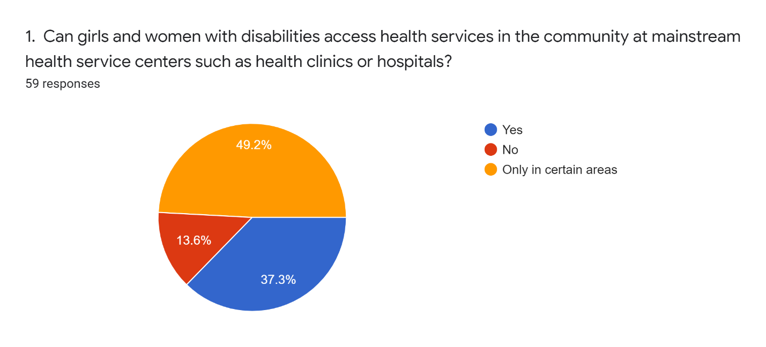

Graph 2: Are services accessible
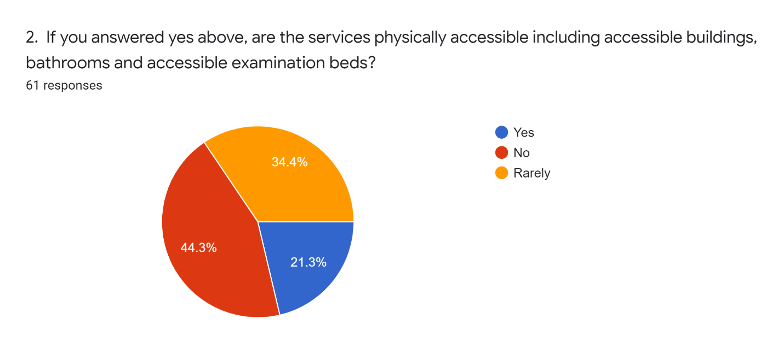
When respondents were asked to rate the barriers to accessing services within the mainstream health system including: accessibility, distance to services, cost, or stigma and discriminatory attitudes, 46.6 per cent said stigma and discriminatory attitudes from healthcare providers. Responses were fairly evenly distributed amongst the remaining barriers indicating that accessibility, services being too far away from the community and cost are also large deterrents from accessing healthcare. Comprehensive reforms that address not only accessibility of services but costs, proximity to the community as well attitudes from healthcare workers are critical to ensuring access to health for all women and girls with disabilities.
In terms of multiple and intersecting forms of discrimination different groups of women and girls with disabilities face, we asked respondents whether women from certain disability groups experience higher rates of discrimination when accessing health services. Respondents overwhelming responded yes to this question (94.9 per cent). They highlighted that Deafblind women and girls and women and girls with multiple disabilities face higher rates of discrimination. Respondents also indicated that women and girls with albinism, women with psychosocial disabilities and women and girls with intellectual disabilities also face high rate of discrimination (see graph 3).

Graph 3: Which groups face the most discrimination
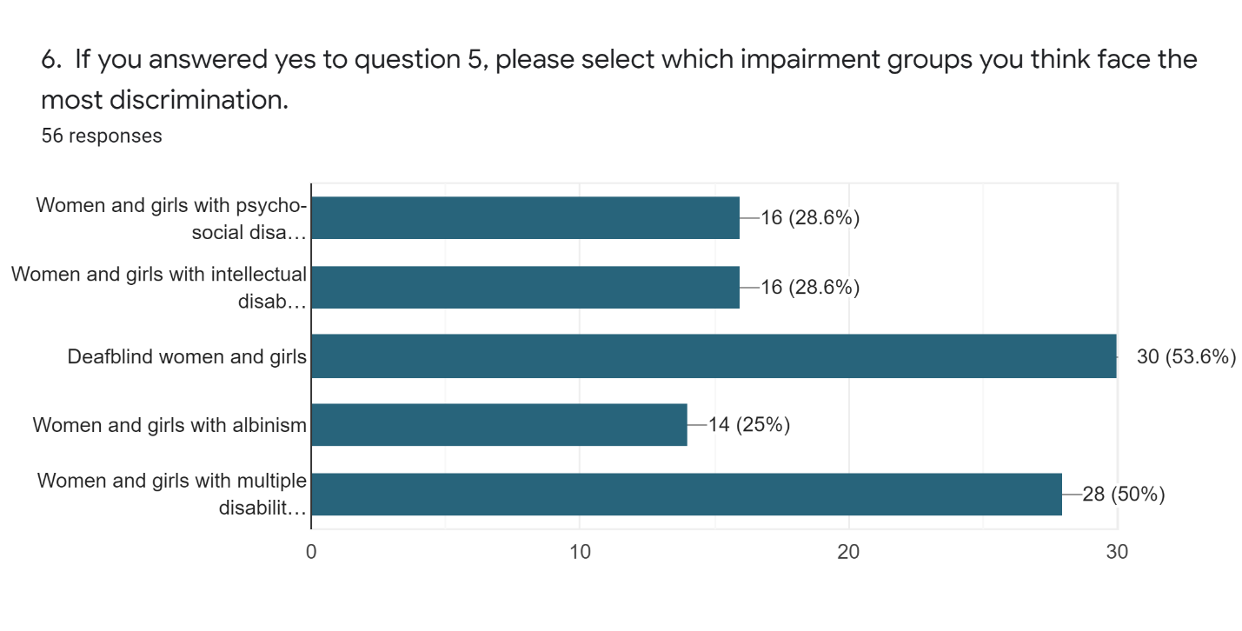
In terms of accessing sexual and reproductive health services, respondents overwhelming agreed that most women and girls with disabilities cannot access these services. Only 32.2 per cent of respondents felt that women with disabilities can access mainstream sexual and reproductive health services including gynecological services, HIV/AIDS programmes, sexual health and family planning services and testing for sexually transmitted diseases. When women with disabilities do access these services, respondents said that they are never or rarely accessible. When asked if services are physically accessible, if information and communication is accessible including easy-to-read or Braille or Sign Language interpretation, 70.2 percent responded never and 29.8% said rarely. Respondents also felt that certain disability groups face greater barriers and experience higher rates of discrimination when accessing these services including: deafblind women, women with multiple disabilities, women with psychosocial disabilities, women with albinism and women with intellectual disabilities (see graph 4).

Graph 4: Which disability groups face the most discrimination in accessing sexual and reproductive health
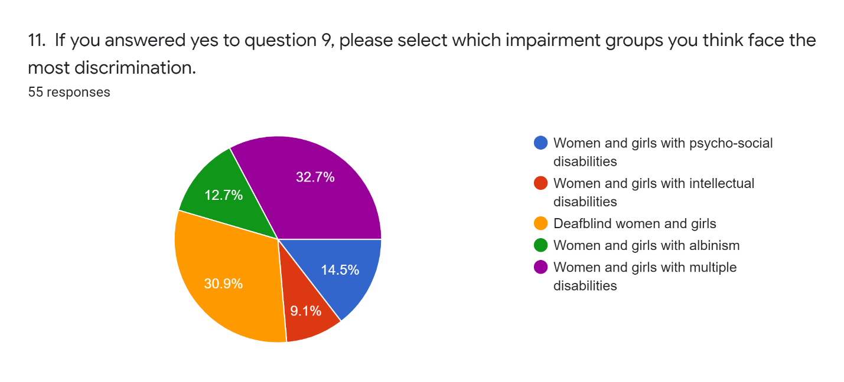
With regard to the availability of specialist services to address the health needs of women and girls with disabilities such as health-related rehabilitation, early intervention, community-based mental health services or speech and language therapy, 44.1 per cent of respondents felt they are rarely available while 18.6 per cent said they are never available. Only 37.3 per cent of respondents said that these services do exist in Kenya. However, when asked if these services are available in the community, 41.1 percent of respondents said never with 37.3 per cent saying only rarely. 88.9 per cent of respondents said that when these specialist services are available, they are not affordable.
SDG 3 aims to achieve universal health coverage and universal access to sexual and reproductive health services by 2030 in targets 3.7 and 3.8. If only 37.3% of respondents report that they can access mainstream health services in their community, there is a large section of the disability community unable to exercise their right to health. Through the online survey, it is apparent that women and girls with disabilities experience large barriers to accessing sexual and reproductive health services in Kenya. Additionally, as required by CRPD Article 25 (Health), health services, including sexual and reproductive health services, in Kenya are not accessible for the majority of women with disabilities surveyed. Also as required by CRPD Article 25, specialist health services to address the specific health needs of persons with disabilities are scarce and when they do exist, they are financially inaccessible for the majority of respondents. If women and girls with disabilities cannot access health services on an equal basis with others in their communities and cannot access services relevant to their health needs, SDG 3 will not be met by 2030.
SDG 3 aims to achieve universal health coverage and universal access to sexual and reproductive health services by 2030 in targets 3.7 and 3.8. If only 37.3% of women and girls with disabilities in Kenya can access mainstream health services in their community, SDG 3 will not be met by 2030.

SDG 4: Quality Education for women and girls with disabilities in Kenya
The online survey also looked at the situation in Kenya for women with disabilities on implementation of SDG 4: Quality Education in line with CRPD Article 24 (Education) and CRPD Article 6 (Women with disabilities). The survey tried to get a better picture of how women and girls with disabilities are accessing education in Kenya.
In assessing whether or not girls with disabilities are accessing mainstream primary education, 43.6 per cent of respondents felt that girls with disabilities do not attend primary school within mainstream schools. Only 21.8 per cent of respondents felt that girls with disabilities attend special schools while 21.8 per cent responded positively that girls with disabilities are accessing mainstream education at the primary school level. These responses show that there is a common perception that girls with disabilities are not accessing primary education within mainstream schools (see graph 5).

Graph 5: Do girls with disabilities attend primary school
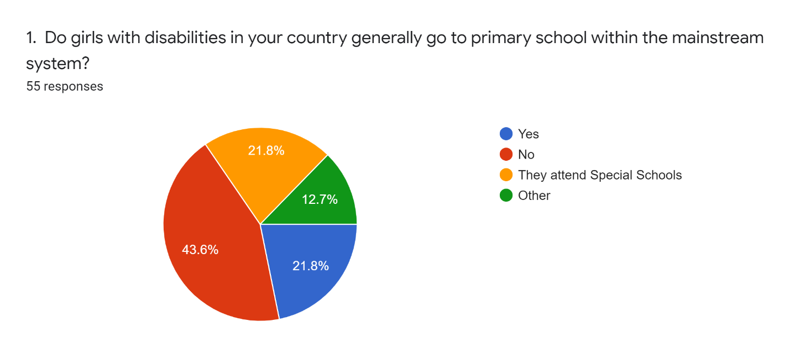
Respondents reported the various barriers to accessing education include: stigma and discriminatory attitudes from the community and schools; lack of trained teachers to support students with disabilities; inaccessible schools and lack of educational resources to support learners with disabilities; prohibitive school fees and unwillingness of family members to support their daughter with a disability to attend school; gender and disability discrimination by both families and communities.
When girls with disabilities do access primary school, we asked respondents about retention and drop-out rates. The majority of respondents (66 percent) responded that girls with disabilities do not complete primary education and 77 per cent felt that they do not go on to complete secondary education. Regarding tertiary levels of education, the overwhelming majority of respondents felt that girls and women with disabilities rarely complete university or vocational schooling (see graph 6).

Graph 6: Do girls and women with disabilities attend higher education

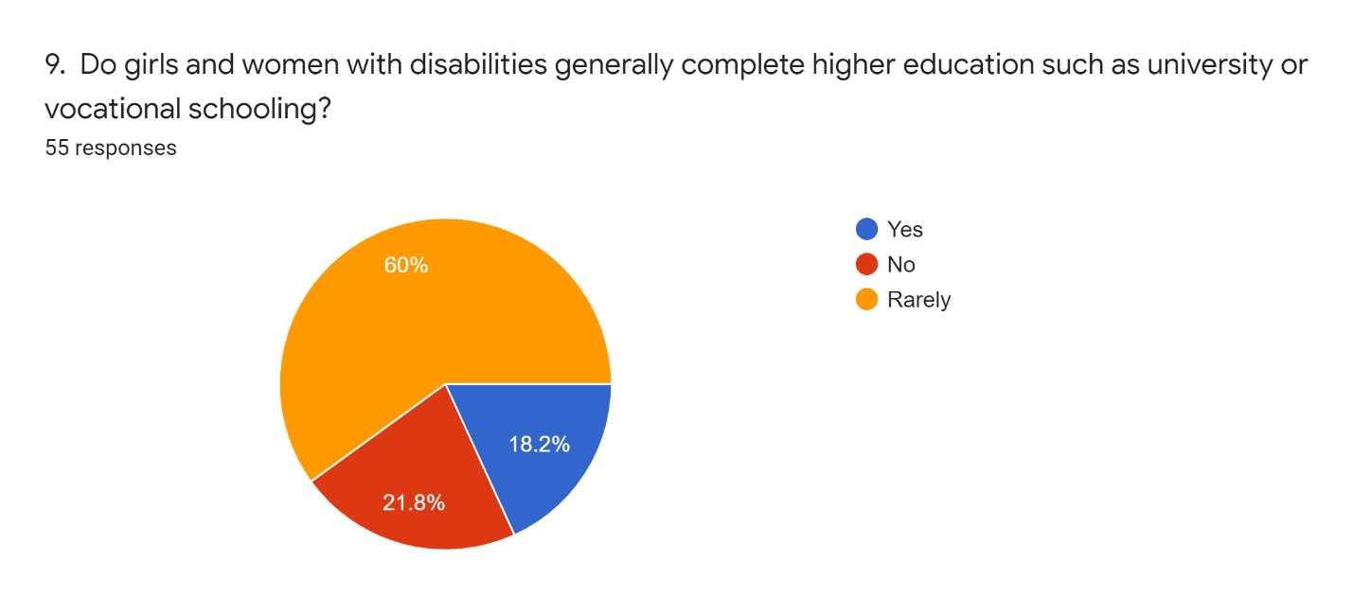
The barriers to accessing mainstream education in Kenya are vast according to the women with disabilities we surveyed. On an individual and community level, respondents felt that gender and disability discriminatory attitudes within families as one of the major barriers in which families do not see value in their daughter with a disability attending school. School fees are also cited as a major barrier for families with a member with a disability. The prohibitive costs of school fees force families to make choices about which member they can support to attend school. Given the pervasive gender and disability discriminatory attitudes, respondents report that families will often send their non-disabled male members to school and keep their female disabled members at home.
On a systems level, respondents highlighted the lack of accessible schools, inadequate support services, untrained teachers on inclusive education methodologies and a rigid curriculum that does not meet the education needs of learners with disabilities as the major barriers to accessing and staying in school. Furthermore, without widespread campaigns to prevent bullying and dismantle stigma and discriminatory attitudes, learners with disabilities and in particular girls with disabilities will continue to face violence including sexual and gender-based violence, harassment and abuse in school. Inaccessible transportation and long travel distances to schools were also cited by respondents as an issue that prevents learners with disabilities from accessing education.
With so many barriers to accessing and staying in school for girls and women with disabilities in Kenya, the country risks not meeting SDG 5 and failing learners with disabilities in achieving a quality education. For example, SDG 5 target 4.5 calls for the elimination of gender disparities in education and ensure equal access to all levels of education and vocational training for the vulnerable, including persons with disabilities, indigenous peoples and children in vulnerable situations by 2030. If the barriers to accessing and staying in schools within the mainstream education system are not addressed, women and girls with disabilities will continue to be excluded from education and this target will not be met.

SDG 8: The right to decent work for women with disabilities in Kenya
This section of the questionnaire looks at the situation regarding access to work and employment for women with disabilities in Kenya. Access to decent work and employment can only be achieved for women and girls with disabilities when the laws and policies ensure access to an inclusive labour force on an equal basis as others and without discrimination. In addition, there are measures in place to support women with disabilities in accessing work in both the public and private sectors such as reasonable accommodation, accessible vocational training programmes and targeted affirmative action measures to bolster the number of women with disabilities getting jobs. Through the questionnaire, we learn what the barriers are to achieving a disability and gender inclusive labour force in Kenya.
We asked respondents if women with disabilities are regularly accessing work or employment (either formal or informal labour). Only 18.9 per cent of respondents answered affirmatively while 52.8 per cent said they are only accessing certain types of jobs while 28.3 per cent felt women with disabilities were not accessing any type of work or employment (see graph 7).

Graph 7: Do women with disabilities access work or employment?
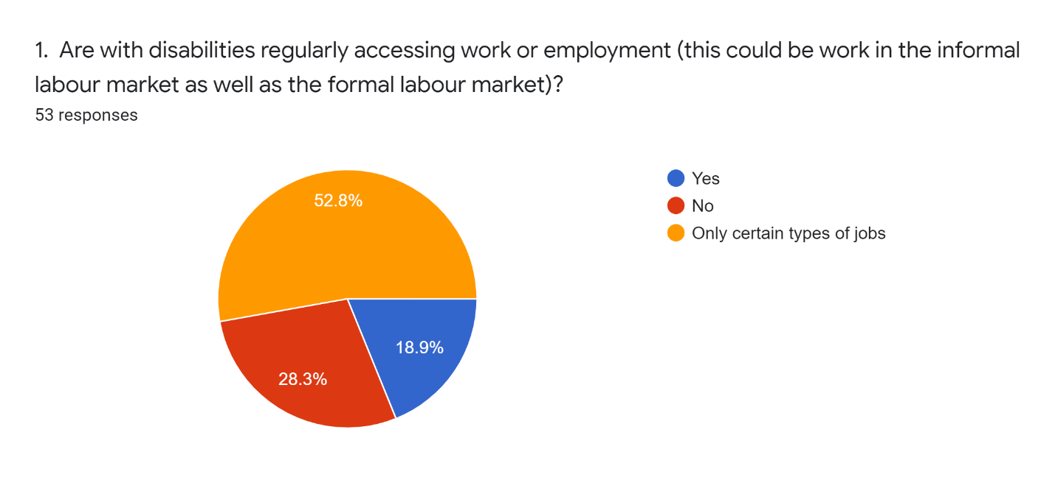

Respondents also gave their views on whether or not women with disabilities who access work or employment are paid a living wage that allows them to live above the poverty line. The majority of respondents (89.1 percent felt that women with disabilities rarely or never receive a fair income (see graph 8).
Graph 8: Do women with disabilities receive a fair wage for their work
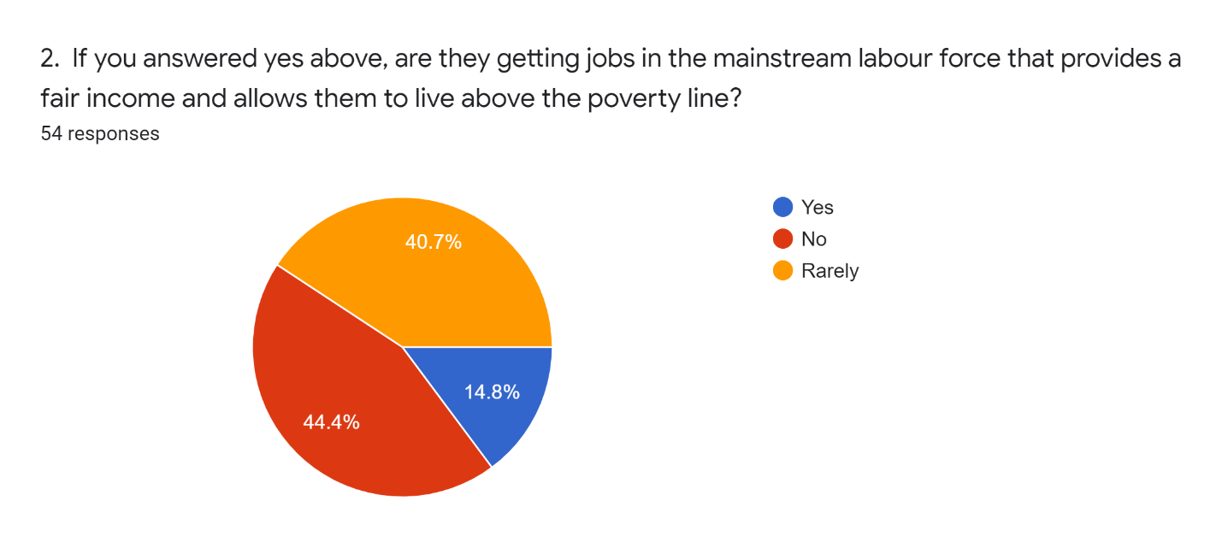
This data shows that there is an overwhelming perception that women with disabilities are not accessing work and employment and when they do get jobs in the mainstream labour force, they are not paid a wage that allows them to live above the poverty line. When they do access work or employment, we asked respondents to identify the kinds of employment sectors they generally work in. The two main sectors women with disabilities work in according to respondents are the informal labour market and low-wage jobs (see graph 9).

Graph 9: What kinds of work and employment do women with disabilities generally access
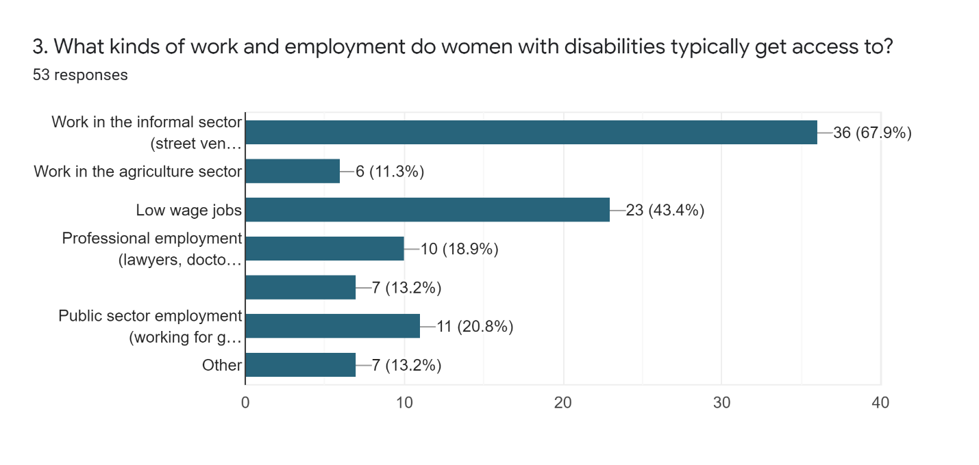

We asked respondents to give their assessment on whether or not workplaces in Kenya are accessible including office spaces and bathrooms. We also asked respondents to assess whether or not employers provide reasonable accommodations to employees with disabilities. On workplace accessibility, only 22.6 percent of respondents said that workspaces are generally accessible. Only 11.3 percent of respondents said that employers regularly provide reasonable accommodations to employees with disabilities (see graph 10). CRPD Article 27 (Work and employment) requires employers to provide reasonable accommodations in accessing work and employment. In practice, women with disabilities who were surveyed overwhelming felt this does not happen.

Graph 10: Do employers provide reasonable accommodations?
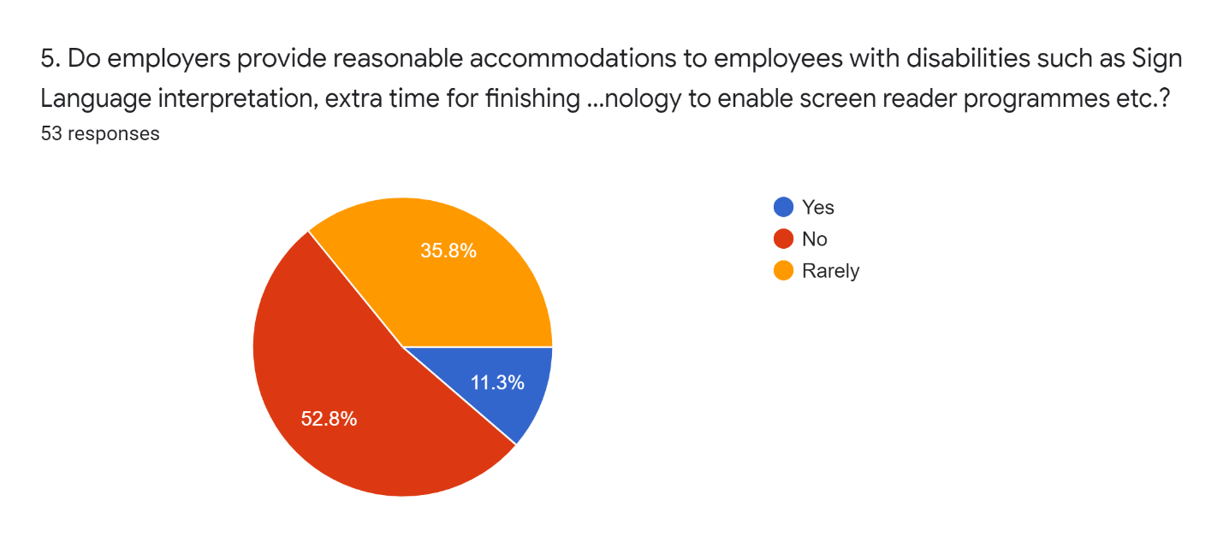

Respondents were asked to rank the main barriers women with disabilities face in accessing work including: discriminatory attitudes, workplace accessibility, lack of reasonable accommodations or lack of education. The respondents ranked discriminatory attitudes as the largest barrier followed by lack of education (see graph 11).

Graph 11: What are the greatest barriers in accessing work and employment
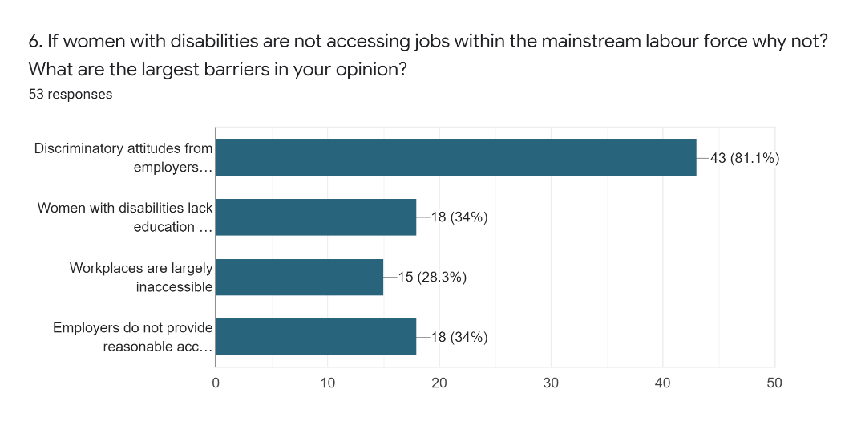

Respondents also weighed in on multiple and intersecting forms of discrimination women from different impairment groups face in accessing work as well as whether or not men with disabilities face the same barriers when seeking employment. When asked if gender plays a role in accessing work, almost all of the respondents answered affirmatively when asked if women with disabilities face greater barriers when accessing work than men with disabilities (94.3 percent). All respondents unanimously agreed that women from certain disability groups face higher rates of discrimination in accessing work and employment. Respondents felt that women with multiple disabilities and Deafblind women were the most under-represented in employment and faced the highest rates of discrimination followed by women with psychosocial disabilities (see graph 12).
Graph 12: Which disability groups face the most discrimination in accessing work and employment
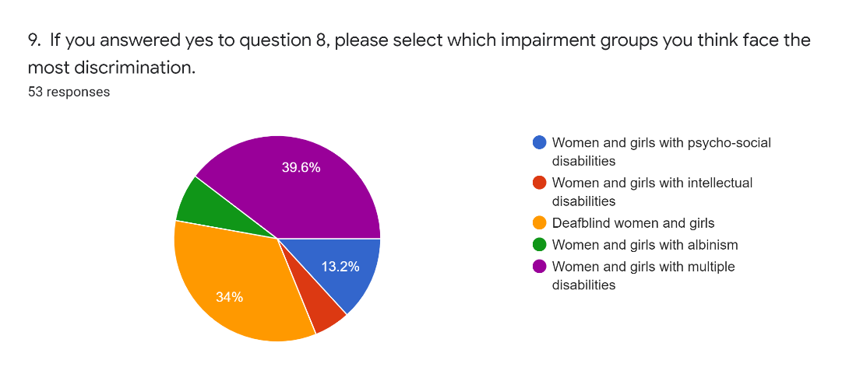
Respondents were also asked if there are positive measures in place to promote employment of women with disabilites such as affirmative action programmes and employer incentives. The majority of respodnents agreed that there are positive measures in place such as tax incentives, targeted recruitment programmes and outreach programmes. However, when we asked about access to vocational training programmes, 58 percent of respondents said that women with disabilites are not regularly accessing these programmes. We asked respondents to describe what the reasons are for not accessing vocational training and they outlined a multitude of issues stemming from stigma and discrimination. For exmaple, respondents described how vocational training programmes are often inaccessible and there is a lack of understanding about inclusion from vocational training administrators themselves. Mulitple respondents reported an overarching belief from employers and ovcational training staff that women with disabilites can make a valuable contribution to the labour market. This stigma creates a major barrier for women with disabilities to access decent work. Respondents also highlighted the exclusion from education women with disabilities face as another major barrier in securing decent work. Finally, respondents highlighted the lack of confidence women with disabilities have in trying to secure work. For women and girls with disabilities, there is a link between the exclusion from education and widespread stigma and discrimination around gender and disability that can result in disempowerment and a lack of self-confidence to go out and look for decent work.
The multiple barriers women with disabilities in Kenya face in accessing work need to be addressed in order for the State to meet SDG Goal 8 Target 8.5 By 2030, achieve full and productive employment and decent work for all women and men, including for young people and persons with disabilities, and equal pay for work of equal value. If the majority of women with disabilities in Kenya are not accessing decent work and when they do get work, it is in low-paid jobs in the informal labour market, the targets for SDG 8 will not be met. Furthermore, if efforts to implement SDG 8 do not address the unique barriers women with disabilities face, the government of Kenya will risk leaving this segment of the population behind.

SDGs 5 and 17: Partnerships for gender equality
This questionnaire looks at the situation in Kenya for women with disabilities on implementation of SDG 5: Gender Equality and SDG 17: Global Partnerships in line with CRPD Article 6 (Women with disabilities). The questions looked at gender equality and whether or not gender equality reforms and policies are inclusive of women and girls with disabilities. The questions also looked at whether or not the women’s rights movement is forming partnerships and alliances with women with disabilities and their representative organizations in Kenya.
We asked respondents if gender equality laws and policies in Kenya are inclusive of women and girls with disabilities. Respondents were divided in their responses with 41.5 percent responding affirmatively, 32.1 per cent saying the policies are not inclusive and 26.4 per cent saying they are only somewhat inclusive (see graph 13).

Graph 13: Are gender equality laws and policies inclusive of women and girls with disabilities
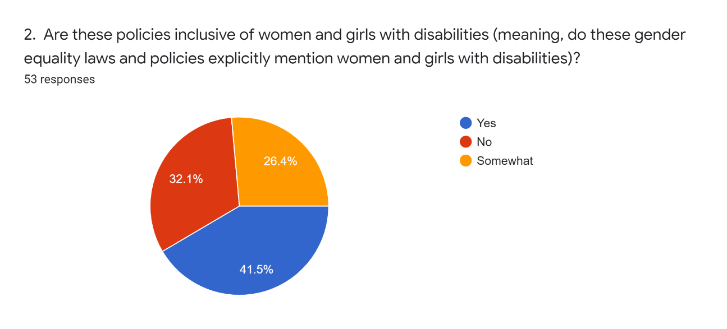

When asked if gender equality efforts in Kenya actually reach women and girls with disabilities, the majority of respondents felt that they either rarely or never did (see graph 14).

Graph 14: Do gender efforts reach women and girls with disabilities
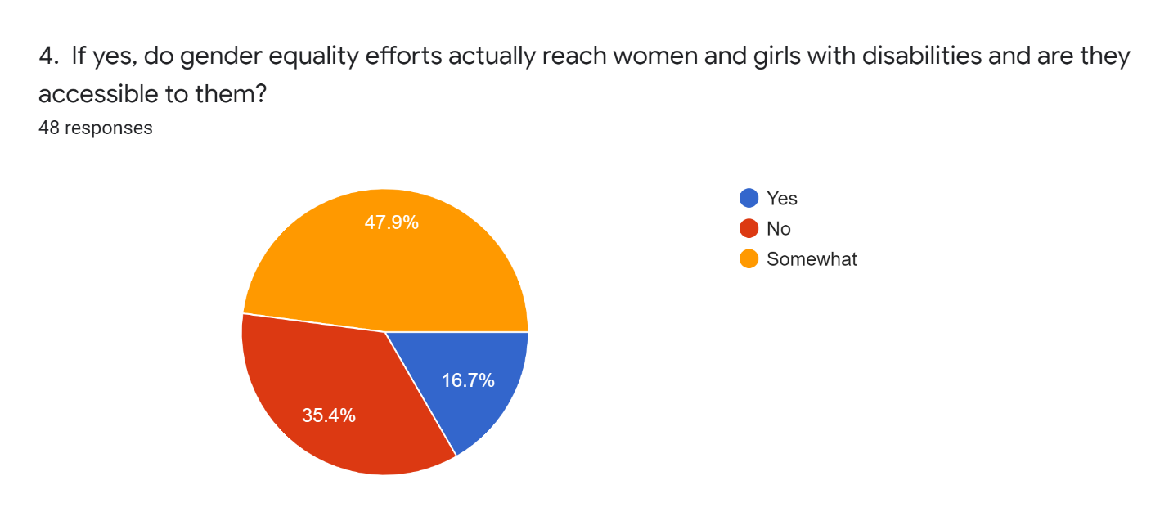

In terms of gender-based violence laws, policies and programmes, respondents overwhelmingly agreed that gender-based violence efforts do exist in Kenya but they are not effectively including women and girls with disabilities. For example, 90.4 percent of respondents are aware that there is a law in place to prevent gender-based violence in Kenya (see graph 15).

Graph 15: Is there a law on gender-based violence
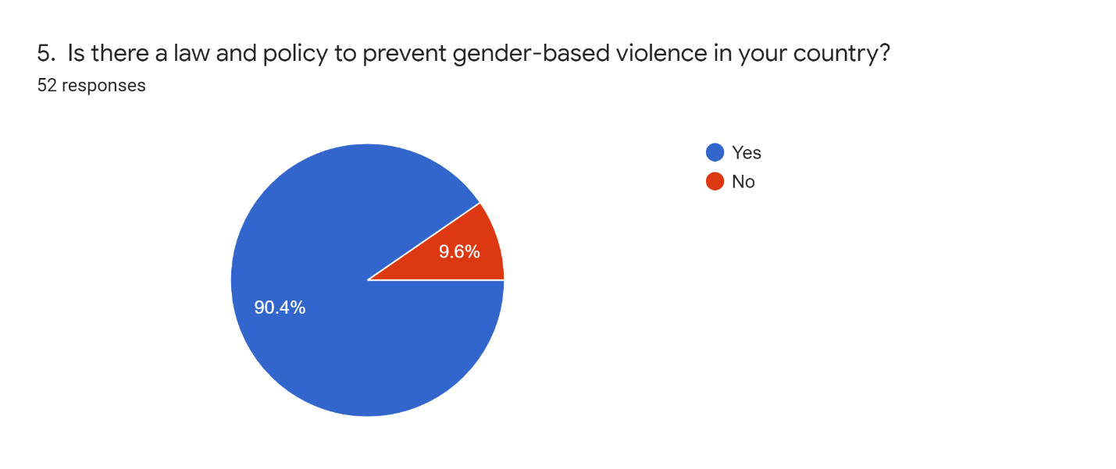

However, over half of the repondents felt that the law is not inclusive of women and girls with disabilities (see graph 16).

Graph 16: Is the law on gender-based vioelnce inclusive
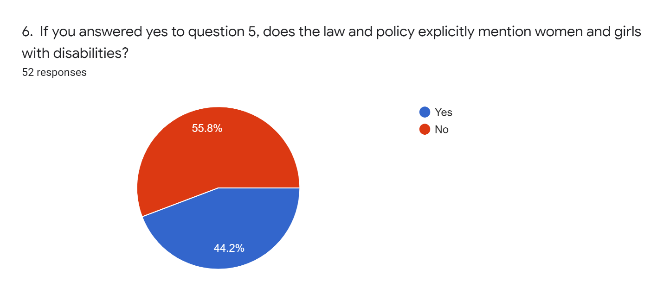
Respondents also weighed in on how this law is implemented in practice. When asked whether gender-based violence programs and services are inclusive of and accessible to women and girls with disabilities, only 29.4 per cent answered affirmatively with 70.6 per cent of respondents indicating that these services are never or rarely inclusive (see graph 17).

Graph 17: Are gender-based violence services and programs inclusive
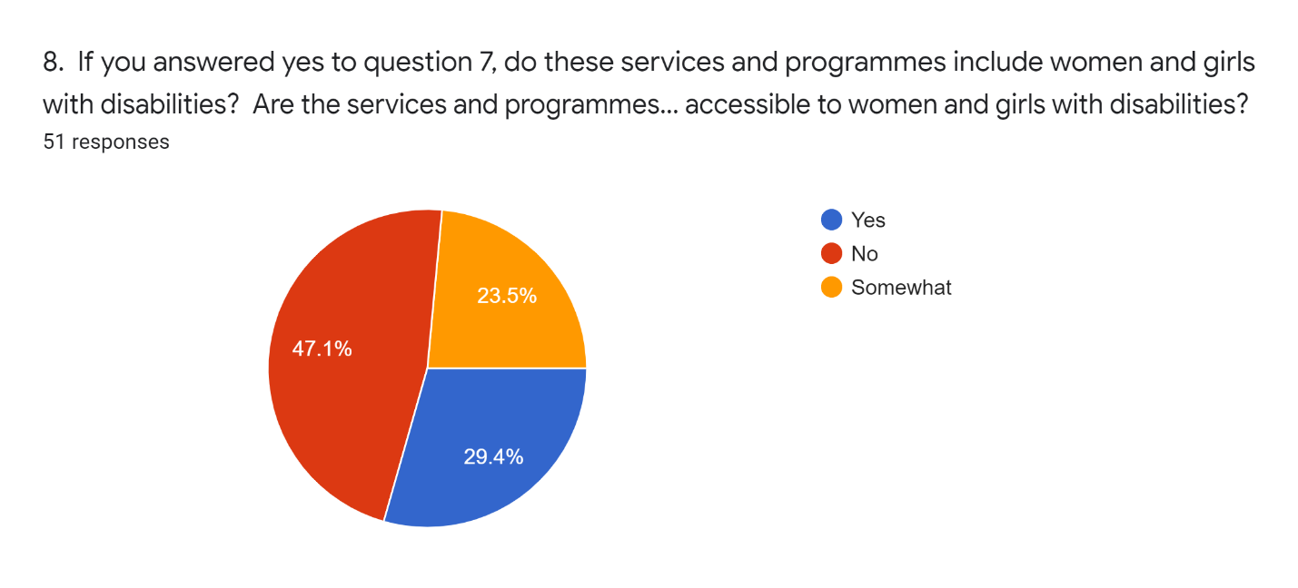

Regarding programs addressing sexual and reproductive health rights, respondents had similar responses, they agreed there are programs and services in place but they are rarely inclusive and accessible (see graph 18).
Graph 18: Are sexual and reproductive health services and programs inclusive

The survey asked women with disabilities to evaluate how collaborative and inclusive the women’s movement in Kenya is with women with disabilities. Respondents were asked to rate whether or not the women’s movement addresses the rights of women and girls with disabilities in their advocacy. Responses to this question were mixed with 34.6 percent answering affirmatively and 28.8 percent answering negatively while 36.5 percent responded somewhat (see graph 19).
Graph 19: Does the women’s rights movement address the rights of women and girls with disabilities 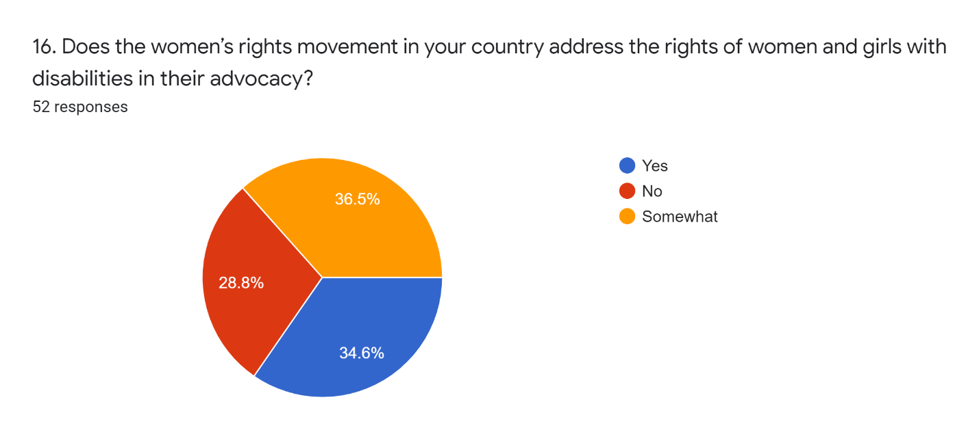

However, when asked whether or not partnerships are forming between women with disabilities and women’s rights actors, only 28.8 percent responded affirmatively. The majority of respondents felt that partnerships are either not or only somewhat forming between movements (see graph 20).

Graph 20: Do women’s rights organization collaborative with organizations led by women with disabilities
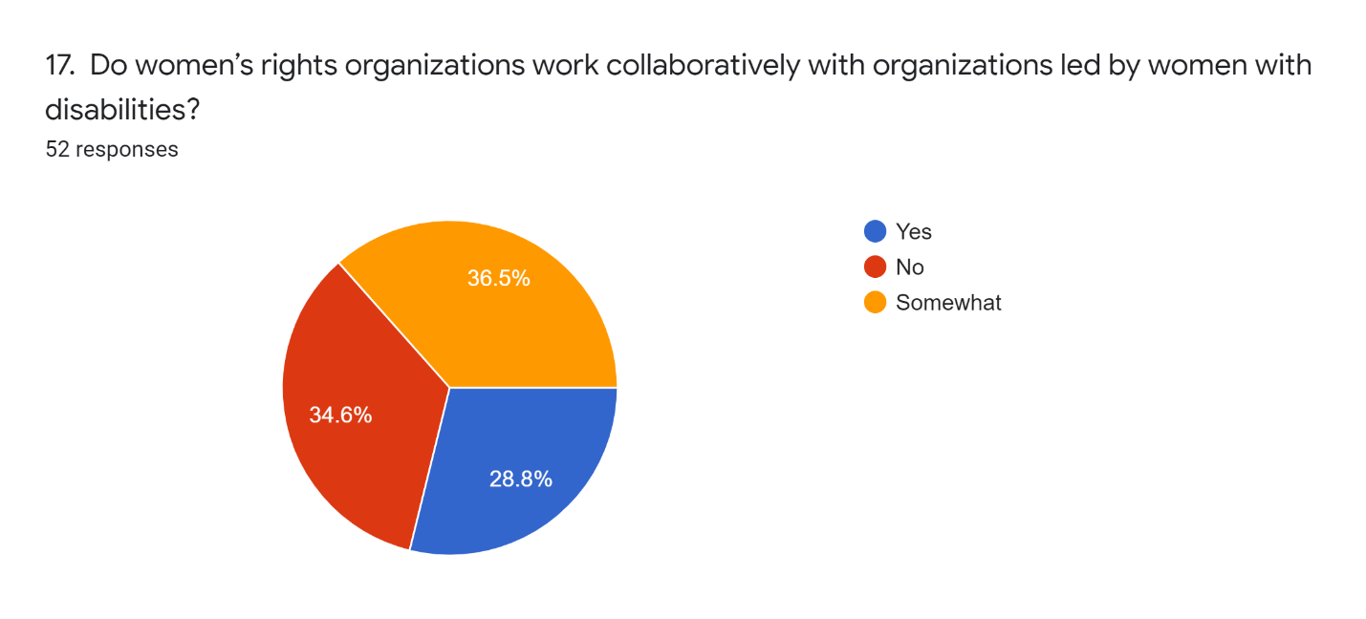

Respondents described some of the efforts that are needed to foster partnerships and collaboration between women with disabilities and the women’s rights movement in Kenya including:
- Women leaders with disabilities need to train and empower the women’s movement to address the rights of women with disabilities within their priorities
- Women with disabilities led organizations need to advocate and demand their rights move visibly both within civil society and towards government
- Women with disabilities need to work together to lobby for amendments to existing gender equality laws to ensure they are inclusive of women with disabilities
- Advocacy to prioritize the rights of women with disabilities within the overall women’s rights agenda needs to be aimed at women’s rights organizations as well as the Ministry responsible for gender
- The Kenyan government should provide a platform for women with disabilities to participate in the women’s rights debate

Conclusion:

The online survey findings provide insight into the lived realities of women and girls with disabilities in Kenya in accessing education, health, work and employment and gender equality measures. It provides an understanding of how the CRPD is being implemented in practice regarding Articles 6 (Women with disabilities), 23 (Respect for home and family), 24 (Education), 25 (Health) and 27 (Work and employment). The survey also provides valuable insight into how SDGs 3, 4, 5, 8 and 17 are being implemented and what needs to be done to ensure they do not leave behind women and girls with disabilities.

From the findings, respondents report experiencing multiple and intersecting forms of discrimination on the basis of gender and disability when exercising their rights to health, education, labour and gender equality. Respondents report a multitude of barriers ranging from stigma and discriminatory attitudes, inaccessible environments and infrastructures, lack of inclusive services and programs and a lack of availability of services and programmes that are relevant to the needs of women and girls with disabilities. From the survey it is evident that women and girls with disabilities experience high levels of exclusion from education, health services, employment while also sighting high levels of stigma and discriminatory attitudes within their communities. It is clear that the CRPD is not being implemented in practice in a way that positively impacts the lives of women and girls with disabilities. The survey highlights that the lack of access to services and programs compounded with the high levels of discrimination and stigma leave women and girls with disabilities disenfranchised and disempowered. The level of exclusion and discrimination women and girls with disabilities in Kenya are facing requires not only reforms of the laws and policies but for programs, services and positive measures to be put in place to effectively address barriers and dismantle stigma and discriminatory attitudes. Measures are also needed to empower women and girls with disabilities to understand their rights and build their confidence to demand change. If these reforms and measures are not put in place by the Kenyan government, they will not meet their SDG targets. More importantly, the SDG process will fail women and girls with disabilities leaving them behind in development efforts.

V. Legal and Policy Analysis: Understanding how GDS 3: Health and Well-being, 4: Quality Education, 5: Gender Equality, 8: Decent Work and Economic Growth and 17: Partnerships for Goals, are being implemented to address the rights of women and girls with disabilities in compliance with the CRPD in Mali

Mali ratified it by Ordinance No. 07-037/P-RM of 05 September 2007 which was ratified in turn by the National Assembly on 08 November 2007. The instruments of ratification of the Convention and its Optional Protocol were deposited with the United Nations on 7 April 2008.
The translation of this international commitment was manifested through the adoption of LAW N°2018-027 on the rights of persons with disabilities on 12 May 2018 by the National Assembly and promulgated on 12 June 2018 by the President of the Republic.

The government in collaboration with civil society is working to develop a draft implementing decree that can ensure the development, modification and/or removal of any discriminatory measures against persons with disabilities in the legal framework and the integration of any inclusive measures within the meaning of the CRPD in order to ensure the equalization of opportunities and outcomes in the policy framework. The draft decree should place particular emphasis on the most vulnerable groups of persons with disabilities, namely women and girls with visual, intellectual and mental disabilities and those living in rural areas.

A. the legal and policy framework of SDG 4: Quality Education in Mali

Enabling every Malian to complete at least one quality basic education in order to provide the country with the skills essential for its emergence has long been a central concern of the various governments that have succeeded one another at the head of Mali. The country has adopted a Ten-Year Education Development Programme (PRODEC) for 2008, but adjusted until 2010 to take account of the new challenges facing the sector following the sector diagnosis carried out in 2009. While the implementation of this programme has been essential to the performance recorded by Mali, the crisis that the country experienced in 2012 has not made it possible to make progress on the last phase of the programme, which should focus on implementing reforms to improve quality and strengthen the decentralized management of basic education. The concern for quality education for all is still relevant, with a political will displayed through several national strategic documents, including the Strategic Framework for Economic Recovery and Sustainable Development (SFREDD), which establishes skills development as a strategic priority and a national challenge for economic and social development.

In view of these national stakes and challenges, but also of the new international commitments made by our country, particularly with regard to the Education Agenda 2030 and the African Union's Agenda 2063, the Government of the Republic of Mali has undertaken to draw up a new ten-year programme, capitalizing on the lessons learned from the implementation of the previous programme and the specific studies carried out.

1 The legal framework of education in Mali

The Constitution of Mali guarantees that Education, instruction, training, work, housing, leisure, health and social protection are rights recognized in article 17 and affirms that every citizen has the right to education. Public education is compulsory, free and secular. Private education shall be recognized and shall be exercised under the conditions defined by the law in article 18.

The Orientation Law on Education

Act No. 99-046 of 28 December 1999, as amended, on the Education Act,which guarantees the right to education for every citizen. It further stipulates that "the right to go to school shall be exercised without discrimination on grounds of sex, social origin, race or religion" (article 9).
This law defines Special Education as a type of education. It refers to special education and inclusive education.
The education system in the Republic of Mali includes non-formal education; special education; normal education; technical and vocational training. The purpose of special education is to provide appropriate educational care for children and adolescents with disabilities in order to enable them to gain or regain their intellectual, physical and moral autonomy and to integrate harmoniously into the social context. Special education is intended for the severely disabled. The organization and modalities of operation of special education are determined by a decree issued by the Council of Ministers. Mildly disabled persons are accommodated in the various orders and types of education. They receive the same learning opportunities as non-disabled learners while at the same time benefiting from special educational care. (Articles 30, 46, 47, 48 and 55)
Ordinance No. 02-062/P-RM of 5 June 2002 on the Child Protection Code stipulates that Disabled children are entitled, in addition to the rights recognized for children, to protection and medical care and to a level of education and training that consolidates their self-care and facilitates their active participation in social life. (Article 16).
Decrees n° 313, 314, 315 of June 14, 2000 relating to the transfer of competences in the fields of Health, Education and Hydraulics;
Decree No. 94-276/P-RM of 15 August 1994 establishing the procedures for implementing the Act on the Status of Private Education.

2 The political framework governing education in Mali

The National Policy on Special and Inclusive Education

This policy emphasizes inclusive education over the traditional form of special education. It is defined as the set of appropriate measures and strategies aimed at providing educational care for children and adolescents with special educational needs within the framework of the national education system, in the perspective of "Education For All".
The objective of this policy is to promote the education of children and adolescents with special educational needs within the framework of the national education system, with particular emphasis on measures that can inform and raise awareness among all stakeholders about the national policy on special and inclusive education; to mobilize human, material and financial resources for the implementation of the policy ; to develop modules on disabilities and disabled persons in the initial training of student teachers; to train competent human resources for the implementation of the policy; to provide special education institutions and inclusive schools with specialized equipment; to fit out and rehabilitate classrooms with a view to making them accessible to disabled students; to develop a platform for collaboration between the various stakeholders: Ministry in charge of education, Ministry of Social Development, local authorities, school promoters and school authorities at the central and decentralized levels; to develop the capacities of special education and inclusive education structures at the central and decentralized levels for monitoring and evaluation; to improve knowledge and understanding of disability and special education in the various Malian living environments; to develop action research on disability, special education and inclusive education; to set up libraries in special education institutions; to facilitate access to education for disabled children of poor parents.
The DPOs who initiated the special education institutions had the merit of having highlighted the problem of the education of children with special educational needs and have greatly contributed to raising the awareness of the public authorities and the community about the right to education of these children on the same level as their fellow citizens.
Unfortunately, the high cost of special education, the limited means of the initiators, the State and the concentration of special education institutions in a few urban centres have made it possible to cater for only a tiny minority of pupils with special educational needs. Other alternatives had to be found, hence the option for inclusive/integrative education based on the principles of equality and social justice.
However, it was noted that the promotion of inclusive education must be the alternative to ensure access to education for children with disabilities, especially girls with disabilities.

Analysis of the Final Results of the RGPH 2009: schooling, instruction and literacy in Mali

Children with disabilities are often marginalized in our societies. However, the extent of this marginalization may depend on the type of disability of the child, the environment in which they live and their gender. The evidence shows that children with disabilities are generally less likely to attend primary school than other children of the same age. The primary NER among children with disabilities is 42.9%. Multi-disabled children are more disadvantaged than other types of disabled, with an enrolment rate of 22.3%. The lack of infrastructure adapted to their case probably constitutes an obstacle to their schooling. In addition to the inequality between types of disability, it should be noted that a disabled child's chance of being enrolled in school may also depend on his or her background. Indeed, in urban areas 62.2% of the disabled are enrolled in school compared to only 36.4% in rural areas.

Ten-year Programme for the Development of Education and Vocational Training for the Second Generation (PRODEC 2), 2019-2028

The vision of the departments in charge of education and vocational training is that, by 2028, Mali will have an efficient and inclusive education system that will train patriotic, responsible, productive and creative citizens who will contribute to the socio-economic development of their country.
This new ten-year programme for the development of education (PRODEC 2) aims to ensure the right of citizens to quality education and training through an inclusive, better adapted, coherent and functional education system. This overall objective is broken down by level of education.
This policy is operationally broken down into five major programmes, each made up of sub-programmes, including programme 3, which devotes its sub-programme 5 to the promotion of inclusive education.
Subprogramme 3.5. Promoting inclusive education at all levels
Beyond gender, considered from a gender perspective, inclusion is seen as any consideration of disadvantaged or vulnerable groups, including those living with disabilities. This subprogramme will focus on the care of Children with Special Educational Needs (CSN).
Specific objective 3.5.1: To ensure comprehensive educational care for Children with Special Educational Needs (CSN)
The option of the programme is to promote access to education, at all levels of the education system, for Children with Special Educational Needs (CSN). This measure will require taking into account SENCs in the construction of infrastructure, the acquisition of teaching materials and support in the areas of health, food, finance and psychosocial support.
To achieve this objective, the following strategies will be developed, namely the establishment of a reference situation (or mapping) of children with special educational needs; planning the construction and equipping of school infrastructures adapted to persons with disabilities; and supporting pupils and students with special needs in terms of health, food, financial and psychosocial support.

Respect for the CRPD

The legal framework remains aligned with the close of non-discrimination through the recognition and mention made of disabled people as a specific group. This opens the door to taking specific measures that can promote the inclusion and empowerment of women and girls with disabilities in schools. The political framework in a progressive manner through the advocacy of the actors is aligned with the prescriptions of the CRPD, namely the last national education policy which foresees as activity the development of a national policy on inclusive education. To be consistent with the CRPD, this policy should ensure that all girls and women with disabilities have the right to education on an equal basis with others. This includes all stages and all types of education, from preschool to basic education at university to lifelong learning. In addition, all girls and women with disabilities should have the right to access inclusive education with adequate individualized support in order to be able to participate in education while paying particular attention to the situation of girls. who are blind, deaf and deaf and blind.

Confusion of terms

The legal framework promotes discrimination between people with disabilities through the use of the terms "Legé handicap" and "severe disability". In the same vein, it reflects in policies a cohabitation between the three forms of education, namely special, inclusive and inclusive education. In addition to all this, people with disabilities are drowned in the group of children in need of special education.

B. the legal and policy framework of SDG 3: Health and well-being in Mali

Empowering people to live healthy lives and promoting the well-being of all people at all ages is essential for sustainable development.
Many more efforts are needed to completely eliminate a wide range of diseases and address many persistent and emerging health problems. By focusing on more effective financing of health systems, improved sanitation and hygiene, better access to health professionals and more advice on how to reduce environmental pollution, significant progress can be made to save lives.
Persons with disabilities have the same right to access health services as others. Although this includes disability-related health issues, it mainly includes access to general health services. Ensuring that medical interventions are only carried out with the free and informed consent of the person concerned is also an important provision.

1 The legal framework for access to health care in Mali

The constitution of Mali adopted by referendum of 12 January 1992 and promulgated by decree n°92-073 p-ctsp of 25 February 1992

The preamble affirms that for the advent of a State governed by the rule of law and pluralist democracy, the State of Mali proclaims its determination to defend the rights of women and children and the cultural and linguistic diversity of the national community, undertakes to ensure the improvement of the quality of life, the protection of the environment and the cultural heritage, and subscribes to the Universal Declaration of Human Rights of 10 December 1948.
The first three articles of the Constitution reaffirm the fundamental values of the human person, deal with equality in law and in duty between all Malians, including persons with disabilities, without mentioning them, declare that all discrimination based on social origin, colour, language, race, sex, religion and political opinion is prohibited, and prohibit the subjection of all persons to torture or to inhuman, cruel, degrading or humiliating abuse or treatment. It provides for measures of punishment for any public official who is guilty of such acts, either on his own initiative or on the basis of instructions.
ARTICLE 17 stipulates that Education, instruction, training, work, housing, leisure, health, and social protection are recognized rights.

The Health Orientation Act

The National Health Act is based on the fundamental principles of equity, justice, solidarity and participation by the population and civil society. It takes into account the international commitments to which the Republic of Mali has subscribed. The priorities of health action are reserved for disease prevention, health promotion and family welfare in rural and peri-urban areas and for improving access to health care for the poorest populations. Beneficiary populations organized in associations or mutual benefit societies, foundations and religious congregations also participate in the design ct / or implementation of the national health policy through the health institutions they are allowed to create and operate. Pharmaceutical policy is an integral part of health policy. Its objective is to make quality essential medicines, including traditional medicines and safe blood products, accessible to the population geographically, physically and financially. The right to health requires that all citizens be informed about the mechanisms for the prevention and transmission of "the most common diseases. (Articles3 2, 5, 16, 32 and 36)

Hospital law

The patient's right to free choice of hospital is a fundamental principle. Limitations to this principle can only be introduced in consideration of the technical capacities of hospital establishments and their pricing methods, the arrangements for coverage under a third-party payment system and the constraints linked to geographical access and means of transport. All hospitalized patients have the right to obtain, through a doctor of their choice, the information contained in their medical records. On discharge from the establishment, the patient must receive, in a sealed envelope, a letter summarising the results of the hospitalisation, specifying the diagnosis, if any, and summarising the discharge prescriptions that have been made. The public hospital service guarantees access to quality emergency care or reference care for all persons present on national territory. To this end, each hospital is obliged to admit in an emergency and at any time, any person whose state of health justifies it. The following are considered to be cases of emergency: patients, pregnant women or victims of accidents whose life or physical integrity, including that of the children they are carrying, may be endangered at short notice. (Articles 1, 4, 7 and 8)

The decree n°08-2716 /ms-sg of 6 Oct 2008 on the patient's charter in hospitals.

Hospitals are obliged to take in all persons regardless of their origin, sex, marital status, age, state of health, disability, political, trade union, philosophical or religious views. If they are unable to admit them, they must make every effort to ensure that they are admitted to another establishment. Equal access of users to the services of hospital staff is guaranteed . Exceptionally, derogation may be based on the age of the user, an apparent disability or the urgency of the case. In this situation,staff must explain to the users present the reasons for the decision to grant this privilege. (Articles 6 and 24)

The Reproductive Health Act

This law deals with equality between men and women in access to reproductive health services in all its forms. However, this law does not mention persons with disabilities, including women with disabilities. This situation means that no specific measures will be taken in this area for the inclusion of disabled women and girls.

The law laying down rules for the prevention, care and control of HIV/AIDS

The current HIV/AIDS law does not contain any measures relating to the inclusion of persons with disabilities. Nevertheless, the draft revision of this law takes into account the specificity of disability in the prevention, care and control of HIV/AIDS.

2 The political framework for health in Mali

Ten-year Programme for Health and Social Development (PRODESS)

This document contains all the objectives structured into tasks to be carried out for a period of 5 years within the framework of the Ten-Year Health and Social Development Plan;
Mali's national solidarity policy is based on the Constitution of the Republic of Mali, the strategic framework for the fight against poverty and international commitments. Its major objective is to ensure the well-being of the population by reducing the main sources of social distress and instability with a view to sustainable human development.
Its implementation is ensured by public and private actors. The general objective of the national social development policy is achieved through the implementation of programmes based on the guidelines of strengthening solidarity and combating exclusion, combating poverty and strengthening social protection. Its specific orientations are the promotion of the socio-economic integration of the elderly and the promotion of the socio-economic integration of persons with disabilities. Following the major achievements and lessons learned from the DDP for the period 1998 to 2011, implementation of a social protection policy and programmes such as RAMED l'AMO, which supports persons with disabilities and other citizens in the management of their health problems.

Respect for the CRPD

The legal framework of health in Mali being made up of several legislations knows a progressive realization in terms of non discrimination. The most recent legislations, namely the hospital law and the patient's charter, contain mentions of disabled people and adopt measures guaranteeing reasonable accommodation even if these remain more open to women and girls with physical disabilities. The political framework for health in Mali aims to be inclusive of people with disabilities through the full and effective participation of the Malian federation of associations of people with disabilities in its process of design, review, implementation, monitoring and evaluation.
The legal and political framework for health in Mali should guarantee and promote the fact that people with disabilities have the same right to access health services as others. Although this includes health issues related to disability, it mainly includes access to general health services. Ensuring that medical procedures are only performed with the free and informed consent of the data subject is also an important provision of this article.

Confusion of terms

The legal and policy frameworks for health in Mali identify people with disabilities under different names. It must also be noted that medical, social and human rights approaches coexist in the treatment of the needs of people with disabilities, which induces the adoption and promotion of certain measures contrary to the requirements of Articles 4, 9, 11, 16 , 23 and 25 of the CRPD.

C. the legal and policy framework of SDG 8: Decent Work and Economic Development in Mali

This eighth objective recognizes the importance of sustained, shared and sustainable economic growth in order to provide decent, quality employment for all. It aims to eradicate undignified work and ensure protection for all workers. It promotes the development of training and employment opportunities for the new generation, accompanied by an increase in skills in "sustainable" jobs. SDG8 also provides for enhanced international cooperation to support growth and decent employment in developing countries through increased aid for trade, development-oriented policies and a global strategy for the employment of women, youth and people with disabilities.
Persons with disabilities face unemployment rates 2 to 3 times higher than those of persons without disabilities. To remedy this situation, a wide range of measures is needed, combining protection against discrimination at all stages of employment with positive action measures.
The analysis of this objective will deal with the legal framework and employment policies as well as the impact of these policies on the population in Mali particularly through targets 8.3 and 8.5.

1 The legal framework of labour rights in Mali

THE CONSTITUTION OF MALI
ARTICLE 17/ - Education, instruction, training, work, housing, leisure,
health and social protection are recognized rights.
ARTICLE 19/ - The right to work and to rest is recognized and is equal for all. Work is
a duty for every citizen, but no one may be compelled to
perform a particular work unless it is in the case of an exceptional service of general interest, equal for all under the conditions determined by law.

Labour Code of 1992
Act No. 92-020/ANRM of 23 September 1992 on the Labour Code of the Republic of Mali makes no specific reference to persons with disabilities. However, the principle of equality of opportunity at work, in employment and in remuneration is set forth therein, affirming that the right to work and training is recognized for every citizen. Under equal conditions of work, professional qualification and performance, wages are equal for all workers, regardless of their origin, sex, age and status. (Articles L4 and L95)

Law on the General Statute of Civil Servants of 2002

Act No. 02-053/ANRM of 16 December 2002 on the general status of civil servants in Mali makes specific reference to persons with disabilities in article 18, providing for special measures for persons with disabilities. For the application of this statute, no distinction may be made between the two sexes and between disabled persons and others, subject to consideration of the provisions of the special statutes and the requirements for the exercise of certain functions. (Article 18). However, special measures may be taken in favour of disabled persons within the framework of the regulations implementing these Staff Regulations. Such measures may in no case be regarded as discriminatory towards other persons". It should be noted that the scope of such an article may be ambiguous in that the verb "may", "may" removes any imperative character. Here, the power is given to decide whether or not to take special measures in favour of persons with disabilities.
Decree No. 05-164/P-RM of 6 April 2005 setting the terms of application of the General Staff Regulations for Civil Servants makes no reference to the special measures in favour of disabled persons provided for in the above-mentioned Article 18. This shortcoming should be corrected by providing for special measures for the disabled.

1999 Social Security Code
When disability occurs during working life, social protection is provided in accordance with the Social Welfare Code in Mali. The National Social Welfare Institute (INPS) is the national body responsible for implementing this Code. The costs of care, rehabilitation and reintegration are borne by the National Social Welfare Institute. The employer is obliged to reclassify the sick worker by assigning him or her to a corresponding post. The sick worker is also entitled to an allowance during the permanent incapacity for work. This code also regulates the pension scheme for sick workers in case of temporary or permanent incapacity to work. Health care and rehabilitation are provided to workers who have suffered from accidents at work and occupational diseases. Family allowances are maintained for disabled children up to the age of 21, regardless of whether or not these children continue their studies or apprenticeship. Social protection is faced with the non-payment of contributions by the employer to the INPS, which jeopardizes the effective care of workers. Often the sick worker takes legal action against the employer who is not affiliated to the INPS, without knowing the consequences, in order to obtain compensation. It should be remembered that the services of the INPS and the National Pension Fund only benefit the beneficiaries, i.e. the registered workers and their families. Hence the thorny question of the social protection of disabled young people and disabled adults who are self-employed and therefore do not benefit from the INPS. In Mali, social protection for disabled persons is provided by the National Directorate of Social Development and Solidarity Economy, which supports disabled persons' organizations in their work. Also, aid in the form of necessary appliances and equipment is provided to disabled persons thanks to the support of technical and financial partners to disabled persons' organizations.

Agricultural Guidance Act, 2006
Easy access to land is a real factor of development for the disabled person and his/her family. Article 25 of the 2006 Agricultural Orientation Act provides that: "The State shall give priority to the establishment of young people, women and vulnerable groups as farmers, in particular by promoting their access to factors of production and through technical or financial support mechanisms in particular. The criteria for declaring the vulnerability of a population group are set by decree issued by the Council of Ministers. Since disability is a factor in a person's vulnerability, it goes without saying that easy access to support mechanisms must concern persons with disabilities. The effective implementation of the Agricultural Policy Act is a major challenge in eradicating poverty among persons with disabilities if their condition is integrated into plans and programmes.

The 2003 Law amending the General Tax Code

Article 319 (new) of this text provides:
"The tax shall not be levied on passenger vehicles belonging to:
a°) beneficiaries of military invalidity and war victims'
pensions;
b°) beneficiaries of an invalidity pension for a work-related accident with a degree of invalidity equal to or greater than 50%;
c°) the blind and the civilly handicapped, the latter having to justify a 90% invalidity by a medical certificate bearing the words " difficult standing station". This provision provides for an exemption in terms of taxes for vehicles belonging to handicapped persons (blind, seriously handicapped). In conclusion, it is safe to say that Mali does not have enough textual provisions on the rights of disabled persons. The disparate provisions found in the general human rights texts do not ensure a real promotion and protection of the rights of persons with disabilities. Hence the need to reform our domestic legal texts. In spite of this state of affairs, our country has registered several actions and good initiatives in favour of persons with disabilities.

Act No. 2018----- 027 of 12 June 2018 on the rights of persons living with a disability

Graduates with disabilities benefit from specific recruitment measures for public and private jobs. The age of recruitment of persons living with a disability in the civil service of the State and local authorities takes into account the delay due to illness or the length of treatment. Persons living with a disability benefit, where necessary, from an adjustment of their position and working environment. Public bodies and private companies reserve a quota of jobs for working persons living with a disability under conditions defined by regulation.

2. the political framework of labour and employment Mali National Action Programme for Employment to Reduce Poverty

The Ministry of Social Development, Solidarity and the Elderly, which is responsible for the design and application of legislation and actions aimed at ensuring the protection of workers through the implementation of an appropriate social security and social welfare system; the design, development and implementation of programmes of animation, education and integration aimed at promoting social development and national solidarity;the social promotion of older persons with a view to ensuring their participation in the life of the city and the nation; the protection and social promotion of persons with disabilities; the fight against exclusion and the reduction of the social divide; the promotion and development of cooperatives and mutual societies and of the associative movement in general; the implementation, in conjunction with the other ministries concerned, of the strategy to combat poverty.

National Employment Policy Action Plan (2015 - 2017)

This action plan in its Table 2, Matrix of actions and timetable for implementing Objective 2, which consists of strengthening actions to promote and create jobs, the promotion of private job-creating activities, support for modern businesses and micro and small enterprises, the targeting of employment promotion measures to take account of the demographic challenge and the specific nature of the problems of integration of certain groups (women, young people, disabled people, returning migrants, etc.), provides in terms of :
- Operational results, Employment opportunities for young people, women, migrants, people with disabilities are created;
- Indicator, Number of young people, women, migrants and persons with disabilities supported and settled ;
- Activity, Supporting professional integration schemes for disabled people.

Compliance with the CRPD
The legal framework for employment in Mali is based on principles similar to those of the CRPD. Failure to mention persons with disabilities, let alone place special emphasis on women with disabilities, significantly reduces the equalization of employment opportunities for women with disabilities through the policy framework:
- the general employment law protects women with disabilities from discrimination, including denial of reasonable accommodation, and harassment at all stages of employment ;
- forms of employment for persons with disabilities (such as sheltered or supported employment) which are exempt from labour standards, and which would result in inferior protection and exploitation, are prohibited in law and prevented in practice;
- Vocational training and services for regular, self-employment and social economy employment are accessible to women with disabilities;
- disabled women who acquire a disability can remain in the labour market during their rehabilitation period, if they so wish;
- The State shall take positive measures to employ women with disabilities;
- The State encourages the employment of disabled women in the private sector through incentives and other measures;
- Women with disabilities are protected from all forms of forced labour.

Confusion of terms
Some laws take into account only the disability acquired in the course of employment and not the employment of disabled persons including disabled women. Others mention persons with disabilities without placing special emphasis on women with disabilities and grant only reasonable accommodation instead of guaranteeing the right to employment.
The policy framework focuses only on self-employment and does not take into account disaggregated statistical data for the granting of subsidies to support it.

D. Gender equality in Mali - SDG 5

Globally, women and girls must enjoy equitable rights and opportunities and be able to live free from violence and discrimination. Women's equality and empowerment is the theme of one of the 17 Sustainable Development Goals, but it is also integral to all aspects of inclusive and sustainable development. In summary, all the SDGs depend on the achievement of Goal 5.

1. Legal framework on gender equality in Mali

The Constitution of Mali guarantees the same rights to citizens of both sexes without discrimination. Progress has also been made in the area of domestic legislation and is characterized by the country's endowment of various codes to govern social, economic and political life. Within this framework, several laws take into account the situation of men and women, particularly in the area of the family (Marriage and Guardianship Code, Nationality Code, Kinship Code), in the area of labour ( Labour Code, Social Security Code), in the criminal area (Criminal Code and Code of Criminal Procedure), in the area of politics (Electoral Act), in the area of land (State and Land Code) and in the commercial area (Commercial Code).
Under these conditions, the achievement of equality in law without the equity mentioned in the Agricultural Guidance Act and international texts seems hypothetical. Thus, while it is true that the State is taking action in favour of organizations of persons with disabilities, the fact remains that much remains to be done to ensure the promotion and protection of the rights of women and girls with disabilities and to ensure strict respect for their dignity. Moreover, women continue to be victims of violence of several kinds, namely physical violence, sexual violence, psychological violence, repudiation, excision, violence resulting from deprivation and discrimination, violence by women against women, forced prostitution and pimping.

Law n°2015-052/ of 18 December 2015 instituting measures to promote gender equality in access to nominative and elective functions

On the occasion of appointments in the Institutions of the Republic or in the different categories of public services in Mali, by decree, order or decision, the proportion of persons of either sex must not be less than 30%.
For the election of deputies to the National Assembly, members of the High Council of Communities or Councillors of Territorial Communities, no list of at least three (03) persons, presented by a political party, group of political parties or group of independent candidates, shall be admissible if it contains more than 70 per cent women or men. However, this law does not apply to elections at the level of traditional chiefdoms of village and fraction councillors, religious, worship or denominational associations or any other grouping with their own statutes and regulations.
Candidate lists for local elections must respect gender alternation as follows: if two candidates of the same sex are registered, the third must be of the other sex. Article 4: The modalities of application of the law shall be defined by a decree issued by the Council of Ministers.
This 4 article law guarantees women's participation in political and public life by granting them a quota of at least 30% representation in nominative positions and electoral lists.

Act No. 2018-027 on the rights of persons with disabilities.

Article 26: Women and children living with a disability shall benefit from specific measures of assistance and protection against exploitation of all kinds, violence, sexual assault and abuse.

2. Policy framework on gender equality in Mali

In the section on the national legislative framework, PNG (Mali) said that while it was true that the State was taking action in favour of organizations of persons with disabilities, much remained to be done to ensure the promotion and protection of the rights of women and girls with disabilities and to ensure strict respect for their dignity.
An analysis of the main sectoral policies reveals that these reference frameworks all contain, to varying degrees, information on the situation of women and proposals for action to ensure their promotion and participation in development. With the exception of certain sectors such as health, education and justice, which propose measures in favour of gender, the treatment of equality between women and men in policies is limited to declarations of intent, which, while praiseworthy, cannot be put into practice due to a lack of specific results, strategies and measures, mechanisms and budgets.
Thus, none of these sectoral policies apart from PRODESS II mentions women and girls with disabilities in order to ensure non-discrimination. The social development component of PRODESS, that efforts are being made to address the needs of disadvantaged social categories (the disabled, the elderly, women and children in difficult circumstances) in terms of health care and access to education. Strategic actions are also being developed for the socio-economic integration of these categories by improving their access to employment and participation in decision-making. However, the impacts of these actions are less visible, especially for disabled people and even less so for disabled women.
PRODESS II states that the increased participation of women, youth and people with disabilities is also targeted in community health management mechanisms.
However, strategic orientation No. 3, which is devoted to recognizing the contribution of women to economic development through their integration into the productive circuits and equal access to employment opportunities and production factors, and which focuses on improving the profitability of the economic operations of women working in the informal sector and in entrepreneurship, sets the objective of supporting the development of income-generating activities for disadvantaged groups (women heads of household, out-of-school girls, migrant girls, disabled persons) with a view to reducing their vulnerability.
The review of sectoral policies shows that there is political will and a certain evolution in the awareness of the need to pay attention to gender. However, the shortcomings noted demonstrate the need for Mali to develop expertise in gender and disability mainstreaming in public policies according to a systemic approach, proven methodologies in gender-based analysis upstream of policies and a professionalization of functions in this area.

Respect for the CRPD
The legal framework on gender equality in Mali deals with the participation of women by setting a quota of 30% for all nominative and elective positions. This has the effect of discriminating against women with disabilities who, due to the absence of equal opportunity measures, will not be able to assert their leadership in competing for these positions against non-disabled women. The same approach to equalizing opportunities between women and men should extend to disabled and non-disabled women through a sub-quota set in the 30% granted to non-disabled women. The implementation of gender equality should ensure that:
• Laws and policies establishing the rights of persons with disabilities pay particular attention to the situation of women with disabilities;
• General laws promoting equality between women and men deal with the situation of women with disabilities;
• Women with disabilities, and the gender approach, are adequately reflected in all consultations with organizations representing people with disabilities;
• The autonomy of women with disabilities is supported by laws and policies.

E. Data and information on disability and gender in Mali - SDG 17: Partnerships for the Goals

Effective partnerships between governments, the private sector and civil society are necessary for a successful sustainable development agenda. These inclusive partnerships, built on principles and values, a shared vision and common goals that place people and the planet at the centre, are needed at the global, regional, national and local levels.
There is a general lack of relevant statistics on disability. Efforts usually focus on data on the prevalence of disability, but these will not be sufficient to monitor how the human rights situation of persons with disabilities is evolving.

1. Legal framework for data and information on disability and gender in Mali

The Law on the Rights of Persons Living with Disabilities

Article 6: The State shall establish a directory of persons living with a disability.
Article 7: Statistical data and the results of studies and research on disability must be disaggregated, available and accessible.

The law governing public statistics

Within the meaning of article 1 of the present law, the definition of the terminologies of accessibility, clarity and understanding, coherence and comparability, development, dissemination, relevance, statistical confidentiality and relevance are in conformity with the spirit of the CRPD with regard to the inclusion of persons with disabilities in the national statistical system in the Republic of Mali.
The fundamental principles of the said law are in line with those of the CRPD, namely quality, dissemination, protection of individual data, sources of information, respondents, coordination and cooperation.
The sanctions provided for in this Act shall include measures that can be used as grounds for recourse by persons with disabilities with regard to the non-production of data on disability, failure to comply with accessible forms of communication and failure to respect the confidentiality of personal information concerning persons with disabilities.

2. Policy framework for data and information on disability and gender in Mali

Mali - General Population and Housing Census (2020)

Mali is planning its fifth general population and housing census (5th RGPH), in 2020, in accordance with Decree No. 98-099/P-RM of 27 March 1998 establishing the periodicity of conducting the census every 10 years. The population and housing census is a nationwide operation to collect, process and analyse data on the entire population and all the dwellings in a country after the 1976, 1987, 1998 and 2009 censuses. Census mapping began in 2019. It will last 12 months. Enumeration should take place one year after the end of the mapping phase. For the 2020 exercise, stakeholders will conduct a digital census in accordance with the International Census Programme for the 2020 round of censuses launched by the United Nations Statistical Commission for the period 2015-2024. Furthermore, this exercise involves the use of ICT and geospatial technologies, which will improve the quality of the data, the reliability of the results and shorten the time frame for publishing the results.

Respect for the CRPD

The legal framework aligns with the CRPD through the fundamental principles of human rights in general. Although the national law governing the statistical system does not guarantee that people with disabilities are taken into account in the collection of statistical data, the political framework through the RGPH 2020 in the Republic of Mali includes a disability variable that is very true that the latter does not. is harmonized with the Washington group questionnaire on disability.

Confusion of terms

The handicap variable integrated into the RGPH 2020 questionnaires identifies people with disabilities through local identifications which are mostly pejorative and sometimes go so far as to infringe the intrinsic dignity of people with disabilities.
This variable does not differentiate between disabilities and functional limitations, which puts personal factors first to the detriment of environmental factors.

F. Focus Group avec l’Union Malienne des Associations et Comités de Femmes Handicapées (UMAFH).

1. Outcome of discussions on SDG 3: Good health and well-being in accordance with Article 25 of the CRPD (health) and Article 6 (women with disabilities) and Article 23 (respect for home and family)
1.1 Women with disabilities in Mali have great difficulty accessing health services in the community and in traditional health service centres such as dispensaries or hospitals.
1.2 Services are not physically accessible for women with disabilities. Accessible buildings, bathrooms and examination beds are not accessible for women with physical disabilities and women of small stature.
Traditional health services do not provide accessible information and communication such as sign language, Braille and information in easy to read formats that will facilitate communication for women who are deaf, blind and women with intellectual and psychosocial disabilities.
1.3 Women and girls with disabilities are unable to access community health services in traditional health centres because :
1.3.1 Services are not accessible in terms of buildings, communication and attitudes through the lack of elevators for multi-storey buildings, failure to comply with standards for ramps built for reasonable accommodation, communication plan and procedure completely ignoring forms of communication for the deaf and blind.
1.3.2 The cost of services is affordable for all women with disabilities, despite the fact that they generally live in precarious situations, since the social protection system, through certificates of indigence and subscriptions to the ANAM, makes it easier for them to do so.
1.3.3 Services are remote and require long distances to be covered.
- Women with physical disabilities and small stature because public transport is inaccessible and taxis are very expensive.
1.3.4 Stigma and discriminatory attitudes of health providers towards women with disabilities are found in the following situations:
- when a woman with a physical disability and short stature has to sit on a gynaecological table
- when a blind woman goes to family planning services, she is treated as if she does not have the right to a life of sexuality;
- when a woman with an intellectual or psychosocial disability presents herself to a health worker unaccompanied, no credit is given to her expression;
- women with albinism for any case where the health worker must be in contact with her such as injections, serum placement and the like.
- women with stuttering when they are unable to express themselves during the consultation in front of an impatient health worker.
1.4 Women and girls with certain groups of disabilities experience higher rates of discrimination in accessing health services because women with physical disabilities, short stature, blind, deaf can access when accompanied. Women with intellectual and psychosocial disabilities, despite being accompanied, sometimes find themselves in situations of rejection by health workers.
1.5 For sexual health and family planning services and screening for sexually transmitted diseases, women with disabilities are treated on an equal footing with others, so some NGOs, such as MARY STOP INTERNATIONAL, mobilize mobile consultation units that visit DPOs for consultations. But this only concerns women with visual and intellectual disabilities.
The HIV/AIDS programmes have been changing since 2008 and are improving as time goes by. The link between HIV and disability is now obvious as it is one of the most inclusive health services in Mali. Health care providers in this field make reasonable accommodations to facilitate access for women with disabilities.
1.6 on HIV health services
These services are gradually being made accessible through the construction of ramps at the different levels of the buildings and toilets.
Information and communication is also gradually being made available in accessible formats such as Braille and easy to read.
The celebration of World AIDS Day incorporates all this aspect of communication, including sign language interpretation of the official launch speech delivered by ministers or the President of the Republic. The Malian Federation of Associations of Persons with Disabilities participates in all consultation frameworks concerning HIV and AIDS in Mali.
The draft revision of HIV laws in Mali also provides for disability-specific reforms in line with other key populations in the response.
1.8 The group of women and girls with intellectual and psychosocial disabilities is the most discriminated against in terms of health.
1.9 Not all specialised services exist within the general health services to meet the health needs of people with disabilities. Others are detached services or funded through some DPOs.
- Early identification for people of small stature
- Early intervention for physical and intellectual disability
- physiotherapy is the most developed among specialized services through the creation of the National Center for Orthopedic Fitting of Mali. (CNAOM).
- health-related rehabilitation,
- the community mental health services are still relevant in Mali. The health approach is still predominant in this field as the DPO in question is based at the CHU du Poing G and the president is a psychiatrist.
- There are no speech therapy services in the General Health Centres. However, there are four (4) speech therapists who work in private practices.
1.10 Almost all of these services have been created for disabled persons. As a result, they remain available (only in urban areas), mostly affordable to women with disabilities.

2. Results of the group discussions on SDG 4: quality education in line with Article 24 of the CRPD (education) and Article 6 of the CRPD (women with disabilities)

2.1 Some girls with disabilities generally attend primary school in the mainstream system with parental support. This is only the case for girls with physical disabilities, albinism, language difficulties, short stature, etc.
2.2 In general the lack of teacher training to support learners with disabilities, stigma and discriminatory attitudes.
- the inaccessibility of toilets for girls with physical disabilities,
- social rejection for girls with albinism and short stature
Overall, the biggest obstacle is the maintenance of the conventional education system at the expense of inclusive education.
2.3 Girls with disabilities generally attend special schools.
SPECIAL SCHOOLS FOR THE BLIND :
Creation in October 1973 by the Malian Association for the Social Promotion of the Blind (AMPSA) of the Institute for Young Blind People of Mali (IJA), which has now become the National Institute for the Blind of Mali (INAM);
The Institut des Jeunes Aveugles (I.J.A.) was the starting point for access to culture for blind children. The first blind children who attended the various orders and types of education are now working in the civil service and in the private sector. They are secondary school teachers, physiotherapists, administrators, animal husbandry engineers, lawyers, musicians, etc. They are also teachers of secondary education, physiotherapists, administrators, animal husbandry engineers, lawyers, and musicians.
In 1978, the Institute for Young Blind People became INAM because it is now involved in the schooling of blind children and the rehabilitation and re-education of pupils, students and civil servants who became blind during their schooling or employment.

SPECIAL SCHOOLS FOR THE MENTALLY HANDICAPPED :
Opening of the Centre Médico-Psycho-Educatif (CMPE) in 1987 in Lafiabougou Bamako;
Opening of the Women's Training Centre for Young Girls with Intellectual Disabilities in 1998 in Djélibougou Bamako;
Establishment of care units for intellectually disabled children in all regions of Mali from 2000 onwards;
Opening of Foyers de Vie Autonome in Moribabougou and Baguinéda in 2000 and 2002 respectively.

Initially the Centre was housed at the PMI of Lafiabougou and as soon as the construction of its premises was completed it moved. AMALDEME's Centre Médico-Psycho-Educatif (CMPE) is based in Lafiabougou in Commune IV of the District of Bamako. Its objective is to ensure the social integration of mentally deficient children through appropriate techniques with a view to their participation in the country's development.
SPECIAL SCHOOLS FOR THE DEAF
Creation in 1993 by AMPSOM of a school for the Deaf, which has now become the School for the Hearing Impaired (EDA) based in the Hippodrome district in Bamako;
Inheritance, by AMASOURDS in 2001 of the School for the Deaf "Jigiya Kalanso" created by CECI/Canada, from two classes integrated into the "Sacred Heart" school of Bakodjicoroni;
Opening in 1999 by AMPSOM of a School for the Hearing Impaired in Kita.
In 2000, AMPSOM will take the name of AMASOURDS (Malian Association of the Deaf).
This association thus benefited from the will, support and combined efforts of the Malian Government, Canada through CECI (Canadian Centre for International Studies and Cooperation), France, Belgium, Switzerland, Fondation Partage, Fondation pour l'Enfance, resource persons and other partners. This will allow the successive birth :
In January 1993, the Experimental Centre for Deaf and Deaf-Mute Youngsters located in the district of Le Fleuve, which has now become the School for the Hearing Impaired (E.D.A.). It was created by AMPSOM in 1993 but the training of its teachers started in July 1992. This training included sign language, O.R.L., Psychopedagogy, drawing and neurology. It lasted two months. Out of the ten people trained, only three remained in school, the others having dropped out because of salary problems.
In 1994, two special classes were integrated into an ordinary school, in this case the Sacred Heart School of Bakodjicoroni, which were created by CECI Canada. The training of the teachers of these classes was provided by a Canadian Co-operator. In 2000, CECI bequeathed these two classes to AMASOURDS, which transformed them into a school called "Jiguiya Kalanso" located in Niamakoro (UNICEF City).
In 1995, the School for the Hearing Impaired (EDA) located in the Hippodrome district. This school was built by the Government and has six classrooms, a Directorate and two latrines.
In 1999 the Kita School for the Hearing Impaired which was opened by AMPSOM/AMASOURDS with funding from a Canadian partner.
2.4 Girls with disabilities have difficulty completing primary school (the child's supervision, courage and parental support).
2.5 The reasons why girls with disabilities generally do not complete primary school are as follows:
- inaccessible toilets;
- threats of sexual violence;
- early marriage.
2.6 Girls with disabilities continue their secondary education with difficulty (the child's supervision, courage and parental support)
In the case of deaf girls, the school curriculum stops after 9 years of study.
2.7 The reasons why disabled girls do not continue their secondary education are as follows:
- Inaccessibility of toilets;
- threats of sexual violence;
- early marriages.

2.8 Girls with disabilities have difficulty completing higher education (the girl's guidance, courage and parental support).
2.9 The reasons why disabled girls do not complete higher education are as follows:
- Inaccessibility of toilets;
- threats of sexual violence;
- early marriages.
2.10 Parents are unlikely to support their daughters' schooling because
2.11 The main obstacles preventing girls and women with disabilities from completing primary and secondary education
d. Stigma and discriminatory attitudes in the community
F. Family keeping disabled girls at home
b. Lack of inclusive and accessible curriculum
a. Physical barriers to accessibility
c. Lack of teacher training in inclusive education
e. Gender- and disability-focused bullying by peers

2.12 Yes
2.13 Girls with psychosocial disabilities and girls with mental disabilities face more barriers to access primary education due to lack of special schools in rural areas. It should be noted that no secondary education system exists in Mali for these categories of disabled girls.

3. Outcome of discussions on SDG 5: Gender Equality and SDG 17: Global Partnerships under Article 6 of the CRPD (Women with disabilities)
Gender Equality
3.1 Mali has laws and policies on gender equality. The law does not take into account the specificity of women with disabilities, but the policy does.
3.2 State programmes and initiatives for gender equality do not include women with disabilities.
NGO programmes and initiatives for gender equality include and promote disabled women.
3.3 The law and policy for the prevention of gender-based violence in Mali exists. They do not mention women with disabilities but consider them in the mention of vulnerable groups.
3.4 Services and programmes for prevention and protection against gender-based violence in Mali. The access of women with disabilities to these services is limited.
3.5 The Support Fund for the Empowerment of Women and the Development of Children (FAFE) is a programme that aims to promote the economic empowerment of women and explicitly includes women with disabilities.
3.6 There are policies and programmes to promote the education of girls and women in Mali. These policies include disabled women in vulnerable groups.
3.7 Yes this exists for all women in general but considers women with disabilities among vulnerable groups.
3.8 The advocacy needed to ensure that gender equality reforms and measures are inclusive and accessible to women and girls with disabilities is the full and effective participation of disabled women's organisations in the various consultation frameworks that deal with sexual and reproductive health.

Partnerships and Collaboration
3.9 The Ministry for the Advancement of Women exists in Mali. It often contacts disabled women's organisations but its involvement with disabled women is not effective.
3.10
3.11 YES
3.12 YES
3.13 Do women with disabilities participate in events and conferences on women's rights? It can be said that if the venues for such events are not accessible at all times, the attitude of the organisers is accessible as long as they remain open to all reasonable accommodation solutions to ensure the participation of women with disabilities on an equal basis with other women. These elements commit women with disabilities to express themselves among other women and make all sacrament holders aware of these events.
3.15 We recommend active participation of women with disabilities in women's rights organizations To foster greater collaboration between women with disabilities and the broader women's rights movement.

4. Outcomes of the discussions on SDG 8: Economic growth and decent work for all and Article 6 (Women with disabilities) and Article 27 (Work and employment)

4.1 Persons with disabilities have difficult access to employment in Mali.
4.2 Persons with disabilities who obtain jobs in the regular labour force that provide them with a fair income and enable them to live above the poverty line represent a tiny proportion of the group of persons with disabilities.
4.3 The types of work and employment to which women with disabilities generally have access are :
- Working in the informal sector remains open to all, requires few qualifications and can be adapted to any capacity, which means that it absorbs a large number of people with disabilities and therefore women with disabilities.
- low-wage jobs also absorb enough disabled women as it requires few qualifications.
- Employment in the private sector remains very limited in terms of access for women with disabilities.
- employment in the public sector has recruited the largest number of persons with disabilities from 1997 to 2011
- Work in the agricultural sector, which in Mali is still carried out on a small-scale, requires quite a lot of effort, especially physical effort. Because of these characteristics, fewer disabled women work in this sector.
4.4 The workplace is not generally physically accessible to disabled women, but in most cases the employer is in favour of reasonable accommodation.
4.5 Employers provide reasonable accommodation to disabled employees in the public sector. For the private sector it depends on the employer's judgement, the cost of reasonable accommodation and the professional competence of the employee.
4.6 YES For the informal sector and No For the public sector

4.7 women and girls with psychosocial disabilities, mental disabilities or intellectual disabilities suffer more discrimination to the extent that none of the above-mentioned types of work is favourable to their employment.
4.8 stigmatization and discriminatory attitudes of employers
4.9 Yes but shy
4.10 Vocational training programs are inclusive and accessible to women with disabilities and can make reasonable accommodations where necessary.
4.11 No, there are no accessible and inclusive employment services in Mali, as advocacy that can raise the profile of the consequences of unemployment for women with disabilities has not yet been successful.
4.112 No there are no supported employment services in Mali to provide personalised vocational coaching and ongoing support to people with disabilities in the workplace.
4.13 Yes Self-employment and entrepreneurship programs include women with disabilities through consultations with DPOs who accompany them in the implementation of these programs.
4.14 In our experience, women with disabilities have difficult access to work in Mali.
The main obstacles are, on the one hand, the inaccessibility of workplaces, discriminatory behaviours and attitudes, and on the other hand, the low level of schooling and the low social position accorded to women and people with disabilities.
In order to overcome all this, laws, policies and programmes related to the defence of women's rights and the employment of Malians are needed to make them inclusive.

Recommendations

The Focus Group of the Union Malienne des Associations et Comités de Femme Handicapées (UMAFH) recommended by SDG measures to improve the enjoyment of the rights concerned on an equal basis with others. These measures include, inter alia
- Developing specialized health services so that they are available, affordable and accessible;
- specifying persons living with disabilities in legislation, policies and programmes in order to move towards the equalization of opportunities;
- promoting inclusive education at the expense of regular, inclusive and special education;
- develop a plan to increase the enrolment of women with disabilities in school;
- to draw up a policy of reducing and providing basic social services free of charge;
- to grant a quota for the representation of women with disabilities in the women's rights movement;
- develop a specific policy for the inclusion of women with disabilities;
- strengthen collaboration between networks of women with disabilities and UN WOMEN'S country offices;
- Pay special attention to women with disabilities in the development and implementation of employment and self-employment strategies.

Conclusion
The Focus Group organized with the Union Malienne des Associations et Comités de Femme Handicapées (UMAFH) took place successfully. It made it possible to collect the situation of women with disabilities in Mali during their interactions with the various services constituting the health, education, employment, gender and partnership sectors.
The participants of this Focus Group made recommendations that will greatly contribute to the implementation of the fundamental rights and freedoms of women with disabilities in Mali, Africa and the world through this regional report called: African Regional Report on the implementation of the SDGs for girls and women with disabilities in accordance with the CRPD.

VI. Legal and Policy Analysis: Understanding how GDSs 3: Health and Well-being, 4: Quality Education, 5: Gender Equality, 8: Decent Work and Economic Growth and 17: Partnerships for Goals, are being implemented to address the rights of women and girls with disabilities in compliance with the CRPD in Niger

As a party to several international human rights instruments, Niger reaffirms in the Constitution of 25 November 2010 its commitment to the principles of the rule of law and explicitly guarantees the rights of persons with disabilities.
The country signed the CRPD in March 2007 and ratified it on 24 June 2008 together with its Optional Protocol. It has also adopted several legislative and regulatory measures that take into account or specifically benefit persons with disabilities.
A law "determining the fundamental principles relating to the integration of persons with disabilities" in Niger was adopted by parliament on 8 November 2019. This law aims to "harmonize national legal instruments relating to the protection and promotion of the rights of persons with disabilities with the obligations of the CRPD.

A. the legal and policy framework of SDG 4: Quality Education in Niger

Niger guarantees the right to education to its population. A State Report on Niger's National Education System (RESEN) was published in 2010. This report highlights the challenges that could constrain the development of the sector in the future. Specifically for primary education, it is important to note that improvements will be necessary in order to achieve universal primary education. Enrolment will still have to increase significantly in the future and integrate the fringes of the out-of-school or early drop-out population and the strong growth of the school-age population. The capacity to build sufficient schools and classrooms is a challenge. Moreover, it is not certain that the enrolment engine based almost exclusively on supply will be sufficient in the future. Indeed, it is difficult to stabilize teachers in difficult areas; and about 30% of children were not enrolled in school despite the presence of a school nearby. These are generally children from economically vulnerable families or living in a situation of disability. Consequently, supply will have to be combined with actions on the demand side both to improve retention and to ensure the inclusion of vulnerable populations and groups (children - especially girls - from poor families living in isolated rural areas, nomadic populations, young people with disabilities, etc.).

1 The legal framework of education in Niger

In Niger, the right to education is guaranteed by legal and regulatory texts, among which we will mainly cite the following:
- The Constitution of the Seventh Republic in its articles:
- Article 12, which stipulates that: "Everyone has the right to education and instruction (....)" ;
- Article 22, which stipulates that: "The State shall ensure the elimination of all forms of discrimination against women, the girl child and persons with disabilities. Public policies in all fields shall ensure their full development and participation in national development";
- Article 26, which stipulates that: "The State shall ensure equal opportunities for persons with disabilities with a view to their advancement and/or social reintegration".

- Ordinance 93/012 of 2 March 1993 on the minimum rules of social protection for persons with disabilities, amended and supplemented by Ordinance 2010-028 of 20 May 2010, devotes six (6) articles (from 7 to 12) to education.

- Article 11 is an anti-discrimination provision, prohibiting all vocational institutions that train for jobs accessible to persons with disabilities from denying them access.
- Articles 28 and 35 of the same ordinance, concern education directly or indirectly, as the first relates to accessibility and the second to awareness-raising in accordance with Articles 8 and 9 of the CRPD respectively.
- Law 98-12 of 1 June 1998 amended by Law 2007-24 of 3 July 2007, on the Orientation of the Niger Education System in its Articles 42, 43 and 61.
- Article 42 of the Act provides

"The mission of special education is to educate or re-educate and train citizens with physical or mental disabilities in order to facilitate their social integration or reintegration.
It is provided by :
- establishments for the physically or mentally handicapped ;
- rehabilitation centres for juvenile delinquents.
- Its article 61 states that special education is primarily the responsibility of the State.
- decree n°2010-637 of 26 August 2010 setting the terms of application of Order 93-012 of 2 March 1993 determining the minimum rules relating to the social protection of disabled persons, amended and supplemented by Order n°2010-028- of 20 May 2010 devotes 15 articles (from 10 to 24) to the education of disabled persons.
- Circular letter No. 000311/MEN/DGEB/DEBI, of 7 December 2007, waiving the age of enrolment for disabled children.
With this letter, children with disabilities can be enrolled in school until the age of twelve (12).
- The Decree N°2010-761/PCSRD/MESS/RS of December 09, 2010, fixing the modalities of attribution of the scholarship in these articles 1 and 18, and the decree N°00133/MESS/RS/MF of June 14, 2014, carrying modalities of application of the aforementioned decree in these articles 4 and 7 grant the benefit of a university scholarship with a bonus of two (02) years of age compared to the other students.

2 The policy framework governing education in Niger

In terms of policies, only one policy frames the education sector in Niger. It is the Education and Training Sector Programme (PSEF 2014-2024). It concerns all levels of education and takes into account the education of persons with disabilities.
It provides, among other things, for the following actions:
- raising awareness of parents, school principals and teachers on inclusive education;
- the elaboration of an action plan for increasing the supply of inclusive education taking into account the human (teachers) and financial constraints of the country and the mapping of persons with disabilities already carried out by the MEN/A/PLN;
- the development and implementation of an action plan for the progressive management of the needs of students with disabilities;
- development of specific reference frameworks for literacy for populations with special needs (nomads, people with disabilities, etc.).

A careful analysis of this programme shows that sensory and intellectual disabilities and albinism have not been sufficiently taken into account. Thus, throughout the document, there is no reference to people who are deaf and hard of hearing, blind people, people with intellectual disabilities and people with albinism. On the other hand, some of the planned actions focus on motor disability. These actions include :
- Improvement of teacher training on the care of children with motor disabilities;
- Systematic construction of classrooms with ramps to facilitate access for children with motor disabilities;
- The integration in the latrine construction module of a stall adapted to the needs of the physically handicapped.

Respect for the CRPD

The analysis of legislative and regulatory measures for the education of people with disabilities in Niger highlights a contradiction between the LOSEN in these articles 42 and 43 mentioned above which reaffirm the rights to education of people with disabilities, but in a particular environment, and ordinance 93/012 of 2 March 1993 which, in its article 7, reaffirms the right of children and adolescents with disabilities to education which must be integrated into the national education system.
Despite the attempt to harmonize the two laws, by ordinance 2010-028 of May 20, 2010 and its implementing decree, specialized education remains privileged in Nigerien legislation, in contradiction with article 24 of the CRPD and SDG 4, whose ultimate goal is to promote inclusive quality education for all. Careful analysis of this program shows that sensory and intellectual disabilities and albinism have not been sufficiently addressed. Thus, throughout the document, there is no reference to deaf and hard of hearing people, blind people, people with intellectual disabilities and people with albinism.
It should be noted that organizations of people with disabilities have never been involved in the development of this program and even less in its implementation in accordance with the role that the CRPD confers on civil society.

B. the legal and policy framework of SDG 3: Health and well-being in Niger

In the field of health, it must be recognized that efforts have been made by the State to ensure access to health care for persons with disabilities, particularly in the area of full coverage of the costs of examinations and hospitalization. However, only a minority of persons with disabilities living in the cities of Niamey and Zinder, where the national hospitals are located, enjoy these benefits, to the detriment of more than 90 per cent of persons with disabilities who live far from these hospitals. Difficulties of access to health care for the disabled include: - inadequate training of health workers on the rights of the disabled; - lack of professional sign language interpreters; - inaccessibility of health centres and health facilities such as consultation tables and delivery beds. - the inaccessibility of pharmaceutical costs.

1 The legal framework for access to health in Niger

The Constitution of the Republic of Niger

Article 12 stipulates that everyone has the right to life, health,physical and moral integrity, healthy and adequate food, drinking water, education and instruction under the conditions defined by law. The State shall ensure the satisfaction of essential needs and services and the full development of everyone. Everyone has the right to liberty and security under conditions defined by law.
Article 13 stipulates that everyone has the right to the enjoyment of the highest attainable standard of physical and moral health. The State shall ensure the creation of conditions conducive to the provision of medical services and medical assistance to all in the event of sickness. The law shall determine the modalities for the implementation of this provision.

DECREE NO. 96-456 OF 28 NOVEMBER 1996 GOVERNING THE BENEFITS PROVIDED BY NATIONAL HOSPITALS.

Article 9 of the Act provides for free medical care for the benefit of disabled persons and members of their families. The implementation of this provision has met with much resistance from the health services. In an attempt to overcome this resistance, the Minister of Health, at the instigation of his colleague in charge of disability issues, had to refer the matter to the public hospitals by circular letter No. 002062 of 22 July 2005 on the implementation of the above-mentioned Decree No. 96-456, with a view to the strict application of the Decree. However, this application is still not effective in the regions and is limited to the capital alone. Although the circular is distributed in all the regions, it has not found favourable echoes.

2 The policy framework for health in Niger

The health development plan (pds) 2011 - 2015
The national public health or health development policy provides health care, adaptation and rehabilitation free of charge to vulnerable persons in terms of consultations, examinations and care, including medical evacuation, upon presentation of their national solidarity card.
The services provided by public-sector health-care facilities, together with interventions during NGO campaigns and the special programme of the President of the Republic, have made a significant contribution to increasing people's access to health care (65 per cent). Thus, less than 1 per cent of the total resident population has a disability.
The services provided by public-sector health-care facilities, together with interventions during NGO campaigns and the special programme of the President of the Republic, have made a significant contribution to increasing people's access to health care (65 per cent). Thus, less than 1 per cent of the total resident population has a disability.

Respect for the CRPD
The legal framework governing health in Niger guarantees health to all citizens without making special mention of people with disabilities, nor less women with disabilities. Failure to specify this close of non-discrimination to women and girls with disabilities limits or restricts the justification for equalization measures for the latter. The legal framework should guarantee women and disabled people non-discrimination in all laws relating to the health sector
The political framework among the criteria for access to basic social services only deals with bootability through free health care, the application of which is not effective and is only viable in urban areas. The policy framework should promote the equalization of opportunities by ensuring women and girls with disabilities the availability, adaptability, bootability, accessibility and quality of general and specialized health services throughout Niger.

C. the legal and policy framework of SDG 8: Decent work and economic development in Niger

1 The legal framework of labour rights in Niger

In the Niger, the right to employment and work for persons with disabilities was strengthened by Ordinance 93/012 of 2 March 1993 on the minimum rules for the social protection of persons with disabilities, as amended and supplemented by Ordinance 2010-028 of 20 May 2010.
This ordinance devotes 15 articles (13 to 27) to the realization of the right to work of persons with disabilities. It sets a quota of five per cent (5%) of the workstations in any public establishment or private enterprise employing at least twenty (20) disabled persons. In addition, a penalty will be applied to any offender. Similarly, it prohibits any discrimination based on disability in competitions. It also establishes the right of persons with disabilities to benefit from technical and material support in order to occupy positions of employment and or access to their workplace. The provisions of this Ordinance have been transposed into the Labour Code and the General Civil Service Regulations.
This analysis shows that provisions have been made to promote the employment of persons with disabilities, prohibit discrimination on the basis of disability in the field of employment, and even make provisions to support persons with disabilities in employment positions.
However, there is insufficient legislation on self-employment and private entrepreneurship of persons with disabilities. The majority of persons with disabilities lack the education and qualifications to occupy the available positions. Unfortunately, this leads to begging and increases poverty.

It should also be noted that despite the limited number of disabled graduates among the unemployed youth, 6.3% are disabled persons, of whom 7.2% are first-time job seekers and 4.2% worked before losing their jobs according to the national youth policy.
In Niger, organizations of persons with disabilities have undertaken several initiatives in the framework of self-employment and private entrepreneurship. These initiatives have led to the creation of several workshops for the manufacture of wire netting, serpières, chalk, balloons, folding chairs and beds as well as several leather goods. However, due to the lack of accompanying measures, 80% of these initiatives have not been able to withstand the unfair competition on the market. Worse still, the operations to remove shops and workshops from the avenues of major cities in 2017 involved a hundred or so workshops for disabled people, each employing at least five people. This situation has increased the vulnerability of disabled artisans. This state of affairs has led thousands of disabled artisans to return to the practice of begging, sometimes even beyond our borders. Recently, in December 2017, Nigerien beggars were expelled from Benin in total despair.

2 The labour and employment policy framework Niger

National Employment Policy adopted on 12 March 2009:

One of the guiding principles of this policy is: "increasing equal opportunities for all jobseekers, men, women, young people and people with disabilities".
Similarly, in the specific objectives, it provides for the creation of more employment opportunities and decent income for vulnerable groups such as women, young people and people with disabilities.
Dealing with Health promotion and social protection, the policy among other strategic orientations proposes to "target and rehabilitate vulnerable groups, such as persons with disabilities, the elderly, youth and persons infected with HIV/AIDS, malaria, tuberculosis and other related infectious diseases, internally displaced persons, refugees, migrants and the working poor".
It also provides for the development of targeted actions for women, young people and people with disabilities, including, among other things, better integration of disabled workers into the labour market.
Specifically, the Employment Policy Action Plan aims at creating productive jobs capable of boosting the national economy and promoting a better redistribution of national wealth, an improvement in the living conditions of workers in general and the effective reduction of poverty. Through the Plan, the active beneficiaries (men, women, young people, disabled) will be able to find employment through paid work or carry out productive activities in the modern sector, agriculture, animal husbandry or the informal sector.
It also aims to combat discrimination and eliminate abuses in the field of work, particularly with regard to vulnerable groups (women, young people and the disabled).

Respect for the CRPD

The analysis of the legal framework shows that measures have been taken to promote the employment of people with disabilities, prohibit discrimination based on disability in the field of employment, and even provisions to support people with disabilities in employment. job positions.
However, there is a lack of legislation on self-employment and private entrepreneurship for people with disabilities. However, the majority of these women have no education or qualification to fill the available positions. Hence, unfortunately, the practice of begging and the increase in poverty.
It should also be noted that despite the limited number of graduates with disabilities among the young unemployed 6.3% are people with disabilities including 7.2% first-time job seekers and 4.2% who worked before losing their job according to the policy National Youth.

D. Gender equality in Niger - SDG 5

1. Legal framework on gender equality and gender in Niger

Legislation and policies in Niger take very little account of the double discrimination women with disabilities experience. Indeed, in order to establish a balance between men and women, a gender policy has been developed. This policy is based on four (4) strategic axes, including among others: The improvement of the socio-cultural environment in relation to demography, peace and security for more equity between men and women; The strengthening of the institutional and legal framework conducive to the effective implementation of the rights of women and girls, the fight against gender-based violence and the equitable participation of men and women in the management of power. In addition to the fact that representative organizations of persons with disabilities did not participate in the drafting of this policy, it takes into account the needs of women with disabilities only in terms of infrastructure accessibility. The ignorance and silence of this policy in the face of the multiple and intersecting forms of discrimination disabled women face and the need for specific action to protect them and promote their rights is regrettable. There are no specific legislative or regulatory measures for the protection of women with disabilities. Women with disabilities benefit very little from general measures for the advancement of women, such as the Quota Act, under which several women have been appointed to positions of responsibility. For women with mental disabilities, they suffer much more marginalization and neglect. Even society seems to turn its back on the injustice, violence and suffering of these women. The overwhelming majority of them are single mothers. It is not uncommon to encounter women with mental disabilities who have given birth on the streets and have been evacuated in inhumane conditions.

2. Policy framework on gender equality and gender in Niger

Gender Policy

This policy is based on four (4) strategic axes, including among others :
Improvement of the socio-cultural environment in relation to demography, peace and security for greater equity between men and women; Strengthening of the institutional and legal framework conducive to the effective implementation of the rights of women and girls, the fight against gender-based violence and the equitable participation of men and women in the management of power.
In addition to the fact that representative organizations of persons with disabilities did not participate in the development of this policy. It takes into account the needs of women with disabilities only in the area of accessibility of infrastructure. The ignorance and silence of this policy in the face of the double discrimination disabled women experience on the basis of disability and gender and the need for specific actions for their protection and the promotion of their rights is to be regretted.

National Strategy for Inclusive Finance
The mission of this strategy is to facilitate access, in a sustainable manner, to diversified, innovative, quality and affordable financial products and services to a growing clientele (the population), particularly financially excluded groups, economically vulnerable groups, especially women, young people, and actors in the rural and informal sectors. This service offer takes place in an appropriate institutional, legal, economic and financial environment.

Respect for the CRPD

The legal framework only guarantees gender equality between men and women without paying special attention to women and girls with disabilities who live in a situation of dual vulnerability.
The political framework through the policy which has the overall objective of contributing to the creation of an environment conducive to the achievement of equity and equality of opportunity and opportunity between men and women, girls and women. Boys in Niger, mentions people with disabilities only in relation to problems of access to infrastructure. It therefore proposes adapting infrastructure to the needs of people with disabilities. It is important to stress here that by not specifically mentioning people with disabilities in the actions it proposes to promote fairness and equal opportunity, this policy further widens the inequalities between people with disabilities and other people. The implementation of gender equality should ensure that:
• Laws and policies establishing the rights of persons with disabilities pay particular attention to the situation of women with disabilities;
• General laws promoting equality between women and men deal with the situation of women with disabilities;
• Women with disabilities, and the gender approach, are adequately reflected in all consultations with organizations representing people with disabilities;
• The autonomy of women with disabilities is supported by laws and policies.

E. Data and information on disability and gender in Niger - SDG 17: Partnerships for the Goals

1. Legal framework on Data and Information on Disability and Gender in Niger

The law governing the National Statistical System
Act No. 2004-011 of 30 March 2004 on the organization of statistical activity and establishing the National Statistical Institute, as amended by Act No. 2014-66 of 5 November 2014, includes persons with disabilities through references to the general population and vulnerable groups. This law reaffirms its alignment with the statistical principles of the African continent which are in line with those prescribed in Article 31 of the CRPD.

Decree N° 2011-059/PCSRD/ME/F of 27 January 2011
This decree innovates with the development and integration of the disability variable in the census forms. The variables selected are the demographic characteristics of persons with disabilities (sex, age, marital status and migration of persons with disabilities) and the socio-cultural characteristics of persons with disabilities (level of education, language of literacy and school attendance); Socio-economic characteristics of persons with disabilities (Activity status, Employment status, Branch of activity, Main occupation, Unemployment and Living environment of persons with disabilities) Characteristics of households headed by persons with disabilities (Mode of water and electricity supply, Type of toilet facilities and Capital goods of households of persons with disabilities).

2. Policy framework on Data and Information on Disability and Gender in Niger

General Census of Population and Housing 2012
Following the review of the results of the RGPH_2012, although efforts are being made to reduce disparities and promote the improvement of living conditions of persons with disabilities and their social inclusion, much remains to be done to accelerate the implementation of the Community-Based Rehabilitation (CBR) Strategy.
CBR should lead to the rehabilitation, equalization of opportunities and social integration of all people with disabilities, through the combined efforts of people with disabilities themselves, their families, the community, Social Services (Health and Education) and appropriate Vocational Training. At the end of this analysis, it is necessary to initiate specific studies and surveys in order to identify possible obstacles that could delay or annihilate the efforts made for the rehabilitation and integration of persons with disabilities in Niger.
In Niger, persons with disabilities represent 4.2% of the total resident population and persons with multiple disabilities with 3.3% of the total resident population have the highest disability rate. Next come the visually impaired (0.3%) and people with physical disabilities of the lower limbs (0.2%). On the other hand, dumb people and those affected by leprosy have almost zero disability rates because of their undernumber in the total resident population. There are almost as many men as women with disabilities: 4.2% of men and 4.1% of women with disabilities. The age groups 0-14 years (1.9%) and 15-64 years (with 2.0%) are most affected by disability. Differential analysis by region reveals disability rates above 4.2%, particularly in the regions of Niamey (6.4%), Zinder (5.3%) and Tillabéry (4.5%). Indeed, the annual intercensal growth rate of the disabled population estimated at 9% is much higher than that of the total resident population (3.9%). Very high rates are observed in the regions of Niamey (10.3%), Zinder (9.8%), Tahoua (9.4%) and Tillabéry (9.4%). There are 102 disabled men for every 100 disabled women. This sex ratio is higher than that of the country's total resident population, estimated at 98.8 men for every 100 women. In Niger, married persons with disabilities aged 10 years and older (monogamous or polygamous) represent 3.7 per cent of the total resident population aged 10 years and older who are married (3.9 per cent in urban areas and 3.7 per cent in rural areas).
Low rates of widowhood or divorce due to the problem of under-staffing are recorded. The total fertility rate for disabled women aged 12-49 is 5.6 children per woman, compared with 7.5 children per woman in the total resident population. Generally speaking, persons with disabilities are literate in French (64.1%), Hausa (16.6%) or Arabic (5.7%). They have no level of education (35.5 per cent), as does the total resident population (55.6 per cent with no level of education). Activity rates among disabled persons aged 15 and over are 34.3%, compared with 58.8% for the total resident population aged 15 and over. More than 95% of disabled persons are employed (98% for women and 95% for men). The majority of disabled persons aged 15 and over are either self-employed (56.4%) or self-employed (35.9%). Agriculture, hunting and forestry and fishing, fish farming and aquaculture are the preferred branches of activity for persons with disabilities, since more than eight (8) out of ten (10) persons with disabilities are
employed in these sectors. Disabled heads of household represent 1.6% of all heads of household of the total resident population. Persons with disabilities generally have limited access to water and electricity in relation to their living conditions, particularly in rural areas. Indeed, for about three out of ten households of persons with disabilities (29.7%), the tap is the main means of water supply. Overall, the battery-powered lamp is the main source of energy used by 73.9% of disabled persons to light their households. Persons with disabilities live in huts (24.4%) or in banco houses (64%). They may be limited in their choice of places of comfort in view of their living conditions. As a result, about seven out of ten (7) households of persons with disabilities use the bush or nature as a type of toilet.

Respect for the CRPD

The legal framework on Data and information on disability and gender in Niger guarantees that all citizens are taken into account in the operations of the statistical system. Although it does not mention women and girls with disabilities, the policy framework from the 2012 RGPH includes a disability variable. However, national statistics bureau has yet to integrate the Washington Group questions on disability in surveys and data collection processes.

RECOMMENDATIONS

SDG3: Ensure healthy living and promote the well-being of all people at all ages.

Legal and policy reforms needed to ensure all women and girls with disabilites access health services, including sexual and reproductive health services, that are accessible and of good quality in the communities where they live in line with CRPD Article 25 (Health) and Article 23 (Respect for home and family):
- Review and strengthen national frameworks to ensure access to inclusive and gender-responsive health services on an equal basis gender-responsive services by ensuring the national legal framework on health explicitly prohibits discrimination on the basis of gender and disability, ensures access to health on an equal basis with others and includes provisions for reasonable accommodations in accessing health services
- Ensure the legal framework on health ensures access to health on the basis of free and informed consent and protects against forced treatment and deprivation of liberty within healthcare settings
- Reform the national legal framework on health must ensure there are provisions for informed consent when accessing health services including sexual and reproductive health services
- Ensure the national policy framework on health provides measures for ensuring health services, including sexual and reproductive health services, are fully accessible including accessible communication and information
- Ensure the national policy framework provides budget and measures to train health professionals on inclusion in health services and on gender equality in accessing health services
- Ensure there are resources allocated for ensuring all health services including sexual and reproductive health services, progressively become fully accessible
- Health sector plans, policies and budgets must set out to develop disability-specific health services that respond to the health needs of persons with disabilities including women and girls with disabilites such as health related rehabilitation, speech therapy, early intervention and occupational therapy
- Repeal all laws that prevent women with disabilities from being considered citizens equal rights. Women and girls with disabilities are often denied legal capacity, which denies them their right to autonomy and integrity. As a result, there are many cases of women and girls with disabilities experiencing informal substitute decision-making, where guardians make decisions for them in many aspects of life. This is a clear deviation from Article 12 of the CRPD, which recognizes that all persons with disabilities have the right to enjoy legal capacity on an equal basis with others in all aspects of life;
- Revise the laws governing health insurance to ensure that they prohibit discrimination on the basis of disability and gender and that health insurance covers disability-related health or support services such as assistive devices, hearing loops, physiotherapy etc. for women and girls with disabilities
- Ensure that data on women and girls with disabilities in accessing health and sexual and reproductive health services is collected and disaggregated by sex and disability

Measures needed to combat discriminatory attitudes and end harmful practices towards women and girls with disabilities in accessing health
- State sponsored awareness raising campaigns on the rights of women and girls with disabilites to health including sexual and reproductive health must be implemented to combat negative stereotypes and end harmful practices by the healthcare system
- State sponsored awareness raising campaigns should also be carried out on the rights of persons with disabilities to decide freely and responsibly on the number and spacing of their children and to have access to age-appropriate information, reproductive and family planning education, and provide the necessary means to enable them to exercise these rights
- States must explicitly condemn forced or coerced sterilization as a violation of rights and provide redress to women and girls with disabilities who are victims of forced or coerced sterilization;
- The healthcare sector must provide an effective mechanism to train doctors and healthcare practitioners (midwives/ nurses)/ on the health and family planning needs of women and girls with disabilities and on how to provide reasonable accommodations in accessing health services
- Training and awareness raising must be provided to actors in the health sector on the human rights, dignity, autonomy and needs of women and girls with disabilities through training and the promulgation of ethical standards for public and private health care
- Ensure budgets are in place and resources are allocated for health centers to provide reasonable accommodations to women and girls with disabilites accessing health services including but not limited to: Sign Language interpretation, Braille printing of health communication materials, health communication materials translated to Easy-to-Read formats, adjustments to examination beds to be accessible, tactile interpretation for women and girls who are Deafblind etc.
- Provide persons with disabilities with the same range, quality and level of free or affordable health care and programmes as provided to others, including in the area of sexual and reproductive health and population-based public health programmes;
SDG 4: Ensure inclusive and equitable quality education and promote lifelong learning opportunities for all.

Legal and policy reforms needed to ensure all women and girls with disabilites access inclusive education on an equal basis with others in line with CRPD Article 24 (Education):
- The legal framework on education must be reformed to promote access to accessible, equitable, quality, inclusive education with provisions that explicitly prohibit discrimination in accessing education on the basis of disability and gender. The legal framework on education must also provide for reasonable accommodations in accessing education as required by CRPD Article 24 (Education)
- The legal framework on education should also ensure that learners with disabilities have access to general higher education, vocational training, adult and lifelong learning without discrimination and on an equal basis with others through inclusive and accessible learning opportunities and reasonable accommodations
- The education policy framework must promote inclusive education reforms to ensure all schools within the mainstream education system are accessible, inclusive with a flexible and adaptive curriculum and adequate support services such as sign language interpretation, occupational therapy, Braille materials and tactile interpretation. The policy framework must also provide resources and training to teachers and schools on inclusive education to support them in implementing inclusive education in the classroom
- Policy implementation mechanisms should also include anti-bullying programmes in schools and communities to prevent gender and disability-based violence in schools, one of the leading factors in high drop-out rates for girls with disabilites in Kenya, Nigeria, Rwanda, Mali and Niger
- The education policy framework should also facilitate the learning of the national Sign Language and the promotion of the linguistic identity of the Deaf community through inclusive bilingual schools
- Ensure that the education of all learners with disabilities, and in particular learners who are blind, deaf or deaf-blind, is provided in the languages, modes and means of communication most appropriate to the individual, and in environments which maximize academic and social development

Measures needed to combat discriminatory attitudes and harmful practices towards women and girls with disabilities in accessing inclusive and quality education on an equal basis
- Invest in State sponsored raising awareness campaigns amongst families and communities on the importance of educating children with disabilities, and in particular, girls with disabilites and promote messages about the rights of women and girls to education and the contributions of women and girls to society;
- Provide resources and staffing to roll-out anti-bullying campaigns to reduce discrimination, violence and abuse in schools. Ensure the involvement of parents and guardians in anti-bullying campaigns
- Promote positive measures to promote access to education by women and girls with disabilites such as affirmative action policies and scholarships to women and girls with disabilites to attend school
SDG5: Achieve gender equality and empower all women and girls

Legal and policy reforms needed to ensure gender equality and empowerment of women and girls with disabilites in line with CPRD Article 6 (Women with disabilities)

- Reform gender equality laws to explicitly prohibit discrimination on the basis of gender and disability and promote equality to all women and girls including women and girls with disabilites through reasonable accommodation in accessing gender equality opportunities;
- Reform gender-based violence prevention and protection laws to explicitly include girls and women with disabilites and ensure reasonable accommodation in accessing gender-based violence prevention and protection programmes and services.

Measures to ensure gender equality for women and girls with disabilities
- Establish and make available funding for gender equality initiatives targeting women and girls with disabilites including awareness-raising and training on the rights of women and girls with disabilites as enshrined in CRPD Article 6 (Women with disabilities);
- Ensure programmes and services to protect, prevent and report gender-based violence, abuse and exploitation are accessible and inclusive of women and girls with disabilities including accessible spaces, including through the provision of accessible information and communication modes and methods such as Sign Language, Braille and Easy-to-Read formats. Information, communication and education on how to avoid, recognize and report cases of exploitation, violence and abuse should be available in accessible formats and communication modes and methods as well;
- State-led awareness raising to promote equality of women and girls with disabilites and prevent harmful practices and discriminatory attitudes that lead to violence, abuse and exploitation of women and girls with disabilities. Campaigns should promote the prevention of violence, abuse and exploitation of women and girls with disabilities and provide information on reporting cases and accessing justice. Campaigns should address the high rates of violence and abuse by caregivers, families and communities as well as state-sanctioned violence such as forced sterilization;
- Women with disabilities should be included in all development planning committees in order to contribute to the process, provide inputs on inclusive and accessible planning as well as on the priorities for women and girls with disabilites;
- Ensure that laws covering the rights of all persons with disabilities include specific sections to cover the rights of women with disabilities;
- Adopt and implement the "quota rule" in most elective public bodies, including parliament by granting a sub-quota for women with disabilities;
- Strengthen and ensure that media platforms play a holistic and educational role in shaping public perceptions and raising awareness of the rights of persons with disabilities, including awareness-raising to dismantle stigma and discrimination;
- Ensure that women and girls with disabilities are able to participate in political parties and decision-making bodies through the provision of reasonable accommodations and in particular, by facilitating their equal representation and participation with women, including women with disabilities, in the Senate, Parliament, councils and other political forums;
- Adopt effective methods to monitor the proportion of the national budget invested in the promotion of gender equality and women's empowerment (gender budgeting) that is inclusive and representative of the specific needs and interests of women and girls with disabilities;
- Ensure that poverty reduction policies and programmes require that all basic programmes and services are accessible, including information and communication, including ensuring that all development initiatives are gender and disability sensitive;
- Sensitization of the judiciary and court users' committees to be aware of disability and to provide reasonable accommodation and access to women and girls with disabilities seeking justice;
- Ensure gender programmes and initiatives such as women’s economic empowerment or women’s access to education are inclusive of women and girls with disabilites and apply an intersectional lens looking at gender and disability.

SDG8: Promote sustained, inclusive and sustainable economic growth, full and productive employment and decent work for all.
- The legal framework on labour in all five countries needs to be amended to comply with CRPD Article 27 (Work and employment) including:
  - the prohibition of discrimination, harassment and violence on the basis of disability in the workplace and relating to working conditions
  - the right to reasonable accommodation in accessing work and employment and recognition that its denial constitutes disability-based discrimination
  - the prohibition of and protection from forced labour, harassment and violence against persons with disabilities
  - equal opportunities for self-employment, entrepreneurship, the development of cooperatives and starting one's own business by persons with disabilities
  - equal treatment regarding trade unions, parental leave and leave entitlements and equal pay for work of equal value
  - complaint mechanisms for all anti-discrimination provisions for reporting discrimination with the provision of effective remedies and sanctions
- Labour and economic empowerment policies must explicitly include strategies, measures and budgets to facilitate access to work and employment by persons with disabilites and include measures to promote equal opportunities for women with disabilites in both public and private sectors. These policies should include positive measures to address multiple and intersecting forms of discrimination women with disabilites face in accessing work and employment;
- States should put in place gender and disability inclusive affirmative action policies to support women with disabilities in accessing work.

Measures needed to combat discriminatory attitudes and promote access to work and employment on an equal basis by women with disabilities
- Implement targeted vocational training programmes that are accessible and relevant to the needs of the open labour market for women with disabilities;
- Support and promote the inclusion of women with disabilities in micro-finance or cooperative programmes to facilitate access to self-employment opportunities;
- Ensure vocational training programmes and employment services are accessible, inclusive and available to all women with disabilities regardless of their disability with training that is relevant to the open labour market;
- Build and fund supported employment and individualized job coaching programs designed to provide on-going support to persons with disabilities in the workplace;
- Engage employers in public and private sectors with support and training on recruiting, training and hiring persons with disabilities, making reasonable accommodations and ensuring job retention;
- Engage and consult with women with disabilites to train employers in both public and private sectors on providing reasonable accommodations;
- Promote the employment of persons with disabilities in the private sector through appropriate policies and measures, which may include affirmative action programmes, incentives and other measures;
- Promote the training and acquisition of skills by women with disabilites to participate in the labour market on an equal basis.
SDG 17: Strengthen the means of implementation and revitalize the global partnership for sustainable development.

Recommendations on data and information
- Advocate for a commitment by States to collect appropriate information, including statistical and research data, to enable them to formulate and implement policies that are inclusive of women and girls with disabilities;
- Ensure that data collected on women and girls with disabilities is disaggregated and used to assist in assessing the implementation of SDGs and the CRPD and that data is used to identify obstacles to the enjoyment of the rights by women and girls with disabilities
- Train national statistics bureaus, enumerators and other actors involved in data collection planning and implementation processes on the Washington Group questions and on the obligation to collect data and information on the situation of women and girls with disabilites as stipulated in CPRD Article 31 (Statistics and data collection)

Recommendations for partnerships to implement the SDGs
- Civil society, donors and gender equality stakeholders should support and facilitate the building of relationships between women with disabilities and the wider women’s movement to ensure the advocacy priorities of women and girls with disabilities are on their agendas and help amplify their voices in joint advocacy initiatives;
- Women’s movement and the disability movement have a responsibility to promote the advocacy priorities of women and girls with disabilites and to promote the leadership of women with disabilites in both movements.

BIBLIOGRAPHY

Rwanda

Republic of Rwanda Ministry of Education, Education Sector Strategic Plan 2018/19-2023/24: http://www.minecofin.gov.rw/fileadmin/templates/documents/NDPR/Sector_Strategic_Plans/Education.pdf

Republic of Rwanda Ministry of Education, Education Sector Strategic Plan 2018/19-2023/24: http://www.minecofin.gov.rw/fileadmin/templates/documents/NDPR/Sector_Strategic_Plans/Education.pdf

Republic of Rwanda Ministry of Education, Law no 36/2018 of 29/06/2018: Determining the Organization of Education: https://mineduc.gov.rw/index.php?id=145

Rwanda’s Constitution of 2003 with 2015 amendments available at the Constitute Project : https://www.constituteproject.org/constitution/Rwanda_2015.pdf?lang=en

Jacqui Mattingly and Patrick Suubi, Education Development Trust, A Study on Children with Disabilities and Their Right to Education: Republic of Rwanda (UNICEF: 2015): https: //www.unicef.org/esaro/Rwanda-children-with-disabilities-UNICEF-EDT-2016.pdf

Republic of Rwanda Ministry of Education, Revised Special Needs and Inclusive Education Policy 2018: https://mineduc.gov.rw/fileadmin/user_upload/pdf_files/SNE_Policy__4.10.2018.pdf

Rwanda’s Constitution of 2003 with 2015 amendments available at the Constitute Project : https://www.constituteproject.org/constitution/Rwanda_2015.pdf?lang=en

Republic of Rwanda, Ministerial Order Nº20/39 of 29/01/2016 determining the medical services provided at each level of health facilities: http://moh.gov.rw/fileadmin/templates/HLaws/Medical_services_at_all_levels_of_HF.pdf

Paul Farmer, Reduced Premature Mortality in Rwanda: Lessons from Success, BMJ 2013;346:f65 doi: 10.1136/bmj.f65 (Published 18 January 2013), available at: https://www.bmj.com/content/346/bmj.f65.full.pdf+html

Special Rapporteur on the Rights of Persons with Disabilities: (A/73/161, 2018, Para 52).

Republic of Rwanda Ministry of Health, National Community Health Policy 2008: https://www.advancingpartners.org/sites/default/files/projects/policies/chp_rwanda_2008.pdf

Republic of Rwanda Ministry of Health, Community Health Strategic Plan 2013-2018: http://www.moh.gov.rw/fileadmin/templates/CHD_Docs/CHD-Strategic_plan.pdf

Republic of Rwanda Ministry of Health, National Mental Health Policy: http://moh.gov.rw/fileadmin/templates/Docs/Posted-National-Mental-health-Policy-1.pdf

Law N° 66/2018 of 30/08/2018 Regulating Labour in Rwanda: http://www.gmo.gov.rw/fileadmin/user_upload/laws%20and%20policies/New_Labour_Law_2018.pdf

Republic of Rwanda Ministry of Public Service and Labour, Revised National Employment Policy 2019: https://www.mifotra.gov.rw/fileadmin/user_upload/FINAL__REVISED_NATIONAL_EMPLOYMENT_POLICY.pdf

Republic of Rwanda Ministry of Public Service and Labour, National Skills Development and Employment Promotion Strategy 2018-2024: https://www.mifotra.gov.rw/fileadmin/user_upload/PDFS/Policies/NSDEPS.pdf
Republic of Rwanda Ministry of Finance and Economic Planning, Rwanda Vision 2020: https://www.sida.se/globalassets/global/countries-and-regions/africa/rwanda/d402331a.pdf

Republic of Rwanda Ministry of Finance and Economic Planning, National Economic Development and Poverty Reduction Strategy II: http://www.minecofin.gov.rw/fileadmin/templates/documents/NDPR/EDPRS_2.pdf

Republic of Rwanda Ministry of Gender and Family Promotion, National Gender Policy 2010: http://gmo.gov.rw/fileadmin/user_upload/laws%20and%20policies/National_Gender_Policy_July_2010.pdf

Nigeria

Ministry of Education Nigeria, Compulsory Free Universal Basic Education Act 2004 : https://www.lawyard.ng/wp-content/uploads/2016/01/COMPULSORY-FREE-UNIVERSAL-BASIC-EDUCATION-ACT2004.pdf

Discrimination against Persons with Disabilites (Prohibition) Act 2018: https://nigeriahealthwatch.com/wp-content/uploads/bsk-pdf-manager/2019/02/1244-Discrimination-Against-Persons-with-Disabilities-Prohibition-ACT-2018.pdf
National Education Policy 2014: http://wbgfiles.worldbank.org/documents/hdn/ed/saber/supporting_doc/AFR/Nigeria/TCH/National%20Policy%20on%20Education.pdf

Federal Ministry of Health of Nigeria, National Health Policy 2016: https://naca.gov.ng/wp-content/uploads/2019/10/National-Health-Policy-Final-copy.pdf

Federal Ministry of Health of Nigeria, National Health Policy 2016, Page 13: https://naca.gov.ng/wp-content/uploads/2019/10/National-Health-Policy-Final-copy.pdf

National Population Commission of Nigeria, Nigeria’s 2004 National Policy on Population for Sustainable Development: https://www.healthpolicyproject.com/pubs/821_FINALNPPReport.pdf

Federal Ministry of Health of Nigeria, National Policy for Mental Health Services Delivery 2013: https://cheld.org/wp-content/uploads/2015/02/national_policy_for_mental_health_service_delivery__2013_.pdf

National Labour Act of Nigeria: http://lawsofnigeria.placng.org/laws/L1.pdf

Federal Republic of Nigeria, National Employment Policy 2017: https://www.labour.gov.ng/Doc/NATIONAL_EMPLOYMENT_POLICY.pdf

African Development Fund, Agricultural Transformation Agenda Support Program – Phase I ATASP-I Appraisal Report: https://www.afdb.org/fileadmin/uploads/afdb/Documents/Project-and-Operations/Nigeria_-_Agricultural_Transformation_Agenda_Support_Program_-_Phase_I__ATASP-I__-_Appraisal_Report.pdf

Nigeria Vision 20: 2020 The 1st NV20:2020 Medium Term Implementation Plan (2010 – 2013): https://www.preventionweb.net/files/14632_1stnipeditedversionvol1.pdf

Federal Republic of Nigeria, Federal Ministry of Women Affairs and Social Development Abuja, National Gender Policy: https://nigerianwomentrustfund.org/wp-content/uploads/National-Gender-PolicySituation-Analysis.pdf

Federal Republic of Nigeria, Federal Ministry of Women Affairs and Social Development Abuja, National Gender Policy Implementation Strategy 2008-2013: http://extwprlegs1.fao.org/docs/pdf/nig151427.pdf

Kenya

William Aseka and Arlene Kanter, The Basic Education Act of 2013: Why it is One Step Forward and Two Steps Back for Children with Disabilities in Kenya, (2014) 2 ADRY 33-50: http://www.saflii.org/za/journals/ADRY/2014/2.pdf

Republic of Kenya, Ministry of Education, The National Special Needs Education Policy Framework 2009: http://www.unesco.org/education/edurights/media/docs/446808882707702aafc616d3a2cec918bfc186fc.pdf

Republic of Kenya, Ministry of Education, Sector Policy for Learners and Trainees with Disabilities 2018: https://planipolis.iiep.unesco.org/sites/planipolis/files/ressources/kenya_sector_policy_learners_trainees_disabilities.pdf

Republic of Kenya Employment Act Chapter 226: http://kenyalaw.org/kl/fileadmin/pdfdownloads/Acts/EmploymentAct_Cap226-No11of2007_01.pdf

Republic of Kenya Ministry of Labour and Social Protection, Strategic Plan 2018-2020: https://labour.go.ke/wp-content/uploads/2019/09/MLSP-Strategic-Plan-2018-2022_17.09.2019.pdf

Republic of Kenya Public Service Commission, Disability Guidelines and Policies for Public Service 2018: https://www.publicservice.go.ke/images/guidlines/Draft_Disability_Policy_and_Guidelines_For_the_Public_Service.pdf

Republic of Kenya, Third Medium-Term Plan for Vision 2030: http://vision2030.go.ke/inc/uploads/2019/01/THIRD-MEDIUM-TERM-PLAN-2018-2022.pdf

The National Health Act of Kenya of 2017: http://kenyalaw.org:8181/exist/kenyalex/actview.xql?actid=No.%2021%20of%202017#part_IV

Special Rapporteur on the Rights of Persons with Disabilities: A/HRC/34/58 (2016): https://undocs.org/en/A/HRC/34/58

Republic of Kenya, Mental Health (Amendment) Bill 2018: http://www.parliament.go.ke/sites/default/files/2018-12/Mental%20Health%20%28Amendment%29%20Bill%2C%202018.pdf

Republic of Kenya, Ministry of Health, Health Policy 2014-2030: http://publications.universalhealth2030.org/uploads/kenya_health_policy_2014_to_2030.pdf

Republic of Kenya, Ministry of Health, National Adolescent Sexual and Reproductive Health Policy 2015: https://ww iy,jk,.w.popcouncil.org/uploads/pdfs/2015STEPUP_KenyaNationalAdolSRHPolicy.pdf

Republic of Kenya, Ministry of Health, Mental Health Policy 2015-2020: http://publications.universalhealth2030.org/uploads/Kenya-Mental-Health-Policy.pdf

National Gender Equality Commission of Kenya, Model Legislative Framework on Sexual and Gender-based Violence 2017: https://www.ngeckenya.org/Downloads/NGEC%20Model%20Legislative%20Framework%20on%20GBV%20for%20County%20Govts.pdf

Republic of Kenya, Sessional Paper No. 02 of 2019, National Policy on Gender and Development: http://psyg.go.ke/wp-content/uploads/2019/12/NATIONAL-POLICY-ON-GENDER-AND-DEVELOPMENT.pdf

Republic of Kenya, Office of the Attorney General and Department of Justice, Sessional Paper No. 3 of 2014, National Policy and Action Plan on Human Rights 2014: http://www.knchr.org/Portals/0/Bills/National%20Human%20Rights%20Policy%20and%20Action%20Plan.pdf

Mali:

Ten-Year Programme For the Development Of Second Generation Vocational Education And Training (PRODEC 2), 2019-2028 of the Republic of Mali:
http://dg-enseignementsup.ml/wp-content/uploads/2019/10/Programme-Decennal-de-D%C3%A9veloppement-de-lEducation-et-de-la-Formation-Professionnelle-PRODEC-2-2019-2028.pdf

The Constitution of February 25, 1992 in the Republic of Mali:
https://www.wipo.int/edocs/lexdocs/laws/fr/ml/ml004fr.pdf

Act No. 99-046 of 28 December 1999 of th
https://www.ilo.org/dyn/natlex/docs/ELECTRONIC/97009/114926/F-568307560/MLI-97009.pdf

Ordinance No. 02-062/P-RM of 5 June 2002 on the Child Protection Code of the Republic of Mali:
http://www.unesco.org/education/edurights/media/docs/c1c5d5eb0edb7d18bb8134184f16acf64533fe9b.pdf

Analysis of the Final Results of the RGPH 2009 from the Federal Republic of Mali:
http://www.instat-mali.org/contenu/rgph/raedu09_rgph.pdf

The Health Orientation Act of the Republic of Mali:
http://mail.cnom.sante.gov.ml/docs/pdf/Loi_No02-049.pdf

LAW N ° 02 - 050 / OF 22 JULY 2002 On Hospital Law of the Republic of Mali:
http://mail.cnom.sante.gov.ml/index.php?option=com_content&task=view&id=223&Itemid=87

The decree n°08-2716 /ms-sg of 6 Oct 2008 On the Patient's Charter In Hospitals of the Republic of Mali:
http://mail.cnom.sante.gov.ml/index.php?option=com_content&task=view&id=650&Itemid=87

Law No 02 - 044 / of 24 June 2002 On Reproductive Health of the Republic of Mali:
http://ftp.sante.gov.ml/index.php?option=com_content&task=view&id=342&Itemid=87

LAw n° 06¬ 028/ of 2 9 June 2006 Fixing the Rules Relating to The Prevention, Care And Control Of Hiv/Aids of the Republic of Mali:
http://mail.cnom.sante.gov.ml/index.php?option=com_content&task=view&id=343&Itemid=87

Ten-year Programme for Health and Social Development (PRODESS) of the Republic of Mali:
http://www.sante.gov.ml/docs/PDDSS_2014-2023.pdf

Act No. 92-020/ANRM of 23 September 1992 on the Labour Code of the Republic of Mali:
https://www.droit-afrique.com/uploads/Mali-Code-du-travail-1992-MAJ-2011.pdf

Act No. 02-053/ANRM of 16 December 2002 On the General Status Of Civil Servants in Mali
http://www.droit-afrique.com/upload/doc/mali/Mali-Loi-2002-53-statut-general-fonctionnaires.pdf

1999 Social Security Code of the Republic of Mali:
https://www.droit-afrique.com/uploads/Mali-Code-prevoyance-sociale-1999-MAJ-2006.pdf

Agricultural Guidance Act of the Republic of Mali, 2006
http://extwprlegs1.fao.org/docs/pdf/mli67609.pdf

The 2003 Law amending the General Tax Code of the Republic of Mali:
https://www.dgi.gouv.ml/CGI/

National Action Programme for Employment to Reduce Poverty of the Republic of Mali:
http://extwprlegs1.fao.org/docs/pdf/mli147202.pdf

National Employment Policy Action Plan (2015 - 2017) of the Republic of Mali
http://extwprlegs1.fao.org/docs/pdf/mli147202.pdf

Law n°2015-052/ of 18 December 2015 Instituting Measures to Promote Gender Equality In Access to Nominative And Elective Functions of the Republic of Mali:

https://www.ilo.org/dyn/natlex/docs/ELECTRONIC/103433/125635/F-893978704/MLI-103433.pdf

Mali's National Gender Policy:
http://www.passip.org/passip_intranet/pdf-intranet/Politique/9-41%20Politique%20Nationale%20Genre_2011.pdf

Law N°2016-005 Of 24 February 2016 Governing Public Statistics of the Republic of Mali:
http://extwprlegs1.fao.org/docs/pdf/mli155371.pdf

Niger

Shadow Report of The Nigerian Federation of Disabled Persons on The Convention on The Rights of Persons with Disabilities:
https://tbinternet.ohchr.org/Treaties/CRPD/Shared%20Documents/NER/INT_CRPD_NGO_NER_31980_F.pdf

The Constitution of the Republic of Niger:
https://www.wipo.int/edocs/lexdocs/laws/fr/ne/ne005fr.pdf

The Health Development Plan of Niger 2011 – 2015:
https://www.ghdonline.org/uploads/NER_Plan_de_Developpement_Sanitaire_2011_-2015.pdf

Alternative Report on The Implementation of Agenda 2030 in Niger:
http://www.internationaldisabilityalliance.org/sgd-reports

Act No. 2004-011 of 30 March 2004 on the Organization of Statistical Activity and the Creation of the National Institute of Statistics of the Republic of Niger:
http://www.stat-niger.org/ins/pdf/1Loi.pdf

Law N° 2014-66 of 05 November 2014 of the Republic of Niger:
http://www.stat-niger.org/statistique/index.php/lois-et-decrets/97-nov2014

UNICEF, Rwanda Education Programme: https://www.unicef.org/rwanda/education
Republic of Rwanda Ministry of Education, Education Sector Strategic Plan 2018/19-2023/24, page 16, available at: http://www.minecofin.gov.rw/fileadmin/templates/documents/NDPR/Sector_Strategic_Plans/Education.pdf p
UNICEF, Rwanda Education Programme : https://www.unicef.org/rwanda/education
Republic of Rwanda Ministry of Education, Education Sector Strategic Plan 2018/19-2023/24, page 17, available at: http://www.minecofin.gov.rw/fileadmin/templates/documents/NDPR/Sector_Strategic_Plans/Education.pdf
Ibid : page 17
Republic of Rwanda Ministry of Education, Law no 36/2018 of 29/06/2018: Determining the Organization of Education, Page 20, available at: https://mineduc.gov.rw/index.php?id=145
Rwanda’s Constitution of 2003 with 2015 amendments available at the Constitute Project : https://www.constituteproject.org/constitution/Rwanda_2015.pdf?lang=en
Jacqui Mattingly and Patrick Suubi, Education Development Trust, A Study on Children with Disabilities and Their Right to Education: Republic of Rwanda (UNICEF: 2015), available at : https: //www.unicef.org/esaro/Rwanda-children-with-disabilities-UNICEF-EDT-2016.pdf
Republic of Rwanda Ministry of Education, Revised Special Needs and Inclusive Education Policy 2018, page 16, available at: https://mineduc.gov.rw/fileadmin/user_upload/pdf_files/SNE_Policy__4.10.2018.pdf
Ibid, pages 6-7
Rwanda’s Constitution of 2003 with 2015 amendments available at the Constitute Project : https://www.constituteproject.org/constitution/Rwanda_2015.pdf?lang=en
Republic of Rwanda, Ministerial Order Nº20/39 of 29/01/2016 determining the medical services provided at each level of health facilities: http://moh.gov.rw/fileadmin/templates/HLaws/Medical_services_at_all_levels_of_HF.pdf
Paul Farmer, Reduced Premature Mortality in Rwanda: Lessons from Success, BMJ 2013;346:f65 doi: 10.1136/bmj.f65 (Published 18 January 2013), available at: https://www.bmj.com/content/346/bmj.f65.full.pdf+html
Specialist services refer to an extended category of services within the general health services to address the health needs of persons with disabilities such as: early identification, early intervention, physiotherapy, health-related rehabilitation, community-based mental health services, speech and language therapy etc.
Professionals who deliver rehabilitation services (e.g., physiotherapists, occupational therapists, speech and language therapists, optometrists, audiologists or general practitioners working on rehabilitation).
Special Rapporteur on the Rights of Persons with Disabilities: (A/73/161, 2018, Para 52).
Republic of Rwanda Ministry of Health, National Community Health Policy 2008, page 10, available at: https://www.advancingpartners.org/sites/default/files/projects/policies/chp_rwanda_2008.pdf
Republic of Rwanda Ministry of Health, Community Health Strategic Plan 2013-2018, available at: http://www.moh.gov.rw/fileadmin/templates/CHD_Docs/CHD-Strategic_plan.pdf
Republic of Rwanda Ministry of Health, National Mental Health Policy, available at: http://moh.gov.rw/fileadmin/templates/Docs/Posted-National-Mental-health-Policy-1.pdf
Specialist services refer to an extended category of services within the general health services to address the health needs of persons with disabilities such as: early identification, early intervention, physiotherapy, health-related rehabilitation, community-based mental health services, speech and language therapy etc.
Professionals who deliver rehabilitation services (e.g., physiotherapists, occupational therapists, speech and language therapists, optometrists, audiologists or general practitioners working on rehabilitation).
As explained by the Special Rapporteur on the Rights of Persons with Disabilities in her report on access to health, the policy framework on health should organize, strengthen and extend comprehensive health-related habilitation and rehabilitation services and programmes for persons with disabilities. Government efforts should be made to ensure access to health-related habilitation and rehabilitation services in the community that are affordable and adequately meet the needs of persons with disabilities. The policy framework should also ensure persons with disabilities have adequate access to affordable assistive devices and technologies. These services should be included in national health-care budgets. (A/73/161, 2018, Para 52)
The Special Rapporteur on Health explains in his report on the right of everyone to the enjoyment of the highest attainable standard of physical and mental health, that: the right to health requires that mental health care be brought closer to primary care and general medicine, integrating mental with physical health, professionally, politically and geographically. It not only integrates mental health services into mainstream healthcare, so they can be accessible for everyone, it ensures that entire groups of people who are traditionally isolated from mainstream health care, including persons with disabilities, receive care and support on an equal basis with others. A/HRC/35/21 (2017), para 78.
In the report by the Special Rapporteur on the Rights of Persons with Disabilities on access to health, she highlights the following three areas as particular areas of concern for improving health outcomes of persons with disabilities. 1. the health and health-care inequalities of persons with disabilities; 2. barriers to accessing healthcare; 3. Specific human rights violations persons with disabilities experience in health-care settings. (A/73/161, 2018, Para 21).
Law N° 66/2018 of 30/08/2018 Regulating Labour in Rwanda, available at: http://www.gmo.gov.rw/fileadmin/user_upload/laws%20and%20policies/New_Labour_Law_2018.pdf
Republic of Rwanda Ministry of Public Service and Labour, Revised National Employment Policy 2019, available at: https://www.mifotra.gov.rw/fileadmin/user_upload/FINAL__REVISED_NATIONAL_EMPLOYMENT_POLICY.pdf
Republic of Rwanda Ministry of Public Service and Labour, National Skills Development and Employment Promotion Strategy 2018-2024, available at: https://www.mifotra.gov.rw/fileadmin/user_upload/PDFS/Policies/NSDEPS.pdf
Republic of Rwanda Ministry of Finance and Economic Planning, Rwanda Vision 2020: https://www.sida.se/globalassets/global/countries-and-regions/africa/rwanda/d402331a.pdf
Republic of Rwanda Ministry of Finance and Economic Planning, National Economic Development and Poverty Reduction Strategy II, page 116, available at: http://www.minecofin.gov.rw/fileadmin/templates/documents/NDPR/EDPRS_2.pdf
Republic of Rwanda Ministry of Gender and Family Promotion, National Gender Policy 2010, available at : http://gmo.gov.rw/fileadmin/user_upload/laws%20and%20policies/National_Gender_Policy_July_2010.pdf
Examples of targeted programs include: leadership empowerment programs for women and girls with disabilities, developing programs that improve access to mainstream education for girls with disabilities, providing rehabilitation and assistive devices to women and girls with disabilities.
These categories include but are not limited to: rural women and girls, LBTQI women and girls with disabilities, women and girls with disabilities living in a caste system, indigenous women and girls with disabilities, women and girls with disabilities from under-represented impairment groups such as: women and girls with intellectual disabilities, deafblind women and girls, women and girls with psychosocial disabilities, women and girls with Albinism.
UNICEF, Nigeria Education Programme : https://www.unicef.org/nigeria/education
Ministry of Education Nigeria, Compulsory Free Universal Basic Education Act 2004 : https://www.lawyard.ng/wp-content/uploads/2016/01/COMPULSORY-FREE-UNIVERSAL-BASIC-EDUCATION-ACT2004.pdf
Discrimination against Persons with Disabilites (Prohibition) Act 2018: see https://nigeriahealthwatch.com/wp-content/uploads/bsk-pdf-manager/2019/02/1244-Discrimination-Against-Persons-with-Disabilities-Prohibition-ACT-2018.pdf
National Education Policy 2014: http://wbgfiles.worldbank.org/documents/hdn/ed/saber/supporting_doc/AFR/Nigeria/TCH/National%20Policy%20on%20Education.pdf
Federal Ministry of Health of Nigeria, National Health Policy 2016, available at: https://naca.gov.ng/wp-content/uploads/2019/10/National-Health-Policy-Final-copy.pdf
Federal Ministry of Health of Nigeria, National Health Policy 2016, Page 13, available at: https://naca.gov.ng/wp-content/uploads/2019/10/National-Health-Policy-Final-copy.pdf
National Population Commission of Nigeria, Nigeria’s 2004 National Policy on Population for Sustainable Development, available at: https://www.healthpolicyproject.com/pubs/821_FINALNPPReport.pdf
Federal Ministry of Health of Nigeria, National Policy for Mental Health Services Delivery 2013, available at: https://cheld.org/wp-content/uploads/2015/02/national_policy_for_mental_health_service_delivery__2013_.pdf
National Labour Act of Nigeria, available at: http://lawsofnigeria.placng.org/laws/L1.pdf
Federal Republic of Nigeria, National Employment Policy 2017, available at: https://www.labour.gov.ng/Doc/NATIONAL_EMPLOYMENT_POLICY.pdf
African Development Fund, Agricultural Transformation Agenda Support Program – Phase I ATASP-I Appraisal Report, page 10, available at: https://www.afdb.org/fileadmin/uploads/afdb/Documents/Project-and-Operations/Nigeria_-_Agricultural_Transformation_Agenda_Support_Program_-_Phase_I__ATASP-I__-_Appraisal_Report.pdf ; page 10
Nigeria Vision 20: 2020 The 1st NV20:2020 Medium Term Implementation Plan (2010 – 2013): https://www.preventionweb.net/files/14632_1stnipeditedversionvol1.pdf
Federal Republic of Nigeria, Federal Ministry of Women Affairs and Social Development Abuja, National Gender Policy, available at: https://nigerianwomentrustfund.org/wp-content/uploads/National-Gender-PolicySituation-Analysis.pdf
Federal Republic of Nigeria, Federal Ministry of Women Affairs and Social Development Abuja, National Gender Policy Implementation Strategy 2008-2013, available at: : http://extwprlegs1.fao.org/docs/pdf/nig151427.pdf
See: http://www.womenaffairs.gov.ng/
Examples of targeted programs include: leadership empowerment programs for women and girls with disabilities, developing programs that improve access to mainstream education for girls with disabilities, providing rehabilitation and assistive devices to women and girls with disabilities.
These categories include but are not limited to: rural women and girls, LBTQI women and girls with disabilities, women and girls with disabilities living in a caste system, indigenous women and girls with disabilities, women and girls with disabilities from under-represented impairment groups such as: women and girls with intellectual disabilities, deafblind women and girls, women and girls with psychosocial disabilities, women and girls with Albinism.
William Aseka and Arlene Kanter, The Basic Education Act of 2013: Why it is One Step Forward and Two Steps Back for Children with Disabilities in Kenya, (2014) 2 ADRY 33-50: http://www.saflii.org/za/journals/ADRY/2014/2.pdf
Republic of Kenya, Ministry of Education, The National Special Needs Education Policy Framework 2009, available at: http://www.unesco.org/education/edurights/media/docs/446808882707702aafc616d3a2cec918bfc186fc.pdf
Republic of Kenya, Ministry of Education, Sector Policy for Learners and Trainees with Disabilities 2018, available at: https://planipolis.iiep.unesco.org/sites/planipolis/files/ressources/kenya_sector_policy_learners_trainees_disabilities.pdf
Republic of Kenya, Ministry of Education, Sector Policy for Learners and Trainees with Disabilities 2018, available at: https://planipolis.iiep.unesco.org/sites/planipolis/files/ressources/kenya_sector_policy_learners_trainees_disabilities.pdf
Republic of Kenya Employment Act Chapter 226, available at: http://kenyalaw.org/kl/fileadmin/pdfdownloads/Acts/EmploymentAct_Cap226-No11of2007_01.pdf
Currently being amended through the PWD Bill 2019 which is under repeal
Republic of Kenya Ministry of Labour and Social Protection, Strategic Plan 2018-2020, available at: https://labour.go.ke/wp-content/uploads/2019/09/MLSP-Strategic-Plan-2018-2022_17.09.2019.pdf
Republic of Kenya Public Service Commission, Disability Guidelines and Policies for Public Service 2018, available at: https://www.publicservice.go.ke/images/guidlines/Draft_Disability_Policy_and_Guidelines_For_the_Public_Service.pdf
Republic of Kenya, Third Medium-Term Plan for Vision 2030, available at: http://vision2030.go.ke/inc/uploads/2019/01/THIRD-MEDIUM-TERM-PLAN-2018-2022.pdf
The National Health Act of 2017: http://kenyalaw.org:8181/exist/kenyalex/actview.xql?actid=No.%2021%20of%202017#part_IV
Special Rapporteur on the Rights of Persons with Disabilities: A/HRC/34/58 (2016): https://undocs.org/en/A/HRC/34/58
Supported decision-making allows persons with disabilities to make their own decisions about their lives with support and stay in charge of their lives, while receiving the support and assistance they need to do so. It is an alternative to guardianship and the person is able to maintain their legal capacity.
Republic of Kenya, Mental Health (Amendment) Bill 2018, available at: http://www.parliament.go.ke/sites/default/files/2018-12/Mental%20Health%20%28Amendment%29%20Bill%2C%202018.pdf
Republic of Kenya, Ministry of Health, Health Policy 2014-2030, available at: http://publications.universalhealth2030.org/uploads/kenya_health_policy_2014_to_2030.pdf
Specialist services refer to an extended category of services within the general health services to address the health needs of persons with disabilities such as: early identification, early intervention, physiotherapy, health-related rehabilitation, community-based mental health services, speech and language therapy etc.
Professionals who deliver rehabilitation services (e.g., physiotherapists, occupational therapists, speech and language therapists, optometrists, audiologists or general practitioners working on rehabilitation).
As explained by the Special Rapporteur on the Rights of Persons with Disabilities in her report on access to health, the policy framework on health should organize, strengthen and extend comprehensive health-related habilitation and rehabilitation services and programmes for persons with disabilities. government efforts should be made to ensure access to health-related habilitation and rehabilitation services in the community that are affordable and adequately meet the needs of persons with disabilities. The policy framework should also ensure persons with disabilities have adequate access to affordable assistive devices and technologies. These services should be included in national health-care budgets. (A/73/161, 2018, Para 52)
Republic of Kenya, Ministry of Health, National Adolescent Sexual and Reproductive Health Policy 2015, available at: https://www.popcouncil.org/uploads/pdfs/2015STEPUP_KenyaNationalAdolSRHPolicy.pdf
Republic of Kenya, Ministry of Health, Mental Health Policy 2015-2020, available at: http://publications.universalhealth2030.org/uploads/Kenya-Mental-Health-Policy.pdf
National Gender Equality Commission of Kenya, Model Legislative Framework on Sexual and Gender-based Violence 2017, available at: https://www.ngeckenya.org/Downloads/NGEC%20Model%20Legislative%20Framework%20on%20GBV%20for%20County%20Govts.pdf
Republic of Kenya, Sessional Paper No. 02 of 2019, National Policy on Gender and Development, available at: http://psyg.go.ke/wp-content/uploads/2019/12/NATIONAL-POLICY-ON-GENDER-AND-DEVELOPMENT.pdf
Republic of Kenya, Office of the Attorney General and Department of Justice, Sessional Paper No. 3 of 2014, National Policy and Action Plan on Human Rights 2014, available at: http://www.knchr.org/Portals/0/Bills/National%20Human%20Rights%20Policy%20and%20Action%20Plan.pdf
TEN-YEAR PROGRAMME FOR THE DEVELOPMENT OF SECOND GENERATION VOCATIONAL EDUCATION AND TRAINING (PRODEC 2), 2019-2028 http://dg-enseignementsup.ml/wp-content/uploads/2019/10/Programme-Decennal-de-D%C3%A9veloppement-de-lEducation-et-de-la-Formation-Professionnelle-PRODEC-2-2019-2028.pdf
THE CONSTITUTION OF 25 FEBRUARY 1992 IN THE REPUBLIC OF MALI https://www.wipo.int/edocs/lexdocs/laws/fr/ml/ml004fr.pdf
Act No. 99-046 of 28 December 1999 https://www.ilo.org/dyn/natlex/docs/ELECTRONIC/97009/114926/F-568307560/MLI-97009.pdf
Ordinance No. 02-062/P-RM of 5 June 2002 on the Child Protection Code http://www.unesco.org/education/edurights/media/docs/c1c5d5eb0edb7d18bb8134184f16acf64533fe9b.pdf
Analysis of the Final Results of the RGPH 2009 http://www.instat-mali.org/contenu/rgph/raedu09_rgph.pdf
The Health Orientation Act http://mail.cnom.sante.gov.ml/docs/pdf/Loi_No02-049.pdf
LAW N ° 02 - 050 / OF 22 JULY 2002 ON HOSPITAL LAW http://mail.cnom.sante.gov.ml/index.php?option=com_content&task=view&id=223&Itemid=87
The decree n°08-2716 /ms-sg of 6 Oct 2008 on the patient's charter in hospitals. http://mail.cnom.sante.gov.ml/index.php?option=com_content&task=view&id=650&Itemid=87
Law No 02 - 044 / of 24 June 2002 on reproductive health http://ftp.sante.gov.ml/index.php?option=com_content&task=view&id=342&Itemid=87
law n° 06¬ 028/ of 2 9 June 2006 fixing the rules relating to the prevention, care and control of hiv/aids http://mail.cnom.sante.gov.ml/index.php?option=com_content&task=view&id=343&Itemid=87
Ten-year Programme for Health and Social Development (PRODESS) http://www.sante.gov.ml/docs/PDDSS_2014-2023.pdf
Act No. 92-020/ANRM of 23 September 1992 on the Labour Code of the Republic of Mali. https://www.droit-afrique.com/uploads/Mali-Code-du-travail-1992-MAJ-2011.pdf
Act No. 02-053/ANRM of 16 December 2002 on the general status of civil servants in Mali http://www.droit-afrique.com/upload/doc/mali/Mali-Loi-2002-53-statut-general-fonctionnaires.pdf
1999 Social Security Code https://www.droit-afrique.com/uploads/Mali-Code-prevoyance-sociale-1999-MAJ-2006.pdf
Agricultural Guidance Act, 2006 http://extwprlegs1.fao.org/docs/pdf/mli67609.pdf
The 2003 Law amending the General Tax Code https://www.dgi.gouv.ml/CGI/
National Action Programme for Employment to Reduce Poverty http://extwprlegs1.fao.org/docs/pdf/mli147202.pdf
National Employment Policy Action Plan (2015 - 2017) http://extwprlegs1.fao.org/docs/pdf/mli147202.pdf
Law n°2015-052/ of 18 December 2015 instituting measures to promote gender equality in access to nominative and elective functions https://www.ilo.org/dyn/natlex/docs/ELECTRONIC/103433/125635/F-893978704/MLI-103433.pdf
Mali's National Gender Policy http://www.passip.org/passip_intranet/pdf-intranet/Politique/9-41%20Politique%20Nationale%20Genre_2011.pdf
LAW N°2016-005 OF 24 FEBRUARY 2016 GOVERNING PUBLIC STATISTICS http://extwprlegs1.fao.org/docs/pdf/mli155371.pdf
SHADOW REPORT OF THE NIGERIAN FEDERATION OF DISABLED PERSONS ON THE CONVENTION ON THE RIGHTS OF PERSONS WITH DISABILITIES https://tbinternet.ohchr.org/Treaties/CRPD/Shared%20Documents/NER/INT_CRPD_NGO_NER_31980_F.pdf
The Constitution of the Republic of Niger https://www.wipo.int/edocs/lexdocs/laws/fr/ne/ne005fr.pdf
The health development plan (pds) 2011 - 2015 https://www.ghdonline.org/uploads/NER_Plan_de_Developpement_Sanitaire_2011_-2015.pdf
ALTERNATIVE REPORT ON THE IMPLEMENTATION OF AGENDA 2030 IN NIGER http://www.internationaldisabilityalliance.org/sgd-reports
Act No. 2004-011 of 30 March 2004 on the organization of statistical activity and the creation of the National Institute of Statistics http://www.stat-niger.org/ins/pdf/1Loi.pdf
the law N° 2014-66 of 05 November 2014 http://www.stat-niger.org/statistique/index.php/lois-et-decrets/97-nov2014

