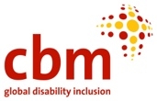
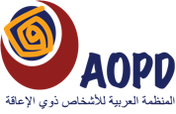
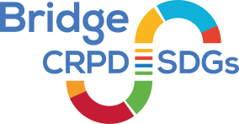
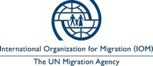
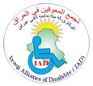
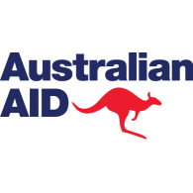

Bridge CRPD-SDGs Module 1 Iraq

Tentative Agenda

9 to 16 November 2021
Erbil, Iraq
 | Day 1  9 Nov, Tuesday | Day 2  10 Nov, Wednesday | Day 3  11 Nov, Thursday | Day 4  12 Nov, Friday | Day 5  13 Nov, Saturday | Day 6  14 Nov, Sunday | Day 7  15 Nov, Monday | Day 8  16 Nov, Tuesday
9.00-09.30 | INTRODUCTION  Opening,  Agenda, Expectation, Rules,  Participants… | CRPD principles:  Respect of difference and diversity  Full and effective participation and inclusion | Review CRPD articles 2mn 1 article
9.30  10.45 |  |  | Access, accessibility and reasonable accommodation  Case studies | Introduction of the agenda 2030 | What states have to do to implement CRPD and SDGs?  Art 4 | Access to justice | Living independently and being included in the community | Have we been inclusive?
11.15  12.30 |  | Equality and non-discrimination |  |  |  | Inclusive education | Livelihood and Employment | Inclusive and CRPD compliant disability movement
 | LUNCH
14.00  15.30 | From Needs to Rights:  HRBA to disability and development | Equality between men and women | Review CRPD articles 2mn 1 article | Free time | Review CRPD articles 2mn 1 article |  |  | Presentation of Module 2 elements and feedback planning  In between modules assignments
 |  |  | Self-determination and autonomy |  | Explanation of the Groupwork assignment | Art 11 | Social protection
15.45  17.15 | Game of life | Accessibility | Principles Recap exercise |  | Group Preparation |  | CRPD recap | Evaluation  Closure
17.3018.00 | Feedback in small groups |  |  |  | Feedback in small groups

