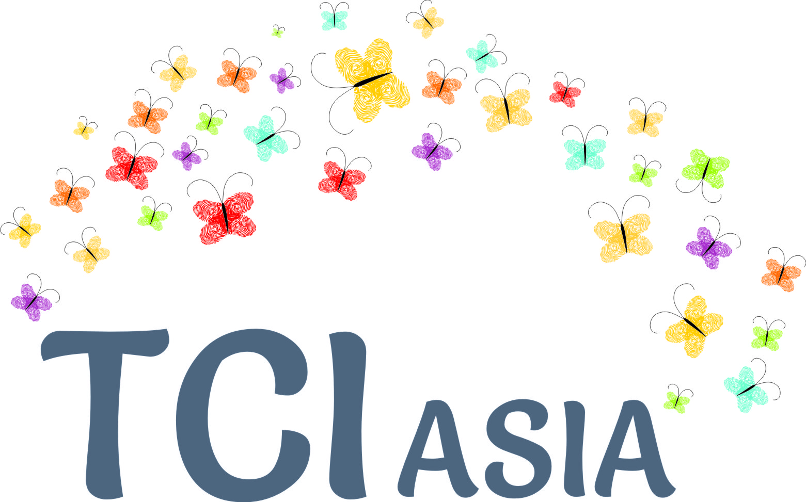
TCI Asia Plenary in Bali, August 2018
The Convenor's office is super excited to present this plan for proceedings in Bali. The plan has been developed with inputs from some SC members, and then, taken to the full SC in our monthly Zoom meetings. The plan is flexible, and gives the overall frame for our week in beautiful Bali.
Proposed draft proceedings
Dates : 27-28-29 August 2018, before the project year is over. (Project cycle for IDA-OSF is September to August). 30th- Steering Committee meeting.

Format of the plenary:

As has become a norm, the plenary format will have the following elements:

- Pre-preparation for new country members (26th mid-afternoon) and 'catching up' sessions in the evenings
- Market Place (Country status reports on status of persons with psychosocial disabilities)
- Capacity building and learning cycles on Inclusion (Presentation of Inclusion synthesis report; Dialogue on WHO Quality Rights; Gender, sexuality and reproductive health)
- Proceedings of TCI Asia on organizational matters: (AGM simulation and testing format; Refreshing Code of Conduct; Approval of TCI Asia Pacific and decision on logo; Sharing 1 year works and budgets; Memberships status; New members to SC; Way forward); News on registration and issues thereof
- This year, additionally, there will be a steering committee meeting, of country members, and where needed their deputies;
- Platform for dialogue with technical assistance agencies and other stakeholders from the cross-disability movement, if budgets permit

Country mobilisation for Bali Plenary: Atleast 20 countries participation is expected, including Malaysia, Singapore, Nepal, Japan, Indonesia, Philippines, SriLanka, India, China, Pakistan, South Korea, Bangladesh, HongKong, Taiwan, Vietnam, Thailand, Fiji, Tonga, Cambodia, Myanmar

Individual member mobilisation: In some countries, we are aware of more than 1 support / advocacy group. In order to have plurality, we are inviting as many as possible, when we become aware of such diverse groups in country. In some countries, there are no emerging leaders, where, we invite cross disability peers to inform, share and invite them to then source out our people from their countries.
Learning thematics proposed by the Steering Committee members to the Bali Plenary

Usually, these thematics are facilitated sessions with presentations, and active dialogue.

1. Inclusion in Development:
- Inclusion in SDGs process
- Intersectionality
- Community services - frame for this, with focus on housing, employment
- Special topic: Reasonable accommodation at the workplace

2. Presenting the Inclusion report: Expanding the pedagogy on Article 19, TCI Asia has prepared 4 inclusion reports, which will be presented as a synthesis, with key learnings and messages.

3. Public Advocacy: Plenary on WHO Quality Rights: Led by Janice Cambri and YeniRosa Damayanti, providing critical points towards a public statement on WHO Quality Rights.

Way forward: As suggested by the Steering Committee,

Creating 1 work package on further study of legal issues:

In the last phase of legal harmonisation, we considered the mental health laws. In this phase, we could consider the disabilities acts in different countries, what is the status? We could make a status report on this, for the next inclusion report. Secondly, we could consider, for this report, the legal incapacity legislations and practices in different countries, what is the status?

Creating 1 work package on MH Financing: EQUALS can support preparation for this aspect, by making a short guideline for people to prepare before hand. Each country could present a case study on monies spent by governments at central and federal level (if applicable), on mental health financing.

Creating 1 work package for a Research panel: Present on works, especially social care institutions.

Planning for regional meet: With support of technical assistance, preparation for a meeting UNESCAP, ASEAN intergovernmental body, SAARC intergovernmental body, WHO regional, etc. and global political movements, our role in it.

Planning for trainings: With support of technical assistance (Bapu Trust, other), preparation of training group for taking country missions, technical consultancy to governments, trainings for pilots, etc.

Planning for INTAR Kenya and inter-regional association:

Consultancy / technical assistance package

Opening up invitations for members contributions to work packages

Vote of thanks and closure

