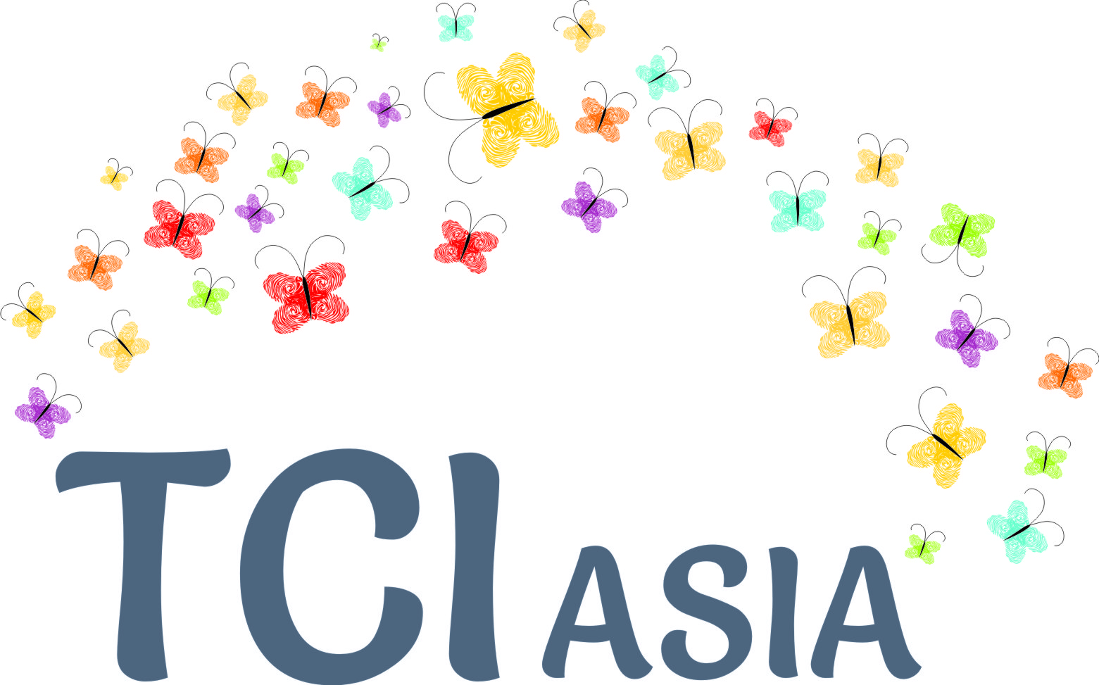

TCI Asia Plenary in Bali, August 2018
[in partnership with Indonesian Mental Health Association, Bapu Trust and International Disability Alliance; and support of Open Society Foundation and CBM-Australia].
Proposed draft proceedings
Dates : 27-28-29 August 2018. 30th- Steering Committee meeting.

Format of the plenary:

As has become a norm, the plenary format will have the following elements:

- Pre-preparation for new country members (26th mid-afternoon) and 'catching up' sessions in the evenings
- Market Place (Country status reports on status of persons with psychosocial disabilities)
- Capacity building and learning cycles on Inclusion(Presentation of Inclusion synthesis report; Dialogue on WHO Quality Rights; focus on mainstreaming of persons with psychosocial disabilities in different development areas)
- Proceedings of TCI Asia on organizational matters: (AGM simulation and testing format; Refreshing Code of Conduct; Approval of TCI Asia Pacific and decision on logo; Sharing 1 year works and budgets; Memberships status; New members to SC; Way forward); News on registration and issues thereof
- This year, additionally, there will be a steering committee meeting, of country members, and where needed their deputies;
- Platform for dialogue with technical assistance agencies and other stakeholders from the cross-disability movement, if budgets permit

Country mobilisation for Bali Plenary: Countries including, Malaysia, Singapore, Nepal, Japan, Indonesia, Philippines, SriLanka, India, China, Pakistan, South Korea, Bangladesh, HongKong, Taiwan, Vietnam, Thailand, Fiji, Myanmar

Provisional agenda

 | Sunday 26 august | Monday 27th |  | Tuesday 28th |  | Wednesday 29th |  |  | Thursday 30th
09.00-09.50 | ARRIVAL | Introduction and Market place |  | E. Work and employment |  | H. Self preservation |  |  | STEERING COMMITTEE
10.05-11.00 |  | A. Reframing the momentum(S) |  | 5. Children with psycho-social | 6. Health | MH movement | ASEAN | Pacific
 |  | Break |  | Break |  | Break
11.15-11.55 |  | B. Updates from the Global level |  | F. Social protection (cash benefit, social housing..) |  | I. Adoption of the Bali declaration
12.00-13.00 |  | 1. WHO Quality rights | 2. Special rapporteur report | 7. Women with disabilities | 8. Disability determination | Plenary Decisions
 |  | Lunch |  | Lunch |  | Lunch
14.15-15.05 | 3pm -6pm  INDUCTION NEW MEMBERS  What is TCI?  CRPD  Art 19  Transformative services  … | C. The inclusion report(s) |  | G. Kenya case study |  | STEERING COMMITTEE
15.15-16.15 |  | D. Human rights based services for inclusion |  | 9. Legal issues | 10. Public financing
 |  | Break |  | Break
16.30-17.30 |  | 3. Advocacy for change | 4. Community support system | Feedback groups in plenary on cross cutting issues  Preparation planning and decision plenary
 | Preparation | SOCIAL EVENT |  | Preparation of the declaration |  | Dinner Steering committee

Thematic sessions:

Below is a short and provisional description of the different sessions planned for the convening. It is important that members of the steering committee contribute to the facilitation of those sessions. Please indicate your interest for contributing or facilitating one or several sessions. Ideally, a diversity of steering committee members would be involved

Plenary sessions description

- Reframing the momentum
This session will tackled the key issues promoted by TCI Asia. It will go back to the original charter of TCI Asia and describe the path achieved since. It will articulate the key steps that are required to reframe the political and donors discussions around mental-health towards inclusive development and inclusive communities and will serve as a background for the overall convening. It will emphasise new ways of articulating questions (For example, when people discuss "how many psychiatrists are there?" wewill ask, "how many support persons are there?" etc). It will put emphasis on the imperative of working on the inclusion of person with psychosocial disabilities in all areas off inclusive development. The session will emphasize the need to understand "inclusion" as a vital practice in community development.
- Update from global level
The session will recap the updates related to TCI Asia engagement at global level including the 11th Conference of States Parties (COSP), the consultations on mental-health and Human Rights as well as on the right to health of person with disabilities that took place in Geneva.We will share the different on-going processes such as the globe summit on mental health planned for fall 2018 in London.
- Inclusion report
The session will cover the presentation of the inclusion report developed by TCI-Asia covering what means 'inclusion' for persons with psychosocial disabilities, scope of legal harmonisation for Asian region, public budget- a case study,Community service for inclusion and other learnings on Inclusion.
- Human Rights based services
This session will address the requirement of human rights based services. Many countries are working on so-called CRPD compliance before but it appears are there is either a lack of understanding or confusion on the exact requirements to achieve such compliance. The session will allow exchange between participants on those trends and seek to identify best ways to ensure the newly developed services are truly grounded on human rights.
- Work and Employment
The session will explore the different issues related to access to employment as well as inclusion of person with psychosocial disability in work and livelihood programs. As for other sessions of the second day there will be a short introduction of key concepts and issues following by open exchange with the participants. This session should allow identification of research topics or further capacity building needs to support TCI members in this field.
- Social Protection (housing…)
This session will cover the different aspect of social protection that could be supporting of inclusion of person with psychosocial disabilities; as well as the specific issues undermining access to social protection, in different country scenarios. It will tackle cash transfer, in kind support, health insurance housing and other type of schemes. It will be the opportunity for members to share their concerns, practices and experiences in advocacy related to social protection reforms.
- Kenya case study
Taking advantage of Michael Njenga, from USP-Kenya, the session will present the context, challenges and successes of advocacy of persons with psychosocial disabilities in Kenya, with regards to legal harmonisation and budget among others.. It will also provide the opportunity for Michael to share the experience of peer support services at community level.
- Self Preservation
This workshop willy and opportunity to share the different practices of TCI members related to self-preservation. It will offer a space to share specific practices, individual or collective such as arts based therapy but also traditional and cultural practices that offer effective support and relief.
- Adoption of Bali declaration
It is proposed that as a conclusion off the convening DCA Asia becoming TCA Asia-Pacific adopt the declaration promoting the values goals and key asks of the organisation. This declaration would become the platform for regional and global advocacy. In particular the declaration would be TCI Asia-Pacific contribution to the upcoming Global Summit on mental health among others.
Parallel workshop description
- Review of QualityRights WHO package
The workshop we present the review of the WHOQuality rights package made by Yeni Rosa and Janice Cambri. It will offer the opportunity of exchange to consider under which conditions TCI Asia would support they use of WHO QR.
- Special Rapporteurs reports (DaniusPuras and Catalina Devandas)
The workshop with present the Report of the special rapporteur on the right to health on mental health as well as the report off the special rapporteur on rights of Persons with disabilities related to legal capacity. Those two documents provide important elements for national and regional advocacy.
- Advocacy for change
This workshop Will focus on experience of members in their advocacy efforts. it will offer opportunity to exchange between members and try to identify the facilitators and obstacles to advocacy it will serve as a background for the second and third day
- Community support systems
This workshop we look at the different elements of support that needs to be available in the community. It will offer the opportunity to present and exchange on members’ practices in the field. It will also look and a necessary condition that would help development and scaling up of community services.
- Children with disabilities
To some extent as the movement is mostly let by adults with psychosocial disability, it may seem that little attention have been paid to children with psychosocial disabilities. The workshop Will be a first attempt for TCI Asia members to consider the key issues and the possible next steps.
- Women with psychosocial disabilities ( sexual and reproductive rights, gender equality)
The workshop will be the opportunity to tackle medical discriminations and specific issues faced by women with psychosocial disability. This will include sexual and reproductive rights as well as mainstreaming off disability in gender equality and women empowerment’s movements.
- Disability assessment and determination
This session we look at the specific issues related to disability assessment and eligibility determination for social protection programs. In most countries disability assessment for persons with psychosocial disabilities is supposed to be carried out by a psychiatrist. This tremendously reinforces the gatekeeping role of the mental health system. The session will seek to identify possible and credible alternative that could be advocated for.
- Legal harmonisation
The workshop will be looking at the progress and challenges relating to legal harmonisation in Asia in the last three years. It will consider disability rights legislation as well as mental health laws.
- Public financing
Based on the work of TCI Asia and EQUALS, the workshop will consider the key elements of that the financing impacting inclusion of person with psychosocial disabilities. It will offer an introduction to CRPD compliance budget advocacy and allow sharing of experience by members.
- Asean/Mental Health Movement/Pacific
Those parallel working groups will focus on exploring engagement opportunities with the ASEAN and the Asean Disability forum, the Mental health movement at regional and national level and with the Pacific region.

